DESeq2 Normalization for Aneuploidy

Samuel Hunter, 2023

First, download files from the AWS server. The files are located in: /scratch/Shares/public/sread2022/data_files/include/deseq2_normalization/

1. Load in your files. Change the path to wherever you stored your files:

1. Load in and clean up your counts file to be DESeq2-compatible. Run DESeq2 with a batch correction:

1. Generate your results table (shrinking log2FoldChange is optional). Also calculate a per-chromosome median fold change:

1. Generate some plots for visualization:

1. You’ll notice that for chr21, most genes are at 1.5x expression (as expected), but a subset are closer to a fold-change of 1.0, and are not considered significant. What can we say about these genes?

**Normalization Method 1: Adjusting Counts By Ploidy**

1. Our metadata table lists the ploidy status for each sample. We can define a function which will print the copy number of the gene based on the sample’s ploidy status. We use this to generate a matrix corresponding to the copy number for each gene in each sample:

1. Re-run DESeq2 with the new normalization matrix:

1. Visualize our results

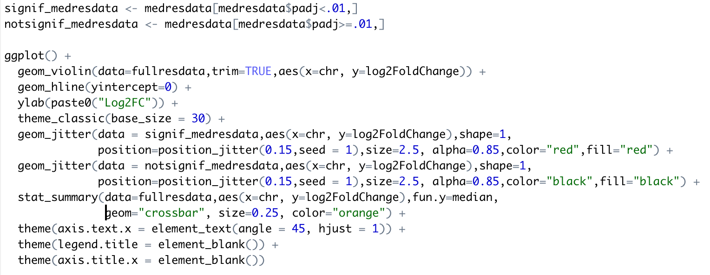

**Method 2: Change the alternative hypothesis**

1. Re-run DESeq2, using an adjusted alternative hypothesis

1. Visualize the results:

