How do I choose my slurm parameters?

Author: Mary Allen, 2022

# Talk to your coworkers. Have they run this before. What resources did it take?

# What if no one has run this before? Guess and Share.

### Look at what's on your supercomputer so you can play nice. Never take over the whole super computer. Half of the CPUs and Memory is about as high as you should go!

* + 1. I want to know what this supercomputer has so I can be nice and share.
       1. First I run sinfo (this tells you the partitions and the node names on the computer)
          1. This computer has a partition named compute and has a node named compute-st-m52xlarge-1.



* + - * 1. The below super computer has many partitions (long, short, sandbox, highmem). It also says the longest you are allowed to use that partition. (timelime limit)

timelimit= The stuff before the dash is days, after the dash is time.

nodes= The number of nodes on your computer that look alike

The default is the short partition. It will run for no more than 1 day.

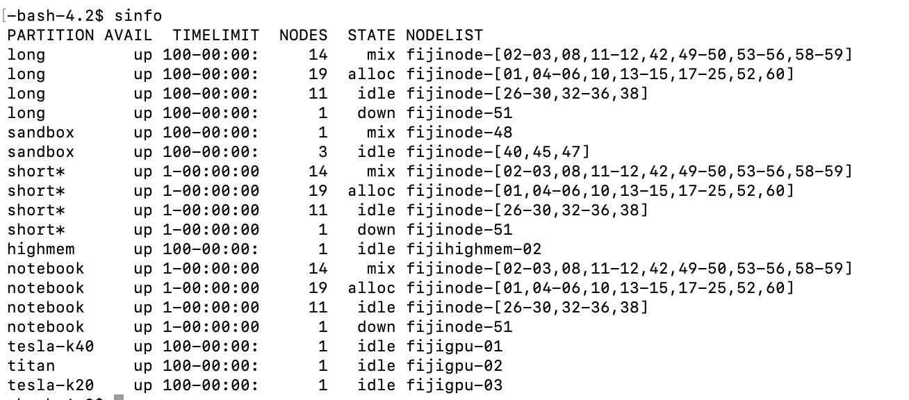

* 1. Now that I know the partitions and their timelimits— that narrows which partition I might need. I tend to start with the smallest time limit. If the job fails due to lack of time- the err file or the email will say that. Then I move to a node with a longer time limit by changing the partition.

Test it yourself.

What is the timelimit on the compute partition?

How many CPUs and how much memory is on one of the nodes.

Create a script that runs the command sleep for 100 seconds. Set the slurm time of that script to 2 seconds. What error message do you get?

* 1. Next— I need to check what the nodes in the partition I’m thinking about have for CPUs and for memory.
     1. I look at some nodes I might want to use.
        1. scontrol show node <nodename>

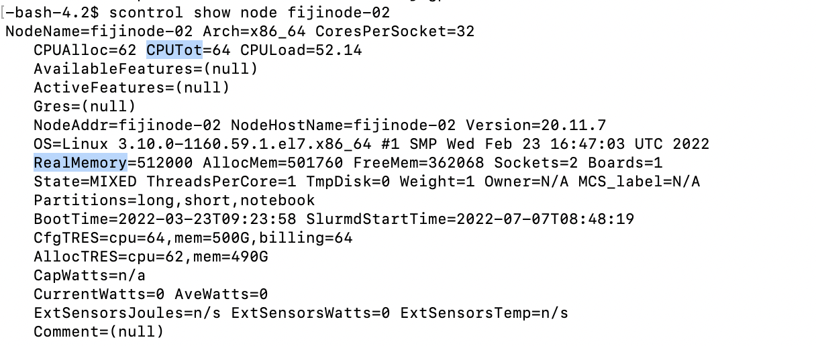

This node has 64 CPUs (62 we can use) and 512000 Megabytes of memory.

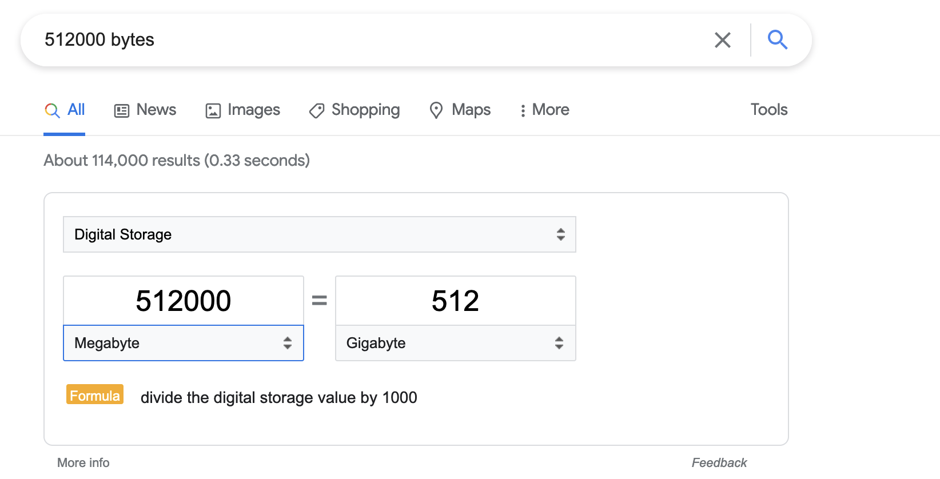

512000 megabytes is 512 gigabytes. Because 512/64 is 8, there are 8 Gigabytes of memory per CPU.

# 3) Design a test job.

Pick your most large input file to do a test run on.

If I have a program without paralyzation, based on what I learned above, I start with 1CPU and the amount of memory that should belong to this CPU. In my case that is 8 because 512/64 is 8.

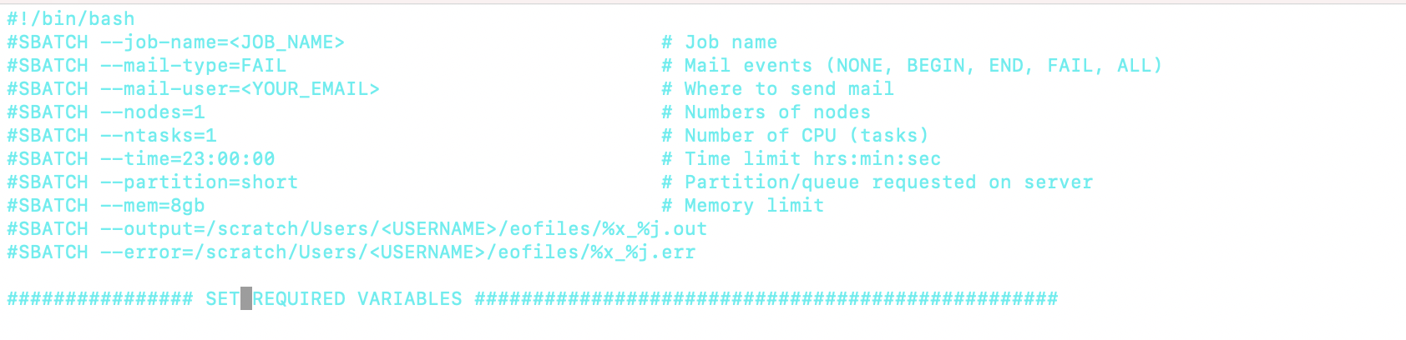

So— if I have a program with paralyzation I generally use half of the CPUs on a node and the number of gigabytes of memory each CPU would get if it was fairly shared. Why half? Then people using 1 CPU can hope on the same node as me. I can set it to all the CPUS, then I get the node to myself-but I often wait in the queue a long time for that.

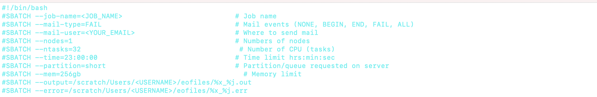

Test it yourself.

Look at what partitions, timelimits, and CPUS are on your super computer.

If your script ran a program that was not parallelized what is fair to take? What if your script ran a program that was parallelized? What is fair to take?

# 

# 4) Optimize your Guess/a.k.a. “Are you playing nice?”

* 1. To check how much time/memory/CPU you are really using:
     1. While the job is running:
        1. sstat --format=AveCPU,AvePages,AveRSS,AveVMSize,JobID -j 2050904.batch #where 2050904 is the jobid #**NOTE**: The **sstat** command requires that the **jobacct_gather** plugin be installed and operational.
        2. scontrol show jobid -dd 2050904 #where 2050904 is the jobid
     2. Or for completed jobs
        1. sacct --format="Elapsed,CPUTime,MaxRSS,AveCPU,AvePages,AveRSS,AveVMSize,JobID, MaxVMSize" -j 2050904.batch #where 2050904 is the jobid
        2. seff jobid

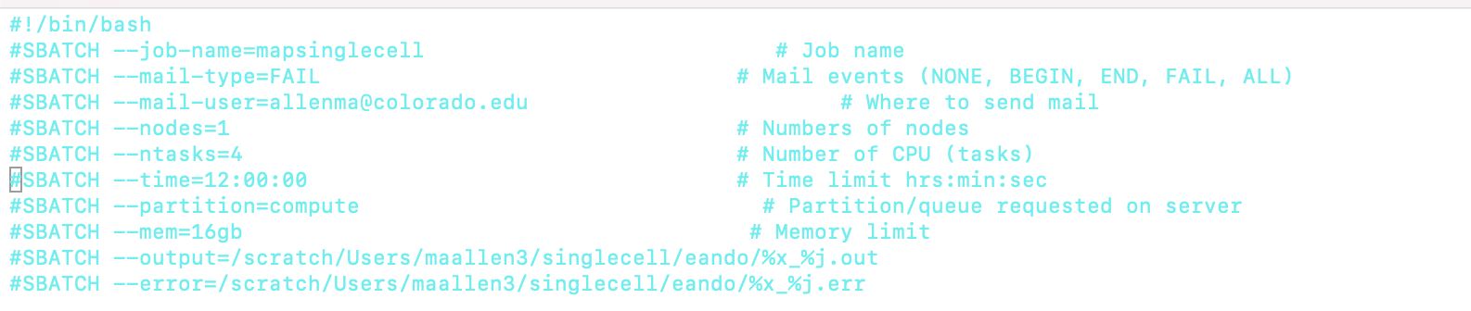



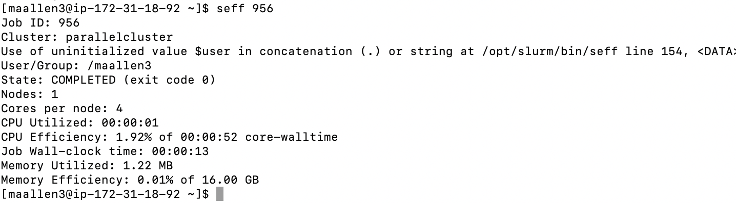

Did using 4 CPUS work well for this script? How do you know?

How much memory did I ask for? How much did I use?

hint: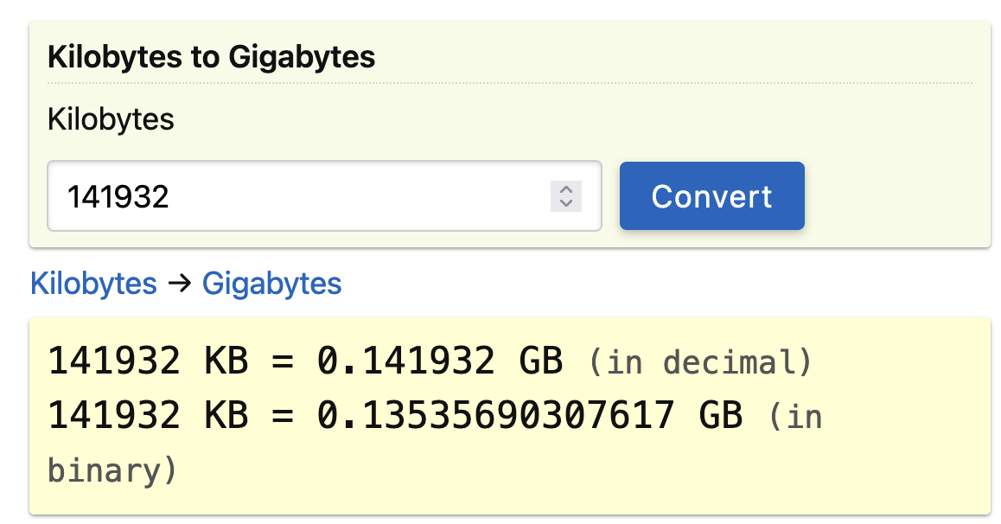

# 5)Run on all your files in individual sbatch scripts. For the slurm command, add 20% more memory than running on the largest file took.