Deseq2 with gene lists walkthrough

Author: Mary Allen

Step 1) Copy our scripts

Log in to the super computer

Make a directory /scratch/User/yourusername/day7/

Cd into the new directory

Copy the two scripts we have provided in

/scratch/Shares/public/sread2021/scripts/day10/Deseq2_to_go/

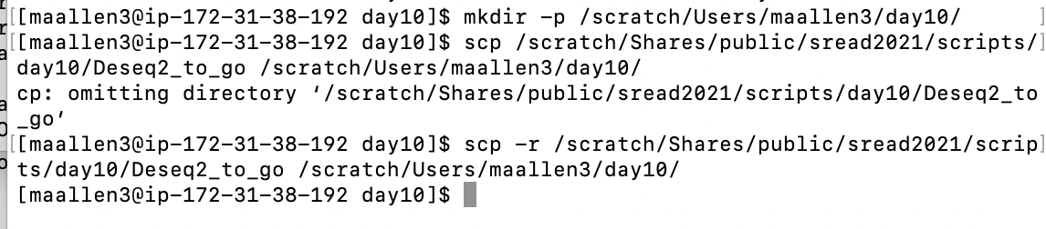

Step 2) Edit Our scripts

In the R script Change your working directory

In the sbatch script change your email and error and output files

####Make sure the error and output directory exist before you run!!!!!!



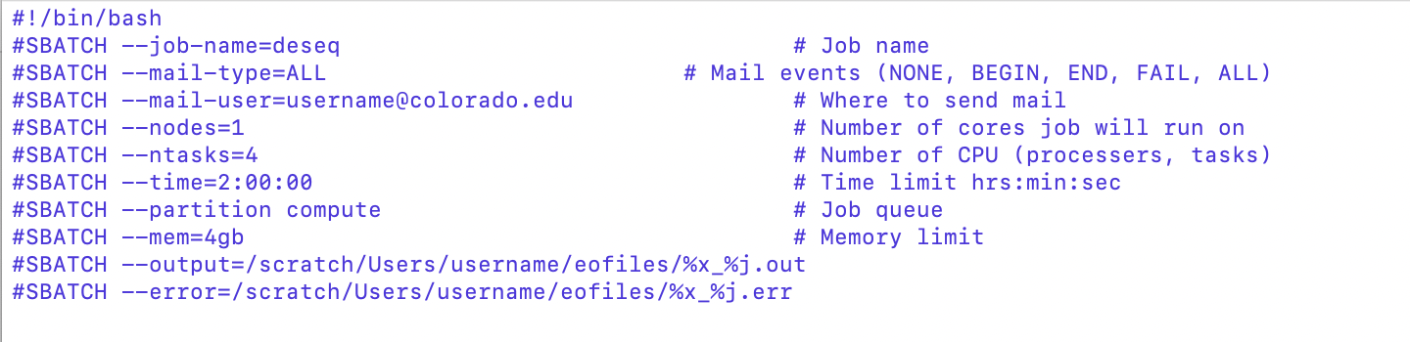

becomes

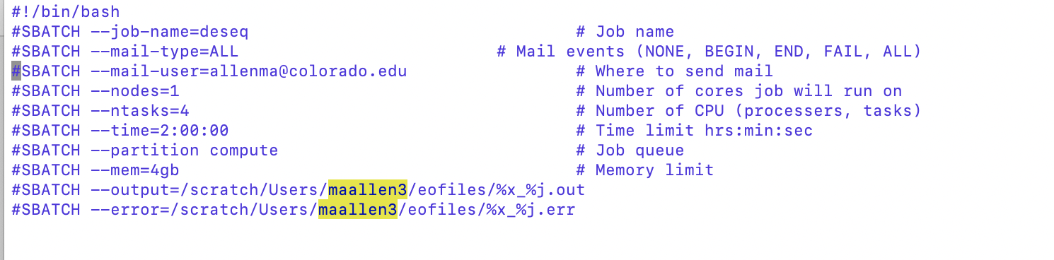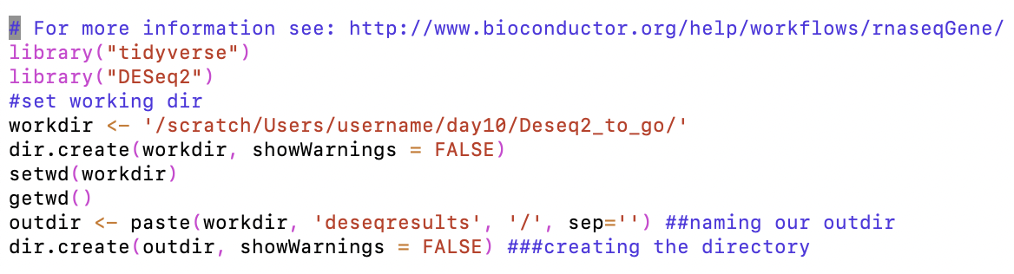

becomes

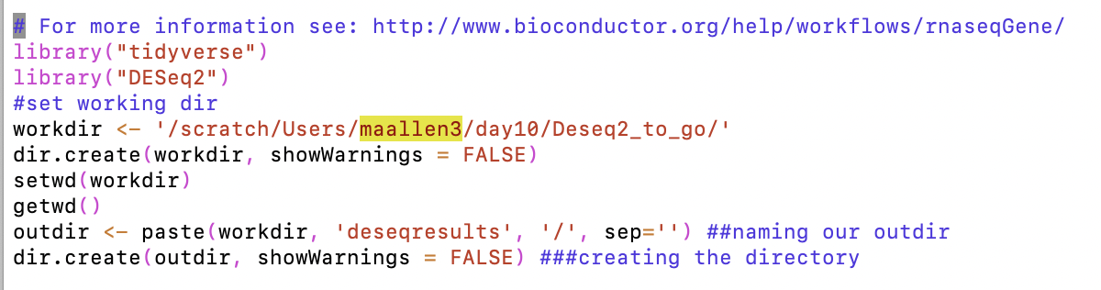

The Deseq2 script should like about like this…

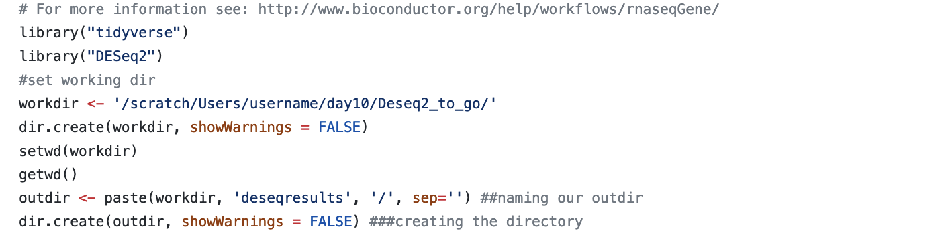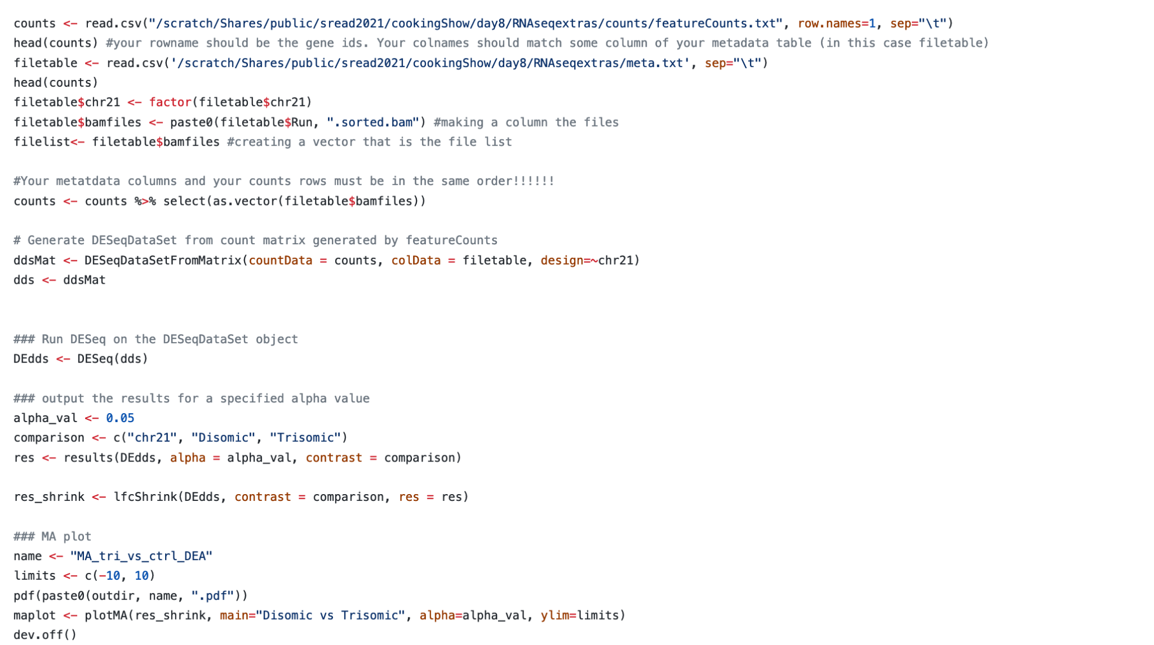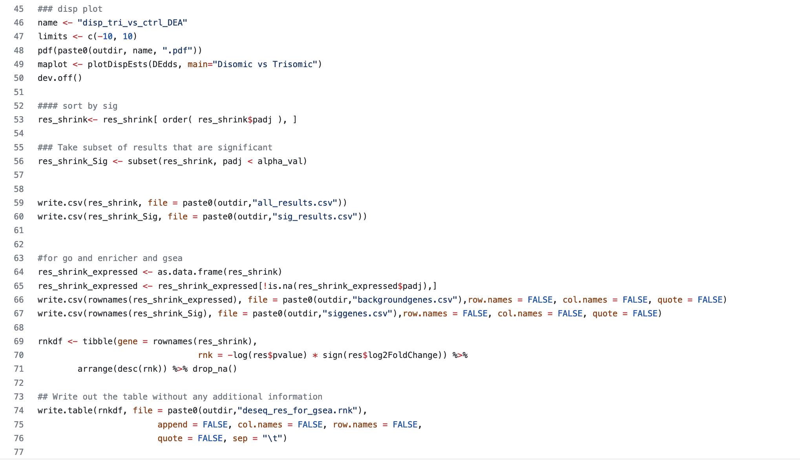

Step 3) Submit the sbatch script to the queue

The sbatch script runs the R script… how?



Look at the number of genes in each csv

Step 4) If it works you will end up with a directory named deseqresults in your working directory. In the deseqresults directory you will end up with many files.

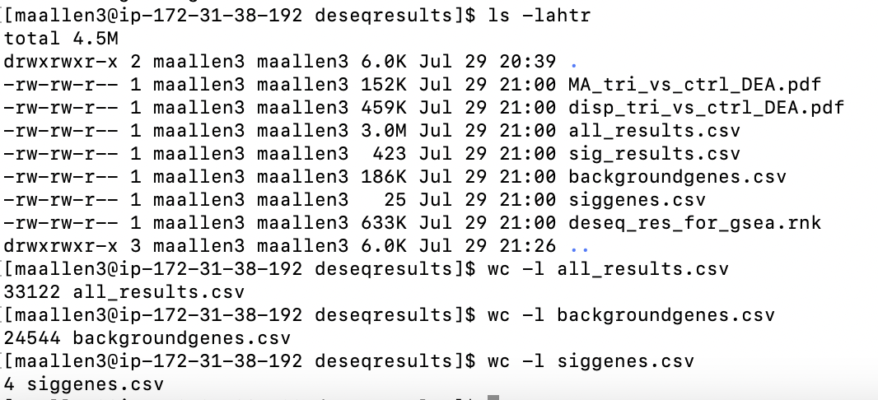

Why are there less background genes than all_results genes?