Window and terminal like systems  
Authors: Mary Allen, Lynn Sanford, 2021 (edited 2023)

To take this class, if you had a pc, you had to download a program to provide a bash terminal. You probably have downloaded Ubuntu, MobogoXterm, or Putty. To get to files you download from the AWS you will know where stuff lives on your PC. Directions for each system are below.

If you use Ubuntu  
Ubuntu is a virtual machine app that runs on top of WSL (Windows Subsystem for Linux). When WSL was installed, it **probably** integrated with File Explorer so that you can access your Ubuntu home directory from there:

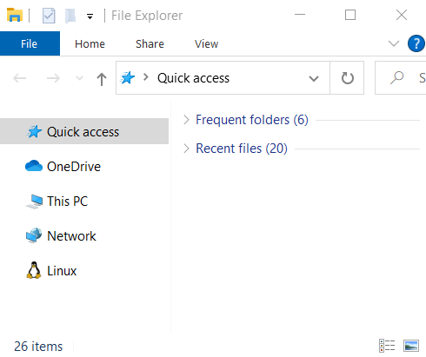

The full path for your home directory is “> Linux > Ubuntu > home > username”

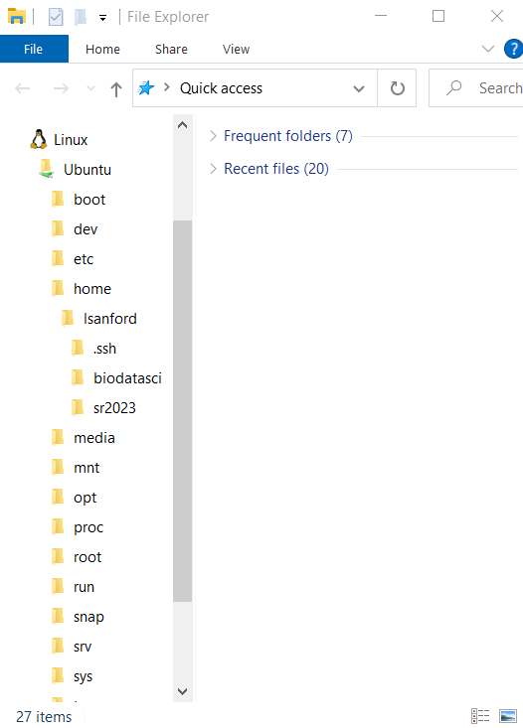

If there is no Linux penguin in your File Explorer, it gets a bit more complicated. The best way to access files is to use the command line to move files **to** your desktop (or anywhere else you’d like on your C: drive), then look at them from there.

From your home directory on the command line, you can access your desktop by one of the following paths, depending on your version of Windows:

* /mnt/c/Users/<computerusername>/Desktop
* /mnt/c/Users/<computerusername>/OneDrive/Desktop

Once you sync files from your home directory to your desktop path, those files will pop up on your desktop.

If you use Mobaxterm

Go to Settings->Configuration->General and set the Persistent home directory to the folder of your choice. Then you will obviously know where it is.

However, if you have not done this before and you already have files in that directory and want to copy them out, try looking in

* C:\Users\your_username_here\AppData\Local\Temp\Mxt73\tmp\home_your_username_here

This assumes version 7.3, you might want to try Mxt7N for other versions like 7.N.

After you've copied your files, then set a persistent directory so that next time it will be easier to find.

If you use Putty  
Putty does not natively allow for file transfers. Another program is necessary for transferring files, such as psftp (also available from the Putty download site), or WinSCP. You can also just use Mobaxterm.