**Single Cell RNA Sequencing Worksheet2: Seurat**

Anthor: Jesse Kurland, edited by Chris Ozeroff. July, 2023

**Reading in data and initial processing**

1. Make a directory called cellranger_outputs_R_objects on your local machine
2. Rsync dpi7_filtered_feature_bc_matrix.zip, dpi4_filtered_feature_bc_matrix.zip, and final_myogenic_subset_seurat.RData from the AWS to this new directory. These can be found in /scratch/Shares/public/sread2023/data_files/day8/.
3. unzip the two cellranger output filtered matrix directories (dpi4 and dpi7).
4. Open Rstudio, and begin installing and loading necessary packages

**If you get an error installing Seurat, use the following line of code instead of devtools::install_github(“satijalab/seurat”):

install.packages("https://cran.r-project.org/src/contrib/Archive/devtools/devtools_2.4.3.tar.gz", repos = NULL, type="source")

1. Set working directory with correct path.



1. Load in files from the “filtered_feature_bc_matrix” directories and use these to create a Seurat object

1. Add metadata columns to Seurat objects

1. Quality control
   * Remove doublets (nFeature_RNA < 2500)
   * Remove debris (nFeature_RNA > 200)
   * Remove mitochondrial contamination (cells/nuclei with percent.mt < 5)

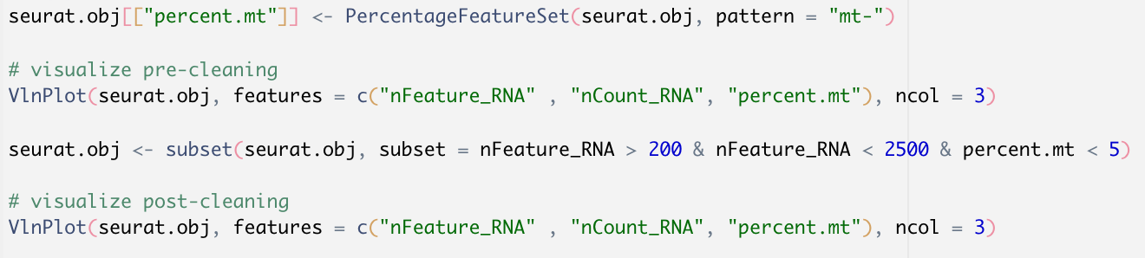

**Note: this step must be done for each Seurat object, substituting obj.7dpi.seurat and obj.4dpi.seurat for searat.obj in each case.

**Merging/Integration**

1. Merging Seurat objects (this has to be done prior to “integration” steps below)

1. Processing merged object

1. Integration using the rpca algorithim

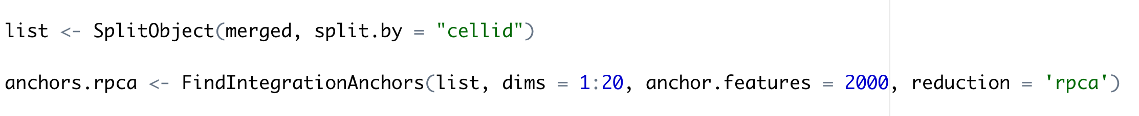

**Clustering and visualization**

1. Read in myogenic subset object



1. Setting parameters for clustering and UMAP

1. Scaling data



1. Conducting PCA reduction
2. A black text on a white background

   Description automatically generatedConducting UMAP reduction (see website for more information <https://pair-code.github.io/understanding-umap/>)
3. A black text on a white background

   Description automatically generatedUsing the louvain algorithim to identify clusters from UMAP processed object
4. Plotting and visualizing clusters

