# Day 7 Worksheet – Installing Rsubread

Author: Rutendo Sigauke

This short worksheet goes over installing Rsubread in R on the AWS. This process can take a while and should be completed before class. RSubread can be found on Bioconductor and instructions to install the package can be found here: <https://bioconductor.org/packages/release/bioc/html/Rsubread.html>.

### **Install Rsubread:**

Installation can be done in the R console (shown below).

* Type **R** in the terminal

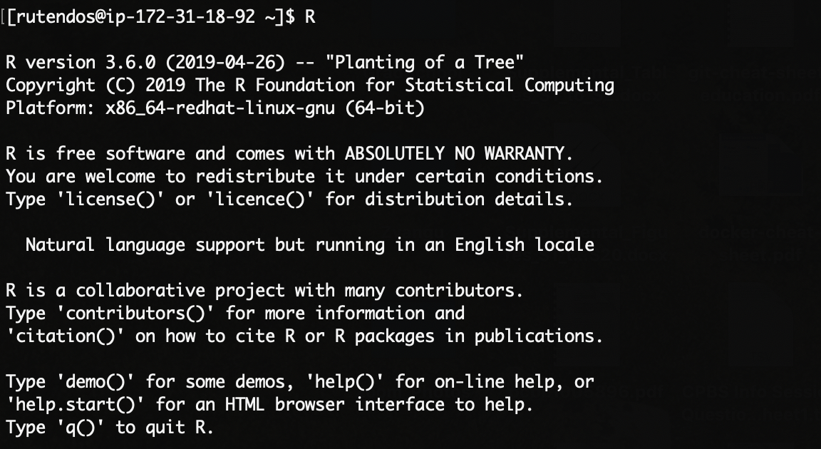

* Rsubread can be found on the **BiocManager**, so to install the counting library, we have to first install **BiocManager**. **BiocManager** library can be installed from the R Comprehensive R Archive Network (CRAN).

**if (!require("BiocManager", quietly = TRUE))**

**install.packages("BiocManager")**

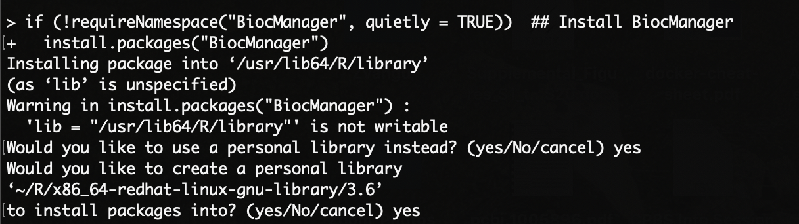

* The above command will initiate a new personal library for your R packages. Select **yes**. Additionally, CRAN mirrors from where to download the packages. We will use the USA (KS) mirror.

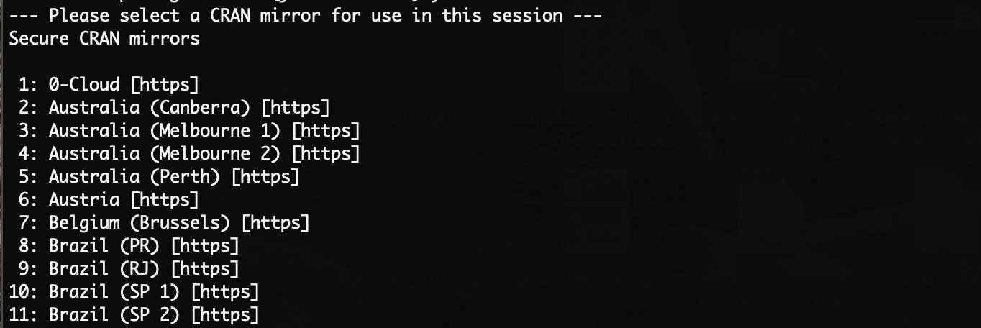

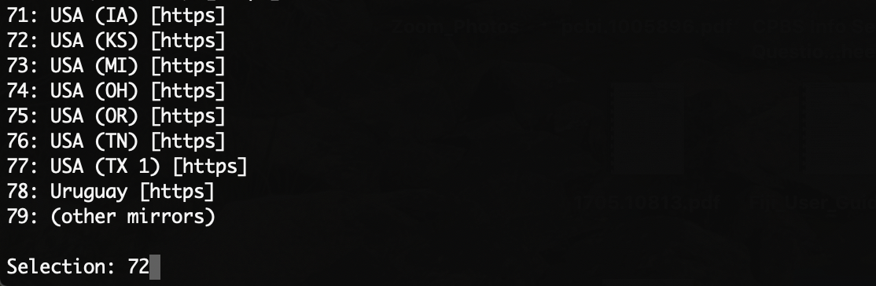

* Now, we can install **Rsubread** from **BiocManager** to our **R** libraries.

**BiocManager::install("Rsubread")**

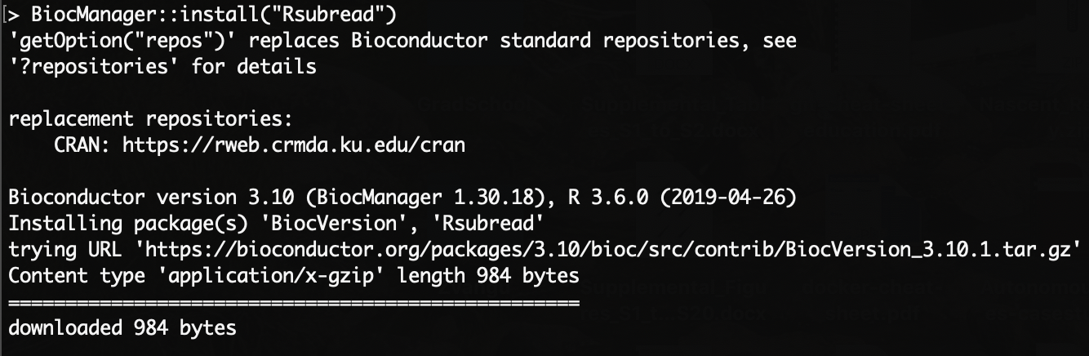

**NB:** This will take a few seconds. If the library is installed successfully, it can be loaded as shown below without any errors.



### **If the above does not work, try installing from source:**

In some cases, you may have to download an older version of Rsubread from source (<https://bioconductor.org/packages/3.17/bioc/src/contrib/Archive/Rsubread/>).

* First, download the tar.gz file with wget to a location on the AWS.

wget <https://bioconductor.org/packages/3.17/bioc/src/contrib/Archive/Rsubread/Rsubread_2.14.0.tar.gz>

* Open R and install the package from the source file as shown below.

install.packages(“/path_to_file/[Rsubread_2.14.0.tar.gz](https://bioconductor.org/packages/3.17/bioc/src/contrib/Archive/Rsubread/Rsubread_2.14.0.tar.gz)”, repos = NULL, type="source")