Senior Software Engineering Project

Veterans Museum

Version 2

Version 1 Content

Ben Ward

John Michael Raimondi

Version 2 Content

Phillip Owens

Nicholas Morgan

# Project Summary

The main task of our project was to help our client, Mr. Bob Borden, have an easier time managing his database of Alabama veterans. We decided to move Bob away from Microsoft Access and build him two standalone applications that he can use to manage this database. Both applications, one for visitors to look at data and one for Mr. Borden to manage data, were written in C# with Windows Presentation Foundation (WPF). We also decided to merge his 6 database files and migrate to MariaDB.

The version 2 of the project addressed a list of action items requested as changes to the project as delivered by the version 1 team. The requested items were meant to address some simple functional changes, new features, and an effective backup solution for the projects data. The functional changes and features were written in C# with Windows Presentation Foundation (WPF), while the backup solution is implemented using Windows batch scripts.

# Table of Contents

Contents

Project Summary 1

Table of Contents 2

Problem and Objectives 3

Design Documentation 4

Database Design 4

Application Design 5

Viewer Application 5

Administrator Application 6

Version 2 action item solutions 10

References 12

# Problem and Objectives

The main objective this project aimed to complete was to alleviate as many of our client’s issues with using Microsoft Access to manage his database as possible. Our client had trouble saving and loading his database and would sometimes create new files on accident. Our solution for this issue was to remove any unnecessary interaction with the backend data through building our applications that will handle loading and saving the database automatically. Both applications connect to this database when launched and the option to choose where to save within the administrator application was removed when saving updated or new records. Configuration files were also made to allow for the use of a separate, centralized server where both applications can connect via network. A cleaner user interface was designed for ease of use, both for users in the viewer side and for our client in the administrator side. The original Access database files were all merged into one and migrated into mariaDB. This was done by opening each database file into Microsoft Access and exporting to a temporary mysql database. These 6 exported databases were then merged into another temporary table where each column was looked at to find discrepancies in naming conventions within the records. Next, each column in all 6 exported database files were updated to match each other and the data was merged again into another temporary table. Finally the data was moved into their permanent tables and exported for use in the final mariaDB implementation.

The goal for version 2 of the project was to implement a list of action items requested by the client after using the product on a daily basis since the original install. The complete list of action items include:

* Backup Solution for data/images.
* Notification for a successful save.
* Add ability to clear forms during data entry.
* Change Dob/Dod to allow partial or incomplete data as available.
* Correct link for user guide on desktop.
* Add Google Maps data to cemetery information page.
* Add ability to link veteran’s Findagrave.com page when available.
* Repurpose veteran “Marker pic” to a “Misc pic” once Findagrave.com link is in place.

# Design Documentation

## Database Design

The following diagram shows the layout for the final implementation of the database including V2 additions.

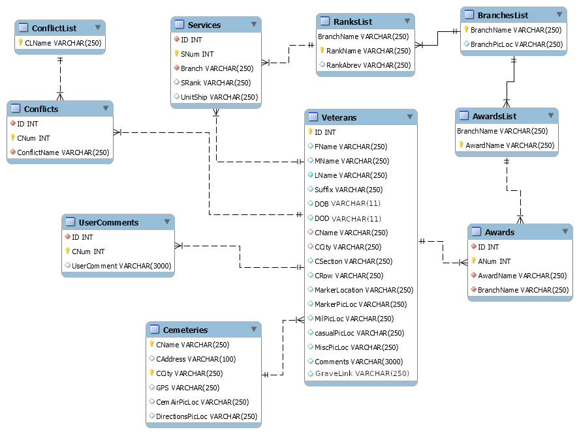

## Application Design

### Viewer Application

The following figures show the final layout of the Viewer application where users can search and view veteran records.

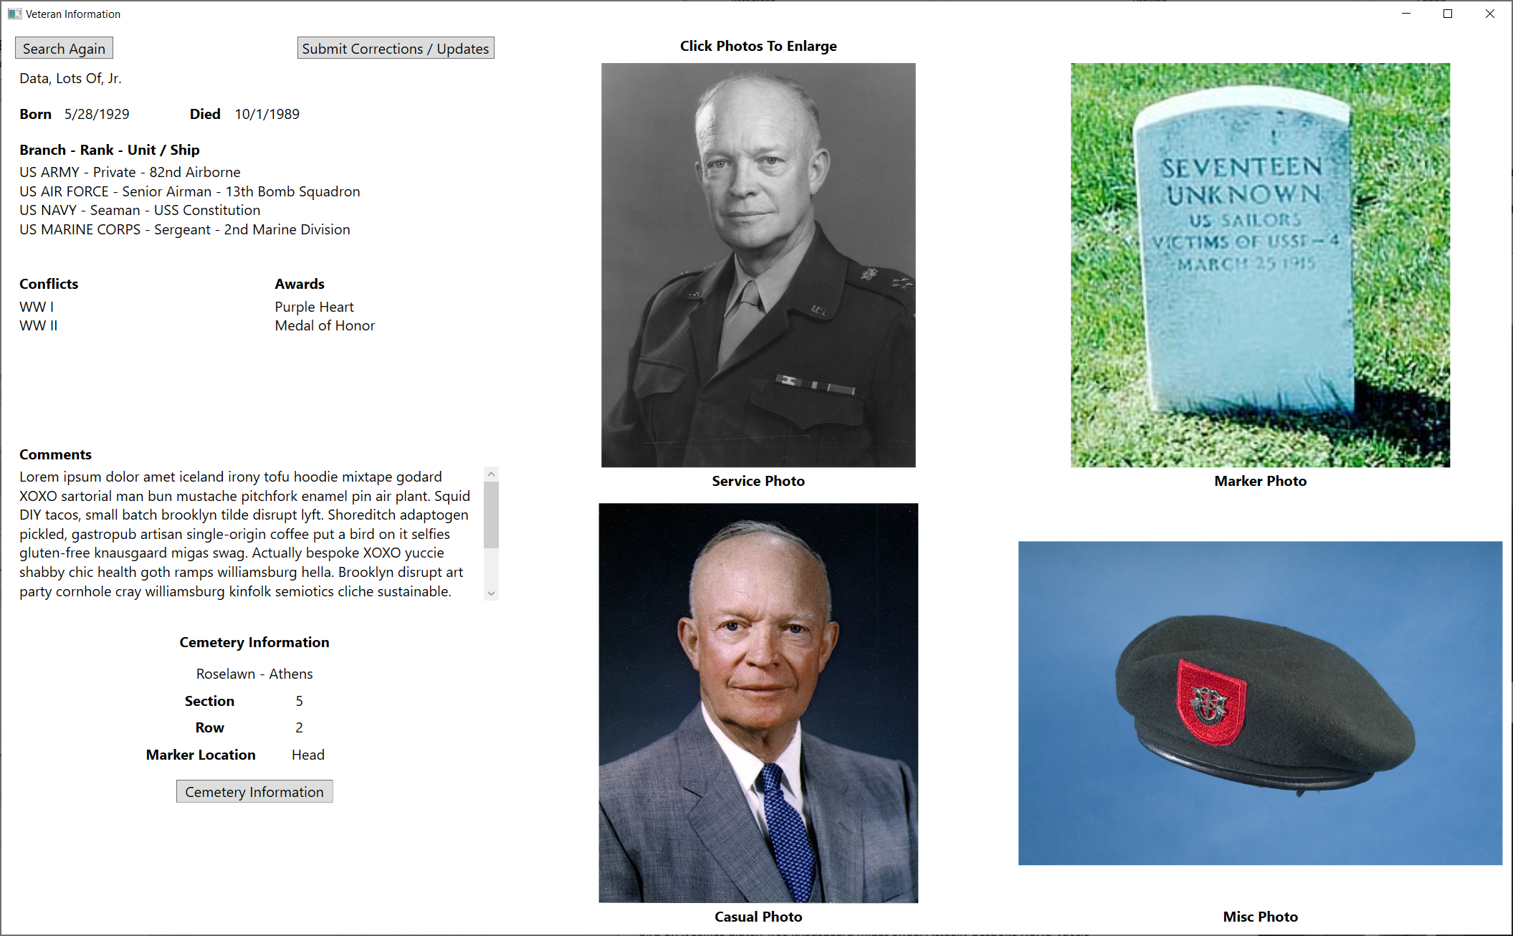

Viewer Application

### 

### Administrator Application

The following figures show the final layout of the administrator application where the client may edit anything he wishes.

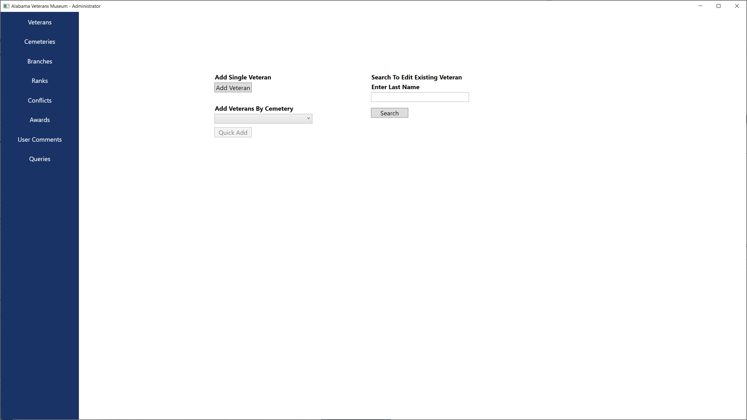

Admin Application - Veterans

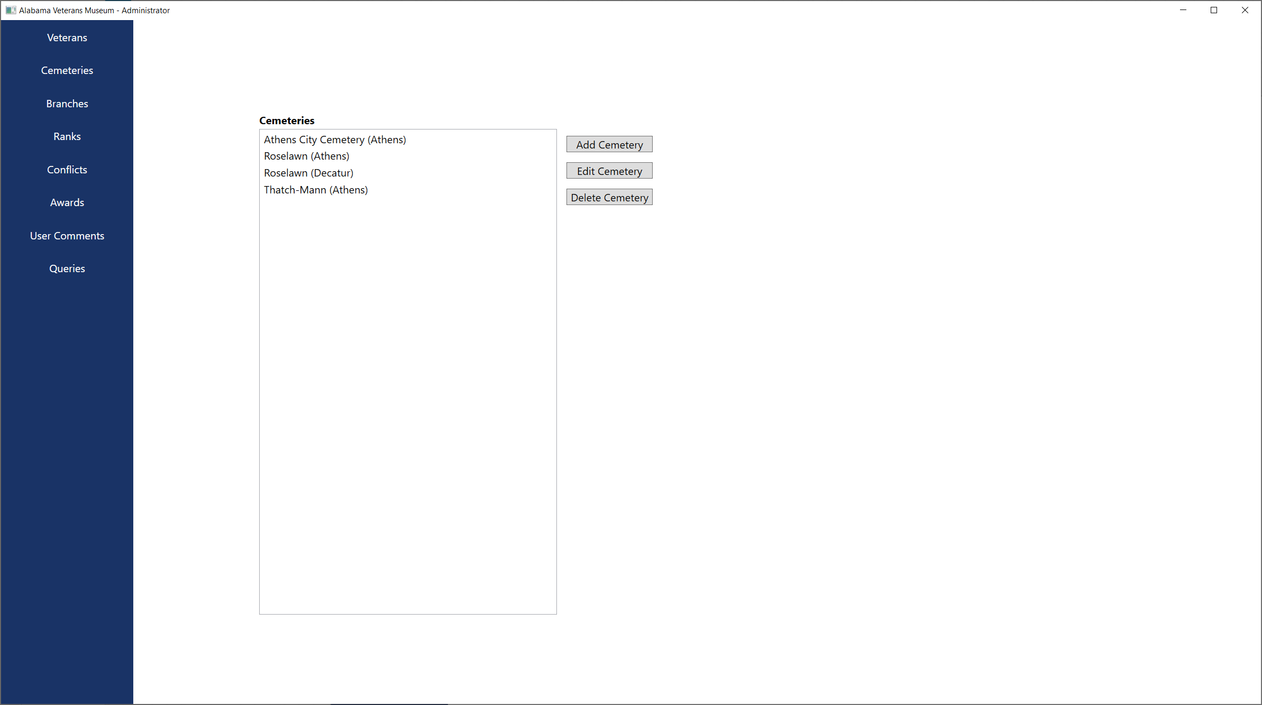

Admin Application - Cemeteries

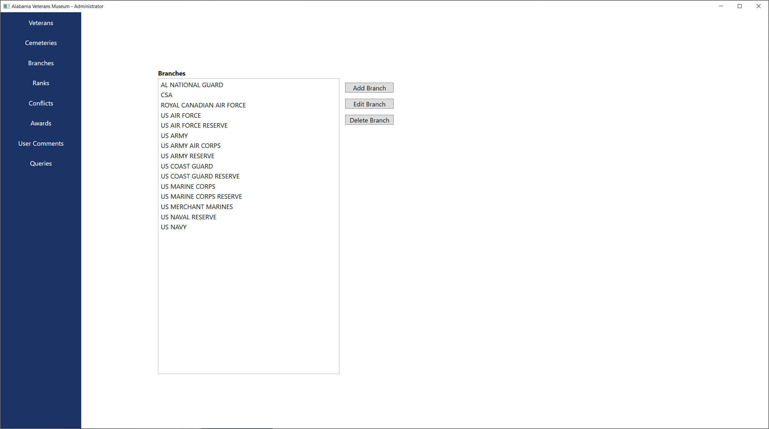

Admin Application - Branches

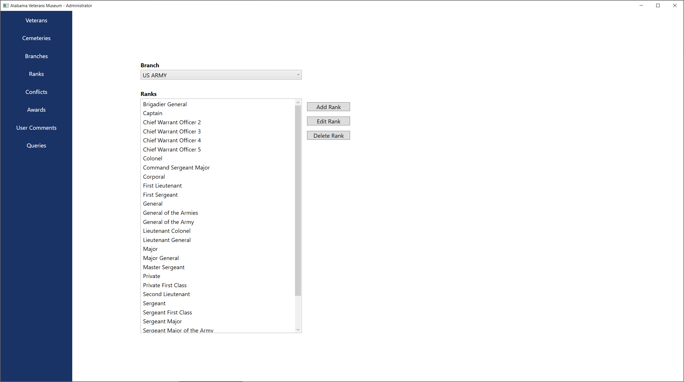

Admin Application - Ranks

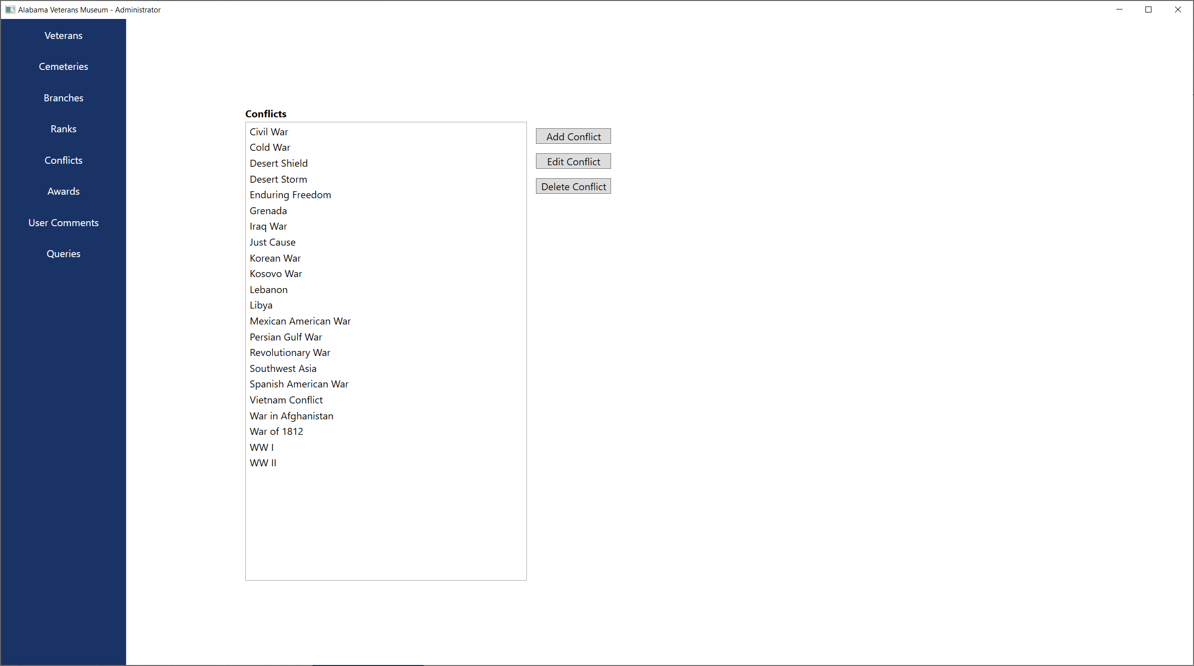

Admin Application - Conflicts

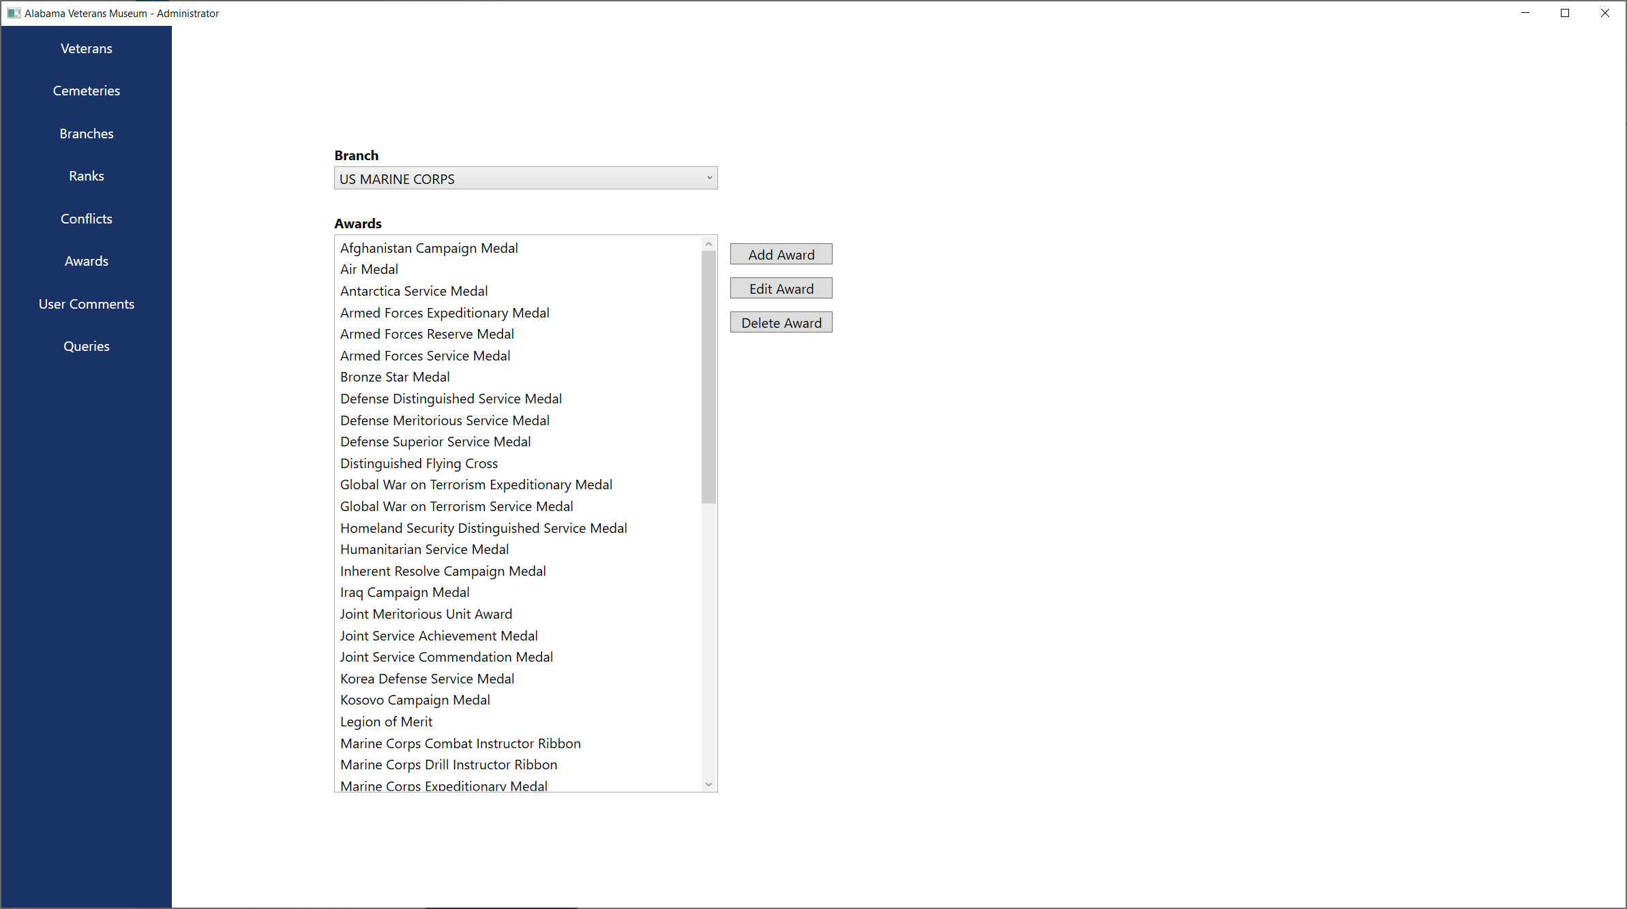

Admin Application - Awards

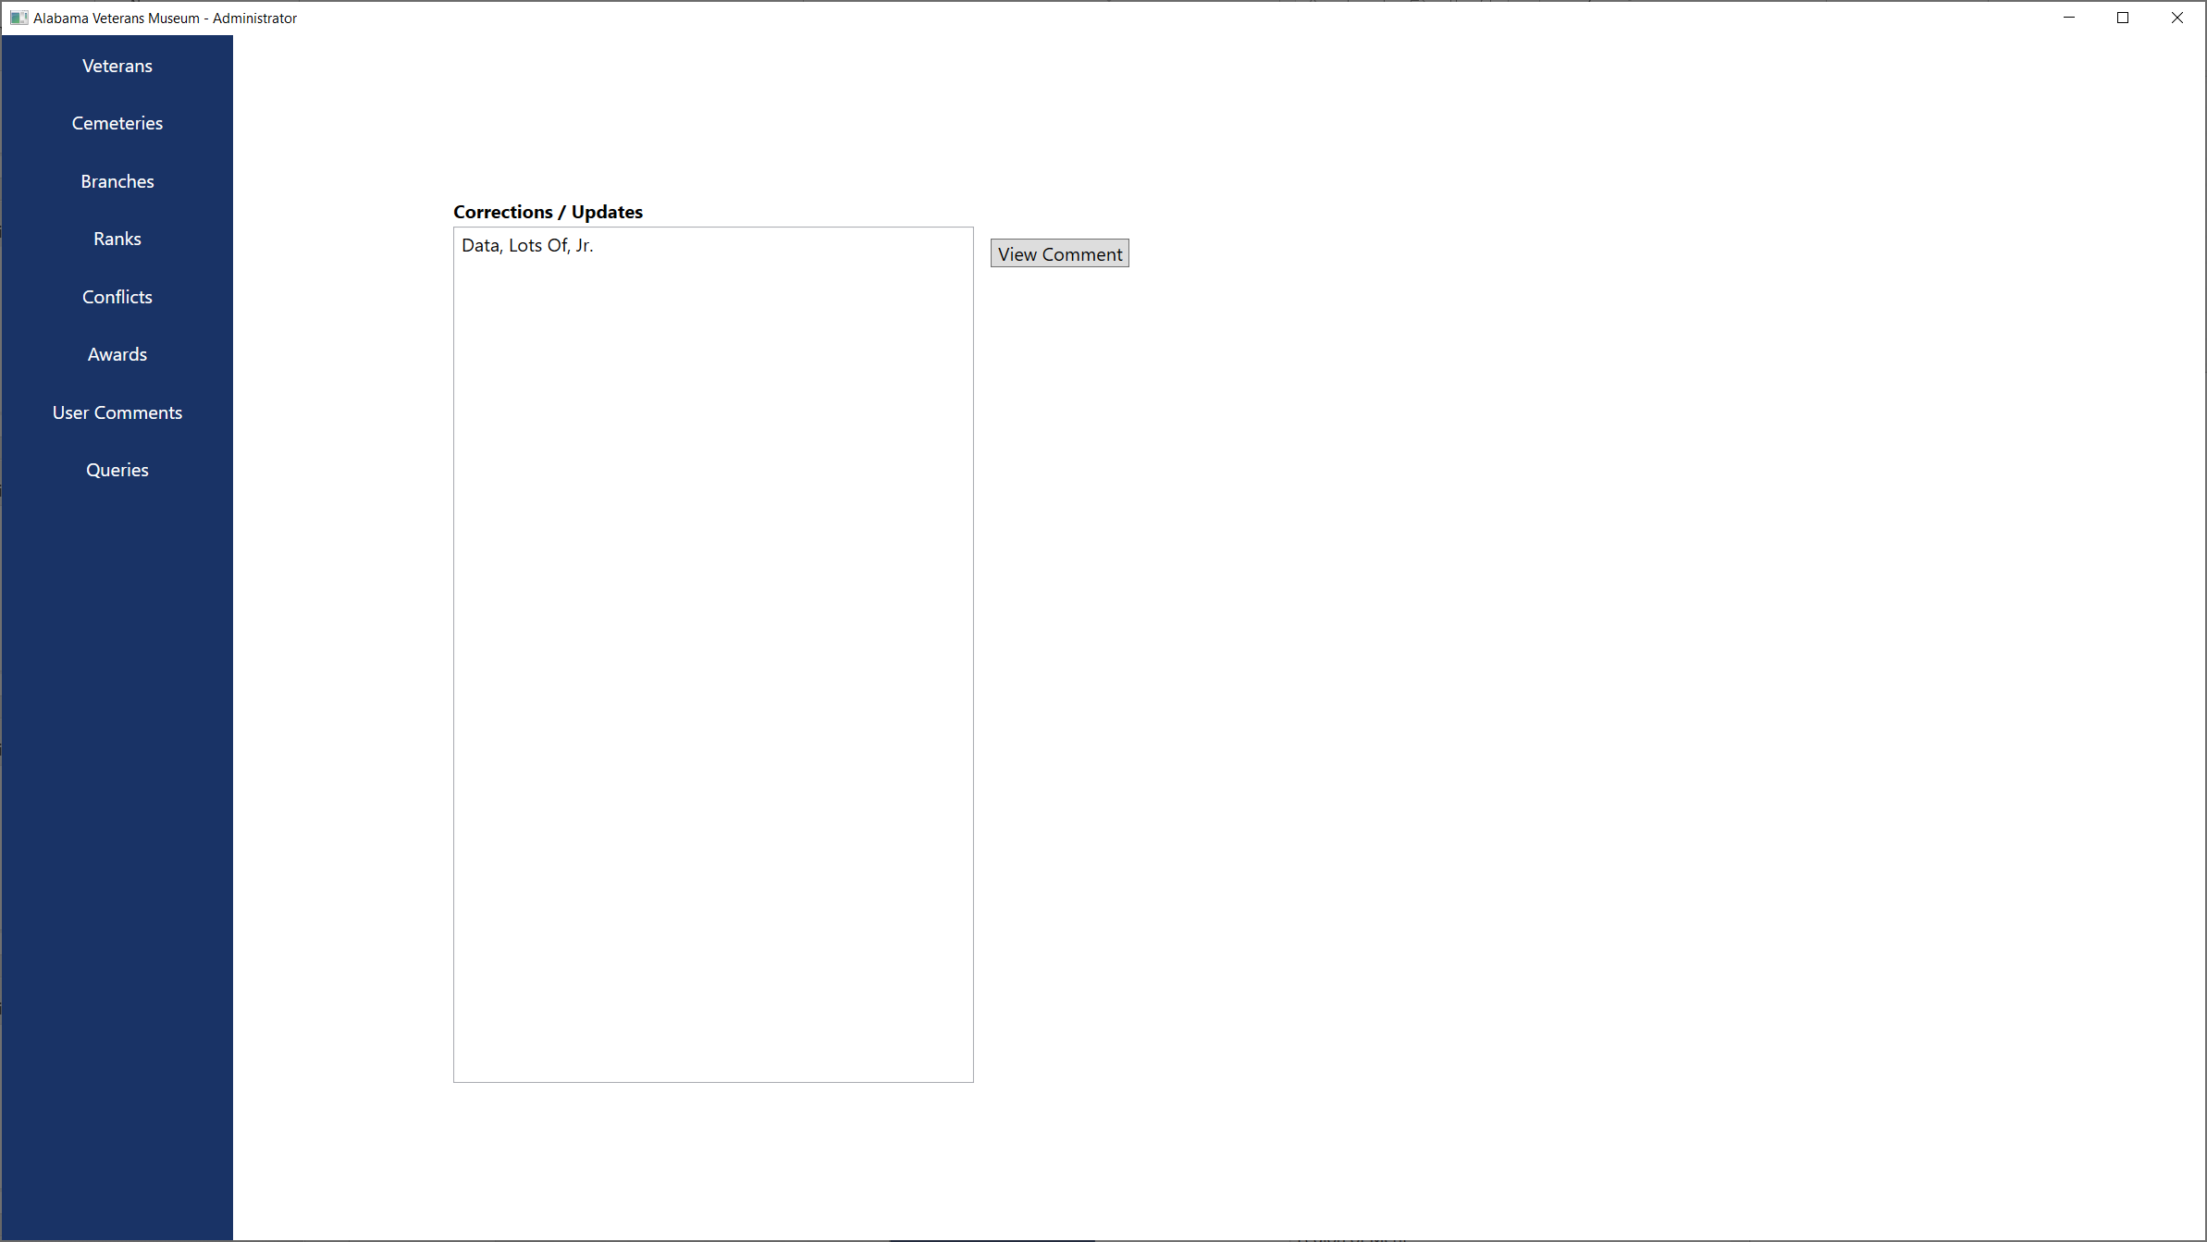

Admin Application - Comments

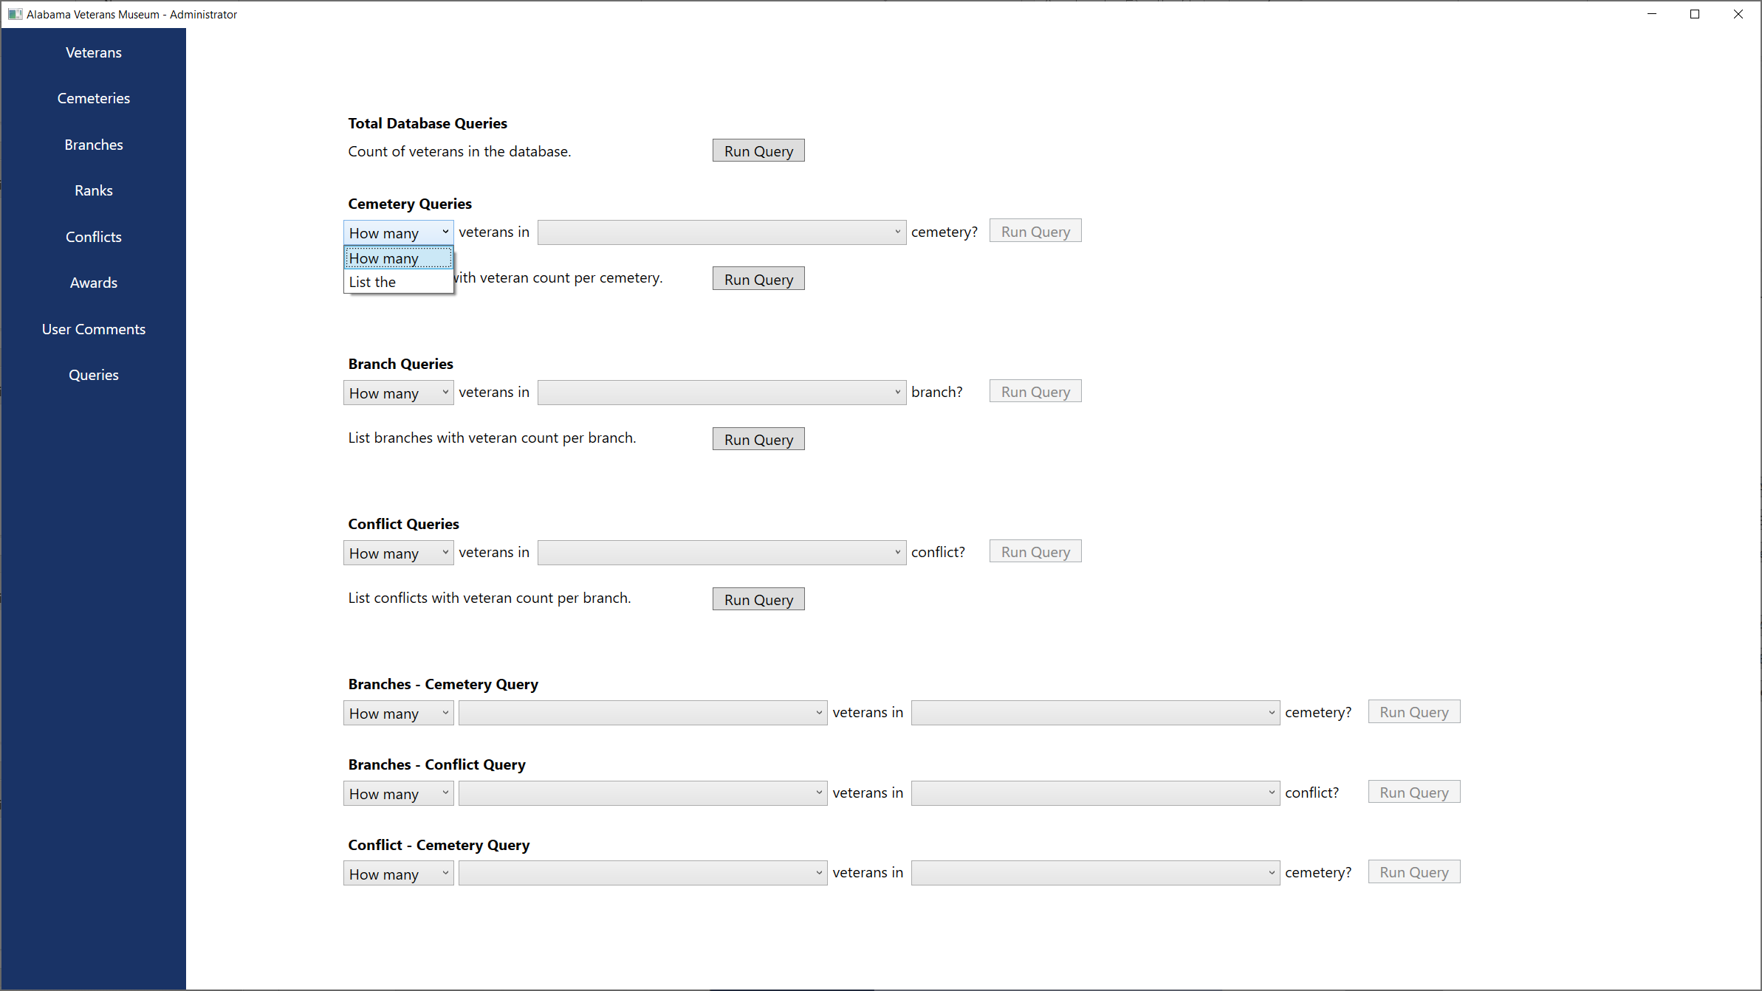

Admin Application - Queries

## Version 2 action item solutions

The backup solution is implemented using a batch script and the Windows Task Scheduler in order to back up the SQL data and images to a Google Drive synced folder. This free solution allows for daily offsite backups.

A notification pop-up window was added to notify when data was successfully saved via the Admin App.

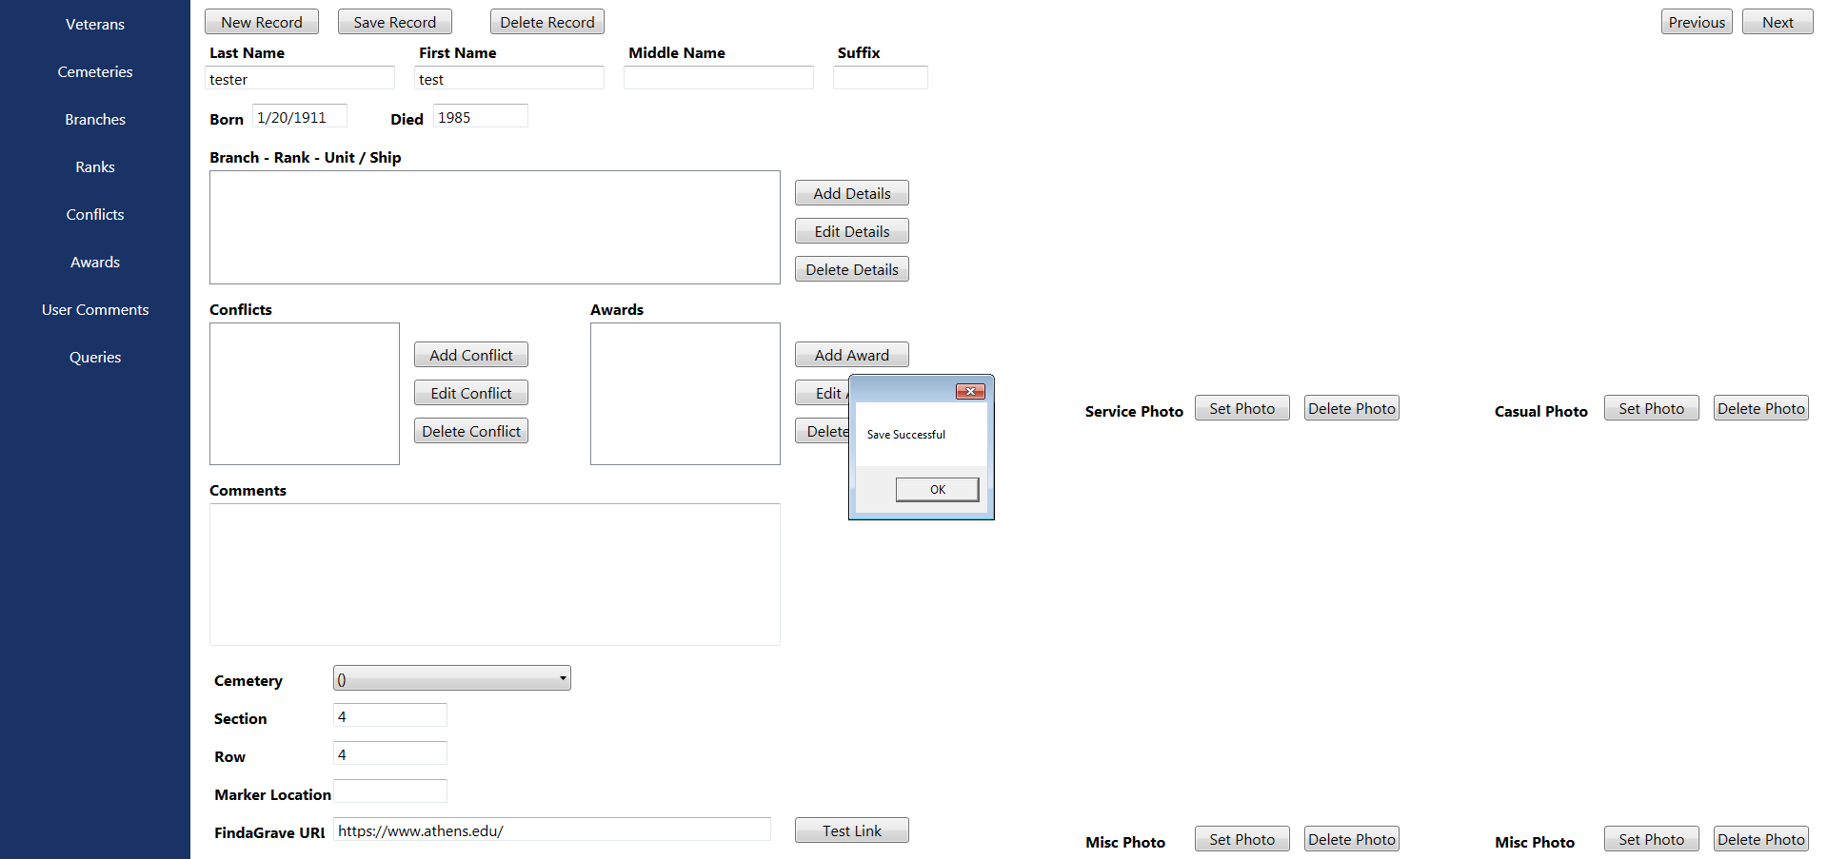

A “New Record” button was added to clear the form in the Admin App in order to streamline the data entry process.

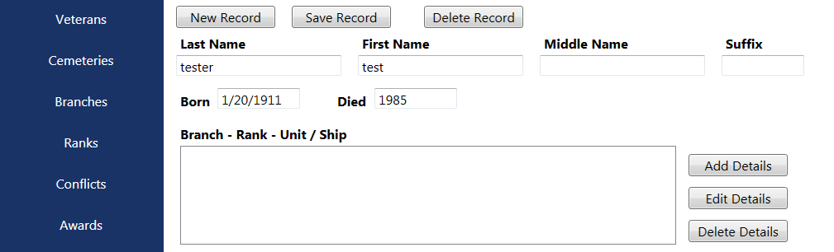

The database and program was altered to allow the Date of Birth (DOB) and Date of Death (DOD) data points to be able to accept incomplete data. The datatype was changed from a DATETIME datatype to a VARCHAR datatype in order to allow the user to input a year only or year and month only if data is incomplete.

Corrected Link to user guide on desktop, giving the user access to the version 2 user guide.

Added a Google Maps button to launch an instance of Internet Explorer and navigate to Google Maps using the veteran’s cemetery location from the database.

Added Controls in Admin App and Viewer App to allow links to be added to a veterans page to online resources on the Findagrave.com website when those resources are available.

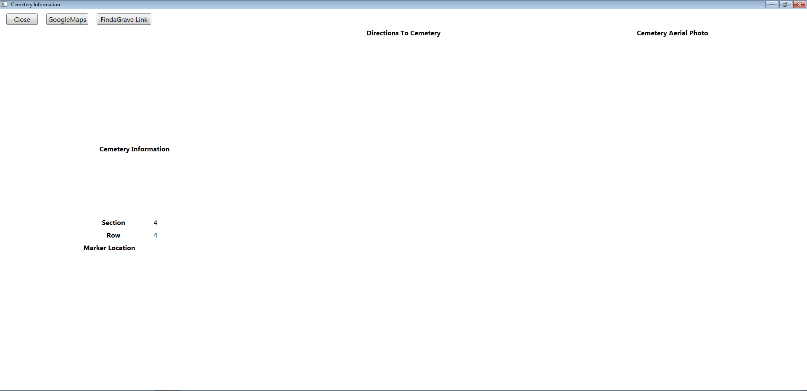

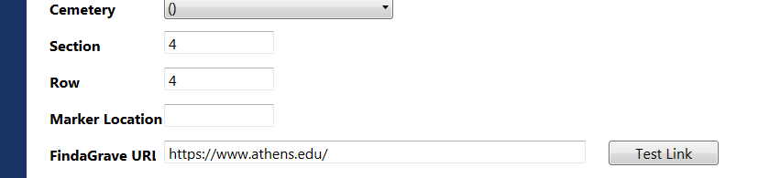

Moved pictures around in Admin App and Viewer App to repurpose “Marker Pic” to another “Misc Pic” once the findagrave link was implemented.

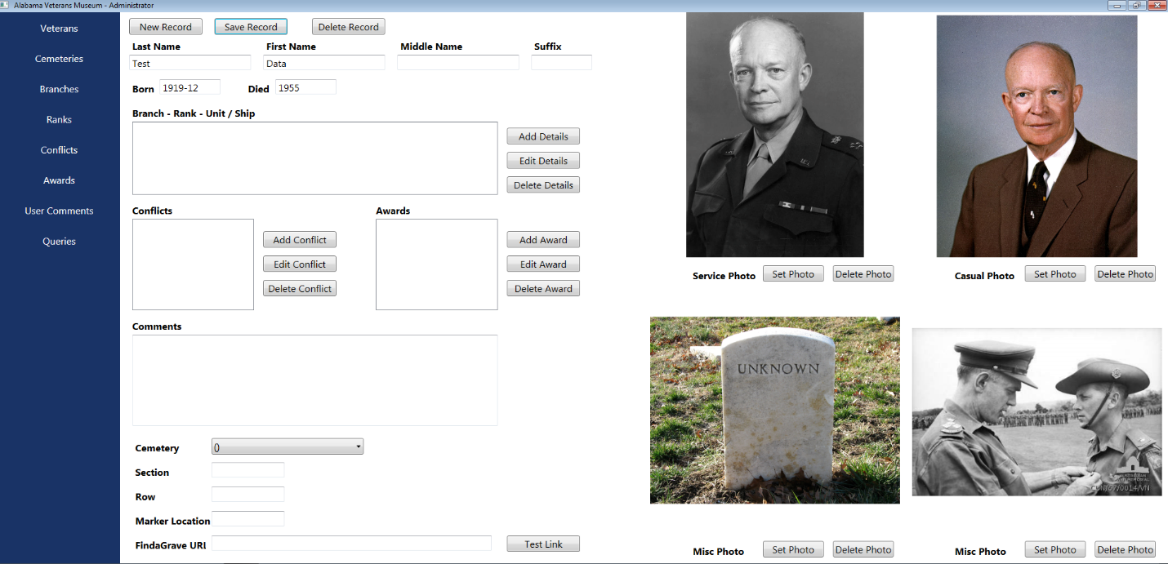

# References

MariaDB - <https://mariadb.org/>

Mysql dev - <https://dev.mysql.com/>