Deep Learning vs. Conventional Methods for Tabular Data Imputation

Ai-Ting, Lin
113427013
whereisaiting@gmail.com
Jia-Hua, Peng
114423056
jhpeng@g.ncu.edu.tw
Li-Feng, Chen
114423006
dowgojashan@gmail.com
Xin-Ping, Wu
114423067
hyperrrrrea7@gmail.com

Abstract
Missing values are a common challenge in data science and rep- resent an important issue in the data analysis pipeline. While Deep Learning (DL) architectures have achieved unprecedented success in unstructured domains, their efficacy on heterogeneous tabular data—compared to conventional Machine Learning (ML) approaches—is heavily contested. Through a comprehensive lit- erature review, this study identified a prevalent hypothesis: while DL theoretically performs well when modeling large-scale and high- dimensional nonlinear data, conventional statistical and ML meth- ods often achieve better imputation fidelity (e.g., MAE and RMSE) and higher downstream classification accuracy in small-sample em- pirical settings. To empirically validate this hypothesis derived from existing literature, this research conducts a systematic comparative evaluation. We use the ”Boy or Girl” classification dataset for small- sample scenarios and the large-scale health survey dataset (BRFSS) to explore the impact of different imputation techniques and sample sizes on the accuracy of classification tasks.

Keywords
Missing Value Imputation; Tabular Data; Deep Learning; Machine Learning; Generative Adversarial Networks; Sample Size Effect

INTRODUCTION
In most real-world datasets, information is organized in tabular form, where rows represent observations and columns represent features. Unlike images (which possess spatial locality) or natural language (which possesses sequential dependencies), tabular data exhibits a high degree of heterogeneity. It simultaneously contains continuous numerical variables and discrete categorical variables, and features often lack obvious spatial or temporal continuity.

Definition of Missing Data
Missing data refers to the phenomenon where specific variables or observations in a dataset lack responses or have incomplete infor- mation. Even a small amount of missing data can have a significant impact on the validity and reliability of research results.

Causes of Missing Data
In practice, missing data may occur at different stages of the data lifecycle, including data collection, system failures, and data inte- gration processes. During data collection, the design of research questions and respondent behavior are among the primary causes of incomplete data. Taking questionnaire collection as an example, respondents may experience survey fatigue due to excessive ques- tionnaire length, lack of trust in the interview mechanism, or refuse to answer due to privacy concerns. In addition, poorly designed questionnaires—such as vague wording, logical inconsistencies, or the absence of a “not applicable” option—may also contribute to incomplete responses.[1]
Missing data may also result from technical failures in data collec- tion systems. For example, in Internet of Things (IoT) or scientific experimental environments, sensors may fail to record data properly during certain periods due to inherent malfunctions, sudden power outages, or external environmental interference.[2] When data is transmitted between different systems or written into a database, file corruption can also occur due to unstable network connections or system errors, resulting in unreadable blanks or gibberish. This type of data omission, caused by the equipment itself or technical issues, tends to occur randomly.
Lastly, in the subsequent data preprocessing and integration stages, when datasets from multiple sources are combined, incon- sistencies in variable definitions or the absence of unique identifiers can lead to unmatched records and missing fields. Furthermore, de- liberately erasing specific features based on privacy protection reg-

ulations can cause data loss for specific demographic groups.[3]

Missing Data Mechanisms
According to Rubin’s (1976) classic taxonomy, missing mecha- nisms are divided into three categories: Missing Completely at Ran- dom (MCAR), Missing at Random (MAR), and Missing Not at Ran- dom (MNAR). MCAR dictates that the occurrence of missing data is purely accidental, meaning the probability of missingness is uniform across all observations. In contrast, MAR indicates that the likeli- hood of an omission can be predicted by other observed variables within the dataset, yet remains independent of the missing value it- self. Finally, MNAR occurs when the missingness is directly depen- dent on the unobserved value. Unlike MCAR and MAR, MNAR in- troduces severe systematic bias into the dataset, rendering it the most complex and challenging mechanism to address analytically.[4]

Classification of Methods for Handling Missing Data
Regarding the treatment of missing values, current literature can pri- marily be categorized into two major approaches[5]:
      - Deletion: This is the simplest approach, usually divided into Listwise Deletion or Pairwise Deletion, which involves directly dropping the data entries with missing values. Although the operation is relatively simple, the cost is the loss of originally useful information, leading to a decrease in statistical power. More problematically, if the data missingness is not ”com- pletely random” (i.e., non-MCAR situations), direct deletion will actually introduce severe estimation bias into subsequent model training.
      - Imputation: Because deletion methods easily lose informa- tion, imputation methods are predominantly used today. They utilize existing observed data to estimate and fill in the miss- ing values, preserving the completeness of the entire dataset as much as possible. Common approaches include statistical methods, machine learning, deep learning, and Representation Learning.

The ”ML vs. DL” Debate on Tabular Data
Historically, missing value imputation relied on conventional ma- chine learning (ML) methods like KNN and Random Forests (e.g., missForest). Recently, deep learning (DL) models such as GANs and Autoencoders have been introduced to capture complex nonlin- ear relationships.[6] However, whether DL can completely replace conventional methods for ”Tabular Data”—which mixes continuous and categorical variables—remains controversial.
Unlike images or text, tabular data lacks spatial continuity. Lit- erature shows that tree-based ML models naturally excel at han- dling such mixed features with stability and minimal hyperparame- ter tuning. Conversely, while DL generative models (like GAIN or VAE) possess high theoretical capacity, their performance heavily
relies on massive datasets. In small-sample scenarios (e.g., < 30,000 records), DL models often struggle to capture the true data distribu- tion, risking convergence issues and ”mode collapse”.[7] Therefore, applying DL to tabular data requires careful consideration of the in- herent data structure and sample size.

Scope and Goals
This study focuses on comparing the performance of conventional machine learning methods and deep generative models for tabular data imputation through both literature review and empirical exper- iments, and explores the impact of sample size on the performance of these two techniques. Specific Goals include:
    - Literature Review: Systematically review and compare recent frontier technologies in machine learning and deep learning for data imputation.
    - Small-Sample Empirical Experiment: Utilize the ”Boy or Girl” task dataset to conduct a small-sample implementation, comparing the performance of machine learning and deep learning models in terms of imputation error and classification task accuracy, in order to verify the hypothesis that ”ML per- forms better with small samples.
    - Large-Sample Extension Experiment and Outlook: To test the impact when the data volume increases, we used nearly 50,000 records of US health survey data (BRFSS) for exper- imentation. By simulating missing data for specific features (such as height), we compared the performance differences be- tween conventional machine learning and deep learning mod- els in a large-sample environment, hoping to establish a clear benchmark for evaluating the future potential of deep learning technologies in big data imputation.

METHODS
  - Searching Criteria
To ensure the technical depth and comprehensive nature of this re- view, a systematic literature search was implemented to identify rel- evant research regarding missing data imputation. The search logic was designed to encompass a wide spectrum of peer-reviewed lit- erature, ranging from foundational statistical theories to the latest machine learning applications.

Information Sources
The literature search was performed across established academic databases and digital libraries to capture a diverse range of com- putational and data science research:
      - IEEE Xplore and ACM Digital Library: Primary sources for retrieving state-of-the-art machine learning architectures and generative models.
      - PubMed (MEDLINE): Utilized for clinical benchmarks and health informatics studies where statistical validity is paramount.

      - Scopus and Web of Science: Used to ensure cross- disciplinary coverage and to verify the academic impact of var- ious methods.
      - General Peer-Reviewed Journals and Conference Proceed- ings: Research from venues such as ICML, NeurIPS, and var- ious computer science journals was included to capture estab- lished benchmarks and relevant background surveys.

Search Strategy and Query Strings
Search queries were constructed using Boolean operators (AND, OR) and wildcards (*) to combine key concepts from three dimen- sions: missingness mechanisms, imputation methods, and tabular data structures.
      - Core Query String: ("missing data" OR "missing values") AND ("imputation" OR "generative" OR "adversarial") AND ("tabular" OR "structured") AND ("machine learning" OR "random forest" OR "MICE").

Inclusion and Exclusion Criteria
Specific boundaries were established to filter the results while al- lowing for a comprehensive overview of the field:

Inclusion Criteria:
- Peer-Reviewed Status: Only articles published in peer- reviewed journals or official conference proceedings were included to ensure that findings are based on validated experimental results.
- Comparative Analysis: Studies must provide a direct comparison between at least two categories of imputation (e.g., conventional statistical methods vs. deep learning).
- Quantitative Performance: Papers must report stan- dardized metrics such as RMSE, MAE.
- Temporal Scope: Research published between 2010 and 2025 to reflect the transition from classical heuristics to modern generative AI.

Exclusion Criteria:
- Non-Peer-Reviewed Preprints: Manuscripts only avail- able on preprint servers that have not yet undergone a for- mal review process were generally excluded, with the ex- ception of seminal foundational works (e.g., the original GAIN framework) that have achieved widespread com- munity validation.
- Unstructured Data: Research focused exclusively on image inpainting or natural language text completion.
- Language: Literature not available in English.

Selection Process
A two-stage screening process was followed to refine the final refer- ence list:
- Title and Abstract Screening: To remove duplicates and filter out papers that did not focus on tabular data or lacked a robust comparative framework.
- Full-Text Review: To verify the quality of the experimental design and the relevance of data scale analysis (small-scale vs. large-scale datasets), ensuring a balanced synthesis of both high-impact studies and broader contextual surveys.

Conventional Statistical Methods

Deletion Methods
      - Listwise Deletion
Listwise Deletion is the most direct method for handling missing values. It removes an entire row from the dataset if it contains one or more missing values.[1] The main advantage of this approach is that it is extremely simple to implement and requires no additional computation. However, this method may substantially reduce the sample size and consequently decrease statistical power.[8],[9]

Pairwise Deletion
Pairwise Deletion is a method used to handle missing values. It excludes observations only when the analysis involves variables with missing data, rather than removing the entire case.[8],[9] The main advantage of this approach is that it retains more available data and preserves a larger sample size and statistical power. How- ever, this method is appropriate only under the MCAR assumption. Different analyses may use different sample sizes. This can make the correlation matrix difficult to interpret and may produce a non- positive definite matrix, which can affect subsequent model estima- tion.[5]

Mean / Median Imputation
Mean / Median Imputation is one of the most common single impu- tation methods in statistics. It replaces missing values with the mean or median of the observed values for that variable. This method is simple to implement and computationally efficient. It can also pro- vide a practical solution when the dataset is very small. However, this method is appropriate only when the missing data mechanism satisfies MCAR. It may underestimate the variance and standard er- rors and bias the correlations among variables. In addition, the mean is sensitive to extreme values and cannot capture complex nonlinear relationships.[5]

MICE
Multiple Imputation by Chained Equations (MICE) is a widely used multiple imputation method for handling missing data. This method would generate several imputed datasets by repeatedly filling in missing values. In this way, the uncertainty associated with impu- tation is incorporated into the final statistical estimates. MICE gen- erally assumes that the missing data mechanism follows the MAR assumption.[10] The method uses an iterative procedure based on a Gibbs sampling framework, where each variable with missing val- ues is modeled conditionally on the other variables in the dataset. Through repeated iterations, the algorithm samples model parame- ters and imputes missing values until the process converges. Finally, there would be multiple completed datasets for subsequent statistical analysis.[7],[10]

Machine Learning Methods

K-Nearest Neighbors (KNN)
KNN imputation is a non-parametric method because it does not assume a specific functional form or probability distribution for the data. This method estimates missing values using the K most sim- ilar observations in the dataset. First, the distance between the in- complete observation and all other observations is computed using a distance metric such as Euclidean distance. Next, the K nearest neighbors are identified. For numerical variables, the missing value is imputed using the mean or weighted mean of the neighbors. If the missing value is a category, the algorithm uses the mode (the most frequent value) among the neighbor[1]. KNN does not require assumptions about the underlying data distribution. This makes the method flexible and applicable to a wide range of datasets. More- over, KNN can accommodate both continuous and categorical vari- ables by using appropriate aggregation strategies such as the mean for numerical attributes and the mode for categorical attributes[1].

MissForest
MissForest is a non-parametric imputation method that utilizes Ran- dom Forest to estimate missing values. The algorithm first initializes missing entries using simple statistical methods, such as mean impu- tation for continuous variables and mode imputation for categorical variables. The variables are then ordered according to the amount of missing data, starting with those with the fewest missing values. For each variable with missing data, a Random Forest model is trained using the observed values as the response variable and the remain- ing variables as predictors. The trained model is then used to predict the missing values. This process is repeated iteratively and the im- puted dataset is updated in each step. The algorithm stops when the difference between successive imputations begins to increase. This method can capture nonlinear relationships and complex inter- actions between variables and does not require strong distributional assumptions. In addition, MissForest can estimate imputation qual- ity using Out-of-Bag (OOB) error.[7][11]

Deep Learning Methods
The integration of deep learning into data imputation primarily fo- cuses on generative frameworks designed to learn the joint prob- ability distribution of the data. Unlike discriminative approaches that predict a missing value based on local correlations, these mod- els attempt to reconstruct the underlying data-generating logic to produce imputations that maintain global statistical characteristics. This paradigm is particularly effective for heterogeneous tabular data, where complex non-linear interactions between continuous and categorical variables are prevalent.

Generative Adversarial Networks (GANs)
GAN-based frameworks have demonstrated significant resilience in scenarios with high missingness rates by capturing the overall data generation logic.[12]
      - Architectural Framework: These models consist of a Gener- ator, which observes available data to predict missing values, and a Discriminator, which attempts to distinguish between ob- served and imputed data points.
      - The GAIN Benchmark: Generative Adversarial Imputation Nets (GAIN) serve as a pivotal benchmark in this domain. GAIN introduces a ”hint vector” to guide the Discriminator, providing partial information about the missingness pattern. This mechanism forces the Generator to learn the true under- lying distribution, ensuring that the imputed values are statis- tically consistent with the observed data.

Variational Autoencoders (VAEs)
VAEs approach imputation by compressing incomplete data into a low-dimensional latent space to learn the probability distribution be- fore decoding and reconstructing the complete data matrix.[13]
      - Heterogeneity and Uncertainty: A primary advantage of VAEs is their capacity for uncertainty quantification, which is critical for risk-sensitive applications such as healthcare.
      - Optimized Models: Models such as MIWAE have optimized importance sampling specifically for incomplete datasets to en- hance reconstruction accuracy. Furthermore, TVAE was de- veloped to explicitly address tabular heterogeneity, allowing the model to handle the distinct statistical properties of mixed- type features effectively.

Diffusion-based Models
Diffusion models represent the current frontier in generative model- ing, simulating physical diffusion processes to reconstruct missing values through iterative denoising.[14].
      - Distributional Fidelity: Recent literature indicates that diffusion-based approaches often outperform GANs and VAEs in preserving the original data distribution and minimizing KL divergence.

      - TabDDPM: Specifically designed for tabular data, TabDDPM captures intricate feature dependencies and has been shown to be highly effective in maintaining the integrity of the data struc- ture during the imputation process. By iteratively refining the data from a noise distribution back to the manifold of real ob- servations, it provides a robust solution for complex imputation tasks.

Evaluation Metrics
To rigorously evaluate the efficacy of the proposed imputation frameworks, this study utilizes metrics categorized under Imputa- tion Fidelity. These measures quantify the proximity between the imputed values and the original ground truth. This assessment is critical for determining a model’s ability to restore missing infor- mation without introducing significant statistical noise.

Imputation Fidelity
Statistical error metrics are employed to assess point-wise accuracy in both small-sample and large-scale empirical settings.[7]
      - Mean Absolute Error (MAE): Measures the average magni- tude of absolute differences between imputed and true values:
n
' |

Performance on Small-Scale Datasets
In small-sample regimes, typically defined as datasets with fewer than 10,000 observations, traditional statistical approaches and tree- based machine learning (ML) models tend to demonstrate supe- rior robustness [15]. This advantage is primarily attributed to their strong inductive biases, which allow these models to generalize ef- fectively even when training data is scarce [16].

The Eﬀicacy of Tree-Based Models
Among traditional ML techniques, the MissForest algorithm is rec- ognized as a premier solution for heterogeneous tabular data [11]. By treating imputation as an iterative prediction task, MissForest leverages the power of Random Forests to capture non-linear rela- tionships without requiring explicit distributional assumptions [11]. Empirical evaluations indicate that MissForest maintains stable per- formance even at missingness rates as high as 60%, whereas para- metric methods like MICE often suffer from performance degrada- tion once missingness exceeds 50% [17].

Inductive Bias and Deep Learning Constraints
The relative underperformance of deep learning (DL) on small tabu- lar datasets is a subject of active research. Unlike images or speech,

M AE = 1 y
n i
i=1
− yˆi| (1)
tabular data often consists of independent features with irregular, high-frequency patterns[15],[16]. Standard neural networks, which

      - Root Mean Square Error (RMSE): A quadratic scoring rule that penalizes large errors more heavily, reflecting the stability of the imputation:
「1 1 'n
possess an inductive bias toward learning smooth functions, often fail to approximate these discontinuous boundaries in low-sample settings, leading to over-fitting of the imputed values [15],[16].

Tabular Foundation Models and Zero-Shot Im-

RM SE = I n

i=1
(yi − yˆi)² (2)

putation
To mitigate the data requirements of DL, recent literature has in-

- Kullback-Leibler (KL) Divergence: Specifically for genera- tive models, KL Divergence is used to quantify the difference between the original data distribution (P ) and the imputed dis- tribution (Q), ensuring distributional consistency:
troduced tabular foundation models such as TabImpute [18],[19],. These models leverage pre-training on large-scale synthetic data to learn generalized representations, allowing them to perform “zero- shot” imputation on unseen datasets [18]. This paradigm shift en- ables DL-based accuracy in data-scarce scenarios without the need

DKL
(P Q) = P (x) log P (x) (3)
Q(x)
' （ ＼∥
x∈X
for task-specific fine-tuning.

LITERATURE FINDINGS AND COM- PARATIVE ANALYSIS
Existing studies consistently demonstrate that the effectiveness of
missing data imputation methods is highly dependent on dataset characteristics, including scale, feature dimensionality, and the un- derlying missing mechanism [7]. Factors such as dataset size and the complexity of feature interactions often dictate whether tradi- tional statistical models or modern deep learning architectures yield superior performance [7, 15]. Consequently, no single algorithm is universally optimal across all empirical scenarios.[7]

Performance on Large-Scale Datasets
As dataset size increases to tens of thousands or millions of sam- ples, the high capacity of generative deep learning models allows them to outperform traditional methods by learning complex latent distributions [7].

Distributional Fidelity and Diffusion Models
In large-scale contexts, evaluation metrics are shifting from point- wise errors toward distributional fidelity, measured by Kullback– Leibler (KL) divergence . Diffusion-based models, such as TabD- DPM, have demonstrated remarkable success in preserving the orig-

Table 1. Technical Comparison of Tabular Data Imputation Methodologies

Category | Algorithm | Mechanism | Core Technical Advantage | Critical Limitation | Comp. Cost
Statistical | Deletion | MCAR | Extremely simple; no compu- tation required [8]. | Severe loss of power; in- troduces bias if non-MCAR  [1],[8]. | Negligible
 | Mean/Median | MCAR | Practical for very small sam-  ples; efficient [1]. | Underestimates variance; bi-  ases correlations [1]. | Very Low
 | MICE | MAR | Iterative Gibbs sampling;  handles uncertainty [17]. | Assumes MAR; limited cap-  ture of non-linear patterns  [17]. | Medium
Machine Learning | KNN | MCAR/MAR | Non-parametric; utilizes local similarity (Euclidean) [20]. | Distance metrics sensitive to scale; high latency for large N  [20]. | Medium
 | MissForest | Any | Iterative Random Forest; ex-  cels at mixed-type data [11]. | High CPU overhead; cannot  be easily GPU-parallelized  [11]. | High
Deep Learning | GAN (GAIN) | Any | Adversarial learning with Hint Vectors for distribution  [12]. | Risk of ”mode collapse”; un- stable convergence in small  samples [12]. | High (GPU)
 | VAE (TVAE) | MNAR | Latent space reconstruction;  uncertainty quantification  [13]. | Reconstruction can be over-  smoothed for tabular data  [15]. | High (GPU)
 | TabDDPM | Any | Iterative denoising; mini-  mizes KL divergence [14]. | Significant inference latency  due to stochastic sampling. | Very High

inal data manifold . Experiments indicate that TabDDPM achieves significantly lower KL divergence than GANs or VAEs, effectively capturing intricate feature dependencies even under extreme miss- ingness rates of 80% [14].

Adversarial Imputation and Latent Variable Modeling
Generative Adversarial Imputation Nets (GAIN) treat imputation as a minimax game where a generator fills missing values to fool a discriminator [12]. In high-dimensional datasets, GAIN often sur- passes MissForest in terms of both speed and accuracy [7].[12] Fur- thermore, Variational Autoencoders (VAEs) excel in Missing Not at Random (MNAR) scenarios by modeling the data through la- tent variables, allowing the framework to infer plausible values even when the missingness is systematically biased [7].

Computational Complexity and Deploy- ment
Computational scalability is a critical factor for real-world deploy- ment. Traditional methods like KNN and MissForest are primarily CPU-bound; KNN, in particular, suffers from the “curse of dimen- sionality,” where distance computations become computationally prohibitive as feature counts increase. [11],[20] Conversely, while generative DL models require significant GPU resources for train- ing, they offer high-speed inference through a single forward pass, making them more suitable for high-throughput production environ- ments [20].

Summary
In summary, the literature reveals a clear trade-off between model complexity and data requirements. While conventional statistical methods (e.g., MICE) and tree-based machine learning (e.g., Miss- Forest) remain the gold standard for small-scale tabular data due to their robust inductive biases [15], [16], generative deep learn- ing models like GAIN and TabDDPM exhibit superior distribu- tional fidelity as dataset scale and dimensionality increase.[7],[14] However, the high computational overhead of diffusion-based ap- proaches and the sensitivity of GANs to mode collapse suggest that practitioners must weigh the marginal gains in accuracy against de- ployment constraints [20].

DISCUSSION
In this section, we will introduce the experiments conducted to eval- uate the differences between traditional machine learning and deep learning methods for data imputation.We designed a two-phase ex- perimental approach: Phase 1 compares the data recovery accuracy of different imputation methods, and Phase 2 evaluates the predic- tion accuracy for gender classification after imputation.

Experimental Setup

Environment and Tools
All experiments were conducted on the Kaggle online platform to ensure a consistent computing environment, with a fixed random seed of 42 applied to all data splitting and model initialization pro- cesses to ensure reproducibility.

Dataset Descriptions
To evaluate the impact of sample size on different imputation tech- niques, we selected two datasets with significantly different scales:
      - Small-scale Dataset (Boy or Girl): This dataset contains ap- proximately 400 samples, representing a typical small-sample scenario. It includes various features such as height, weight, star sign, phone OS, and IQ. The target variable is gender, which is used to evaluate the performance of imputation meth- ods on downstream classification tasks.
      - Large-scale Dataset (CDC BRFSS): Downloaded via the kagglehub library, this dataset contains hundreds of thou- sands of health-related records from the Behavioral Risk Factor Surveillance System (BRFSS). This large-scale dataset is used to assess whether deep learning models demonstrate superior representation capabilities when a vast amount of data is avail- able.

Experimental Design and Protocol
We use a control-variable approach to ensure that all processes re- main identical except for the choice of the imputation method. The experimental pipeline is organized as follows:
      - Data Preprocessing and Cleaning: The raw datasets undergo initial cleaning to handle anomalies. Categorical features are transformed using Label Encoding to ensure they are compat- ible with both machine learning and deep learning algorithms.

Phase 1: Recovery Accuracy Analysis

Experiment Objectives and Method Selection
In this experiment, we picked four methods based on the analysis from Chapters 2 and 3. We chose MICE and MissForest to rep- resent traditional machine learning, and GAIN and VAE for deep learning. By comparing these four, we want to observe two main things: first, which method is the most accurate at restoring missing values under the same conditions; second, how sample size affects performance. Basically, we want to find out if deep learning is supe- rior for large datasets, and if traditional machine learning is actually more accurate when we only have a small sample size.

Experimental Design and Evaluation Metrics
The experimental design focuses on two datasets: the Boy or Girl dataset and the CDC BRFSS. To evaluate reconstructive perfor- mance, we target the ”Height” feature and simulate data loss using a Missing Completely at Random (MCAR) mechanism. Specifically, we randomly mask 10% of the observations, using the remaining 90% of the data as the training baseline for the models. To quantify the effectiveness of the imputation as a regression task, we utilize four metrics to assess the fit between the imputed values and the ground truth:
First, Mean Absolute Error (MAE) measures the average ab- solute difference between the imputed values and the actual values, providing a direct reflection of the prediction error scale:
n
' |

      - Phase 1: Recovery Accuracy Analysis: To test the recon- structive capability of each method, we simulate data loss by
M AE = 1 y
n i
i=1
− yˆi| (4)

randomly masking 10% of the values in the continuous fea- tures. Various imputation techniques are then applied to fill these gaps, and their performance is evaluated using distance- based metrics (such as MAE and R²) by comparing the im- puted values against the original ground truth.
Second, Root Mean Square Error (RMSE) is employed to cap-
ture the stability of the imputation. Compared to MAE, RMSE is more sensitive to large errors due to the squaring of differences, which helps identify potential outliers in the results:
「1 'n
1

      - Phase 2: Downstream Performance Evaluation: This phase investigates the impact of different imputation methods on the
RM SE = I n

i=1
(yi − yˆi)²
(5)

final predictive outcome. Using a unified downstream classifi- cation model, we measure the gender prediction accuracy. This allows us to determine which imputation strategy provides the highest utility for practical classification tasks.
Third, the Coeﬀicient of Determination (R²) is used to evaluate the model’s ability to explain the variance in the original data. An R² value closer to 1 indicates that the imputed data closely follows the distribution of the original dataset:

      - Missing Data Mechanisms: We differentiate the complex-

n
�
2 i=1
�−
(yi − yˆi)²

(6)

ity of our experiments by utilizing two mechanisms: Missing
R = 1 n
i=1
(yi
− y¯)2

Completely at Random (MCAR) for Phase 1 to establish a base- line for recovery accuracy, and Missing at Random (MAR) for Phase 2 to simulate more complex dependencies between fea- tures.
Finally, we include Bias to observe if the model exhibits system- atic errors, such as a tendency to consistently over- or under-estimate the height values:
Bias = 1 '(yˆ − y ) (7)
n
n
i
i

i=1

i=1
By analyzing these four metrics collectively, we can comprehen-

sively evaluate each imputation method’s performance across dif- ferent data scales in terms of accuracy, stability, and distribution fitting.

Recovery Performance on Small Dataset
In the tests conducted on the small-scale ”Boy or Girl” dataset, the experimental results align with the initial hypothesis, demonstrat- ing that traditional machine learning significantly outperforms deep learning models in terms of data recovery capability. According to the observations in Table 2, MissForest stands out across all metrics, achieving the highest R² of 0.2131 and the lowest MAE of 3.9075. This confirms that the random forest-based imputation method, even with limited data, can accurately capture the non-linear correlations between height and other features through its ensemble learning mechanism.
In contrast, the performance of the two deep learning models, GAIN and VAE, is highly unsatisfactory. Their MAE values are as high as 8.3544 and 5.8562, respectively, which are not only con- siderably higher than those of MissForest but also behind the control group, Median Imputation (M AE = 4.9310). More significantly, both models exhibit negative R² values, implying that generative models completely fail to capture the data distribution in an environ- ment with approximately 400 samples, with their prediction biases exceeding the statistical baseline.
This phenomenon validates the perspective presented in Chap- ter 3: deep learning models rely heavily on large volumes of sam- ples for weight optimization and feature representation learning. In scenarios involving simple feature dimensions and minute sample sizes, neural networks are prone to getting stuck in local optima or suffering from severe overfitting, which prevents the models from converging effectively.

Table 2. Recovery Performance Comparison - Small Dataset

Method | MAE (cm) | RMSE (cm) R² Bias (cm)
Median Impute | 4.9310 | 5.8398 | -0.1278 | -1.9655
MICE | 4.5183 | 6.5659 | 0.1341 | 0.8883
MissForest | 3.9075 | 4.8780 | 0.2131 | -1.6122
GAIN | 8.3544 | 9.2752 | -0.7280 | -6.0957
VAE | 5.8562 | 7.4658 | -0.1196 | -0.5622

Following the numerical evaluation in Table 2, we examine the visual distribution to further understand the imputation quality. The following figures show the relationship between actual values and imputed values for each method.
As shown in Figure 1, the Median Imputation results in a single horizontal line. This is because it lacks the ability to predict indi- vidual variance, simply filling all missing values with the dataset’s center point.
Regarding traditional machine learning, Figure 2 and Figure 3 show a clearer correlation. While MICE displays a general diago-

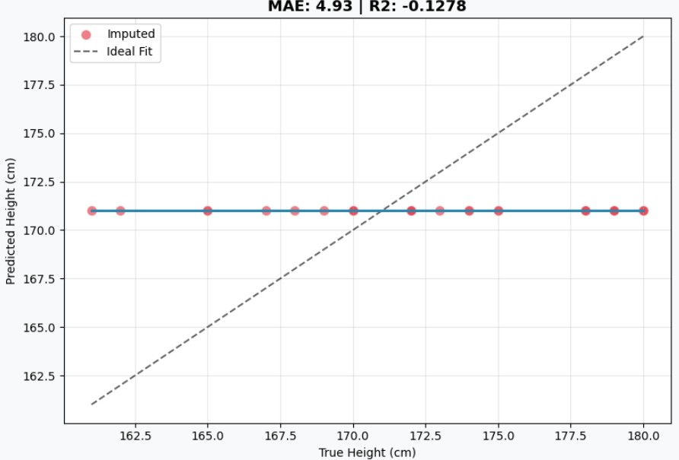

Figure 1. Median Imputation (Baseline).

nal trend, it still exhibits significant dispersion, with many points far from the y = x line . In contrast, MissForest provides the most ac- curate results, with points clustered tightly along the diagonal, con- firming its superior performance in capturing feature relationships even with limited data.
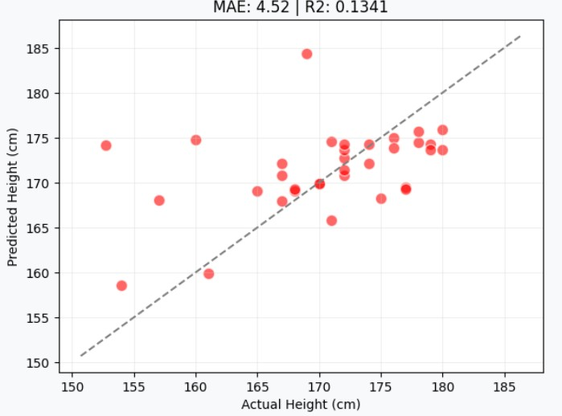

Figure 2. MICE Imputation.

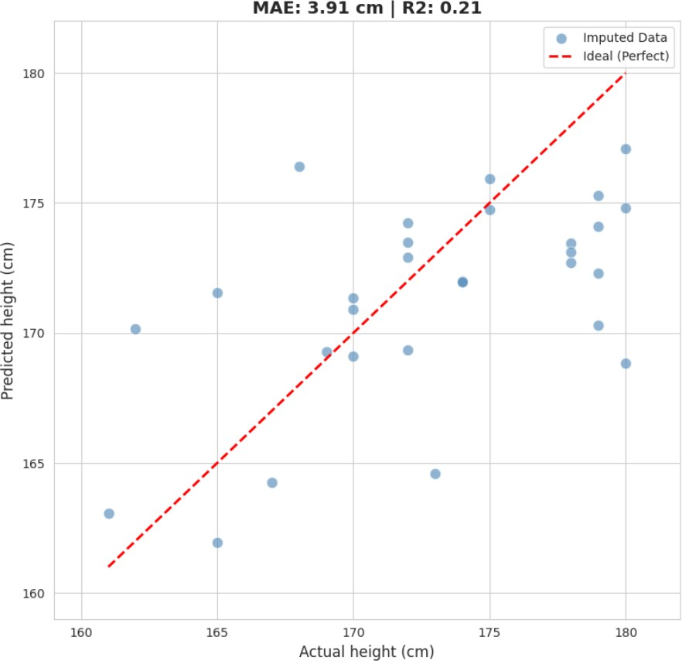
Figure 3. MissForest Imputation.

However, the deep learning models fail to produce meaningful predictions in this small-sample scenario. As seen in Figure 4 and Figure 5, both GAIN and VAE produce predictions that are highly concentrated around the median value. Instead of aligning with the diagonal y = x line, the imputed points are scattered only around a horizontal band. This indicates that the models have failed to cap-

ture any individual variance and are simply outputting values near the statistical average to minimize training loss, which visually ex- plains their poor convergence and negative R² results.
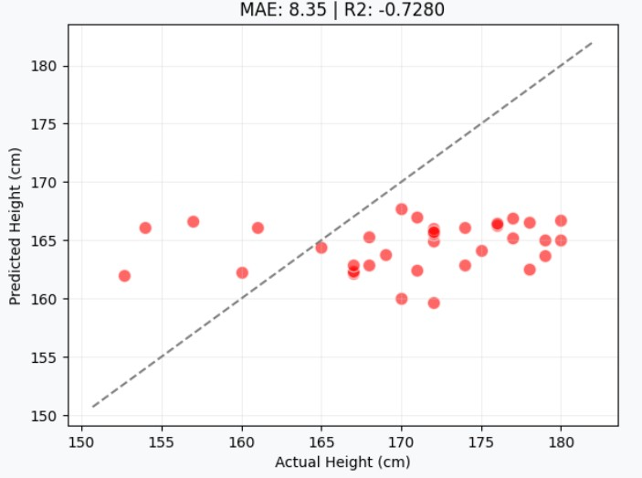

Figure 4. GAIN.

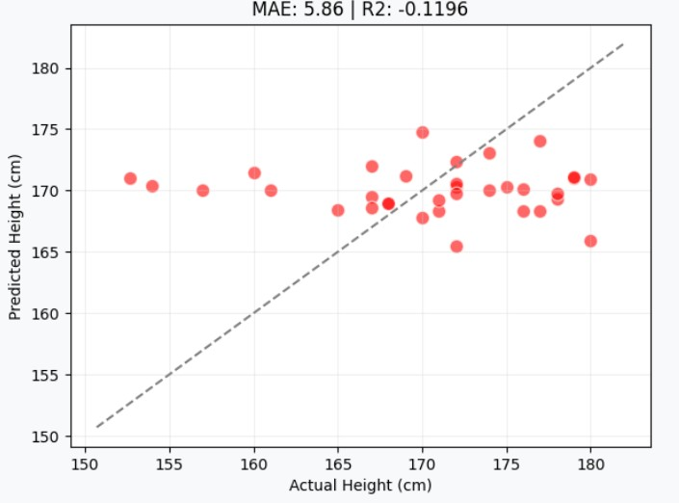
Figure 5. VAE.

In summary, for small-scale datasets with simple feature dimen- sions, deep learning models are not the optimal choice for missing value imputation. Their recovery performance often lags behind ba- sic statistical baselines, whereas traditional machine learning like MissForest demonstrates superior robustness. These findings sug- gest that model selection must prioritize the impact of data scale on algorithmic convergence; pursuing complex models without suffi- cient data leads to lower imputation fidelity.

Recovery Performance on Big Dataset
In the tests using the large-scale dataset (CDC BRFSS), the ex- perimental results show a completely different trend compared to the small-sample tests. When the amount of data increases signifi- cantly, the advantages of deep learning models start to appear. Ac- cording to the data in Table 3, VAE showed a dominant advantage in all evaluation metrics. Its R² reached the highest in the entire group at 0.9386, and the MAE was only 0.724. This shows that in a big data environment, VAE can accurately learn the data distribution and the complex relationships between features.
In contrast, traditional machine learning methods like MICE and MissForest still maintain good stability, with R² values of 0.5572 and 0.5664, respectively. However, their recovery accuracy is clearly behind VAE. This proves that while traditional methods can still provide reliable results when dealing with massive amounts of data, their ability to represent data has reached a bottleneck. They find it hard to improve the imputation quality further through big data, unlike certain deep learning models.
It is worth noting that another deep learning model, GAIN, still performs poorly at this stage. The failure of GAIN is mainly due to the gap between distribution matching and point-wise accuracy. While GAIN focuses on making the overall statistical distribution look real to fool the discriminator, it often ignores the exact precision for each individual data point, leading to a low R².
Furthermore, GAIN often suffers from “mode collapse,” where the generator simply predicts the average height to stay “safe,” which explains the horizontal patterns seen in its scatter plots. Another possible reason for this failure is the choice of data encoding. In this experiment, we used Label Encoding , but GAIN is generally more suitable for One-Hot Encoding to handle categorical features correctly. Additionally, the adversarial training process is highly unstable for tabular data, making it difficult to converge even with large datasets. In summary, the large-scale experiment confirms that when the data scale is large enough, deep learning—especially gen- erative models like VAE—has great potential to surpass traditional methods, provided the training is stable.

Table 3. Recovery Performance Comparison - Big Dataset

Method | MAE (cm) | RMSE (cm) R² Bias (cm)
Median Impute | 8.8916 | 10.8688 | -0.0927 | -1.9041
MICE | 5.4667 | 7.0170 | 0.5572 | 0.0222
MissForest | 5.4062 | 6.9443 | 0.5664 | 0.0045
GAIN | 8.118 | 10.0684 | 0.0791 | -2.47
VAE | 0.724 | 2.576 | 0.9386 | 0.0664

In the large-scale dataset (CDC BRFSS) tests, the visual distri- bution plots reveal significant differences in how algorithms scale with data.
Regarding traditional machine learning, MICE and MissForest (Figure 7 and Figure 8) show improved stability compared to small samples. The points begin to align more clearly with the diagonal line, proving that the models successfully learned the linear trends between features. However, their density along the diagonal is lower than VAE, suggesting that traditional ensemble methods reach a per- formance bottleneck when dealing with massive datasets.

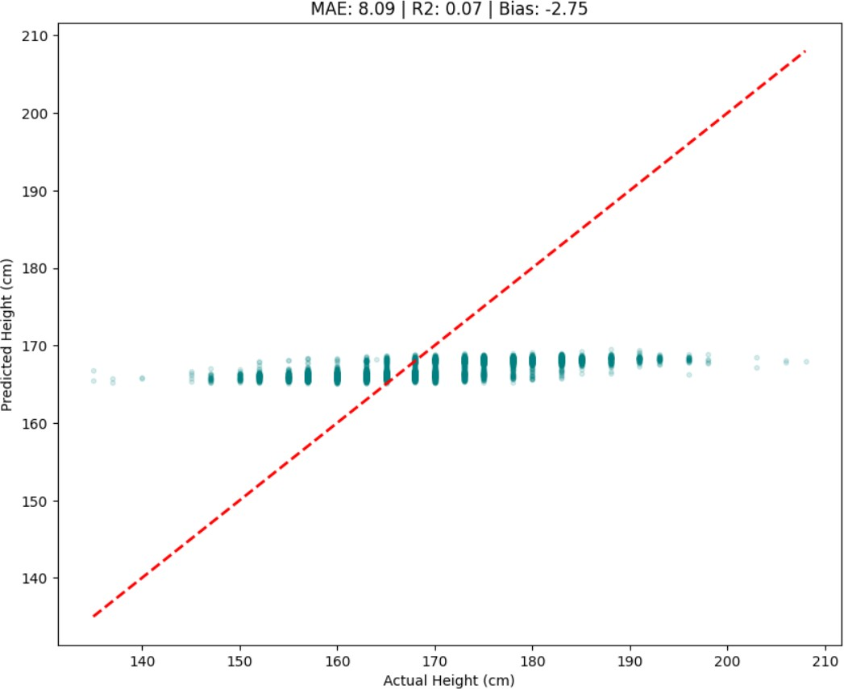

Figure 6. Median Imputation. Similar to the small dataset, it fails to capture any individual variance.
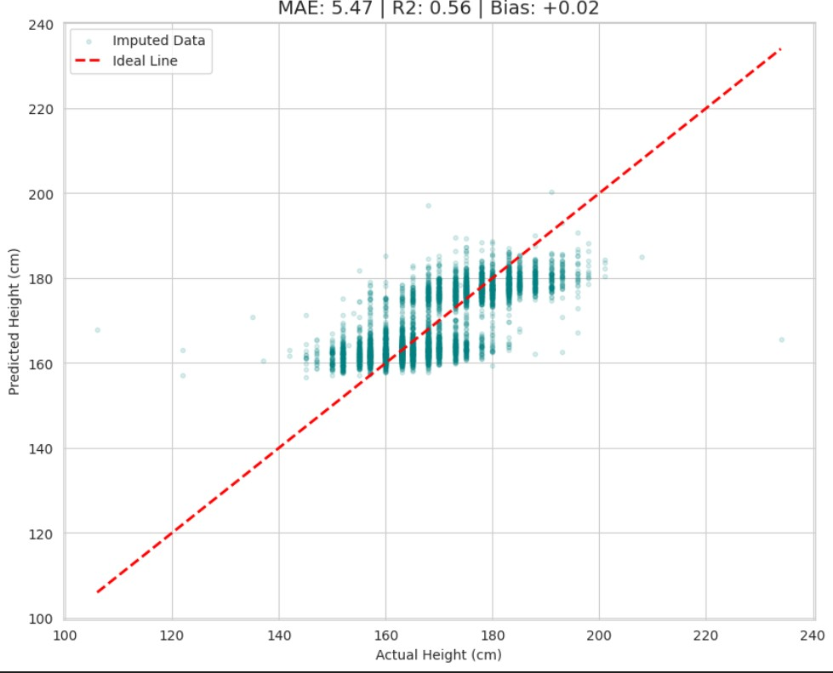
Figure 7. MICE Imputation. The distribution begins to align with the diagonal, but still shows noticeable spread.
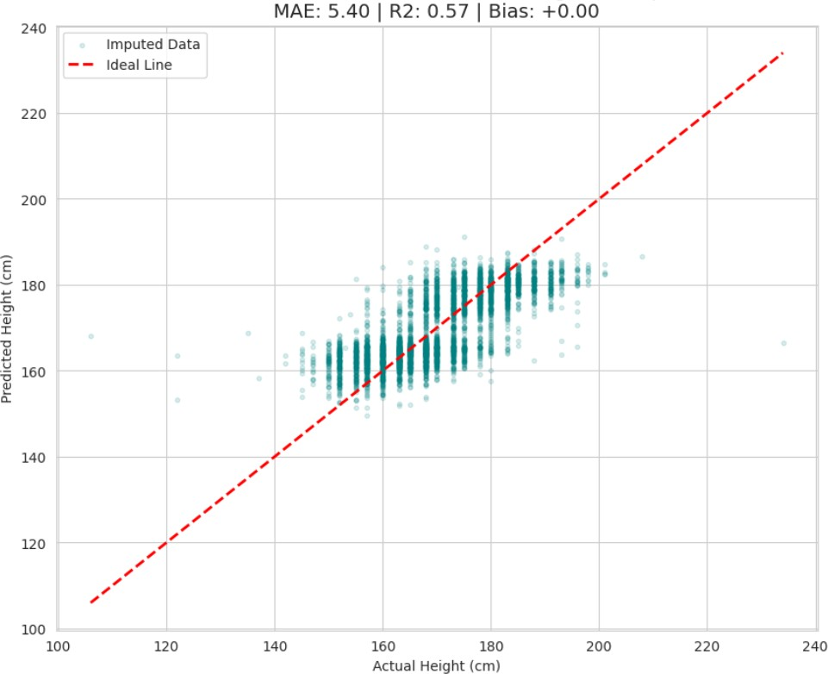
Figure 8. MissForest Imputation. Performance is stable, but the density around the diagonal is lower than VAE.

On the other hand, the deep learning models show extreme differ- ences. As seen in Figure 9, GAIN continues to struggle with con- vergence. The imputed points are scattered only within a horizontal
band around the median, failing to follow the diagonal line. This confirms ”mode collapse,” where the generator only predicts aver- age values to stay ”safe” from the discriminator. In sharp contrast, VAE (Figure 10) demonstrates superior distribution learning, with points tightly concentrated along the y = x diagonal. With suffi- cient data support, the latent space of VAE effectively reconstructs the complex underlying logic of tabular data, achieving the highest imputation fidelity in the entire group.
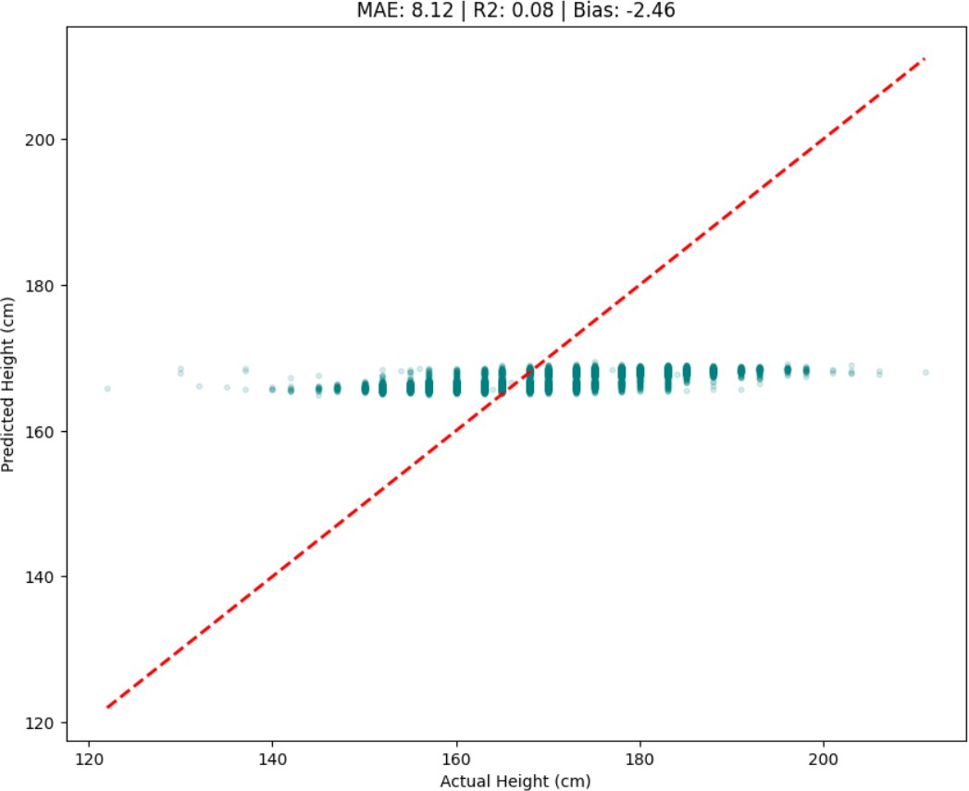

Figure 9. GAIN. The points are widely scattered in a horizontal pattern, showing mode collapse around the median.

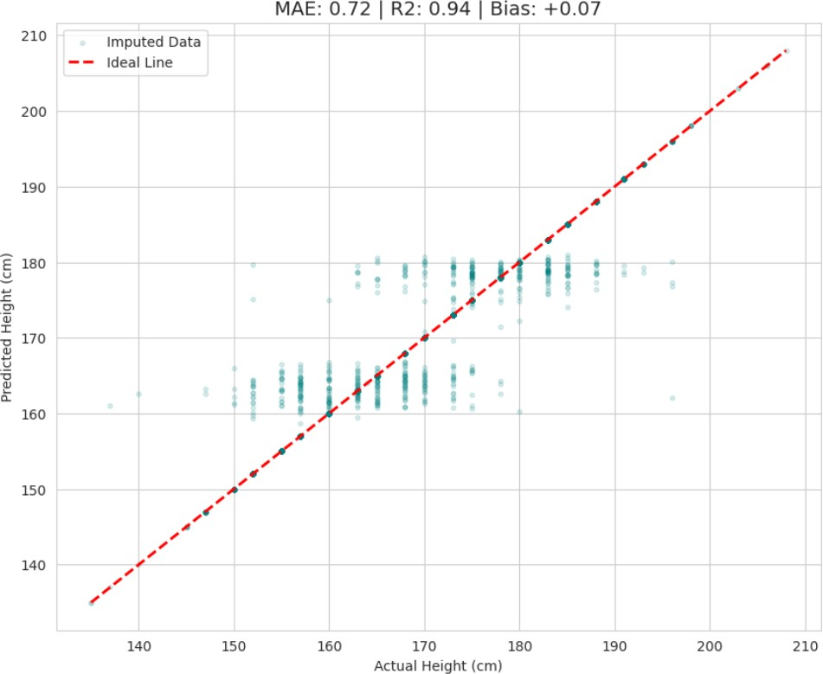
Figure 10. VAE. The points are highly concentrated along the
y = x line, visually confirming the R² = 0.9386 result.

In our large-scale experiment, we observed a clear reversal in per- formance. As the data size grows, the recovery accuracy of tradi- tional machine learning remains stable, but it seems to have a limit. On the other hand, with enough data support, certain deep learning methods show a strong ability to learn features, which greatly im- proves the imputation accuracy. This proves that for handling miss- ing values in large datasets, generative deep learning models are a better and more promising solution.

Phase 2: Downstream Performance Eval- uation
Accuracy measures the overall proportion of correct predictions:
T P + T N

Accuracy =
T P + T N + F P + F N
(8)

Experimental Objectives and Model Selection
The main goal of this phase is to verify the relationship between imputation quality and actual application effects. In Phase 1, we
Precision and Recall are used to measure the accuracy of positive predictions and the ability to find all positive cases, respectively:

evaluated the data recovery accuracy. However, the method with the highest accuracy does not always mean it provides the most useful
P recision = T P T P + F P
, Recall = T P T P + F N
(9)

feature information for future tasks. Therefore, Phase 2 focuses on evaluating the effects of different imputation strategies on the gender classification task.
We chose the ”Boy or Girl” dataset as our research object. This dataset includes various numerical and categorical features, which can effectively simulate complex tabular data environments. The dataset itself already contains a large amount of original missing values, and its distribution fits the Missing at Random (MAR) mech- anism. We used these natural missing values directly for the exper- iments to reflect the logic of correlated missing data in real-world scenarios.

Experimental Design and Evaluation Metrics
To explore how imputation algorithms affect different types of data (numerical and categorical), we divided the imputation process into three main scenarios for comparison:
      - Numerical Imputation (Model) + Categorical Imputation (Unknown): We only use specific algorithms to fill numerical features like height, weight, and IQ. Categorical features like star sign or phone OS are filled with ”Unknown.” This design helps us observe how the quality of numerical data recovery alone contributes to the classification task.
      - Baseline (Median/Mode) + Model Imputation: Numerical features are filled with the median, while categorical features are filled using the target algorithm. This scenario is used to test if the algorithm performs better than simple statistical base- lines when handling discrete categorical data.
      - Full Imputation: Both numerical and categorical features are processed by the same algorithm (such as MissForest or VAE). This evaluates the overall performance of the imputation plan in capturing complex relationships within ”mixed data.”
In all scenarios, the downstream gender prediction model uses the LightGBM classifier. To ensure fairness and reproducibility, the core hyperparameters of the classifier (such as learning rate and number of leaves) remain unchanged. The only variable in the ex- periment is the imputation method used for the input data.
Since the dataset has a clear class imbalance (the proportion of Gender 1 is much higher than Gender 2), Accuracy alone is not enough to show model performance. Therefore, we use the follow- ing metrics for a comprehensive evaluation. The evaluation metrics are defined as follows.
The F1-Score, which is the harmonic mean of Precision and Recall,
serves as our core metric for handling class imbalance:
F 1-Score = 2 P recision × Recall (10)
×
P recision + Recall
Additionally, we use ROC-AUC to check the model’s ability to dis- tinguish between classes at various thresholds, and the Confusion Matrix to visualize where the model mistakes one gender for an- other. This comprehensive analysis helps determine if the imputed data successfully preserves the key physical differences between genders.

Results and Discussion
Based on the experimental data in Table 4, we analyzed how differ- ent imputation methods affect the gender classification task on the Boy or Girl dataset. The results show that traditional machine learn- ing methods, specifically MICE and MissForest, generally perform better than the Control Group and deep learning models. Among all configurations, MissForest using numerical imputation with ”Un- known” categorical data achieved the highest Accuracy 0.8913 and F1-Score 0.7723. This proves that for small tabular datasets, Miss- Forest can effectively recover key physical features like height and weight, which significantly improves the prediction performance of the LightGBM classifier.
For both MICE and MissForest, filling only numerical features while leaving categorical data as ”Unknown” performed slightly bet- ter than Full Imputation. For example, the Accuracy of MissFor- est dropped from 0.8913 to 0.8842 when categorical features were also imputed. This suggests that in small-sample scenarios, imput- ing highly uncertain categorical features might introduce noise that slightly reduces classification precision. However, the Full Imputa- tion version of MissForest reached the highest Recall 0.7383, mean- ing it was the best at finding the minority class.
On the other hand, the performance of deep learning models was relatively average. GAIN with full imputation only achieved an Ac- curacy of 0.8747 and an F1-Score of 0.7104, which is identical to the Control Group. This indicates that the data generated by GAIN did not provide extra useful information for classification. VAE per- formed slightly better than GAIN, reaching an F1-Score of 0.7435 with full imputation, but it still behind MICE and MissForest. These results confirm the core finding of this study, when dealing with small mixed tabular data, generative models like GAIN and VAE are limited by the sample size, making their data utility lower than traditional ensemble methods like MissForest.

Table 4. Downstream Classification Performance on Boy or Girl
Dataset

Method | Numerical | Categorical | Acc | Precision | Recall | F1-Score | ROC-AUC
Control Group | Median | “Unknown” | 0.8747 | 0.8553 | 0.6075 | 0.7104 | 0.9089
MICE | MICE | “Unknown” | 0.8913 | 0.8280 | 0.7196 | 0.7700 | 0.8980
MissForest | MissForest | “Unknown” | 0.8913 | 0.8211 | 0.7290 | 0.7723 | 0.8979
MissForest | MissForest | MissForest | 0.8842 | 0.7900 | 0.7383 | 0.7633 | 0.8865
GAIN | GAIN | “Unknown” | 0.8771 | 0.8161 | 0.6636 | 0.7320 | 0.9035
GAIN | Median | GAIN | 0.8723 | 0.8354 | 0.6168 | 0.7097 | 0.9113
GAIN | GAIN | GAIN | 0.8747 | 0.8553 | 0.6075 | 0.7104 | 0.9035
VAE | VAE | “Unknown” | 0.8794 | 0.8784 | 0.6075 | 0.7128 | 0.9035
VAE | Median | VAE | 0.8652 | 0.8678 | 0.5514 | 0.6743 | 0.9149
VAE | VAE | VAE | 0.8842 | 0.8452 | 0.6636 | 0.7435 | 0.8850
Note: “Unknown” indicates that categorical features were not imputed but replaced with a constant label to evaluate the specific impact of numerical feature recovery.

Visual Analysis and Discussion
The analysis of the Confusion Matrices reveals the model’s ability to identify gender groups, especially the minority class (Gender 2). As shown in Figure 11, the Control Group misclassifies 42 females as males, indicating limited sensitivity to the minority class. In contrast, Figure 12 shows that MissForest (Numerical + Unknown) achieves the best results, with the clearest diagonal distribution and only 29 misclassifications. This proves that this strategy preserves the most discriminative features. Finally, as seen in Figure 13, VAE performs better than the baseline but still has 36 misclassifications, likely due to noise introduced during imputation.
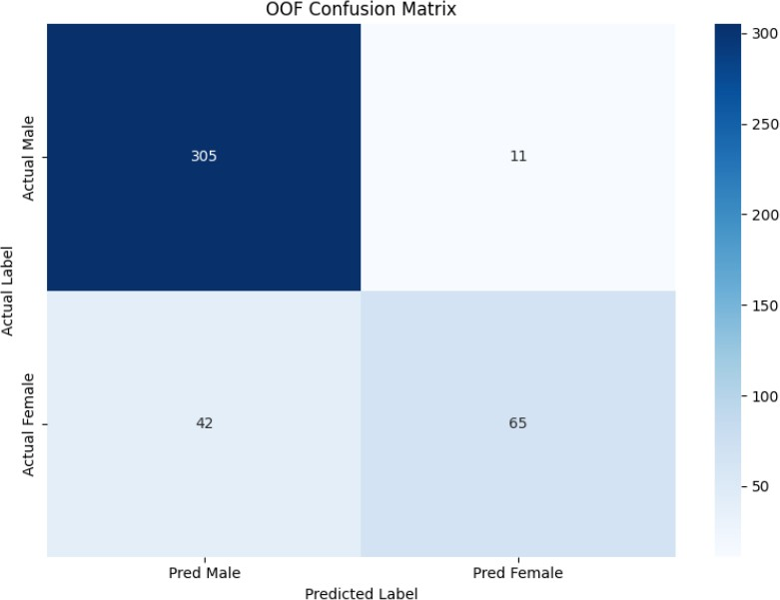

Figure 11. Confusion Matrix: Control Group. The model shows lower sensitivity to the minority class.

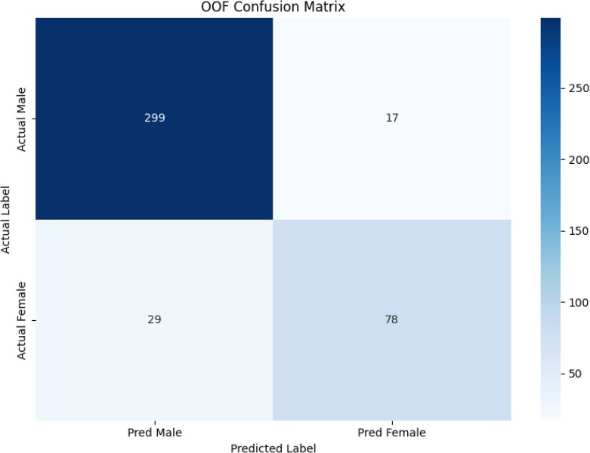

Figure 12. Confusion Matrix: MissForest (Numerical + Un- known). This shows the clearest diagonal and best F1-Score.
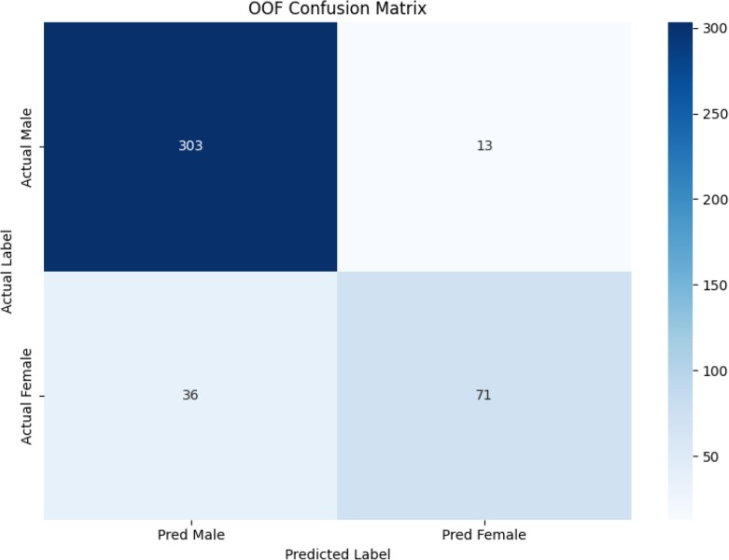
Figure 13. Confusion Matrix: VAE (Full Imputation). In- creased noise leads to more misclassifications than MissForest.

Next, we use ROC Curves to check the stability of the LightGBM classifier. As shown in Figure 14, Figure 15, and Figure 16, all three cases achieve an AUC above 0.88, representing excellent pre- dictive performance. Although the Control Group has the highest AUC (0.909), this is mainly due to its consistent predictions on the majority class. MissForest and VAE maintain strong discriminative power while providing richer feature information, ensuring stability in real-world applications.
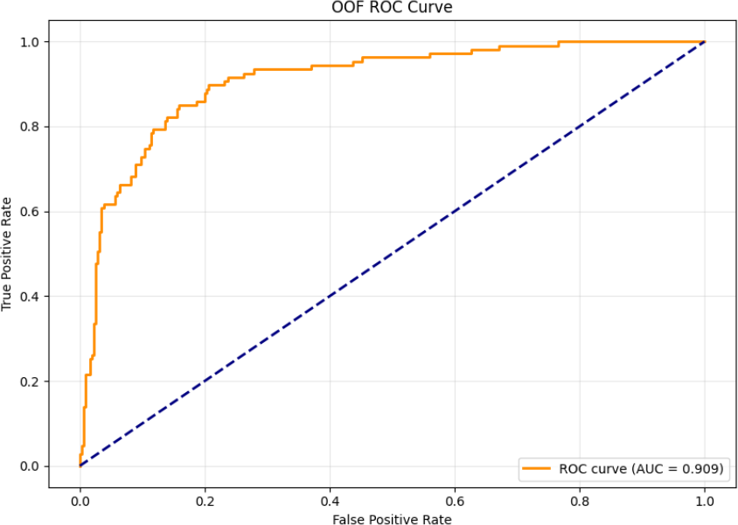

Figure 14. ROC Curve: Control Group. High AUC reflects sta- bility on original distributions.

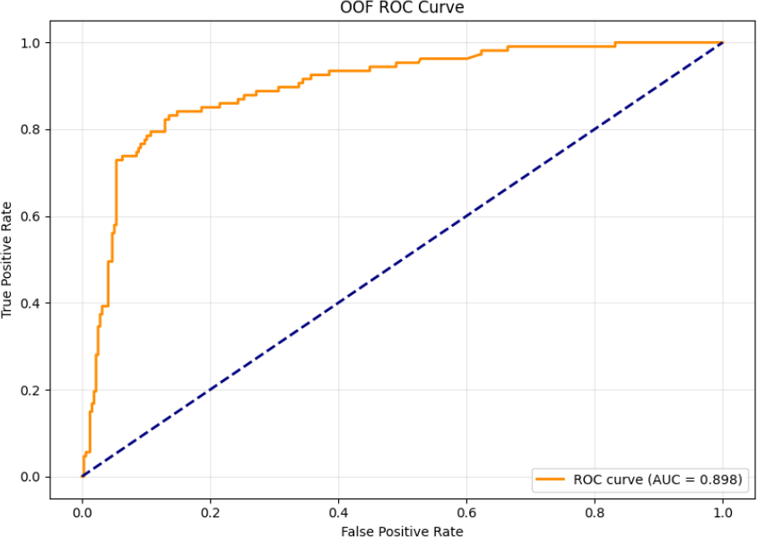

Figure 15. ROC Curve: MissForest (Numerical + Unknown). The model maintains robust discriminative power.
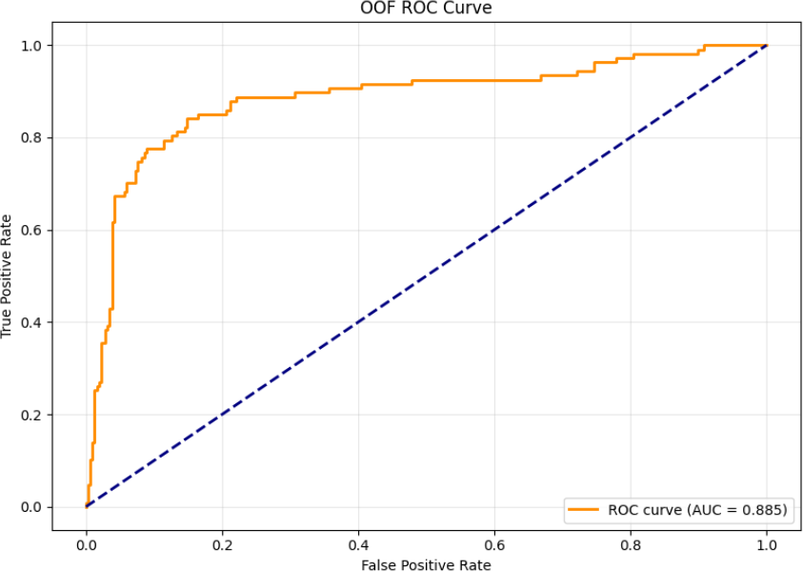
Figure 16. ROC Curve: VAE (Full Imputation). Shows a slight decrease in power due to noise on a small sample size.

- CONCLUSION
This research confirms that there is no single ”best” algorithm for tabular data imputation. Its performance depends heavily on the data scale and the missing mechanisms, such as MCAR, MAR, or MNAR.
Our analysis and experimental results show that in small-sample environments (such as the Boy or Girl dataset), traditional models like MissForest perform better. Because of their strong inductive bias, they capture non-linear relationships more accurately and offer higher stability and F1-Scores than deep learning models like GAIN and VAE. However, as the data size grows to a large scale (such as the CDC BRFSS dataset), deep learning models like VAE show superior performance. By learning latent space distributions, VAE can accurately reconstruct the underlying data logic and surpass the limits of traditional machine learning.
In summary, practitioners should first understand the characteris- tics of their dataset—including the missingness type, data size, and time cost—to achieve the best results in model training.

REFERENCES
- D. Popovich. “How to treat missing data in survey research”. In: Journal of Marketing Theory and Practice 33.1 (2025), pp. 43–59. doi: 10.1080/10696679.2024.2376052.
- T. H. Noor et al. “An IoT-Based Energy Conserva- tion Smart Classroom System”. In: Intelligent Automa- tion & Soft Computing 35 (2023), pp. 3785–3799. doi: 10.32604/iasc.2023.032250.
- M. Alwateer et al. “Missing data imputation: A comprehen- sive review”. In: Journal of Computer and Communications 12 (2024), pp. 53–75. doi: 10.4236/jcc.2024.1211004.
- D. B. Rubin. “Inference and missing data”. In: Biometrika
63.3 (1976), pp. 581–592. doi: 10.1093/biomet/63.3.581.
- Y. Zhou, S. Aryal, and M. R. Bouadjenek. “A comprehensive review of handling missing data: Exploring special missing mechanisms”. In: Preprint submitted to Elsevier (2024).
- R. Shahbazian and S. Greco. “Generative adversarial net- works assist missing data imputation: A comprehensive sur- vey and evaluation”. In: IEEE Access 11 (2023), pp. 88908– 88928. doi: 10.1109/ACCESS.2023.3306721.
- Y. Sun et al. “Deep learning versus conventional methods for missing data imputation: A review and comparative study”. In: Expert Systems with Applications 227 (2023), p. 120201. doi: 10.1016/j.eswa.2023.120201.
- R. J. Little and D. B. Rubin. Statistical analysis with missing data. John Wiley & Sons, 2019. doi: 10.1002/9781119482260.
- W. Li, G. Deng, and D. Pan. “Ultra-high dimensional feature selection and mean estimation under missing at random”. In: Open Journal of Statistics 13.6 (2023).
- M. J. Azur et al. “Multiple imputation by chained equations: What is it and how does it work?” In: International Journal of Methods in Psychiatric Research 20.1 (2011), pp. 40–49. doi: 10.1002/mpr.329.
- D. J. Stekhoven and P. Bühlmann. “MissForest—non- parametric missing value imputation for mixed-type data”. In: Bioinformatics 28.1 (2012), pp. 112–118. doi: 10.1093/bioinformatics/btr597.
- J. Yoon, J. Jordon, and M. Schaar. “GAIN: Missing data im- putation using generative adversarial nets”. In: International Conference on Machine Learning. PMLR. 2018, pp. 5689– 5698. URL: http://proceedings.mlr.press/v80/yoon18a.html.
- P. A. Mattei and J. Frellsen. “MIWAE: Deep generative mod- elling and imputation of incomplete data sets”. In: Inter- national Conference on Machine Learning. PMLR. 2019, pp. 4413–4423. URL: http : / / proceedings . mlr . press / v97 / mattei19a.html.
- A. Kotelnikov et al. “TabDDPM: Modelling tabular data with diffusion models”. In: International Conference on Machine Learning. PMLR. 2023, pp. 17564–17579. URL: https : / / proceedings.mlr.press/v202/kotelnikov23a.html.

- L. Grinsztajn, E. Oyallon, and G. Varoquaux. “Why do tree-based models still outperform deep learning on typi- cal tabular data?” In: Advances in Neural Information Pro- cessing Systems 35 (2022), pp. 507–520. URL: https : / / proceedings . neurips . cc / paper _ files / paper / 2022 / hash / 0378c7692da36807bdec87ab043e243f - Abstract - Conference.html.
- E. Beyazit et al. “An inductive bias for tabular deep learning”. In: Advances in Neural Information Processing Systems 36 (2023), pp. 43108–43135.
- M. J. Azur et al. “Multiple imputation by chained equations: What is it and how does it work?” In: International Journal of Methods in Psychiatric Research 20.1 (2011), pp. 40–49. doi: 10.1002/mpr.329.
- Jacob Feitelberg et al. “TabImpute: Universal Zero- Shot Imputation for Tabular Data”. In: arXiv preprint arXiv:2510.02625 (2025). doi: 10.48550/arXiv.2510.02625.
- N. Hollmann et al. “TabPFN: A transformer that solves small tabular classification problems in a second”. In: arXiv preprint arXiv:2207.01848 (2022).
- D. Bertsimas, C. Pawlowski, and Y. D. Zhuo. “From predic- tive methods to missing data imputation: an optimization ap- proach”. In: Journal of Machine Learning Research 18.196 (2018), pp. 1–39.

WORK DIVISION
The authors confirm and agree that their work description and con- tribution are correct.

Name | Work description | Contribution
Ai-Ting, Lin 113427013 | - Literature search  - Reviewing traditional Machine Learning imputation methods  - Drafting Sections 2, 3 | 25%
Li-Feng, Chen 114423006 | - Literature search  - Empirical experiments design and evaluation  - Drafting Section 4 | 25%
Jia-Hua, Peng 114423056 | - Literature search  - Overall manuscript synthesis and formatting  - Drafting Sections 1, 5,  Abstract | 25%
Xin-Ping, Wu 114423067 | - Literature search  - Reviewing Deep Learning imputation methods  - Drafting Sections 2,3 | 25%

