Enterprise Monitoring Solution: From Reactive to Proactive Operations
When I became CTO in 2018, our SaaS company’s ~200 servers alerting and monitoring existed through fragmented, custom alerting systems, and generally lacked visibility. Important information, such as system performance was not readily available. I implemented a dockerized Grafana/Prometheus monitoring solution that transformed how we understood and managed our infrastructure.

The Solution
Deployed comprehensive monitoring across 50 Windows and 150 Linux servers. Most Linux systems were primarily Docker Swarm hosting isolated customer applications. Most Windows servers hosted IIS and/or SQL Server. The platform captured system metrics (CPU, memory, disk), application-specific data (IIS, SQL Server, Docker), quality metrics (CAPA), and business KPIs—all visualized through role-based dashboards integrated with company SSO.

Impact
The results were dramatic: - 5-10X reduction in customer-facing emergencies through early problem detection - Proactive issue resolution before customers were affected - Faster incident response as client-facing teams could quickly identify root causes and engage the right resources - Continuous improvement enabled by trending data that highlighted areas needing attention - Observable quality improvements in both software and hosting operations
By democratizing access to operational data beyond DevOps—giving visibility to quality, business, and support teams—we shifted from reactive firefighting to strategic, data-driven operations management.
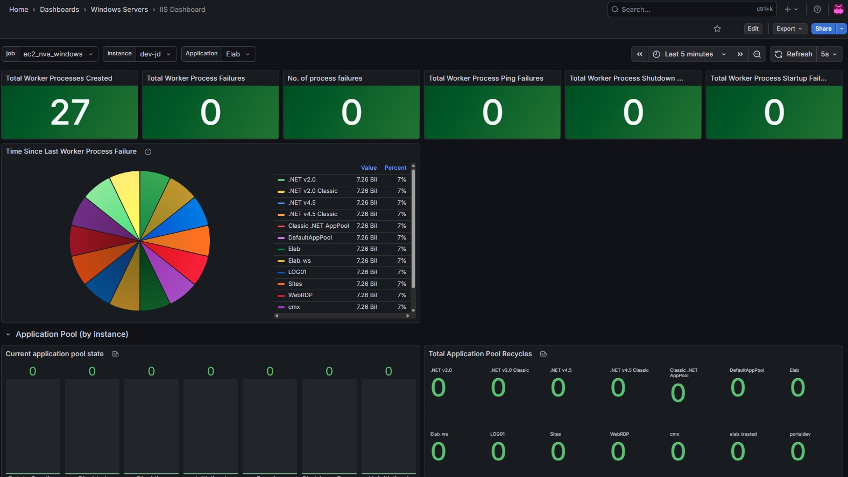
IIS monitoring example
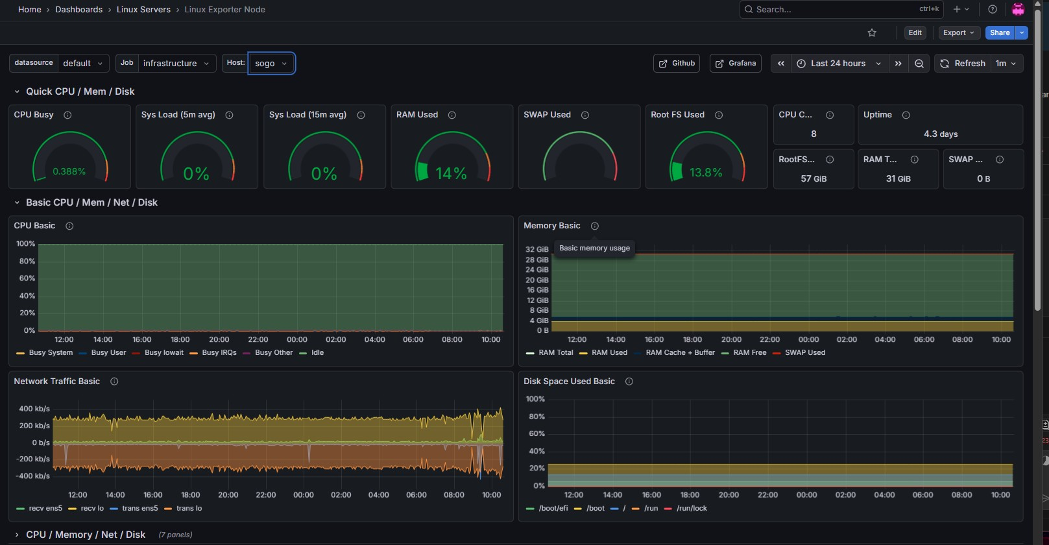
Linux monitoring example
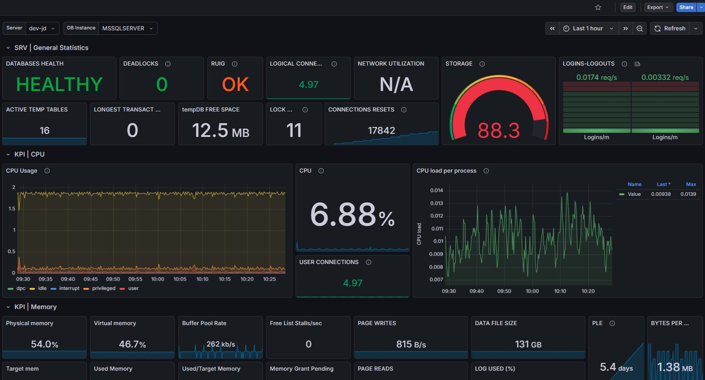
SQL Server monitoring example
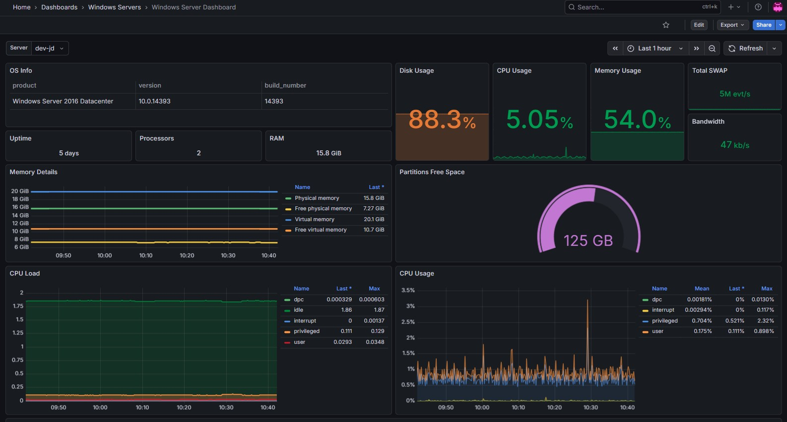
“SQL Server monitoring example”

