Michael Lootes

30/11/20

Borwell Software Challenge

Table of Contents

Design 1

Test Plan 1

Test Log 0

Figure1 1

Figure2 2

Figure3 3

# Design

txtLength

txtWidth

txtHeight

lblPaint

lblArea

lblVolume

btnCalculate

Height of Wall

Width of room

Length of room

Paint Calculator

# 

# Test Plan

|  |  |  |  |
| --- | --- | --- | --- |
| Test Number | Element to test | How to test | Expected result |
| 1 | Calculation button | When the application is run, the calculate button will be pressed. | This test should result in the three labels at the bottom of the form to show values. |
| 2 | Calculations | The application will be given three separate value sets. The following values will be used (In Metres):   * 1.2, 3, 2.5 * 2, 4, 1.2 * 2.5, 1, 2 | The application should provide the values of ((In Metres) Area, Volume, (In Litres) Paint):   * 12.96, 9, 32.4 * 64, 9.6, 76.8 * 6.25, 5, 12.5 |
| 3 | Validation | Attempt to input strings instead of floats into text boxes | Validation should occur, presenting the user with an error message and prompting them to try again. |

# 

# Test Log

|  |  |  |  |  |  |  |
| --- | --- | --- | --- | --- | --- | --- |
| Test Number | Element to test | How to test | Expected Result | Actual Result | Pass/Fail | Figure |
| 1 | Calculation Button | When the application is run, the calculate button will be pressed. | This test should result in the three labels at the bottom of the form to show values. | When the test was conducted, the calculated values appeared in the corresponding boxes. | Pass | See Figure 1 |
| 2 | Calculations | The application will be given three separate value sets. The following values will be used (In Metres):   * 1.2, 3, 2.5 * 2, 4, 1.2 * 2.5, 1, 2 | The application should provide the values of ((In Metres) Area, Volume, (In Litres) Paint):   * 12.96, 9, 32.4 * 64, 9.6, 76.8 * 6.25, 5, 12.5 | When test was conducted, the three sets of values were passed through, and all calculations matched what was expected. | Pass | See Figure 2 |
| 3 | Validation | Attempt to input strings instead of floats into text boxes | Validation should occur, presenting the user with an error message and prompting them to try again. | When test was conducted, the fields had text inputted and the validation message appeared, prompting the user to try again. | Pass | See Figure 3 |

## Figure1

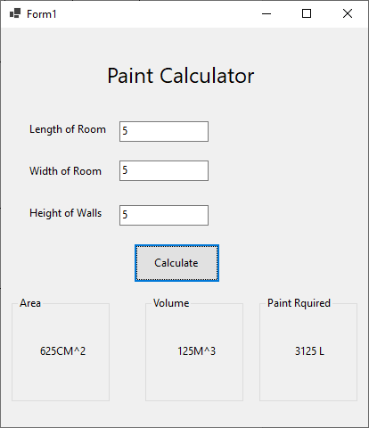

This figure shows the results from test 1, the length, width and height were all entered as five, when the button was pressed, the calculations were passed into the boxes at the bottom of the UI.

## Figure2

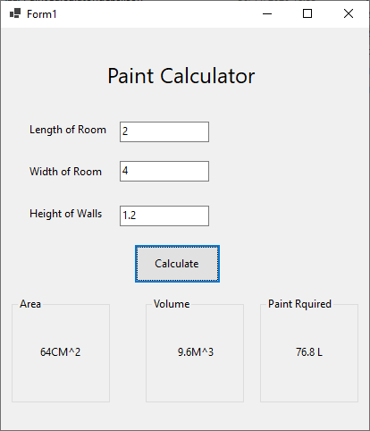

Figure 2 shows the three value sets which were tested on the application, along with results returned.

## Figure3

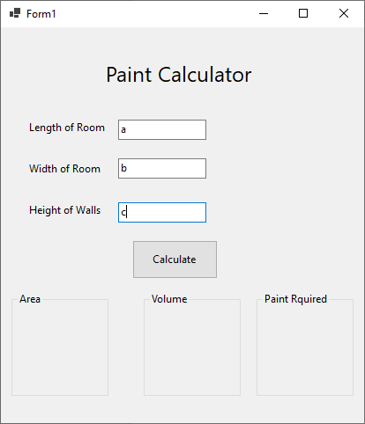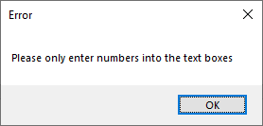

Figure 3 shows the validation which has been implemented, if the user enters letters instead of numbers they will be presented with this error.

# Improvements which could be made

If I had more time to work on this application I would have made a better solution to displaying the correct measurement unit, as implementing the proper display for a squared or cubed number would have taken a lot more time as it required Unicode to be used within the labels, which may have caused errors and caused key parts of the program to break.

Another change which could have been made would have been to reset the boxes when the text boxes are edited, this would have been a simple fix, either with a button or simply get the program to clear the boxes as soon as a text box is changed. With the second option it would have been possible to improve the program and make it update the calculations live as the text boxes were edited.

More time would have also enabled me to make an improved UI, which would have created a better user experience with the application. And as part of this I would have included tooltips to prompt users with their inputs (allowing them to know what they need to input.)