# Paint Calculator

To build the application, first it must be opened within visual studio. After this click on the build tab at the top of the screen and click on ‘Build PaintCalculator’. This will begin the building process and will create a release folder.

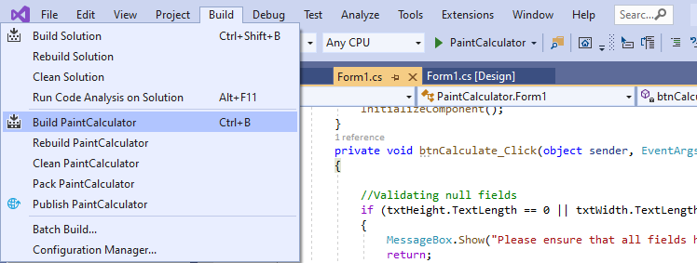

If this was successful the console should display this (the directory will be the one that the repository was cloned to.) 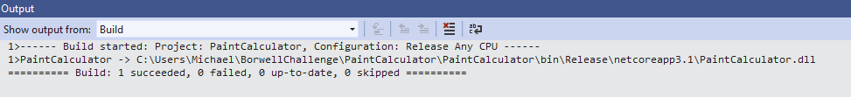

Navigate to the release folder to find the application and double click on it. It will open. (The release folder will be in the cloned repository directory and will contain the executable file which is ready to use.

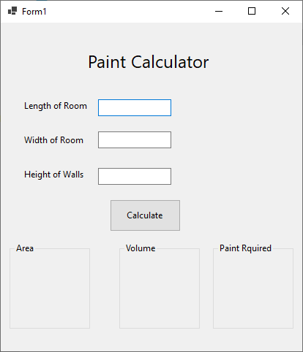

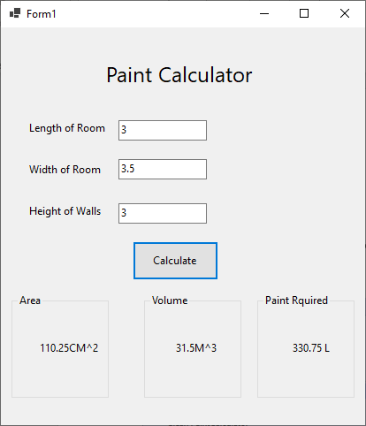Enter numbers into the text boxes that are presented on the UI, once this is done, click on the calculate button, this will take the three values entered and display them in the corresponding boxes at the bottom of the screen.

