SMSLIBRE
Machine Data Import for QGIS
User Guide
Version 1.0.0
Olds College Centre for Innovation — Smart Farm
Internal tool — not for public distribution

Contents
1. What SMSLIBRE is
2. Before you start
3. Installing the plugin
4. Your first import
5. The dialog, control by control
6. Choosing the right folder
7. Supported formats
8. Understanding what you get
9. Working with the data in QGIS
10. Troubleshooting
11. Using the sidecar from the command line
12. Testing a whole drive
13. Building from source
14. Licensing and distribution
15. Quick reference

1. What SMSLIBRE is
SMSLIBRE is a QGIS plugin that reads precision-agriculture machine data — yield monitor logs, as-applied spray records, as-planted seeding data, field boundaries and variable-rate prescriptions — and turns them into map layers you can work with directly in QGIS.
You point it at the folder your display wrote to a USB stick. It works out which manufacturer's format that is, converts everything it finds into a GeoPackage, and adds the layers to your map with sensible styling already applied. Every sensor channel the machine logged becomes an attribute you can query, filter, classify and export.

Why it exists
Ag Leader SMS can read these cards, but it is Windows-only desktop software and getting data out of it and into a GIS workflow is slow and manual. SMSLIBRE puts the same import capability inside QGIS, where the analysis actually happens.

How it fits together
The vendor import libraries are .NET assemblies, so the plugin does not try to load them into QGIS's Python. Instead it runs a small console program — the "sidecar" — as a separate process and reads back a single JSON summary. If a vendor library crashes on a malformed card, QGIS is unaffected.
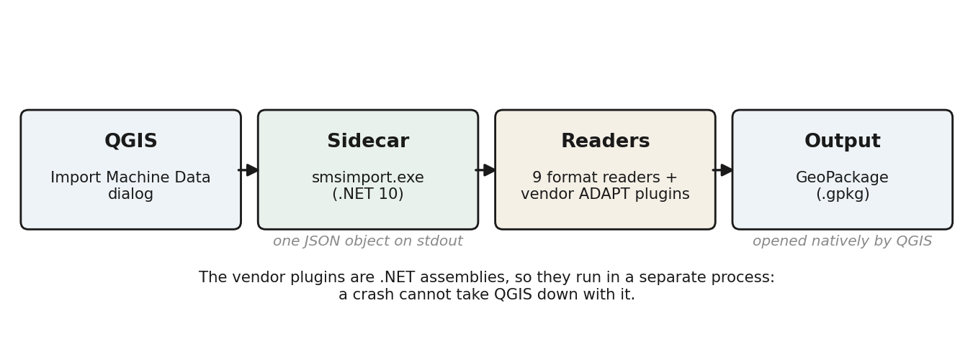
Figure 1. The plugin runs the readers in a separate process and gets a GeoPackage back.

What has been tested
Before release, every directory on both Smart Farm shared drives was taken through the full pipeline — detect, import, open the GeoPackage, validate every coordinate:
Shared drive | Directories walked | Cards imported | Features
Olds College Smart Farm Vault | 13,458 | 553 | 108,864,986
210600 STAAR | 9,240 | 82 | 67,377,366

176 million features imported, with no invalid or out-of-range coordinates surviving anywhere. Six cards fail, all for known reasons documented in chapter 10 — none of them a format the plugin claims to support.

2. Before you start

What you need
Requirement | Detail
Windows | Windows 10 or 11. The sidecar is built for win-x64.
QGIS | 3.22 or newer. Tested on QGIS 3.44 LTR and 4.0.
Disk space | About 200 MB for the plugin. Imported GeoPackages can be large — a very wide John Deere card can produce several GB.
The card | The original folder written by the display, or a copy of it. See chapter 6 — pointing at the wrong folder is the most common problem.

Which build do you want?
There are two builds and the difference matters. Both contain the same code; they differ only in whether John Deere's licensed material is bundled.

Build | File | John Deere support | Who it is for
Internal | smslibre_import_INTERNAL.zip | Works immediately — Deere's plugin release and our licence key are bundled | Olds College staff. Never share outside the organisation.
Public | smslibre_import.zip | Not until you supply your own Deere ADAPT release and application id | Anyone else, or a machine where the licence must not go.

Distribution rule
The internal build contains material licensed to Olds College by John Deere. The licence forbids redistributing it. Do not email it, do not attach it to a GitHub release, do not put it on a public share. Chapter 14 has the detail.

3. Installing the plugin

Install from ZIP
- Close QGIS completely if it is open. See the warning below.
- Start QGIS.
- From the menu choose Plugins → Manage and Install Plugins…
- Select Install from ZIP on the left.
- Browse to smslibre_import_INTERNAL.zip (or the public zip) and choose Install Plugin.
- QGIS reports success. Close the plugin manager.

You now have a toolbar button and a menu entry under Plugins → SMSLIBRE → Import machine data…

Nothing may be holding the plugin folder
Installing replaces the whole plugin folder. If QGIS is open, or an import is still running, some files are locked — the installer deletes everything it can around them and you are left with a broken, partial install.
Symptoms: the plugin fails to load, or an import that was running dies with no message at all. Close QGIS first, and check Task Manager for a lingering SmsImport.exe before reinstalling.

Checking it worked
Open the dialog from the toolbar. It should look like this, with the Sidecar path already filled in under Settings. If the Sidecar box is empty, the install did not complete — reinstall with QGIS closed.
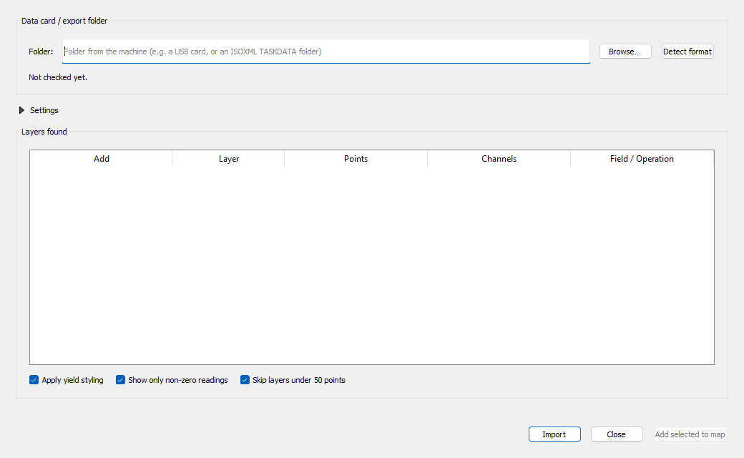
Figure 2. The import dialog as it opens. Settings is collapsed because an internal build needs no configuration.

Where things end up
What | Where
The plugin | `%APPDATA%\QGIS\QGIS3\profiles\default\python\plugins\smslibre_import
The sidecar | `...\smslibre_import\bin\SmsImport.exe
Imported data | `%USERPROFILE%\Documents\SMSLIBRE\smslibre_<date>_<time>.gpkg
Your settings | QGIS settings, under the smslibre_import prefix

Imported files are kept, not cleaned up
Layers on your map point at the GeoPackage in Documents\SMSLIBRE. That folder is deliberately not a temporary directory — deleting a file there breaks any saved project that uses it. Tidy it up periodically, but check your projects first.

4. Your first import
Five steps, start to finish.

Step 1 — Open the dialog
Click the SMSLIBRE button on the toolbar, or Plugins → SMSLIBRE → Import machine data…

Step 2 — Choose the card folder
Click Browse… and select the folder from the machine. Pick the folder that contains the display's folder — not the deepest folder with files in it. Chapter 6 covers this properly; it is the one thing people get wrong.

Step 3 — Detect the format
Click Detect format. The plugin asks every reader it has whether it recognises the folder, and reports what it found.
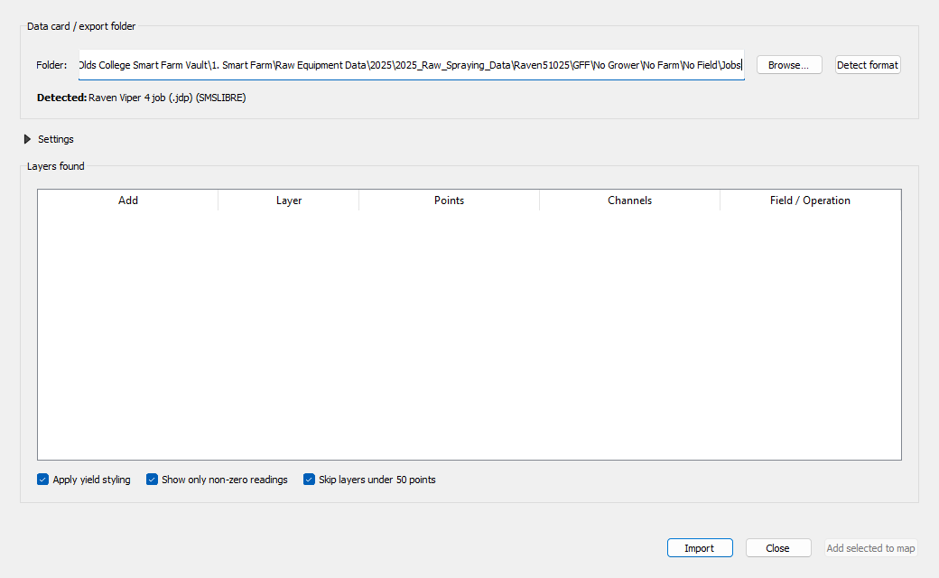
Figure 3. A Raven Viper 4 job folder recognised. The name in brackets is who supplies the reader — SMSLIBRE for our own, or the vendor for an ADAPT plugin.
Detection is optional — you can press Import directly — but it is fast and tells you immediately whether the folder is right.

Step 4 — Import
Click Import. A progress bar appears and the dialog stays responsive; the work happens in a background process. A small card takes seconds. A large John Deere card with thousands of layers can take fifteen minutes or more, and reading from a network drive is slower than from a local disk.
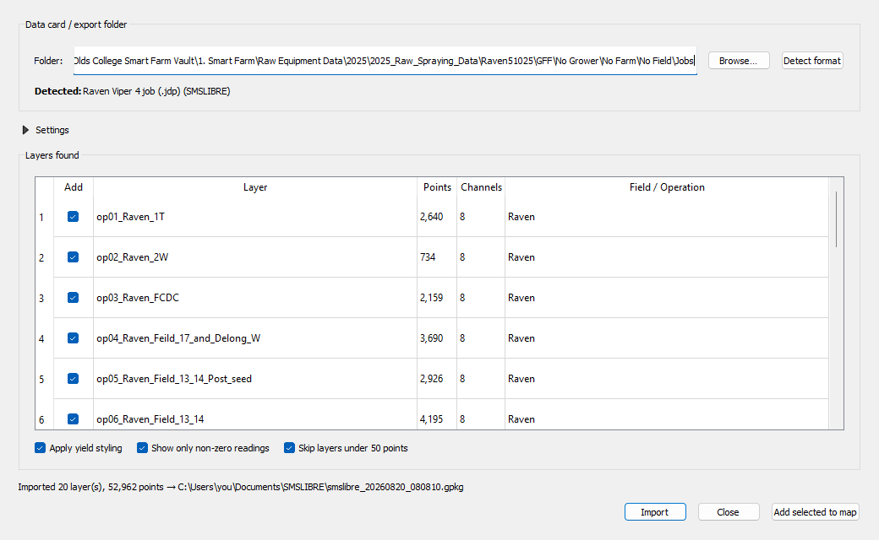
Figure 4. After import: every layer found, with its point count and channel count. Layers under 50 points are unticked automatically.

Step 5 — Add the layers you want
Tick the layers you want and click Add selected to map. They are added with styling already applied. The status line tells you where the GeoPackage was written — note that path if you want to reopen the data later without re-importing.

5. The dialog, control by control

Data card / export folder
Control | What it does
Folder | The card folder to read. Type or paste a path, or use Browse…
Browse… | Opens a folder picker.
Detect format | Asks the readers what they make of the folder and reports the answer. Does not import anything.

Settings
Collapsed by default, because an internal build is already configured. It remembers whether you left it open. Everything here is saved between sessions.
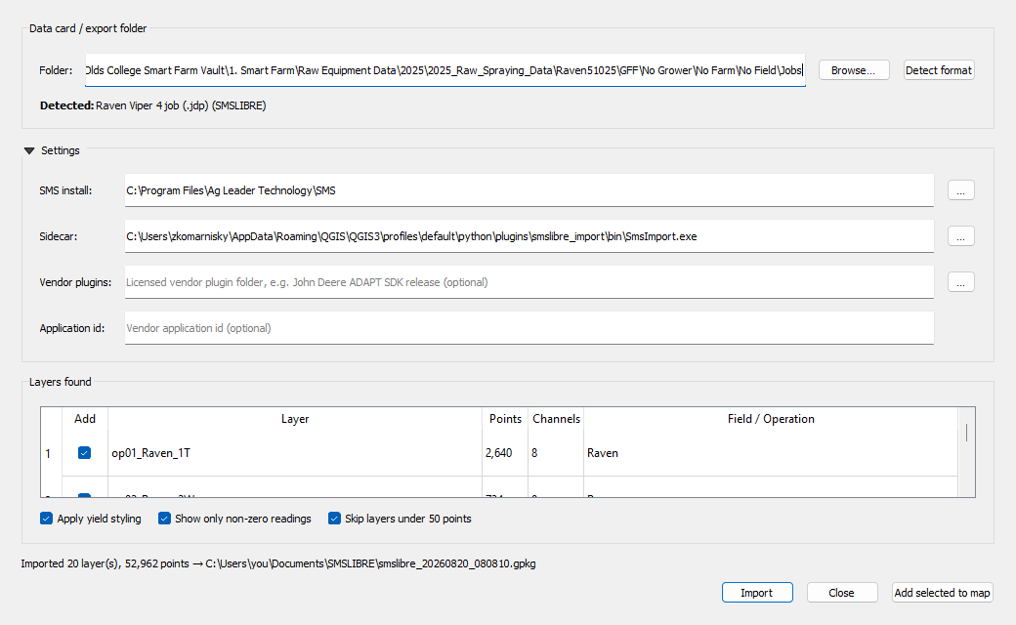
Figure 5. Settings expanded. On an internal build the first two are filled in automatically and the last two are left blank on purpose.
Setting | What it is for
SMS install | Your Ag Leader SMS folder. SMS ships the ADAPT plugin suite, and that is where the ISOXML, Climate, CNH and other vendor readers come from. Found automatically at C:\Program Files\Ag Leader Technology\SMS.
Sidecar | The SmsImport.exe that does the work. Filled in by the installer. Only change this if you are testing a build you compiled yourself.
Vendor plugins | A licensed vendor plugin release — in practice John Deere's ADAPT SDK download. Bundled in the internal build, so normally left blank.
Application id | The GUID issued with a vendor licence. Bundled in the internal build.

Layers found
One row per layer the card produced. Layer names are built from a sequence number, the field name and the operation type, so they sort in a sensible order in the QGIS layer tree.
Column | Meaning
Add | Tick to add this layer to the map.
Layer | The table name inside the GeoPackage.
Points | How many logged records the layer holds.
Channels | How many sensor channels were recorded — these become attribute columns.
Field / Operation | The field name and operation type the machine recorded, when it did.

The three options
Option | Default | What it does
Apply yield styling | On | Picks the most meaningful numeric channel — yield first, then rates, then elevation — and applies a quantile red-to-green ramp. Without this a layer is a mass of identical dots.
Show only non-zero readings | On | Hides records where the styled value is zero. Machines log zeros on headland turns and during transport; leaving them in flattens the colour range and makes a yield map unreadable.
Skip layers under 50 points | On | Unticks tiny layers. Cards routinely contain dozens of stub layers with a handful of points that are not worth mapping.

The buttons
Button | What it does
Import | Converts the card. Enabled once you have chosen a folder.
Add selected to map | Adds the ticked layers. Enabled after a successful import.
Close | Closes the dialog. The GeoPackage stays on disk — you can add it to a map later through Layer → Add Layer → Add Vector Layer.

6. Choosing the right folder
This is the single most common problem
"The plugin cannot open my data" is almost always the wrong folder selected, not an unsupported card. The readers look for a specific structure and will decline anything else — including the folder one level too deep.
The rule: select the folder that CONTAINS the display's own folder. For a John Deere GS3 card, the display writes a folder called GS3_2630; you select its parent, not it, and not the RCD folder inside it.
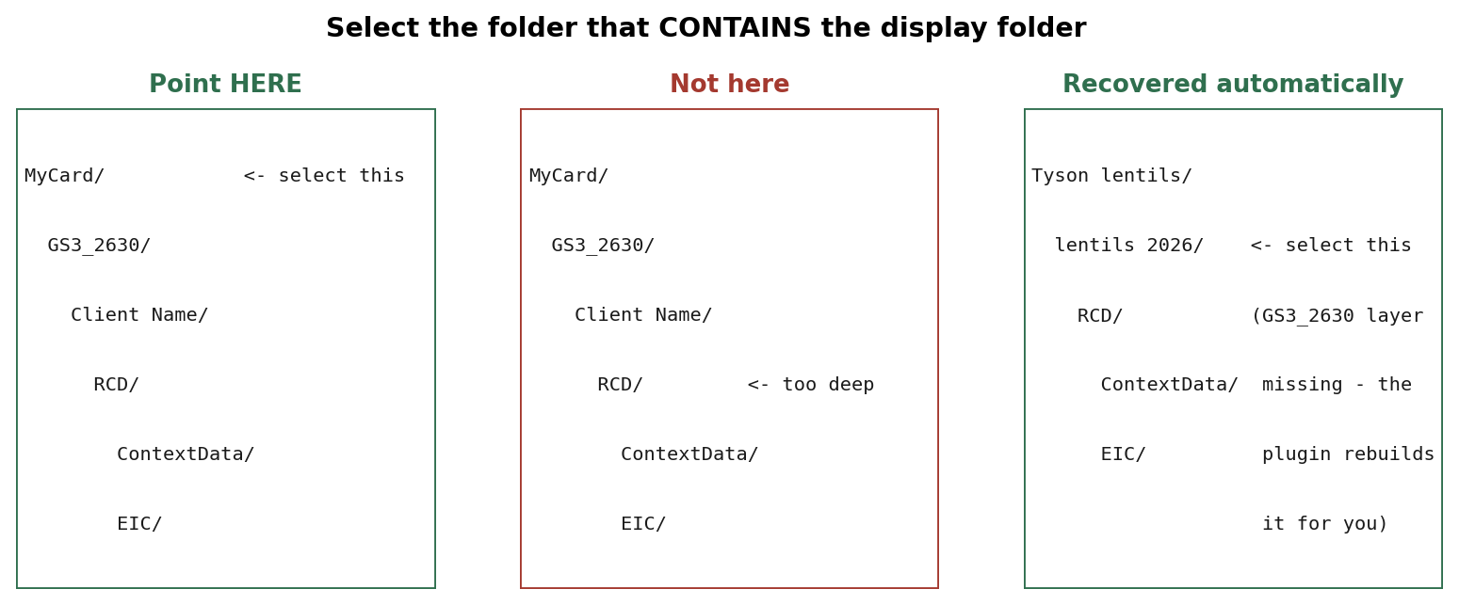
Figure 6. Left: correct. Middle: too deep, nothing will be recognised. Right: a card that lost its display folder in a copy — SMSLIBRE rebuilds it for you.

What to select, by format
If the card contains… | Select…
`GS3_2630\<client>\RCD\ | the folder above GS3_2630
`JD-Data\log\*.jdl | the folder above JD-Data
`TASKDATA\TASKDATA.XML | the TASKDATA folder, or the folder above it
`*.jdp files (Raven) | the Jobs folder holding them
`RCD\ with no display folder above it | the folder holding RCD — SMSLIBRE recovers it
`*.zip files that are cards | the folder holding the zips — they are unpacked for you

When you are not sure
Use Detect format and work upward. Select a folder, press Detect, and if nothing is recognised try its parent. Detection is quick and harmless. The readers search downward from wherever you point them, so being one level too high is usually fine — being too deep is not.
SMS's own Vault is not readable
Ag Leader SMS keeps imported data in an internal Vault in its own format. The vendor ADAPT plugins cannot read that, and neither can SMSLIBRE. Always use the original card or a fresh export from the display.

7. Supported formats
SMSLIBRE has nine readers. Five come from the vendor ADAPT plugin suite that ships with SMS; four were written for this project to handle cards the vendor plugins decline.

What works
Format | Reader | Notes
John Deere Gen4 (4600, 4640) | ProtobufPlugins | Needs the Deere licence. The most common card here; can be very large.
John Deere GS3 / GS4 (2630, 4600) | RCDPlugins | Needs the Deere licence. Reads the RCD folder structure.
ISOXML / ISO 11783 | ISO v4 Plugin | No licence needed. Also the export route for AGCO, New Holland and others.
Raven Viper 4 / Viper 4+ | Raven Viper 4 job (.jdp) | Written for this project. Track, elevation, speed, distance, applied and target rate, sections on, heading, cross-track error.
Raven Slingshot | Raven Slingshot (.jdp.zip) | Written for this project. No licence needed.
Ag Leader / ADM | ADMPlugin | No licence needed.
Cards inside a .zip | Card in an archive | Written for this project. Unpacks and imports, including cards with no unzipped copy anywhere.
Loose Gen4 .jdl logs | John Deere Gen4 logs (.jdl) | Written for this project. For logs copied out of their card folder.
Stranded RCD folders | John Deere RCD folder | Written for this project. For an RCD folder copied without its display folder.
ISOXML prescriptions | (part of the ISOXML path) | Variable-rate plans become polygon zones with product, rate and unit.
Field boundaries | (any reader that finds them) | Become a polygon layer named field_boundaries.

What does not work, and why
Format | Status | What to do
Trimble AgData | Licence refused | The plugin loads but rejects our application id. A licence request is with Trimble. No workaround in the plugin.
New Holland / CNH Voyager2 (.cn1) | Not readable | The card's TASKDATA.XML is a 208-byte empty placeholder; the real data is in CNH's own files, which no ADAPT plugin reads. Export ISOXML from the display instead — that imports perfectly.
Raven native jobs without TASKDATA | Partially readable | Track, speed and rates are read. Some job types store their logs in a form that is not decoded.
Precision Planting | Untested | The plugin is present but no Precision Planting cards exist here to test it against. It claims some drone-imagery folders by mistake — see chapter 10.

Coverage in practice
From the release sweep of the Smart Farm Vault, by reader:
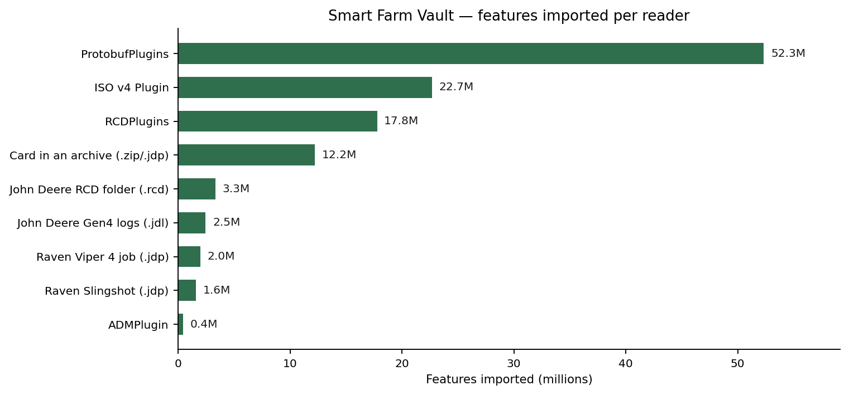
Figure 7. Features imported per reader across the Smart Farm Vault. John Deere formats dominate by volume; the readers written for this project cover the long tail of cards that had been moved, zipped or stripped of their structure.

8. Understanding what you get

One GeoPackage per import
Every import writes a single .gpkg file to Documents\SMSLIBRE, named with the date and time. A GeoPackage is an OGC standard container — it is really a SQLite database — and QGIS, ArcGIS, GDAL and R all read it natively. Each layer from the card is a table inside it.

What a layer looks like
A logged operation layer has this shape:
fid INTEGER row id
geom BLOB the GPS point
timestamp TEXT when the record was logged
elevation REAL \
speed REAL | one column per channel the machine
rate_applied REAL | recorded — anywhere from 3 to 1,500
rate_target REAL /

Channel names come from the machine, so they vary by manufacturer and implement. A combine logs yield and moisture; a sprayer logs applied rate and section states; a seeder logs population and down-force. Everything the card recorded is kept — nothing is summarised away.

Other layer types
Layer | When it appears | What is in it
`field_boundaries | The card defines field boundaries | Polygons with field, farm, grower and description
`prescription_zones | The card is a variable-rate plan | Polygons with task, field, product, rate and unit

A real example
This is an imported Raven sprayer job, coloured by applied rate. The pale green line at the top is the machine driving to the field with the boom off; the block below is the actual spraying pattern; red is where the rate dropped to zero. Nothing here was drawn by hand — it is one layer from one import, styled by the plugin's own default.
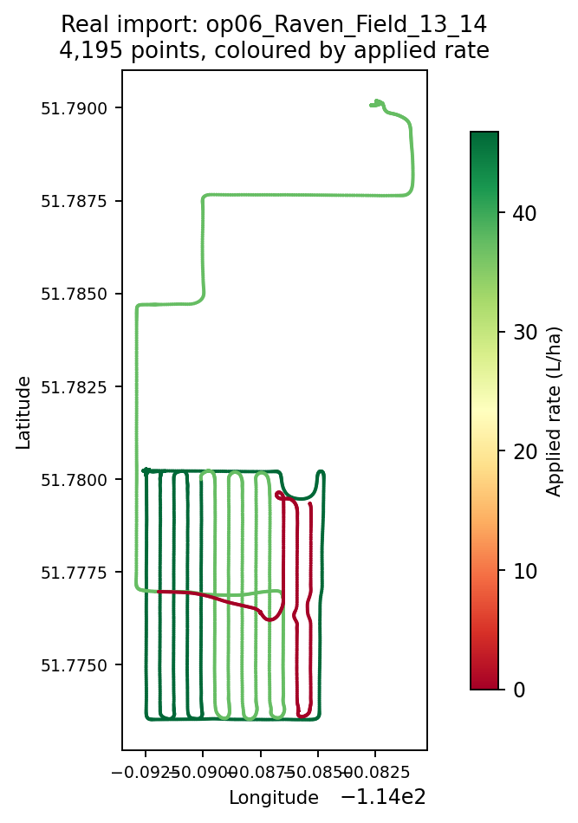
Figure 8. One imported layer: 4,195 points of a real spray job, coloured by applied rate in litres per hectare.

When an import finds nothing
An empty result is not necessarily a failure, and the plugin tells you which it is. A prescription-only card, a setup card with just boundaries, or a Voyager2 card with a placeholder TASKDATA each produce a specific message rather than a bare "nothing found".

9. Working with the data in QGIS

What the automatic styling does
With Apply yield styling ticked, the plugin looks through the layer's numeric fields and picks the most meaningful one, preferring in order: yield volume or mass per area, dry yield, harvest moisture, applied rate, target rate, seed rate, then elevation. Configuration and status fields — offsets, widths, latencies, flags — are never chosen. It then applies a quantile classification with a red-to-green ramp, the convention for yield maps.

Changing what is displayed
The automatic choice is a starting point. To map a different channel: right-click the layer → Properties → Symbology, and change the Value field. The classification stays; only the source column changes.

Filtering out noise
If you left Show only non-zero readings off and the map looks flat, apply a filter instead of re-importing. Right-click the layer → Filter… and use something like:
"Yield_Volume_Per_Area" > 0

-- or a sensible agronomic range, to drop start-of-pass spikes
"Yield_Volume_Per_Area" BETWEEN 1 AND 400

Useful things to do next
- Compare a prescription against what was actually applied by loading prescription_zones under the as-applied layer.
- Map applied rate against yield for the same field to see whether the extra input paid for itself.
- Interpolate a yield surface: Processing → Interpolation → IDW, using the yield field.
- Clip to a boundary with Vector → Geoprocessing Tools → Clip, using field_boundaries.
- Export for a report: right-click the layer → Export → Save Features As…, choosing CSV, shapefile or GeoJSON.
- Join several seasons on a common field to look at year-over-year variation.

Reopening data without re-importing
The GeoPackage keeps everything. Layer → Add Layer → Add Vector Layer, browse to the .gpkg in Documents\SMSLIBRE, and QGIS lists every layer inside it. Re-importing the same card is only necessary if you need it converted again.

10. Troubleshooting

No installed reader recognises this folder
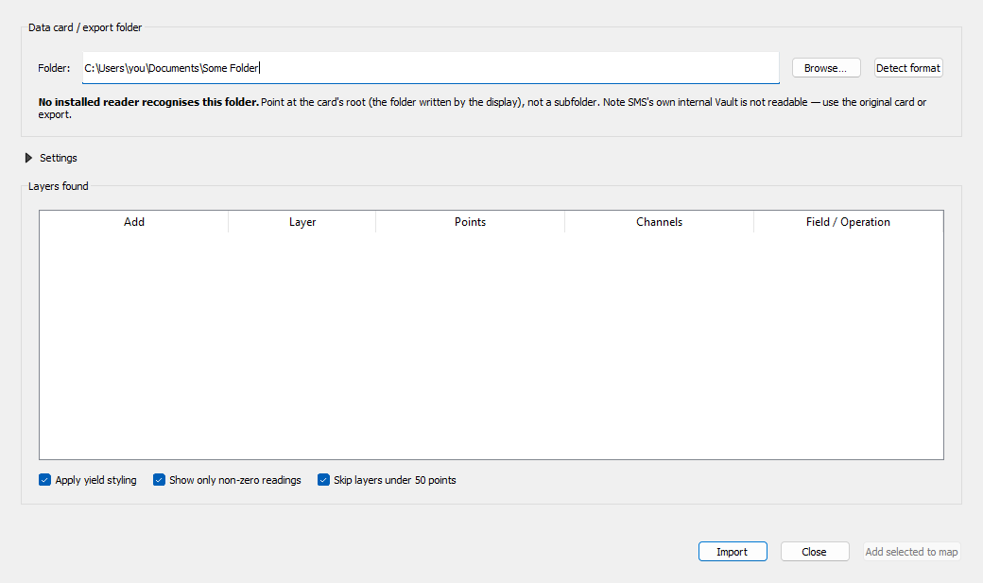
Figure 9. The message shown when detection finds nothing.
In order of likelihood:
- You selected a folder one level too deep. Try the parent — see chapter 6.
- It is an SMS Vault folder rather than a card. Use the original card.
- It is a Voyager2 (.cn1) card. Export ISOXML from the display instead.
- It genuinely holds no machine data — documents, imagery or shapefiles.

Common messages and what they mean
Message | Cause | What to do
Invalid license provided for 'Trimble AgData Plugin' | The Trimble plugin will not accept our application id | Nothing in the plugin fixes this. A licence request is pending.
Plugin.Initialize() must be called using your application id | A John Deere plugin has no licence available | You are on the public build. Use the internal build, or set Vendor plugins and Application id in Settings.
This card's TASKDATA is an empty placeholder written by CNH | A New Holland / Voyager2 card | Expected. Export ISOXML from the display.
No logged work here: N of M archive(s) hold a prescription | The folder holds rate plans, not recorded work | Expected. The prescription_zones layer has the plans in it.
Sidecar not found | The plugin folder is incomplete | Reinstall with QGIS closed and no SmsImport.exe running.
Sidecar produced no output | The sidecar was killed, usually by a reinstall during an import | Close QGIS, check for a stray SmsImport.exe, reinstall, try again.
Import timed out after 3600s | A very large card on a slow network drive | Copy the card to a local disk and import from there.

The import succeeded but the map looks wrong
Symptom | Explanation
Everything is one colour | The styled channel is constant, or zeros dominate. Tick Show only non-zero readings, or pick a different field in Symbology.
Points are scattered across the world | This should no longer happen — corrupt GPS fixes are rejected on import. If you see it, report it: it means a new failure mode.
A layer has far fewer channels than expected | A GeoPackage table cannot exceed 1,999 columns. On extremely wide cards the channels with the most readings are kept and the rest dropped; the status line says how many.
Layers named op01, op02, … | The card recorded no field or operation name. The numbering keeps them distinct and in order.

Precision Planting errors on drone imagery
The Precision Planting ADAPT plugin claims any folder whose name ends in SET — which matches MicaSense drone capture folders such as SYNC0001SET — and then fails with a null reference error. This is the vendor plugin misbehaving, not your data. Ignore it, or move drone imagery out of folders you sweep.

11. Using the sidecar from the command line
The sidecar is a normal console program. It is useful for scripting, for batch conversions, and for diagnosing a card without opening QGIS. It prints a single JSON object on stdout; progress goes to stderr.

The four commands
smsimport plugins --sms <smsInstallDir>
smsimport detect <cardPath> --sms <smsInstallDir>
smsimport scan <root> --sms <smsInstallDir> [--depth N] [--max N] [--min-depth N]
smsimport import <cardPath> <out.gpkg> --sms <smsInstallDir> [--plugin <name>]

Command | What it does
`plugins | Lists every reader available, and why any failed to initialise. The first thing to run when John Deere formats are not detected.
`detect | Reports which readers claim a folder. Imports nothing.
`scan | Walks a folder tree and reports every card it finds. Use --min-depth 2 on a large share: readers search recursively, so asking about the top of a drive means walking the whole thing.
`import | Converts a card to a GeoPackage.

Examples
The executable lives inside the installed plugin:
cd "%APPDATA%\QGIS\QGIS3\profiles\default\python\plugins\smslibre_import\bin"

:: what readers do I have, and did any fail to load?
SmsImport.exe plugins

:: what is this folder?
SmsImport.exe detect "D:\Card\MyField"

:: convert it
SmsImport.exe import "D:\Card\MyField" "%USERPROFILE%\Documents\myfield.gpkg"

:: find every card on a drive
SmsImport.exe scan "G:\Shared drives\My Drive" --depth 12 --min-depth 2

Reading the output
Every command returns JSON with an ok field. On success an import also reports the layers written, and anything it had to discard — rejectedPoints for implausible GPS fixes, droppedChannels where a layer exceeded the column limit. Those numbers are worth checking on an unfamiliar card.

12. Testing a whole drive
tools/vault_test.py takes every directory under a root through the full pipeline — discover, import, open the GeoPackage, validate every coordinate — and writes both a machine-readable result file and a markdown coverage report. This is how the release numbers in chapter 1 were produced.
python tools/vault_test.py \
--root "G:/Shared drives/Olds College Smart Farm Vault" \
--out analysis/vault \
--depth 14 --cap 200000 --workers 5 --min-depth 2 \
--timeout 7200 --scan-timeout 21600

Option | Why you would use it
`--min-depth 2 | Do not interrogate the top levels of a big share. Essential: without it a vault-wide scan can take hours before it starts.
`--reuse-scan | Skip the discovery walk and reuse the last one. Use after changing import code, since discovery's answer has not changed.
`--only-detected | Re-import just the folders a reader already claimed.
`--resume | Continue a run that was interrupted. Results are checkpointed every ten cards.
`--workers N | Parallel imports. Five is a reasonable ceiling on a network share.

Two files are produced: results.json, which the regression test suite reads as its corpus, and COVERAGE.md — a report of what imported, what did not, and why, with unclaimed folders characterised by the file types they hold so a format gap is distinguishable from a folder of PDFs.
Budget the time
A full sweep of both Smart Farm drives takes about five and a half hours and needs the network drive mounted throughout. Run it overnight.

13. Building from source

What you need
- .NET 10 SDK
- Python 3.9 or newer
- Ag Leader SMS installed, for the vendor ADAPT plugins
- For the internal build: the secrets/ folder and vendor/jd-plugins/, which are not in source control

Building
git clone https://github.com/Dozer3530/SMSLIBRE.git
cd SMSLIBRE

:: public build — no licensed material
python qgis_plugin/build_plugin.py --runtime win-x64

:: internal build, and install it into QGIS in one step
python qgis_plugin/build_plugin.py --runtime win-x64 --internal --install

Zips are written to build/. Close QGIS before using --install.

Running the tests
dotnet test sidecar/tests/SmsLibre.Import.Tests -c Release

:: skip the tests that need the shared drive
dotnet test sidecar/tests/SmsLibre.Import.Tests -c Release --filter "Category!=Corpus"

67 tests, none skipped when the shared drive is available. They cover the coordinate rule, the column limit, every reader's claim logic, and a corpus suite that re-imports a real card for each reader from the last sweep's results. If the corpus tests skip, the drive is not mounted.
Rebuild the zip after any C# change
The sidecar is a compiled binary inside the plugin folder. Editing the C# source and reloading the QGIS plugin changes nothing until you rebuild and reinstall.

14. Licensing and distribution
Read this before sharing anything
Olds College holds a John Deere SDK Licence for Display Plugins for ADAPT. It permits internal use and prohibits redistribution.

The rules
You may | You may not
Use the internal build on Olds College machines | Send the internal build to anyone outside the organisation
Share the public build freely | Attach the internal build to a GitHub release, even a private one
Share imported GeoPackages — your data is yours | Publish the licensed plugin binaries or the licence key
Build the internal zip yourself from the repo | Reverse-engineer the licensed John Deere components

How the build enforces it
The packager strips licensed material from the public zip even if it is present in the working folder, and prints a warning when it produces an internal build. The secrets and vendor plugin folders are excluded from git. These are safety nets, not permission — the responsibility is yours.

15. Quick reference

Paths
What | Path
Plugin folder | `%APPDATA%\QGIS\QGIS3\profiles\default\python\plugins\smslibre_import
Sidecar | `...\smslibre_import\bin\SmsImport.exe
Imported data | `%USERPROFILE%\Documents\SMSLIBRE\
SMS install | `C:\Program Files\Ag Leader Technology\SMS
Repository | `https://github.com/Dozer3530/SMSLIBRE

Glossary
Term | Meaning
ADAPT | AgGateway's open framework for agricultural data. Manufacturers publish plugins for it; SMS ships a set of them.
Card | The folder a display writes to a USB stick, and by extension any copy of it.
Channel | One sensor value logged per record — yield, moisture, rate, speed. Becomes an attribute column.
DDI | Data Dictionary Identifier. The ISO 11783 code identifying what a channel measures.
GeoPackage | An OGC standard file format for spatial data. One file, many layers.
ISOXML | The ISO 11783 exchange format. Vendor-neutral, and the best route for machines whose native format is not supported.
Prescription | A planned application rate map, made before the work is done.
Sidecar | The separate console program that runs the readers.
TASKDATA | The root XML file of an ISOXML card.

Getting help
Report problems at https://github.com/Dozer3530/SMSLIBRE/issues. A useful report includes: what folder you selected, what Detect format said, the exact message you saw, and — most usefully — the output of running SmsImport.exe detect on the same folder from the command line.

