AWS and Azure Cloud Pricing Comparison Report
Small Web Application Hosting Cost Evaluation

1. Introduction
This report compares the estimated monthly cost of hosting a small web application on Amazon Web Services (AWS) and Microsoft Azure. The comparison covers compute, storage, networking costs, cloud discount mechanisms, and cost optimization strategies.

2. Application Specifications
Component | Specification
Application type | Small web application
Compute | 1 virtual machine
CPU | 2 vCPU
Memory | 4 GB RAM
VM storage | 50 GB
Object storage | 100 GB
Monthly data transfer | 100 GB outbound
Deployment | Single availability zone

3. AWS Monthly Cost Estimate
The AWS Pricing Calculator estimate includes Amazon EC2 for compute and Amazon S3 Standard for object storage.
AWS Service | Description | Monthly Cost
Amazon EC2 | Linux t3.medium compute estimate | $15.04
Amazon S3 | 100 GB S3 Standard storage estimate | $2.30
Total | AWS estimated monthly cost | $17.34
Figure 1: AWS EC2 estimate
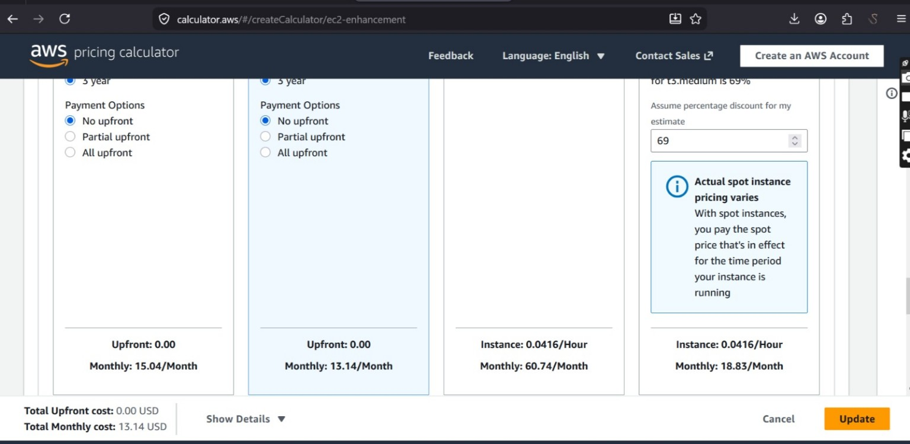
Figure 2: AWS S3 storage estimate
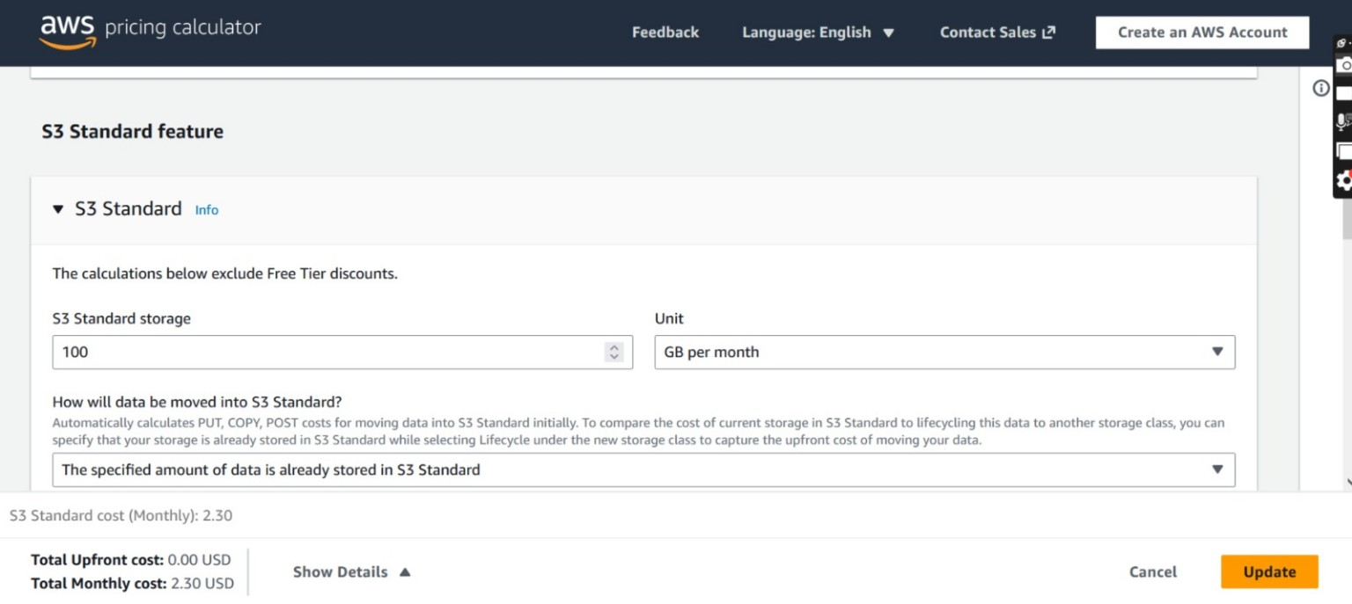
Figure 3: AWS total estimate
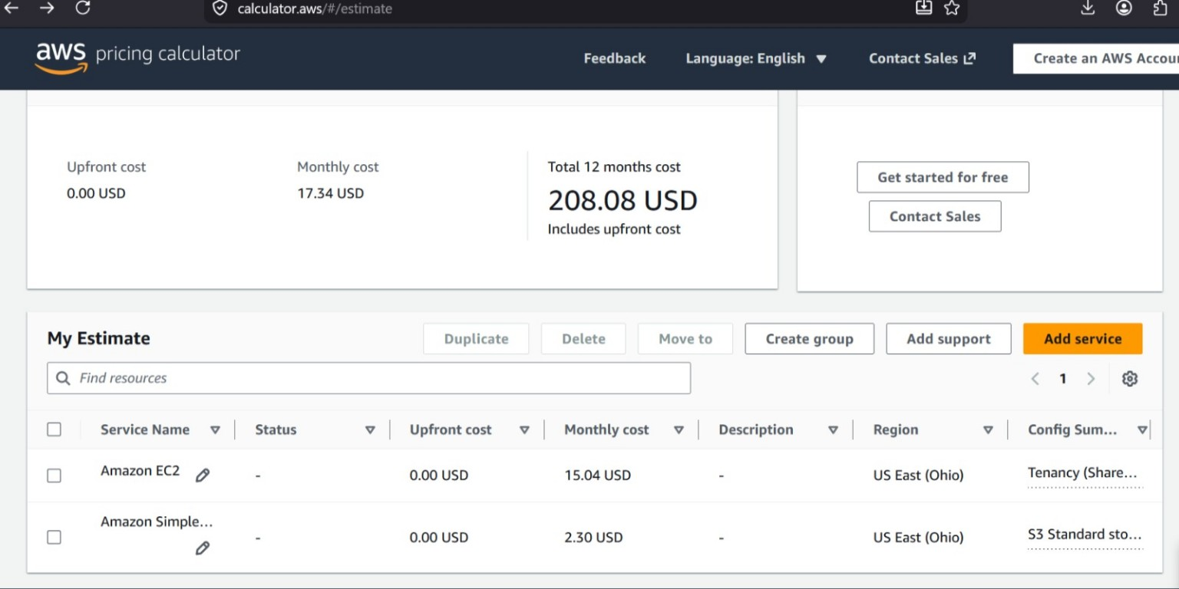

4. Azure Monthly Cost Estimate
The Azure Pricing Calculator estimate includes Azure Virtual Machines and Azure Blob Storage. Both Linux and Windows scenarios were considered.
Azure Scenario | Description | Monthly Cost
Linux VM + Storage | B2ls v2, 2 vCPU, 4 GB RAM, 100 GB storage | $42.76
Windows VM + Storage | B2ls v2, Windows license included, 100 GB storage | $49.48
Figure 4: Azure Linux estimate
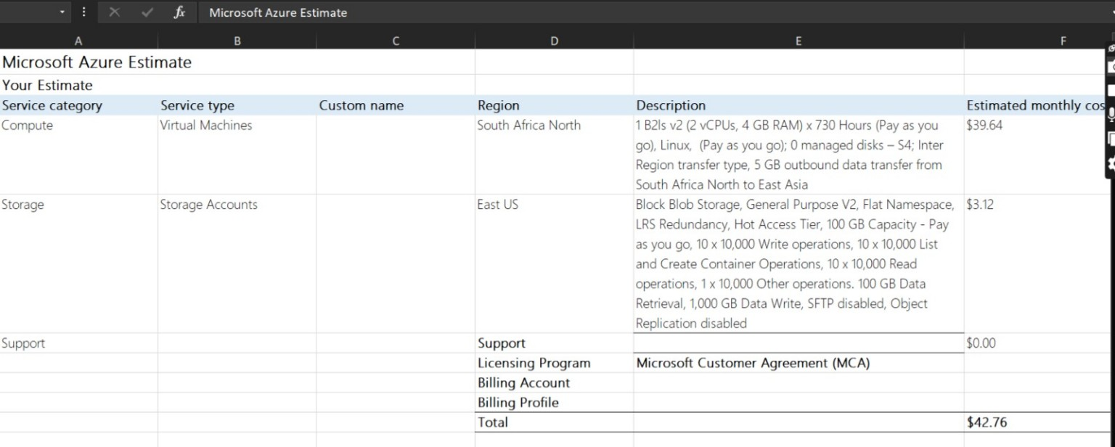
Figure 5: Azure Windows estimate
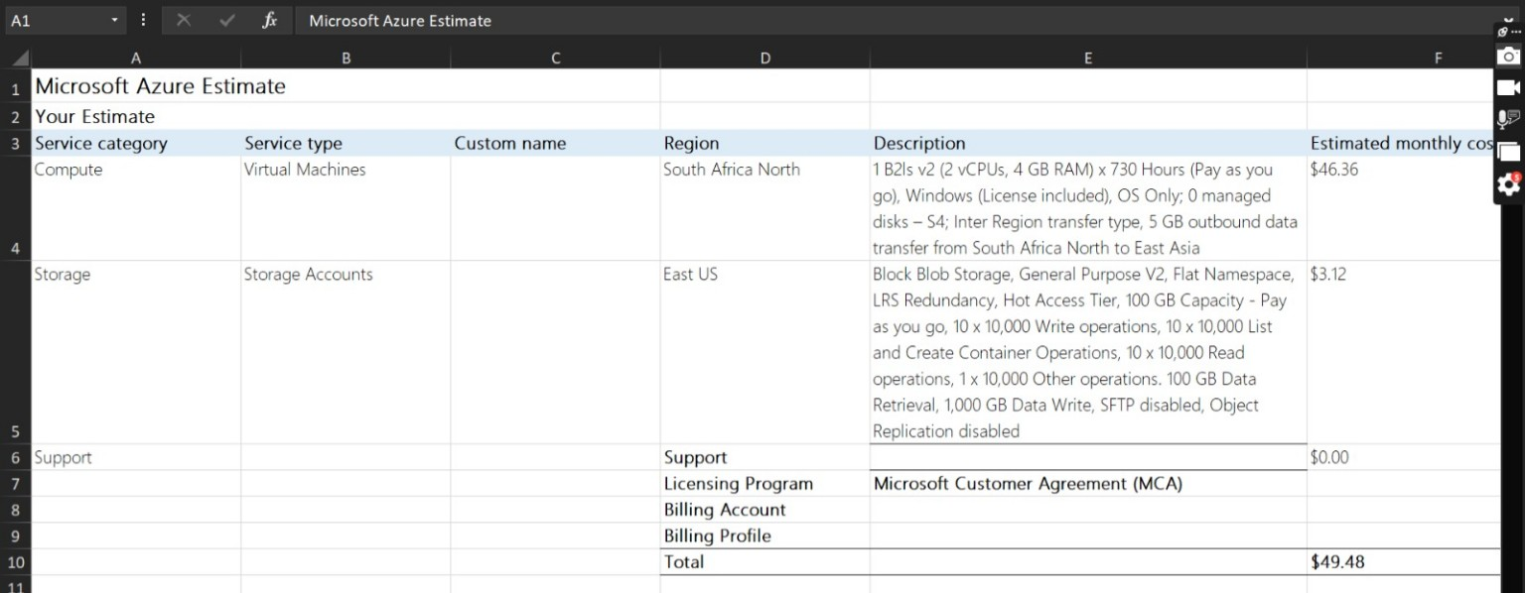

5. Networking Cost Comparison
Both AWS and Azure charge for inter-zone data transfer. AWS shows approximately $0.01 per GB in each direction across Availability Zones, while Azure shows approximately $0.01 per GB for inter-zone data transfer. Since this deployment uses a single availability zone, inter-zone transfer costs are expected to be minimal.
Figure 6: AWS inter-zone transfer note
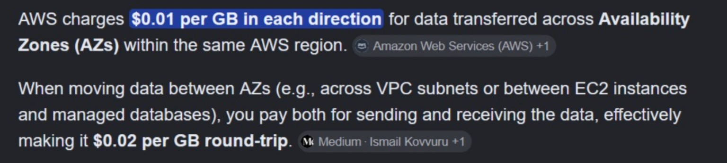
Figure 7: Azure inter-zone transfer note
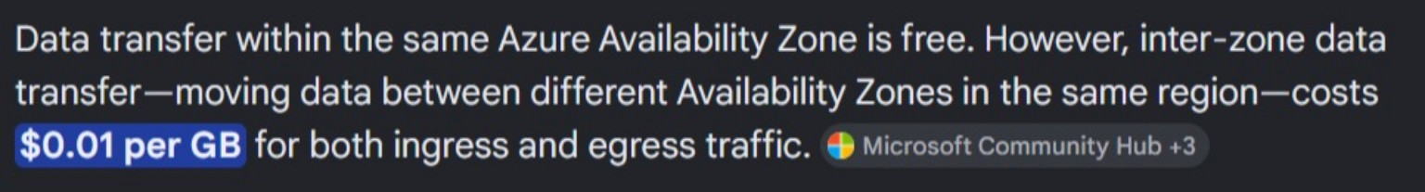

6. Discount Mechanisms
AWS provides Savings Plans that reduce compute costs when users commit to consistent usage for one or three years. Azure provides Reserved Virtual Machine Instances and Azure Hybrid Benefit, which can reduce VM costs, especially for Windows workloads when eligible Microsoft licenses are available.
Figure 8: AWS Savings Plan options
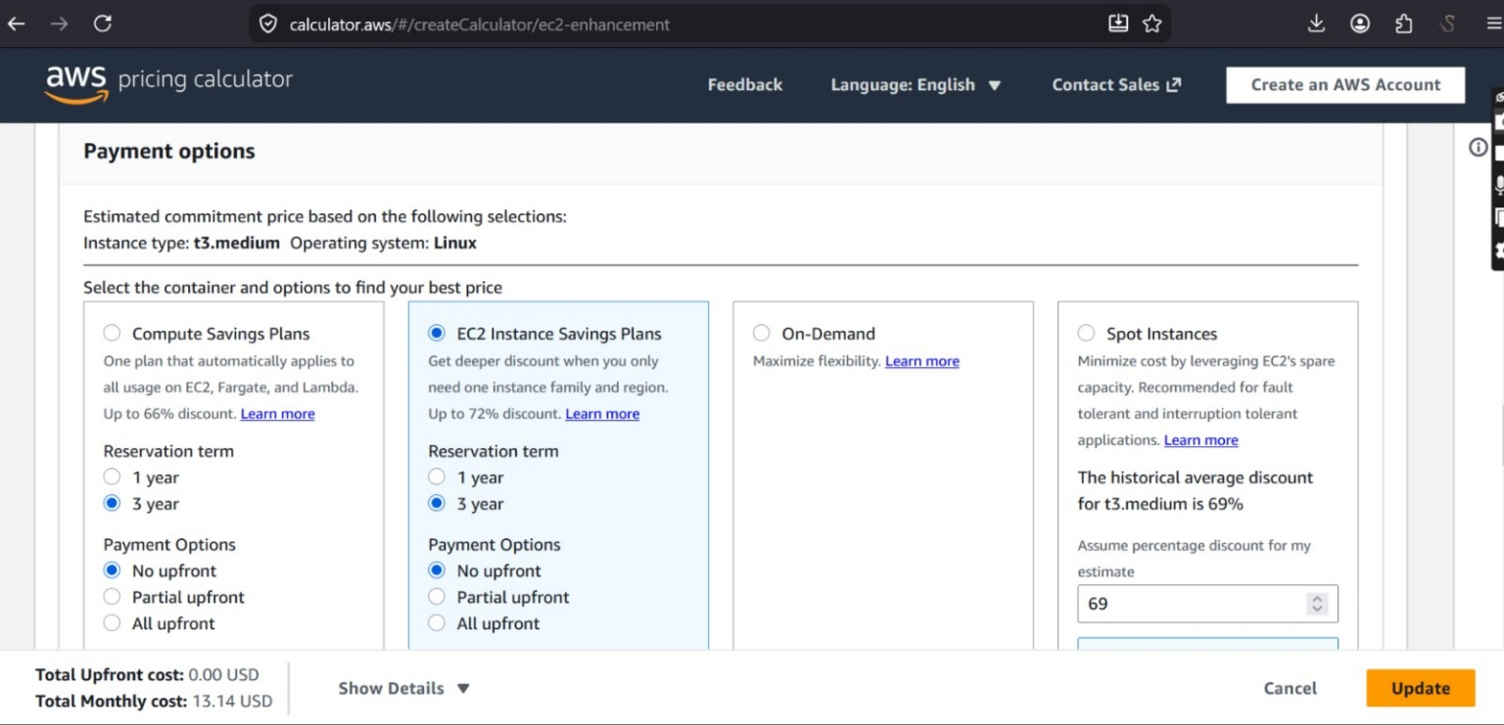

7. Final Cost Comparison
Provider | Scenario | Estimated Monthly Cost | Observation
AWS | Linux EC2 + S3 | $17.34 | Lowest estimated monthly cost
Azure | Linux VM + Storage | $42.76 | Higher than AWS for this scenario
Azure | Windows VM + Storage | $49.48 | Highest cost due to Windows licensing

8. Recommendation
AWS is the most cost-effective option for this small Linux-based web application based on the estimates provided. Azure may be more suitable for organizations already using Microsoft technologies or where Windows licensing benefits can be applied.

9. Cost Optimization Strategies
1. Use AWS Savings Plans or Azure Reserved Virtual Machine Instances for predictable long-term workloads.
2. Right-size virtual machines and keep services within one availability zone where possible to reduce unnecessary compute and networking costs.

10. Conclusion
This comparison shows that both AWS and Azure can host a small web application, but AWS provides the lowest monthly estimate in this specific scenario. The final provider choice should consider cost, existing licenses, technical requirements, and long-term cloud strategy.

