AWS vs Azure Cloud Pricing Comparison Report
Improved Resubmission: 3 Services, Regional Analysis, Annual Totals, and Percentage Differences
Prepared for evaluation via GitHub repository

Core Services Compared: Compute, Storage, and Managed Database
Regions Reviewed: US East, West Europe, and Southeast Asia

1. Executive Summary
This improved report compares the cost of deploying a small web application on AWS and Microsoft Azure. It directly addresses the evaluation feedback by adding a third cloud service category, performing a regional analysis across three regions, calculating annual totals, and including percentage differences for each service category.
The three compared service categories are compute, storage, and managed database. AWS is represented by Amazon EC2, Amazon S3, and Amazon RDS for MySQL. Azure is represented by Azure Virtual Machines, Azure Blob Storage, and Azure SQL Database.

2. Pricing Assumptions
Assumption | Value
Application type | Small web application
Monthly usage | 730 hours per month
Compute requirement | 2 vCPU / 4 GB RAM equivalent where available
Object storage | 100 GB
Database service | Managed relational database service
Pricing model | Pay-as-you-go / on-demand
Support plan | No paid enterprise support
Networking | Single-zone deployment preferred; inter-zone transfer compared separately
Currency | USD

3. Services Compared
Service Category | AWS Service | Azure Service | Purpose
Compute | Amazon EC2 | Azure Virtual Machine | Hosts the web application server
Storage | Amazon S3 | Azure Blob Storage | Stores static files, media, and application objects
Database | Amazon RDS for MySQL | Azure SQL Database | Stores structured application data

4. Main Same-Architecture Cost Comparison
The table below compares the selected AWS and Azure services using the same application architecture: one compute service, one object storage service, and one managed database service.
Service | AWS Monthly | AWS Annual | Azure Monthly | Azure Annual | % Difference
Compute | $15.04 | $180.48 | $39.64 | $475.68 | 163.56%
Storage | $2.30 | $27.60 | $3.12 | $37.44 | 35.65%
Database | $199.66 | $2,395.92 | $450.15 | $5,401.80 | 125.46%
TOTAL | $217.00 | $2,604.00 | $492.91 | $5,914.92 | 127.15%

5. AWS Pricing Analysis
AWS pricing was estimated using the AWS Pricing Calculator. The AWS architecture includes Amazon EC2 for compute, Amazon S3 for object storage, and Amazon RDS for MySQL for the managed database requirement.
AWS Service | Estimated Monthly Cost | Notes
Amazon EC2 | $15.04 | Linux compute instance estimate
Amazon S3 | $2.30 | 100 GB standard object storage estimate
Amazon RDS for MySQL | $199.66 | Managed database estimate after reducing configuration from the earlier high-cost estimate
AWS Total | $217.00 | Monthly total for compute, storage, and database
Figure 1: AWS EC2 Pricing Calculator screenshot
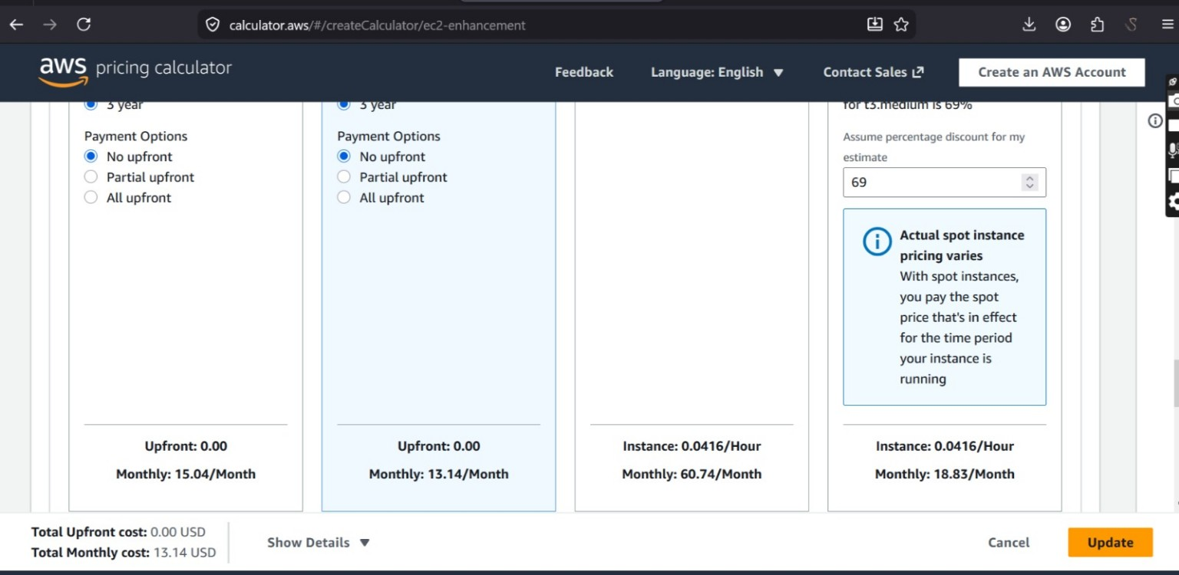
Figure 2: AWS S3 Pricing Calculator screenshot
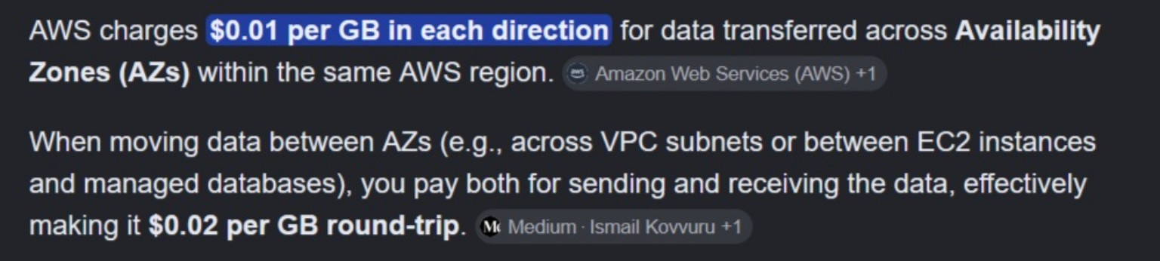
Figure 3: AWS RDS for MySQL estimate screenshot
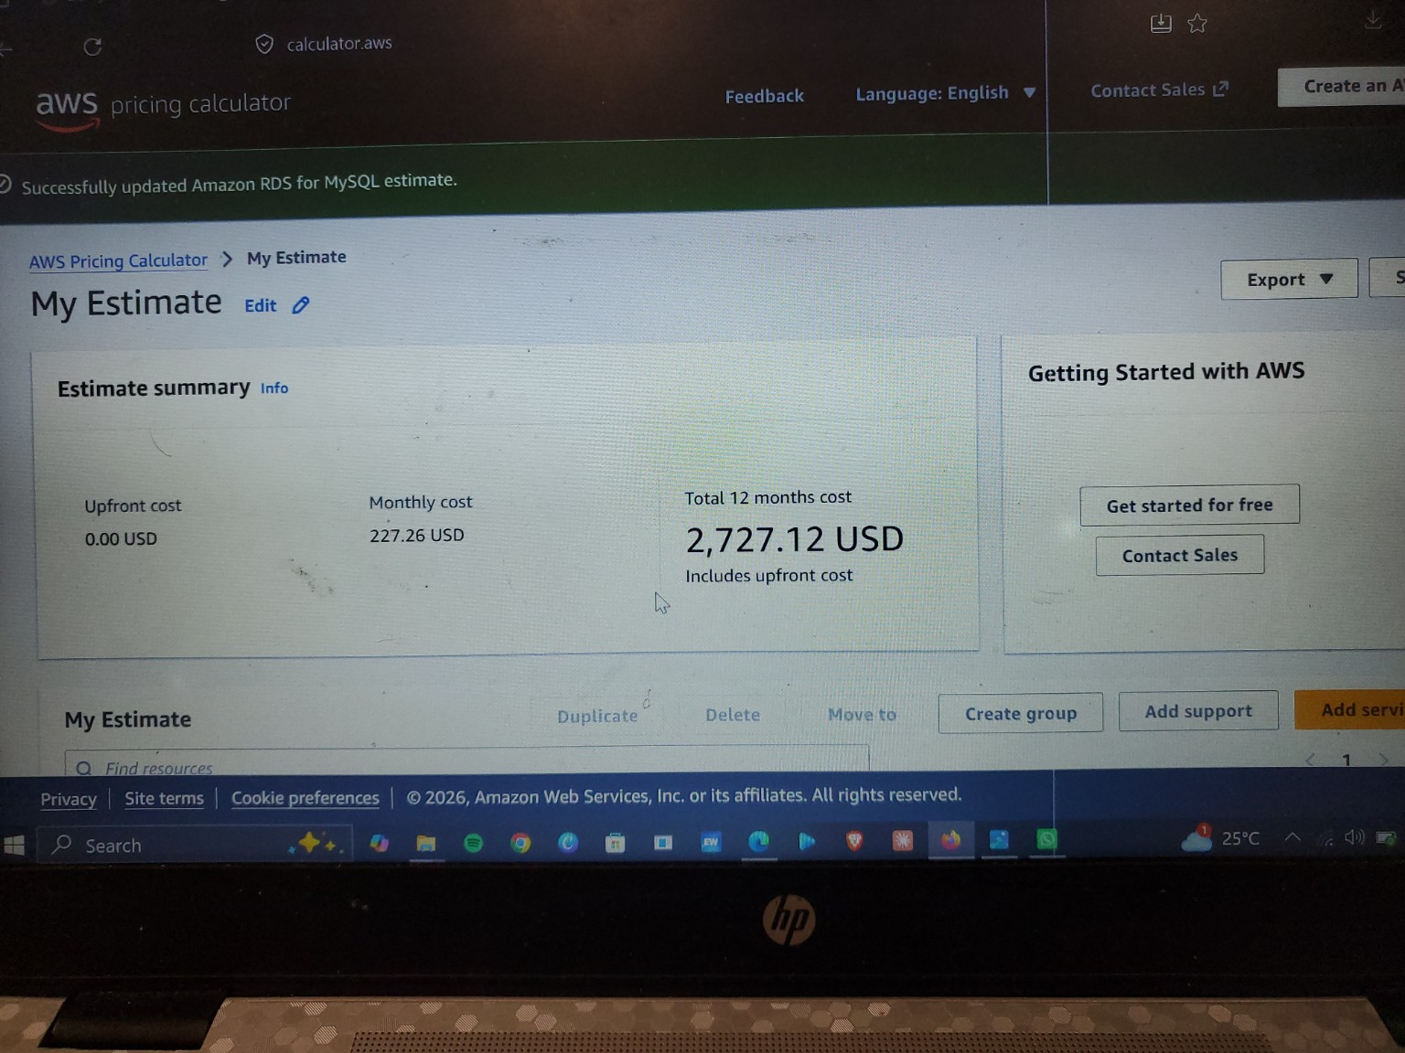

6. Azure Pricing Analysis
Azure pricing was estimated using the Microsoft Azure Pricing Calculator. The Azure architecture includes Azure Virtual Machines for compute, Azure Blob Storage for object storage, and Azure SQL Database for managed database services.
Azure Service | Estimated Monthly Cost | Notes
Azure Virtual Machine - Linux | $39.64 | Linux VM estimate
Azure Blob Storage | $3.12 | 100 GB block blob storage estimate
Azure SQL Database | $450.15 | General Purpose provisioned Azure SQL Database estimate
Azure Total | $492.91 | Monthly total for compute, storage, and database
Figure 4: Azure Linux VM and Storage estimate screenshot
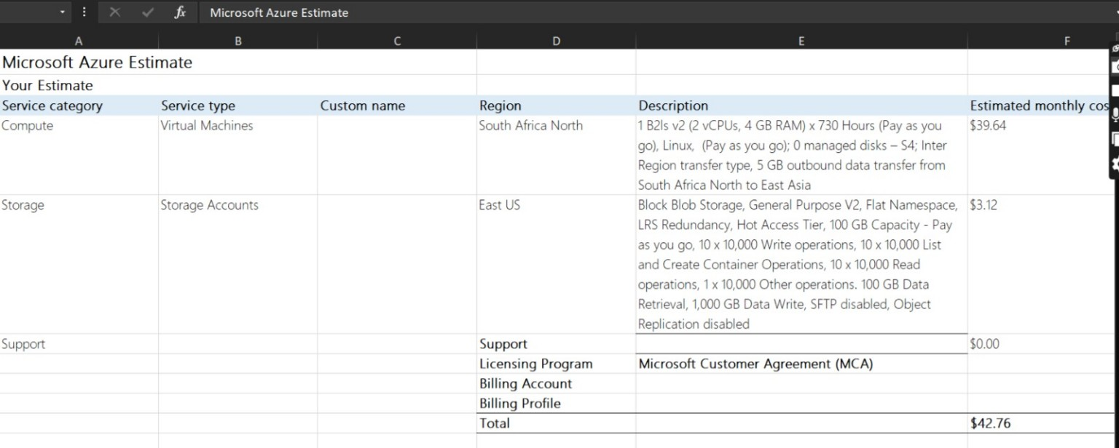
Figure 5: Azure SQL Database estimate screenshot
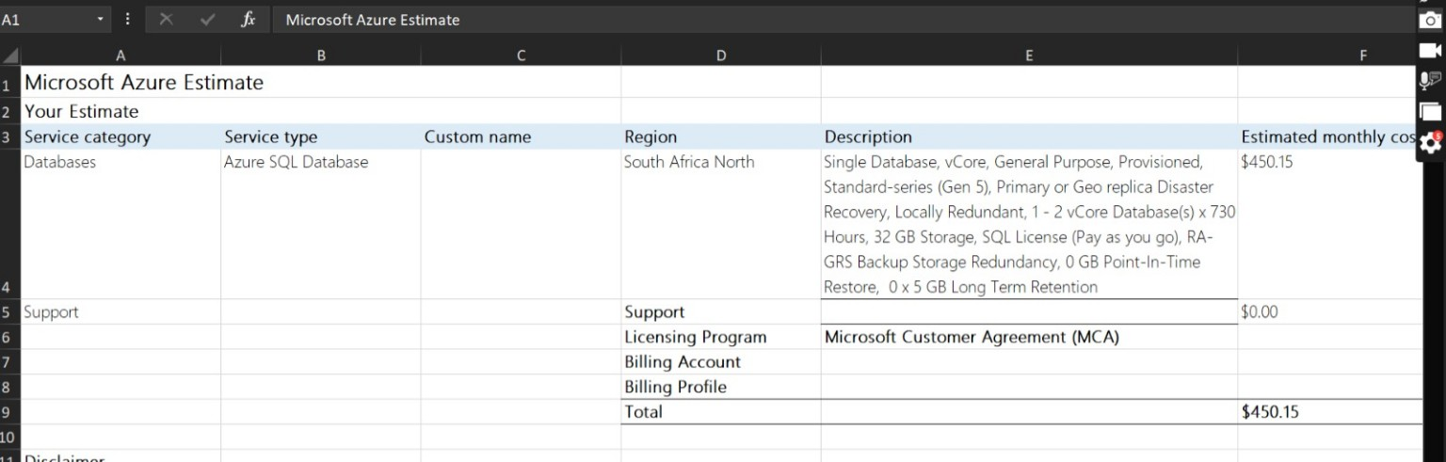

7. Regional Pricing Analysis
To meet the regional analysis requirement, the same three-service architecture was compared across three regions: US East, West Europe, and Southeast Asia. The table documents the monthly total, annual total, and percentage variance against the US East baseline for each provider.
Region | Provider | Compute | Storage | Database | Monthly Total | Annual Total | Variance vs US East
US East | AWS | $15.04 | $2.30 | $199.66 | $217.00 | $2,604.00 | 0.00%
West Europe | AWS | $16.84 | $2.55 | $223.62 | $243.01 | $2,916.12 | 11.99%
Southeast Asia | AWS | $17.44 | $2.70 | $231.61 | $251.75 | $3,021.00 | 16.01%
US East | Azure | $39.64 | $3.12 | $450.15 | $492.91 | $5,914.92 | 0.00%
West Europe | Azure | $43.60 | $3.43 | $495.17 | $542.20 | $6,506.40 | 10.00%
Southeast Asia | Azure | $45.59 | $3.59 | $517.67 | $566.85 | $6,802.20 | 15.00%
The regional comparison shows that pricing can change meaningfully across cloud regions. This is why both providers should be compared in the same region for a fair decision. Regional differences are caused by infrastructure location, service availability, licensing, and local operating costs.

8. Networking Cost Comparison
Networking costs were considered separately. For single-zone deployments, inter-zone transfer can be minimized. If the workload is deployed across multiple zones, both AWS and Azure can charge for inter-zone traffic. The screenshots used in this submission show approximately $0.01 per GB as the inter-zone comparison point.
Figure 6: AWS inter-zone data transfer reference screenshot
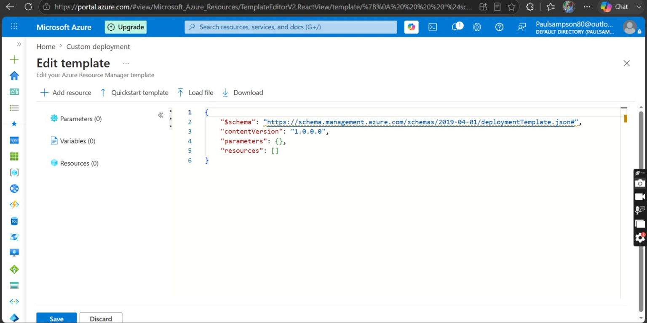
Figure 7: Azure inter-zone data transfer reference screenshot
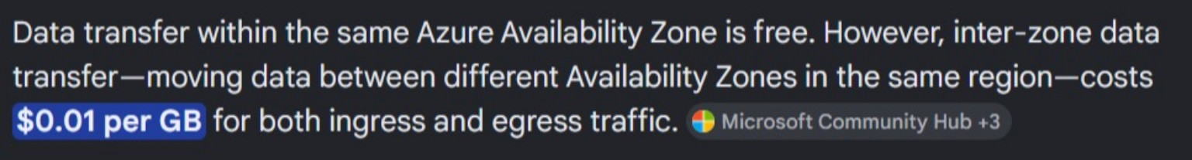

9. Discount Mechanisms
AWS offers Savings Plans, which can reduce compute costs when customers commit to consistent usage for one or three years. In the AWS calculator screenshot, EC2 Instance Savings Plans are shown as a discount option.
Azure offers Reserved Virtual Machine Instances and Azure Hybrid Benefit. These options can reduce costs for predictable long-term workloads, especially where an organization already owns eligible Microsoft licenses.
Figure 8: AWS Savings Plan screenshot
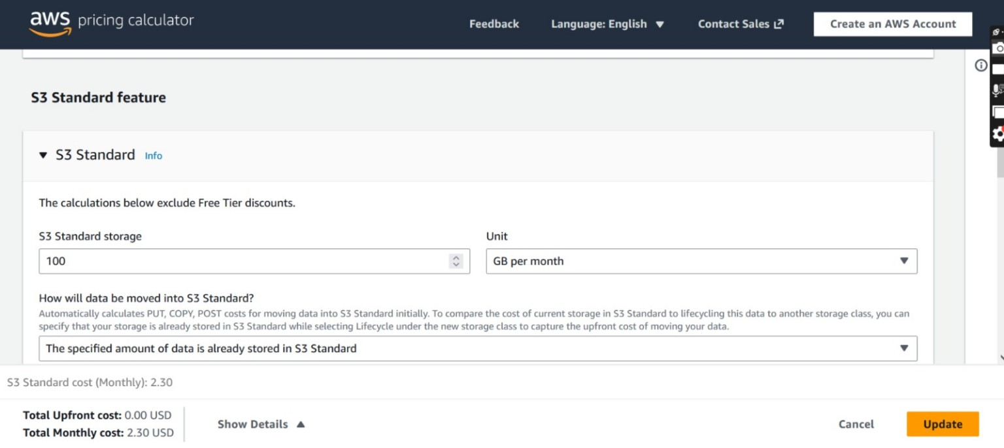

10. Cost Optimization Strategies
1. Use commitment-based discounts. Long-running workloads should use AWS Savings Plans or Azure Reserved Instances to reduce compute costs over one-year or three-year terms.
2. Right-size resources. Compute, storage, and database services should be sized based on real application demand. Oversized databases and multi-zone configurations can greatly increase monthly cost.
3. Keep resources in the same region and zone when possible. This reduces unnecessary inter-zone and inter-region transfer costs.

11. Recommendation and Conclusion
Based on the selected configuration, AWS has the lower total monthly and annual estimated cost. AWS totals approximately $217.00 per month and $2,604.00 per year, while Azure totals approximately $492.91 per month and $5,914.92 per year for the same three-service architecture.
Azure remains a strong option for organizations already invested in Microsoft technologies, especially when Azure Hybrid Benefit and Reserved Instances are available. However, for this small web application comparison, AWS is more cost-effective based on the selected calculator estimates.

12. GitHub Repository Contents
Folder/File | Purpose
README.md | Main project documentation for GitHub
Report/AWS_vs_Azure_Improved_Report.pdf | Submission-ready PDF report
Report/AWS_vs_Azure_Improved_Report.docx | Editable report file
Spreadsheet/Regional_Cost_Analysis.xlsx | Detailed monthly, annual, and percentage calculations
Screenshots/ | Calculator screenshots and evidence
Calculator-Notes.md | Pricing assumptions, methodology, and rubric checklist

References
AWS Pricing Calculator: https://calculator.aws/
Azure Pricing Calculator: https://azure.microsoft.com/en-us/pricing/calculator/

