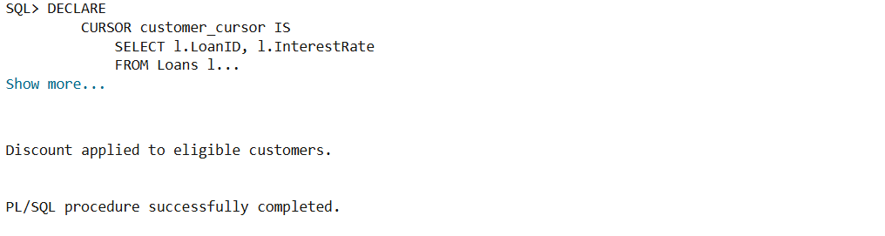

Output when the Scenario 1 code was run

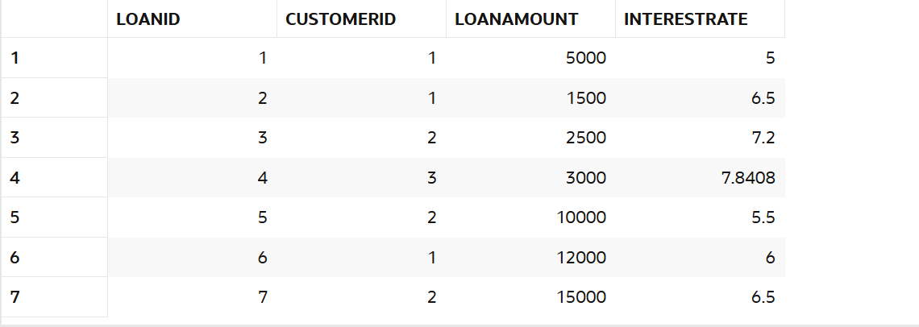

Output with the reduced interest rates as required

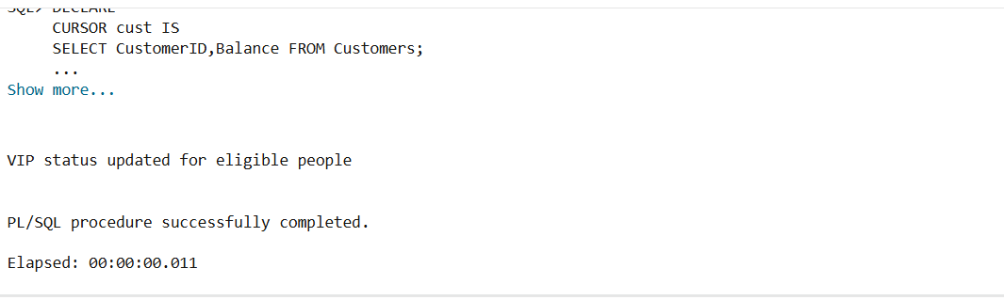

Output when Scenario 2 code was run

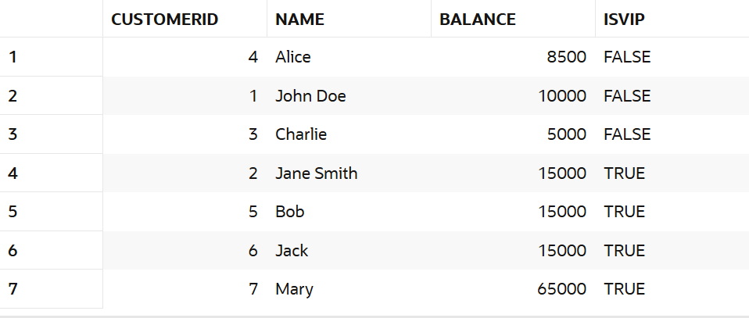

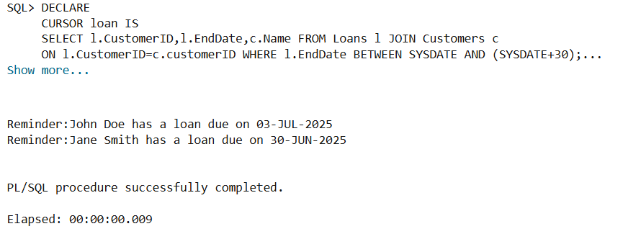Output when Scenario 2 test code was run with the IsVIP attribute as required

Output when Scenario 3 code was run