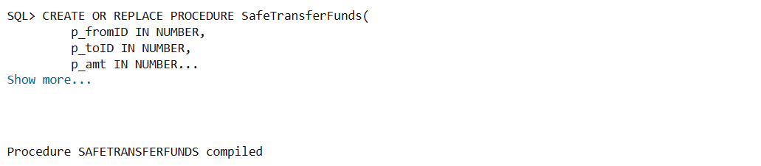

Output when Scenario 1 code was run

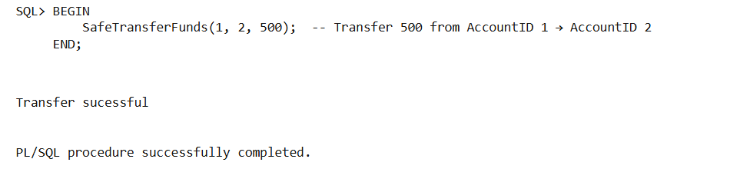

Output when test code was run for valid input parameters

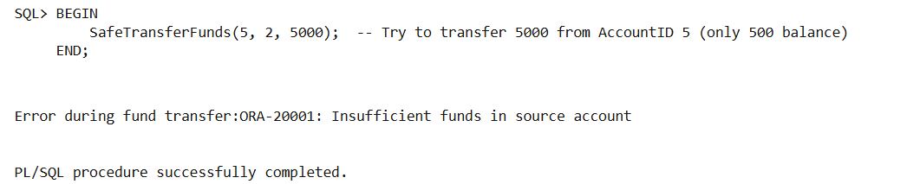

Output when Test code was run for invalid parameters

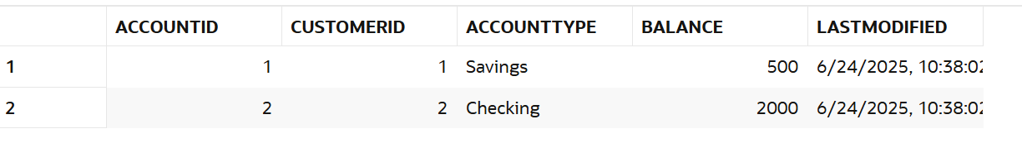

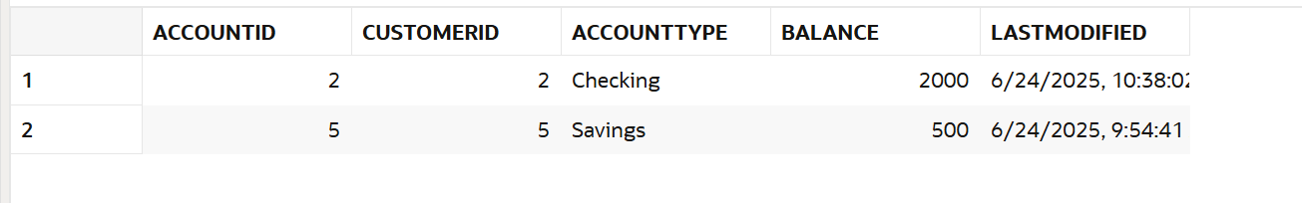

Final results

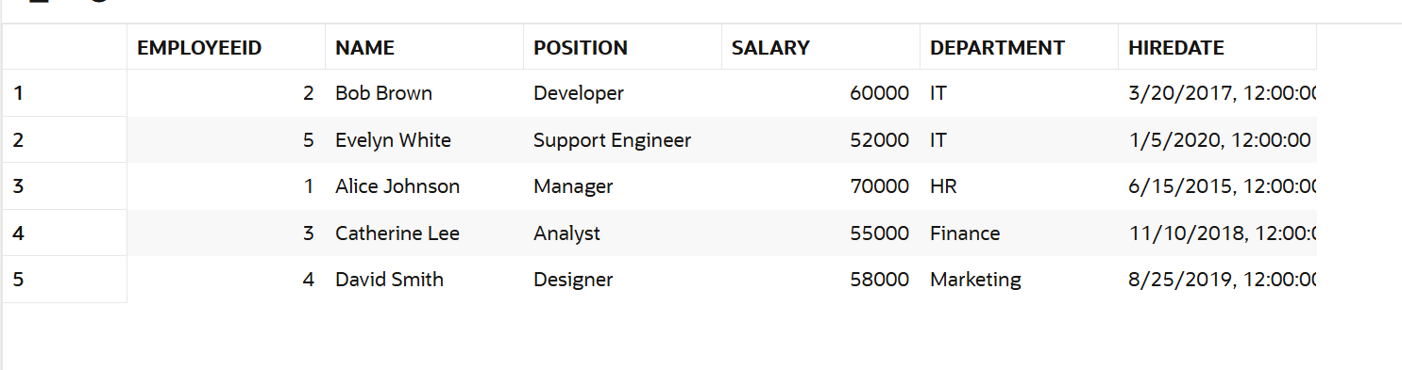

Table showing the salary of Employees

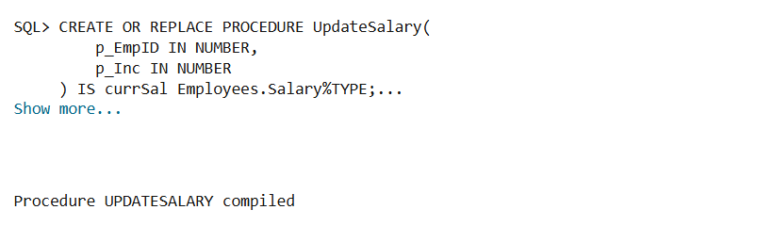

Output of the Scenario 2 code when run

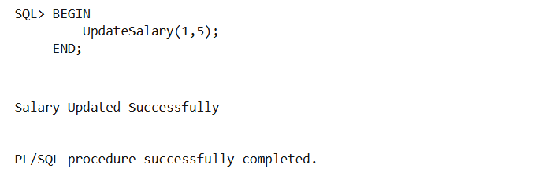

Output of Test code with valid input parameters

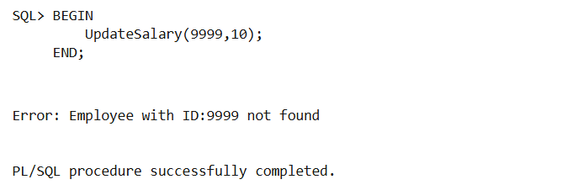

Output of test code with invalid input parameters

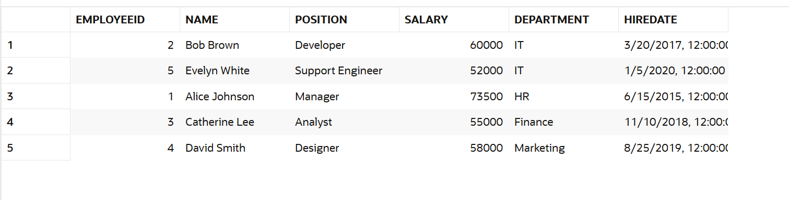

Final result table of Employees after running the test codes

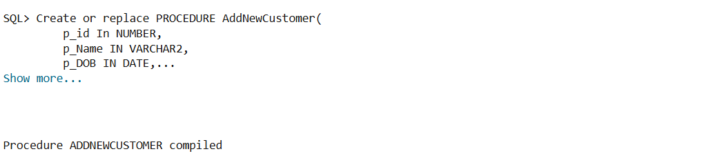

Output of Scenario 3 code when run

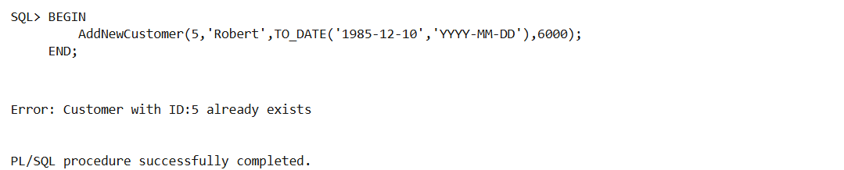

Output of test code with invalid input parameters

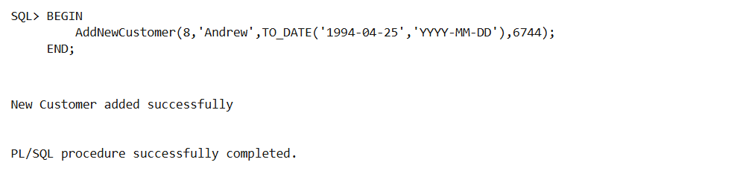

Output of test code with valid input parameters