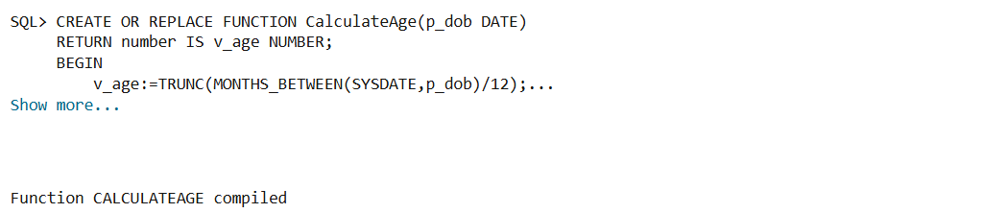

Output when Scenario 1 code is run

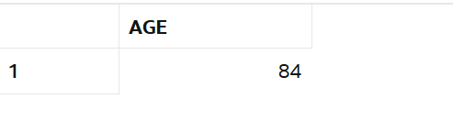

Output of the function call

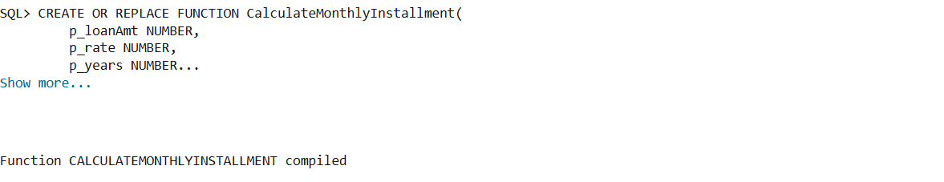

Output when Scenario 2 code is run

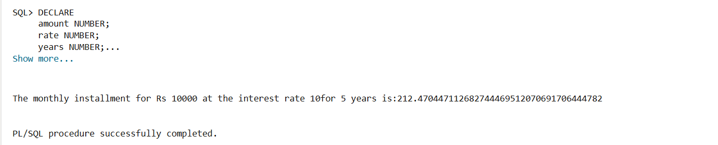

Output of the function call

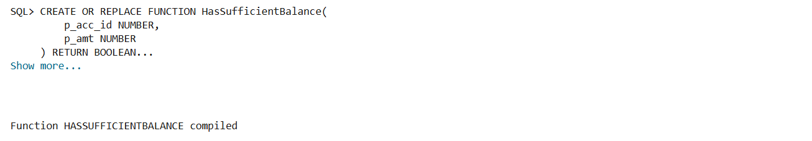

Output when Scenario 3 code is run

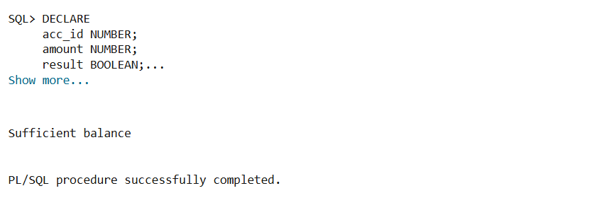

Output of the function call