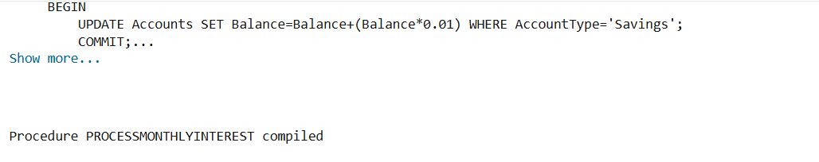

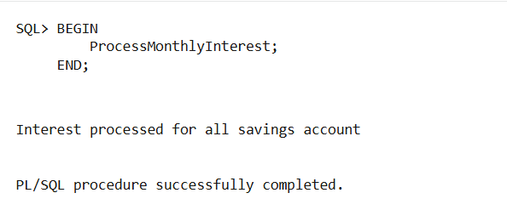

Output when Scenario 1 code is run

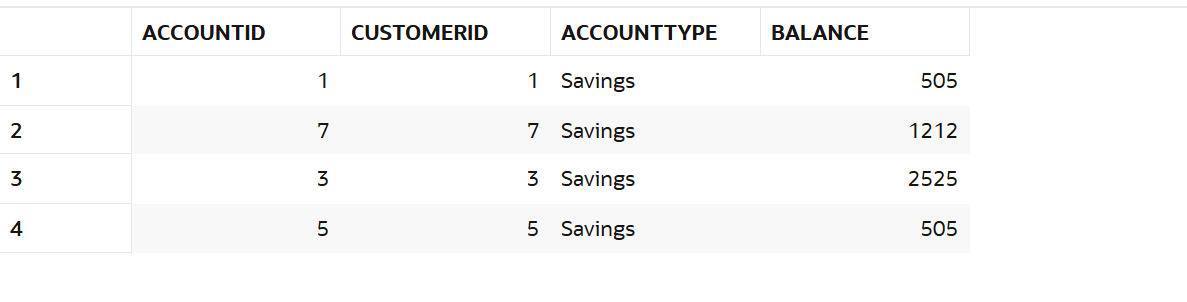

Result table of Customers with Savings account

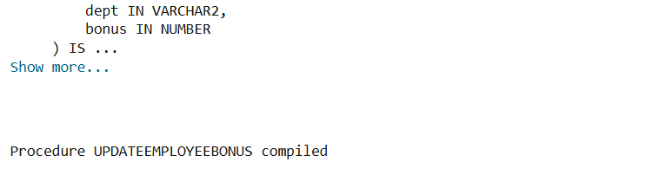

Output of Scenario 2 code after running it

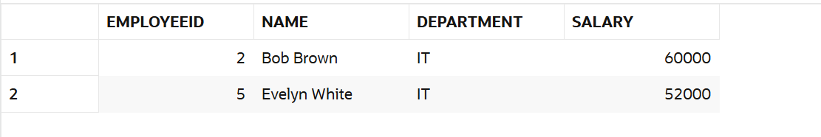

Salary of IT Employees before Procedure call

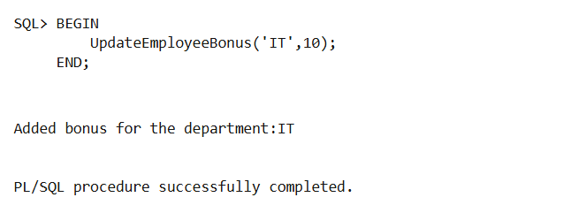

Procedure called

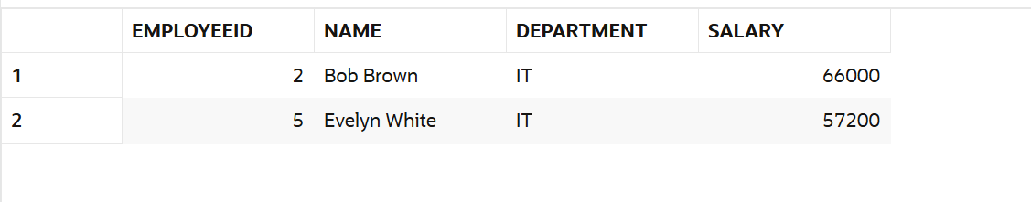

Salary of IT Employees after Procedure call

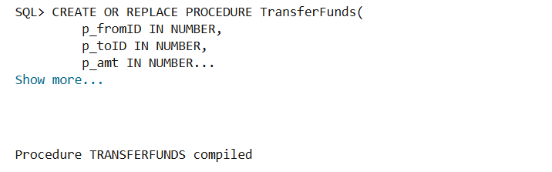

Output of Scenario 3 code when run

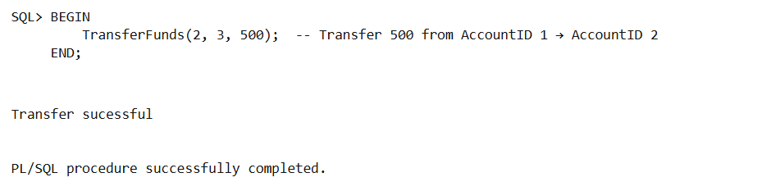

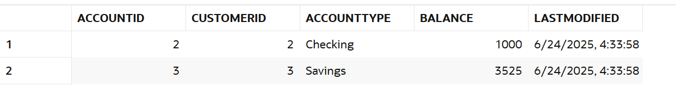

When Procedure is called with valid input parameters

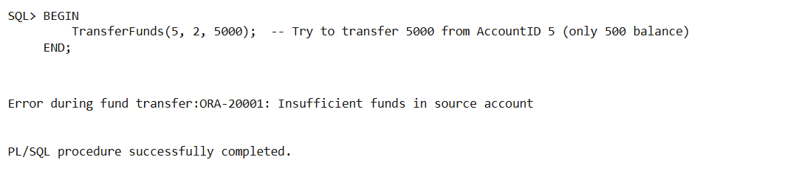

When Procedure is called with invalid input parameters

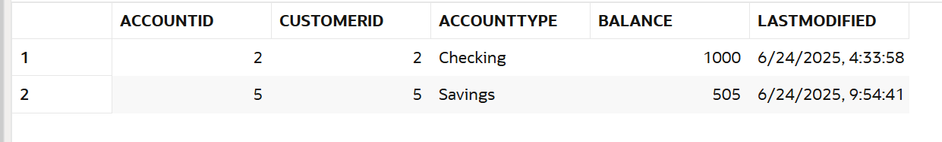

Result table showing the transfer