Microservices

Creating Microservices for account and loan

Created a new folder microservices, then created two Spring Boot projects from Spring Initializr. One project for Account and another for Loan. The dependencies used are Spring Boot DevTools and Spring Web. Extracted both the zip folders and moved the project folders into the microservices folder created earlier.

Inside account folder opened Command prompt and wrote the command : mvn clean package. With this the maven project was Build successfully and Build Success was shown. Then imported the project into Eclipse IDE and create com.cognizant.account.controller package, inside the package create AccountController class which will be RestController.

AccountController class

**package** com.cognizant.account.controller;

**import** java.util.Map;

**import** org.springframework.web.bind.annotation.GetMapping;

**import** org.springframework.web.bind.annotation.PathVariable;

**import** org.springframework.web.bind.annotation.RequestMapping;

**import** org.springframework.web.bind.annotation.RestController;

@RestController

@RequestMapping("/accounts")

**public** **class** AccountController {

@GetMapping("/{number}")

**public** Map<String,Object> getAccount(@PathVariable String number){

**return** Map.*of*(

"number",number,

"type","savings",

"balance",234343

);

}

}

Now running the main class AccountApplication.java file as java application, the server starts at port 8080. In postman on typing the url http://localhost:8080/accounts/00987987973432 the following output came:

Output:

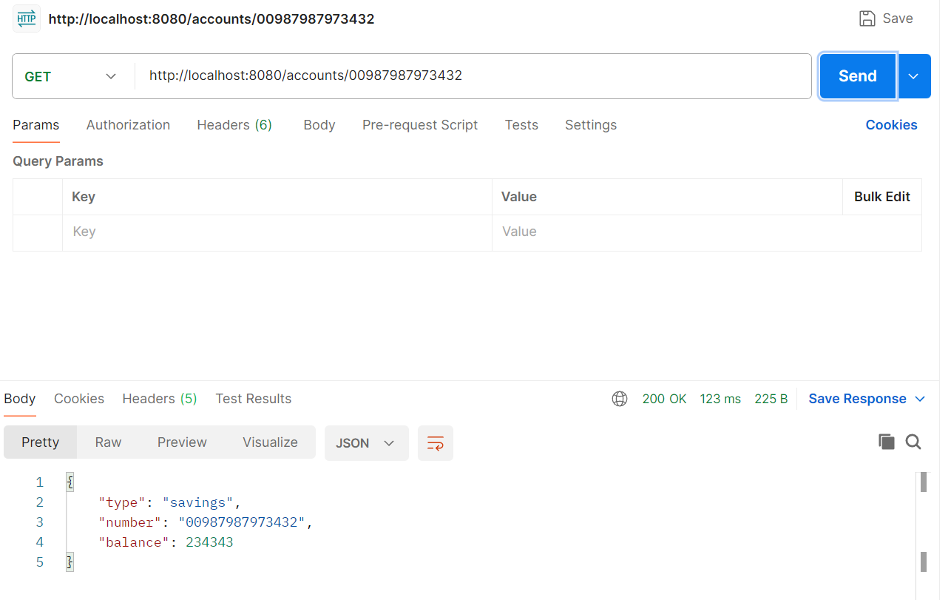

In browser on going to the same url, the following response came:  
  
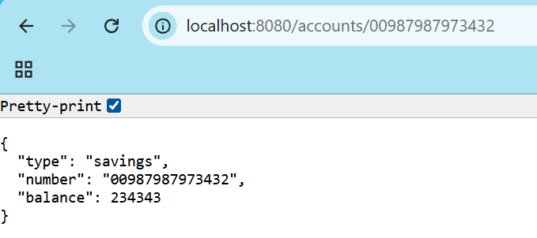

For the loans microservice, same approach was followed starting from opening command prompt inside the loan folder, building the project then importing in Eclipse IDE. After that com.cognizant.loan.controller package was created and inside it LoanController class is created.

LoanController class

**package** com.cognizant.loan.controller;

**import** java.util.Map;

**import** org.springframework.web.bind.annotation.GetMapping;

**import** org.springframework.web.bind.annotation.PathVariable;

**import** org.springframework.web.bind.annotation.RequestMapping;

**import** org.springframework.web.bind.annotation.RestController;

@RestController

@RequestMapping("/loans")

**public** **class** LoanController {

@GetMapping("/{number}")

**public** Map<String,Object> getLoan(@PathVariable String number){

**return** Map.*of*(

"number",number,

"type","car",

"loan",400000,

"emi",3258,

"tenure",18

);

}

}

Also the server.port property had to be changed for loan project because account project was already running on default port 8080. So, inside application.properties of loan project wrote the line server.port=8081.

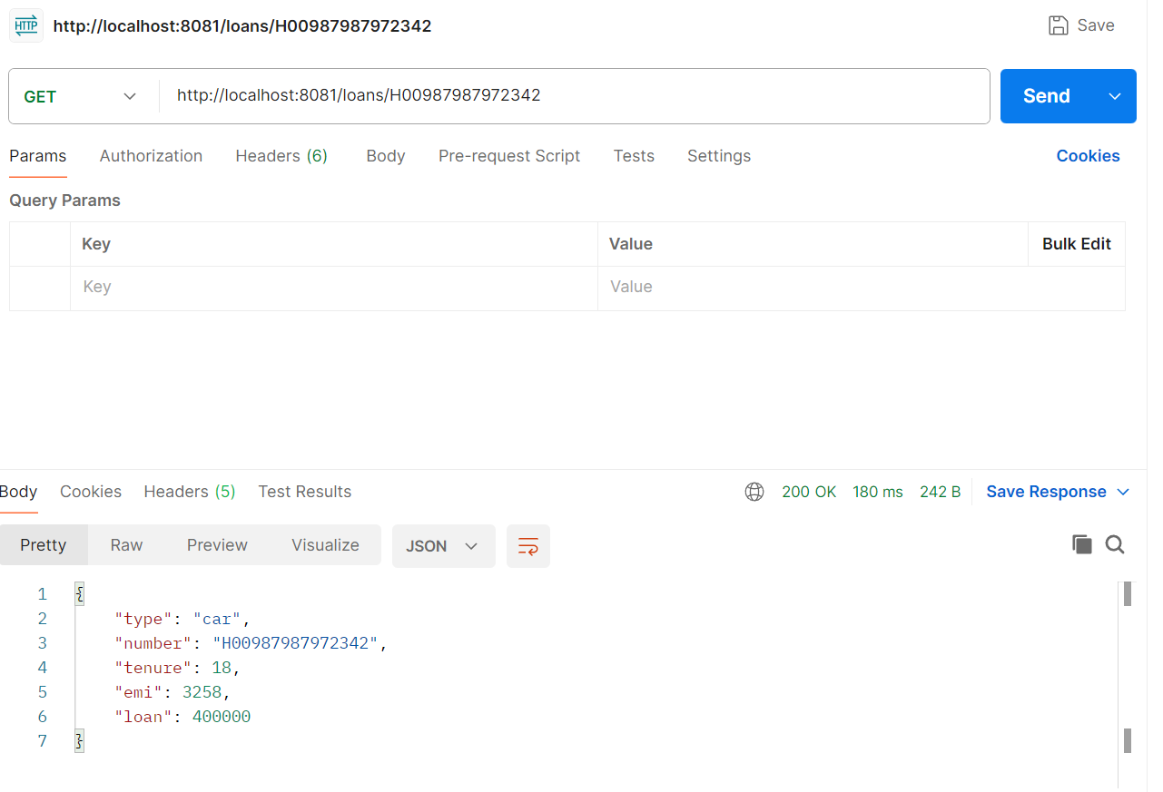Now running the main class LoanApplication.java file as java application, the server starts at port 8081. In postman on typing the url http://localhost:8081/loans/H00987987972342 the following output came:

In browser on going to the same url, the following response came:

