React.js

Assignment 1

Code:

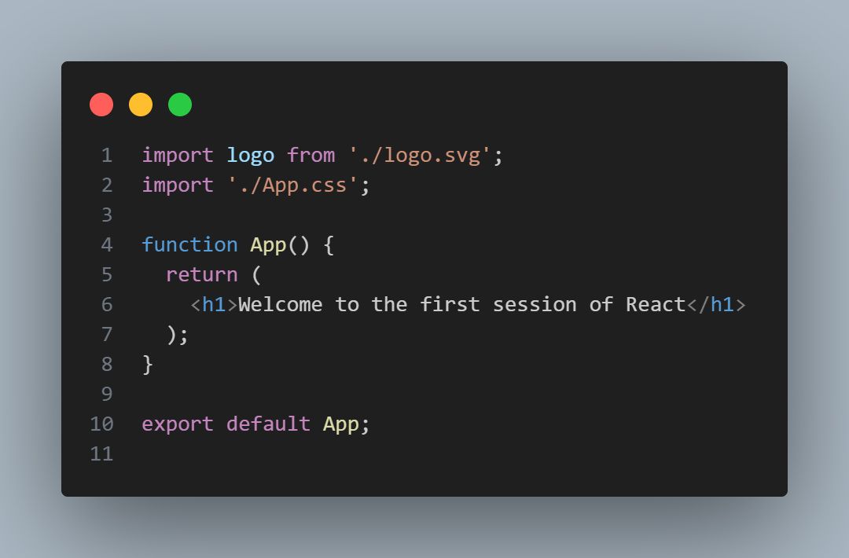Inside App.js of myfirstreact project, wrote this code after removing the existing code

Output:

On typing npm start the following output came.

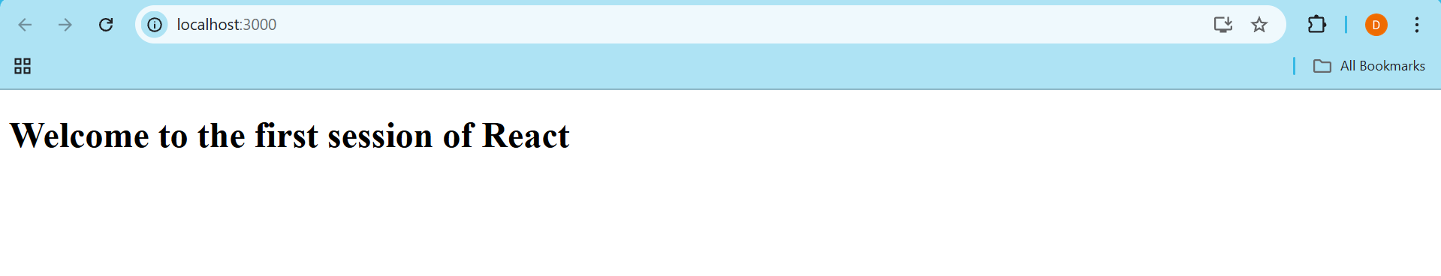

Assignment 2

Code:

Inside src folder of StudentApp project, created Components folder and inside that About.js, Contact.js and Home.js.

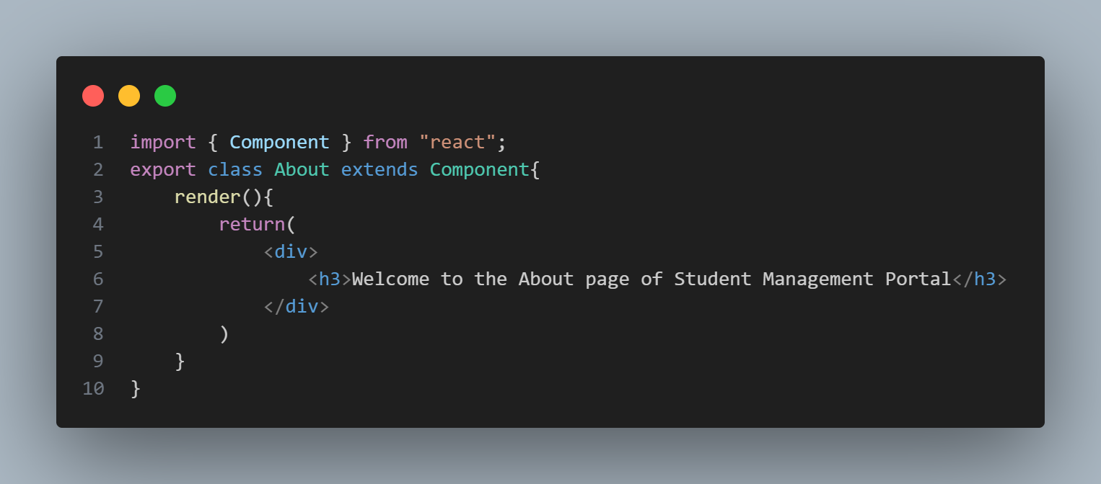 About.js

Contact.js

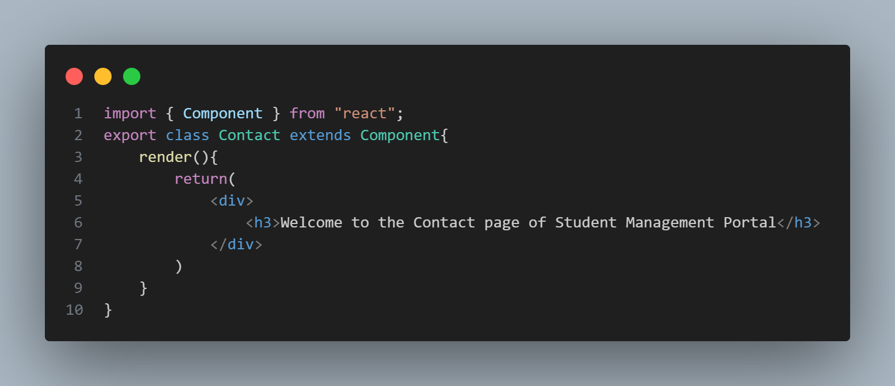

Home.js

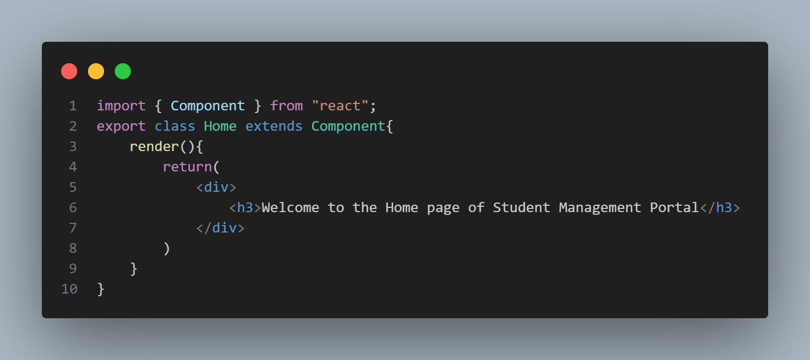

App.js

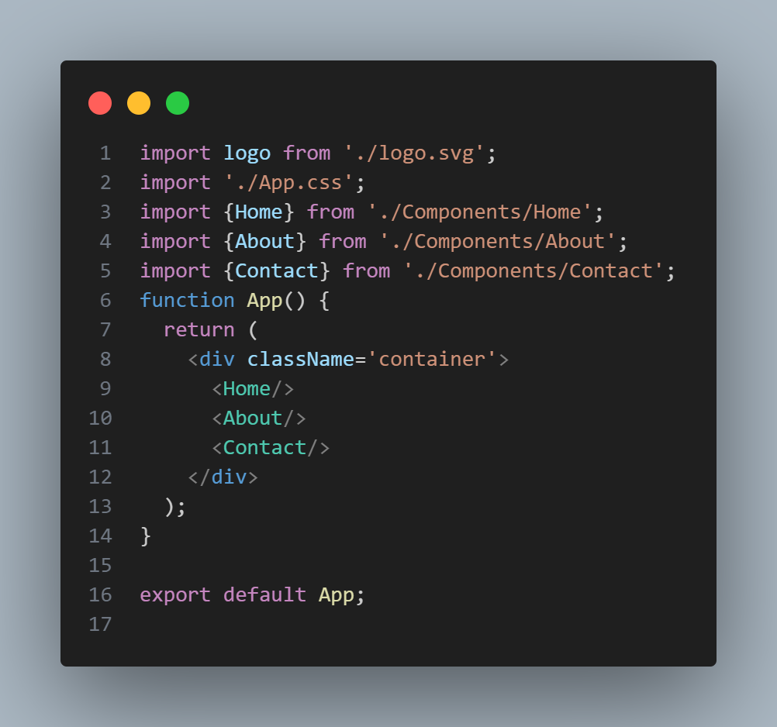

Output:

On typing npm start the following output came.

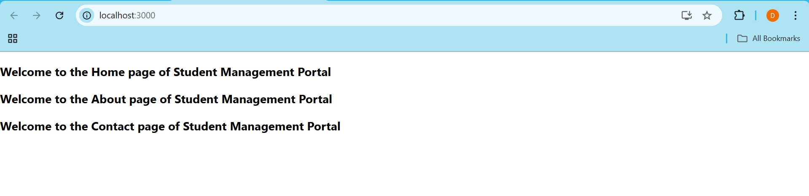

Assignment 3

Code:

Inside src folder of scorecalculatorapp project, created Components and Stylesheets folder. Inside Components folder created CalculateScore.js and inside Stylesheets folder created mystyle.css file.

CalculateScore.js

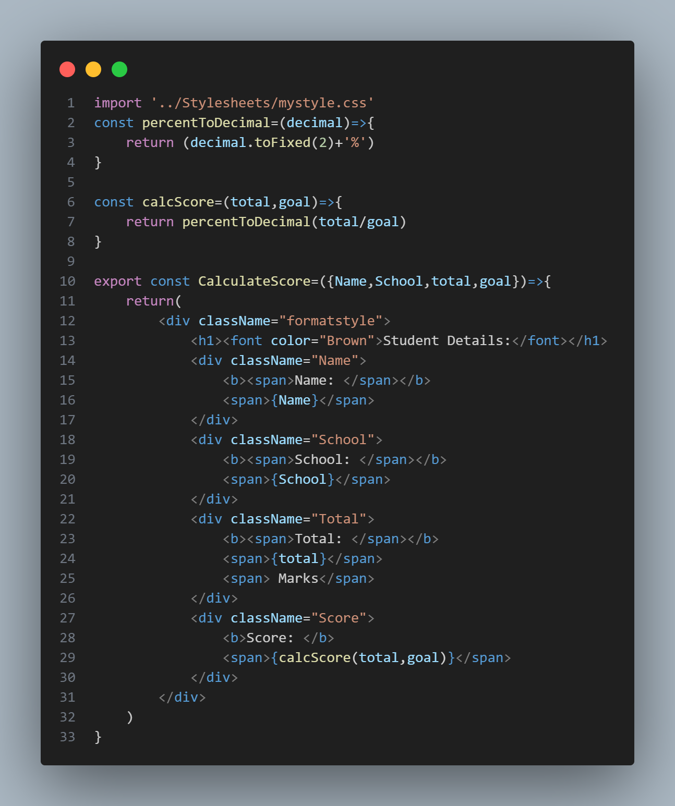

mystyle.css

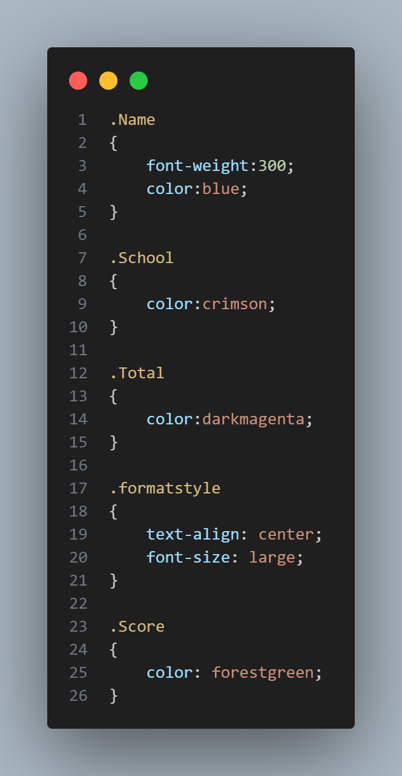

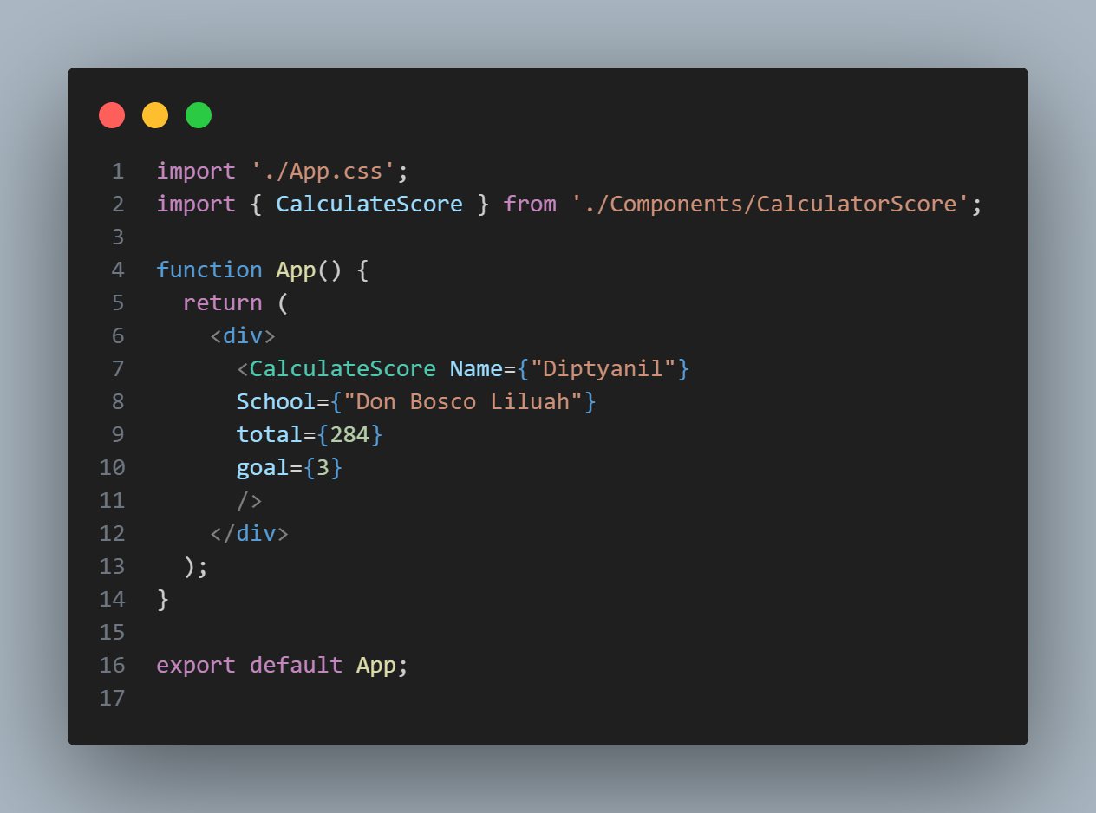App.js

Output:

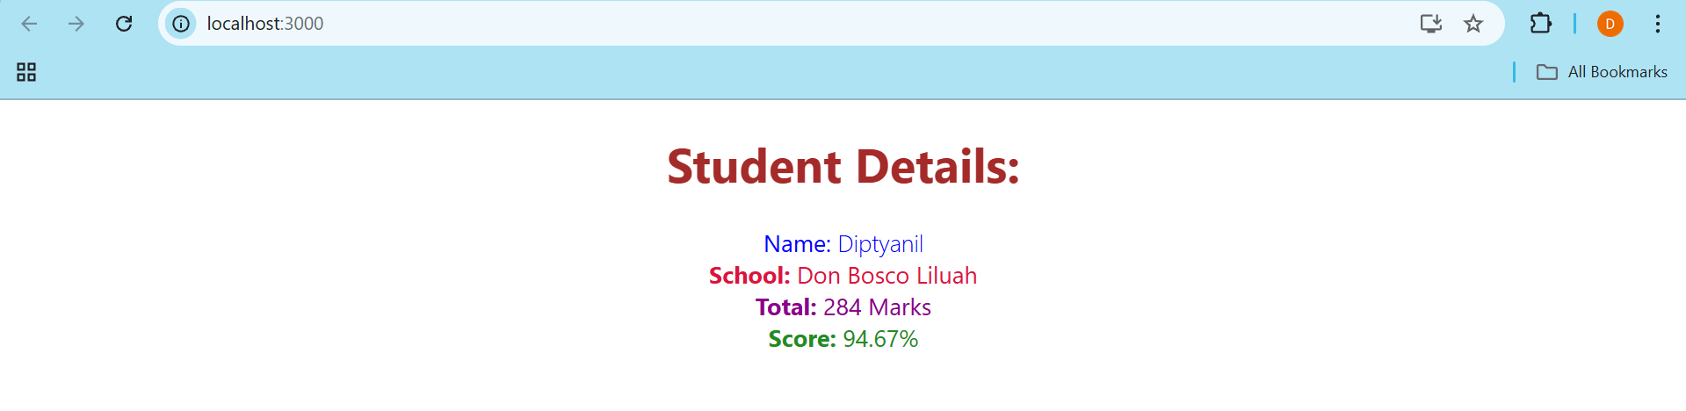

Assignment 4

Code:

Inside the blogapp project, created Post.js file, created loadPosts() function in Posts.js component. Also implemented componentDidMount() and componentDidCatch() hooks.

Post.js

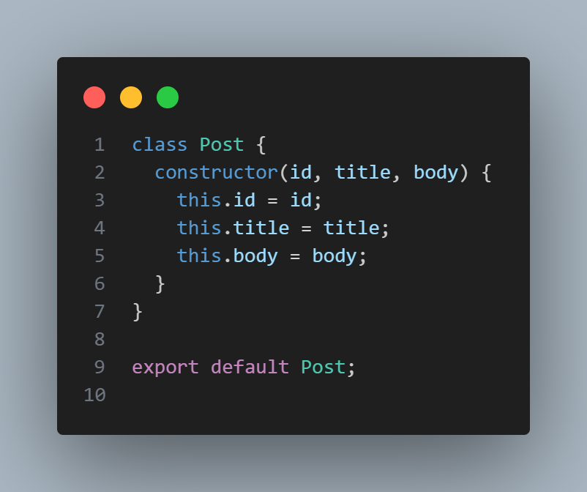

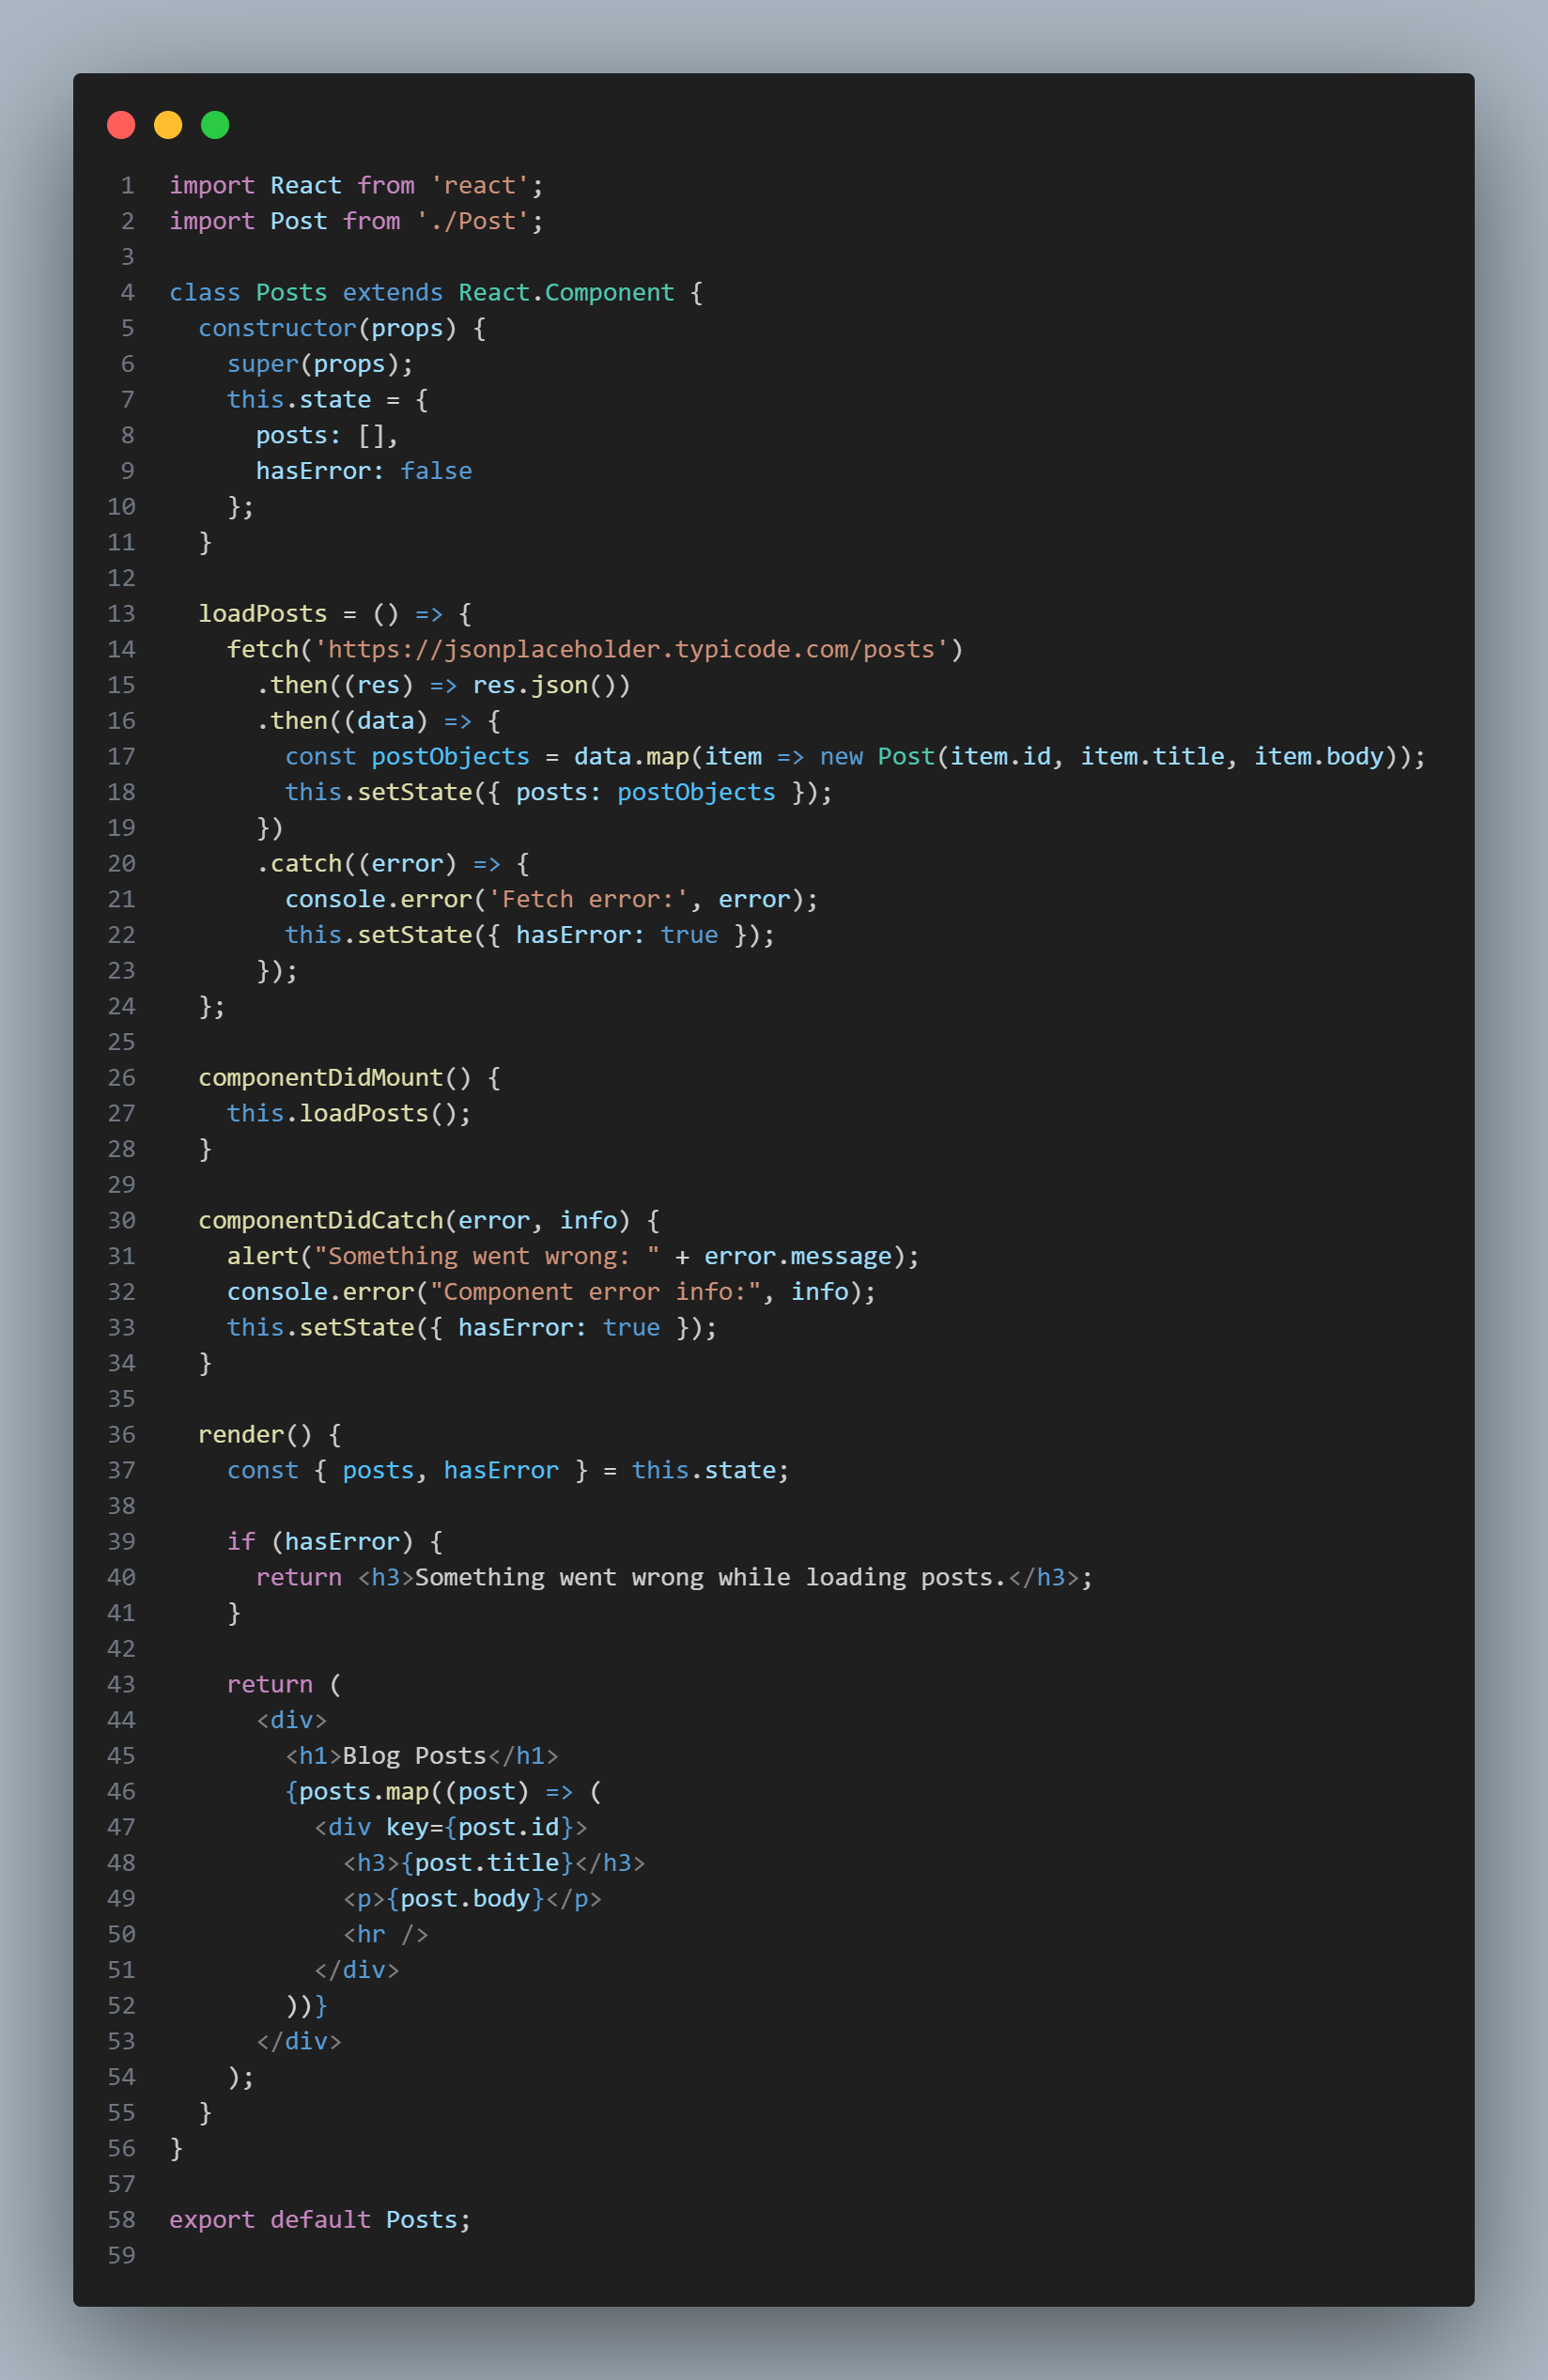Posts.js

App.js

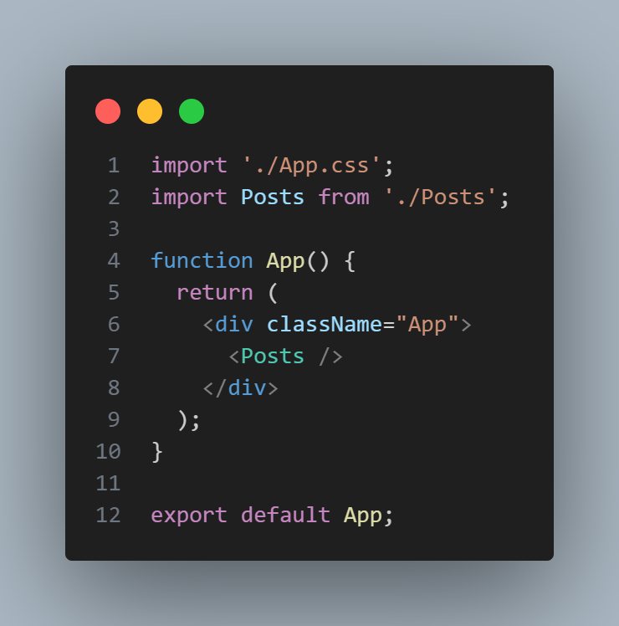

Output:

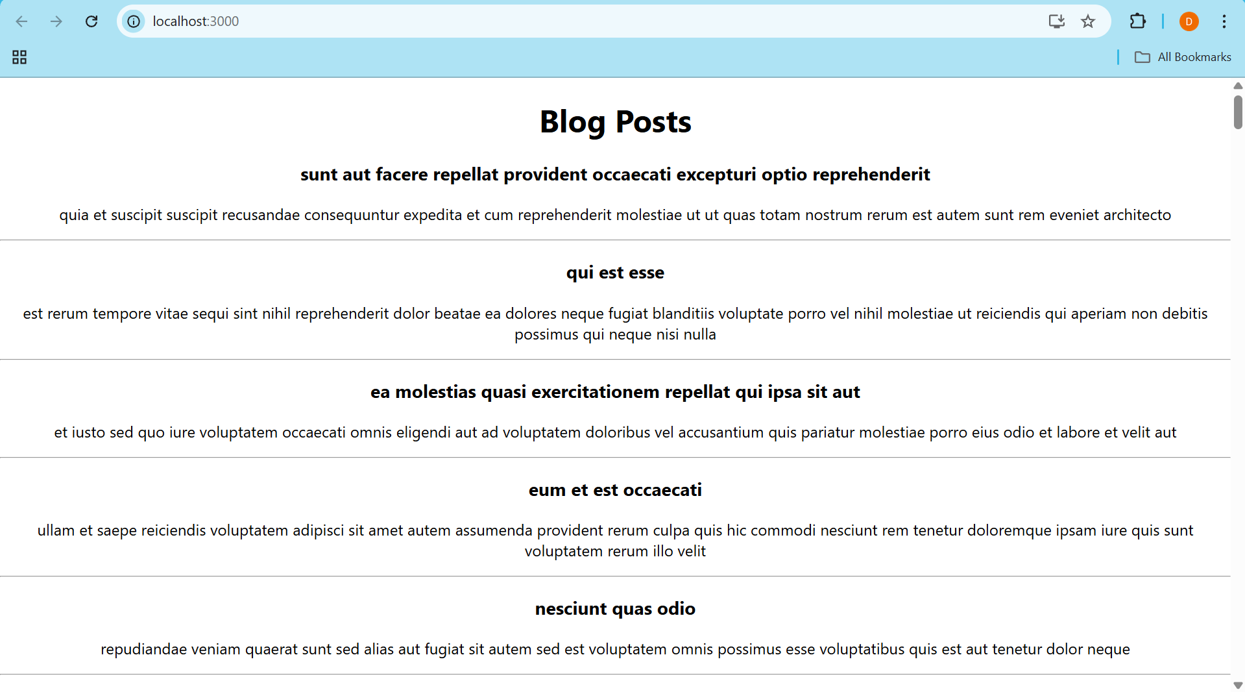

Assignment 5

Code:

Inside the project, created CohortDetails.js file with all props and all the card details. Created a new file CohortDetails.module.css and added required styling. And finally called the components in App.js.

CohortDetails.js  
  
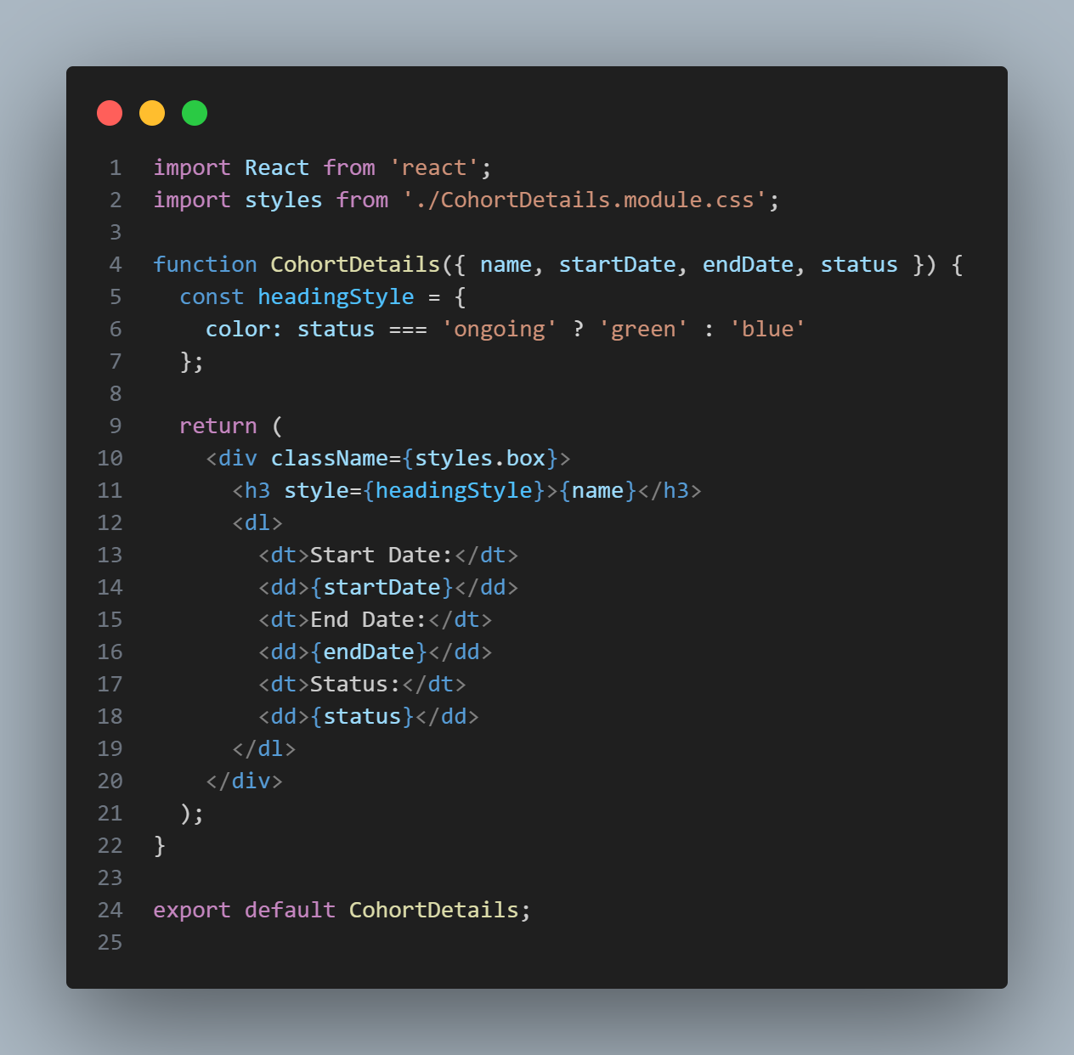

CohortDetails.module.css

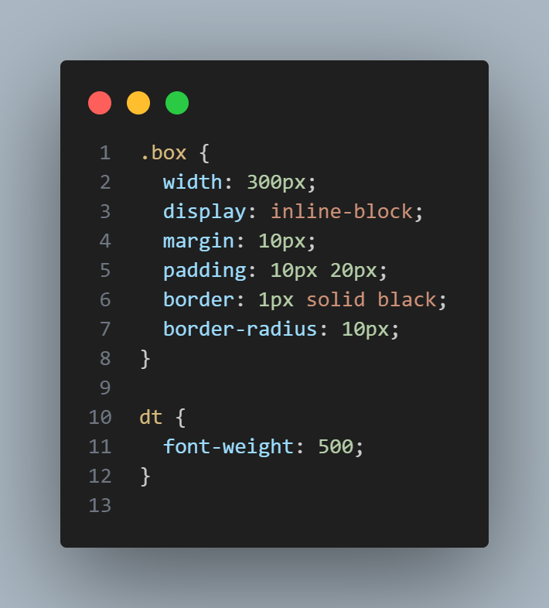

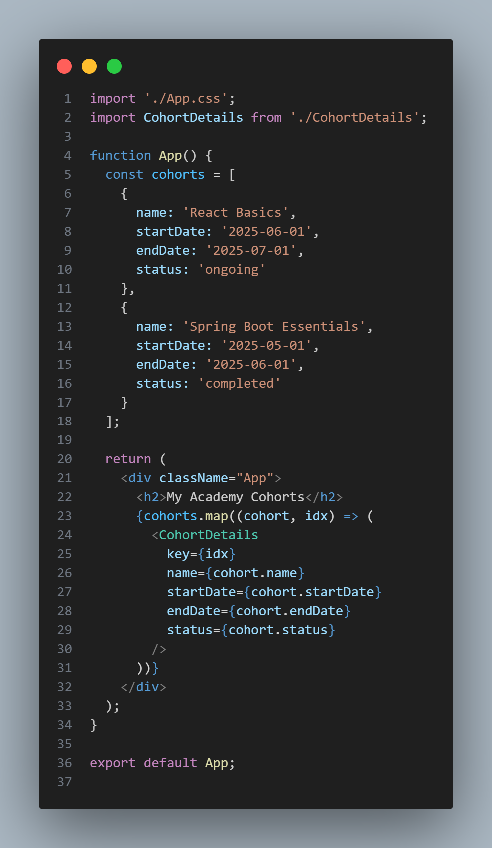App.js

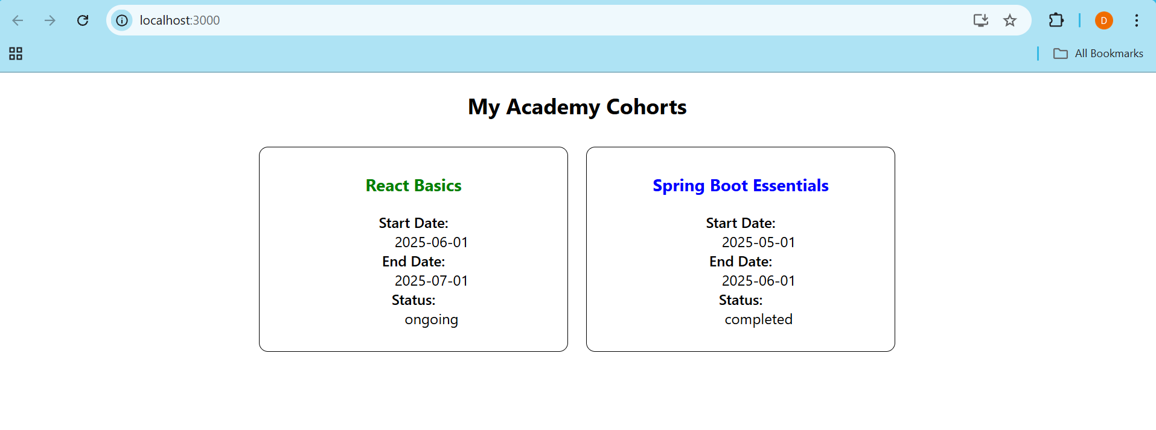Output: