Git

Assignment 1

First installed notepad++ and added notepad++.exe in the environment variables. Then opened git bash and wrote the command : git config --global --list, to check the user.name and user.email, after that proceeded with the steps as said in the assignment. The commands along with the output are given together as screenshots. Also notepad++ is set as default editor using the followung code:

git config --global core.editor "'C:/Program Files/Notepad++/notepad++.exe' -multiInst -nosession"

Made a repository GitDemo and added file welcome.txt and then committed and pushed to GitLab.

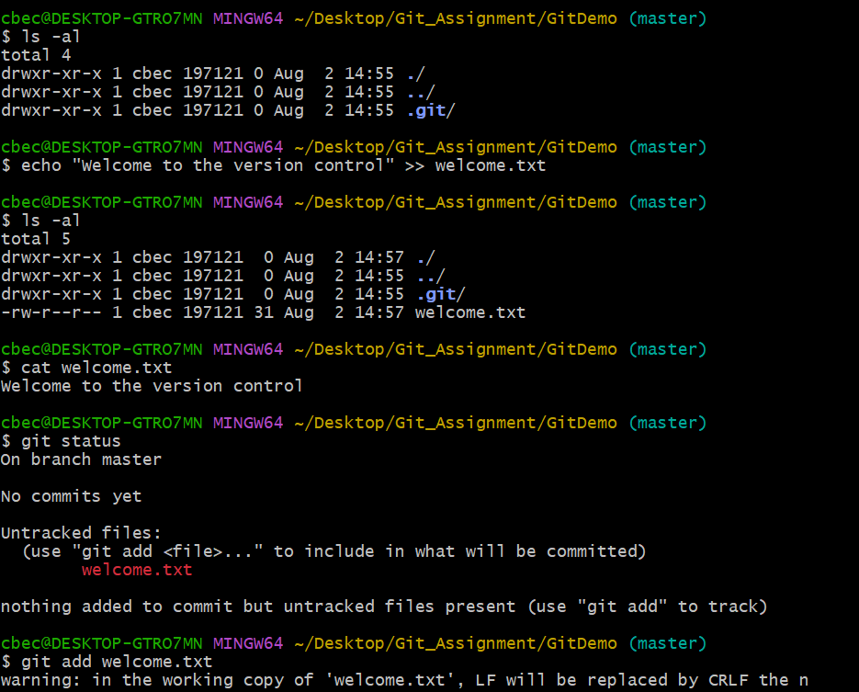Code & Output

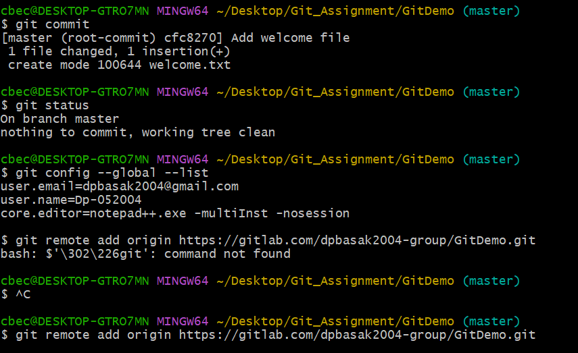

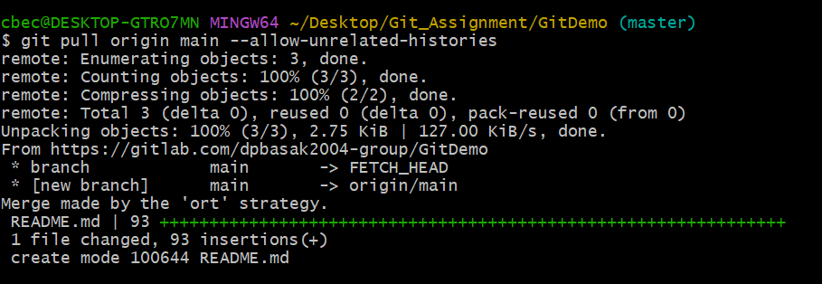

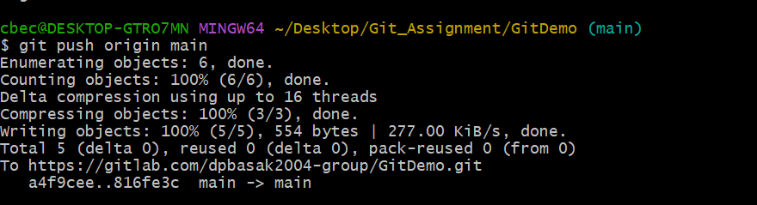

Assignment 2

Created log folder and a debug.log file along with these created .gitignore file and added these files to the gitignore file.

Code & Output

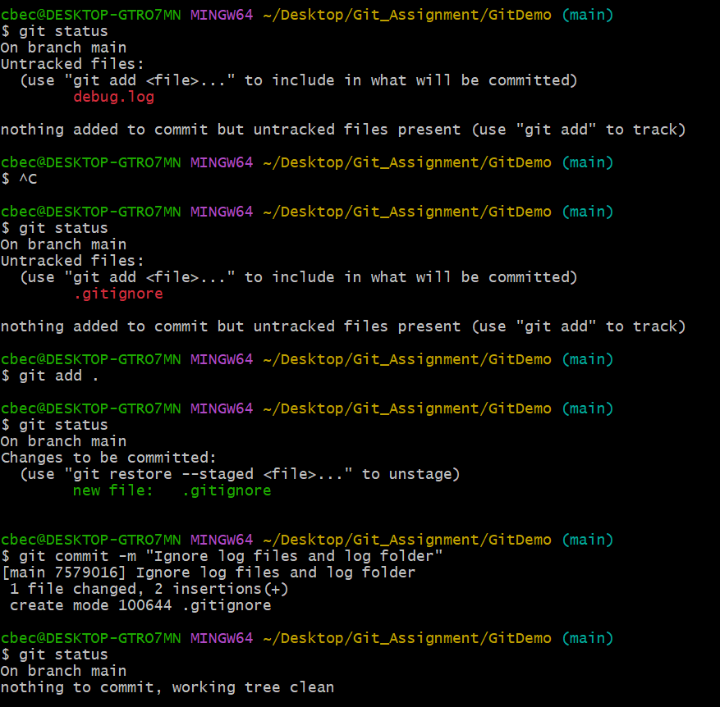

.gitignore file contents :

\*.log

log/

\*.orig

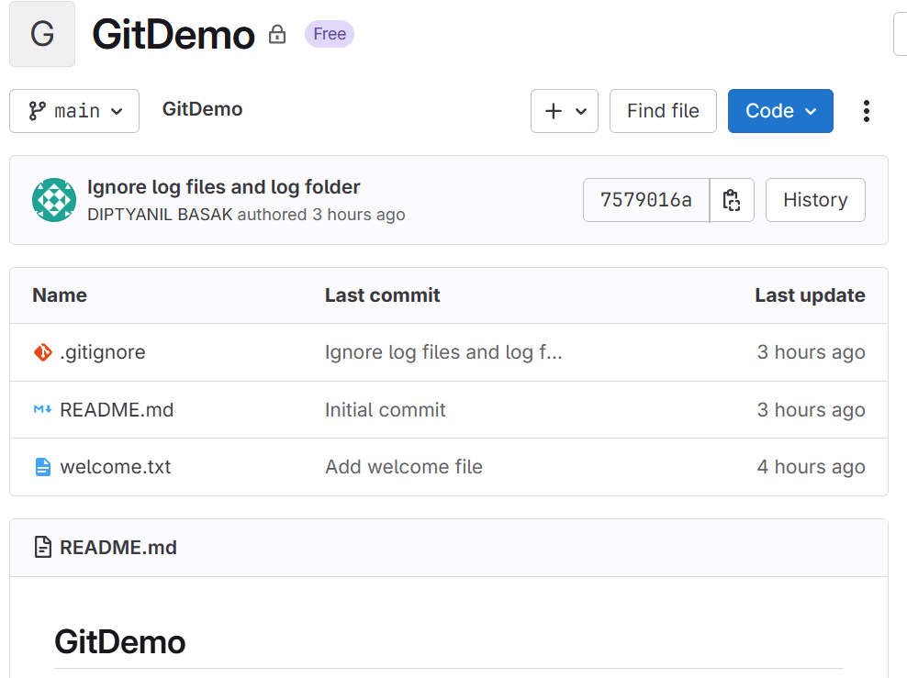

After pushing the gitignore file along with the previous txt files, the GitLab repository looks as above.

Assignment 3

Created a new branch GitNewBranch and added code in that branch committed it then merged with main branch and deleted the branch.

Code & Output

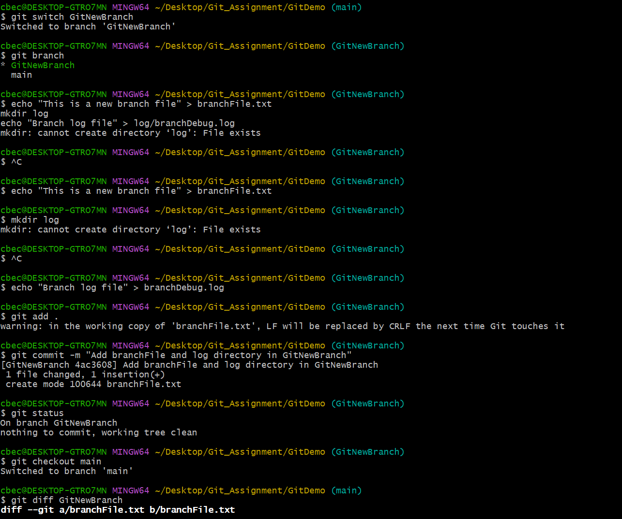

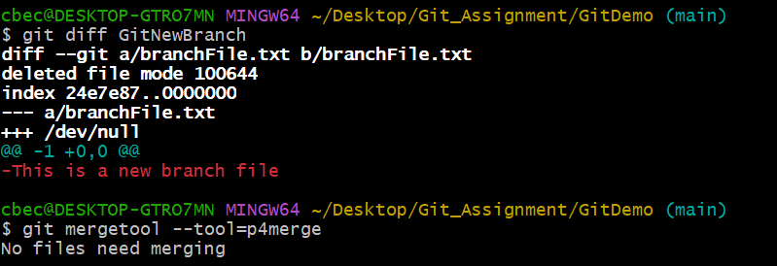

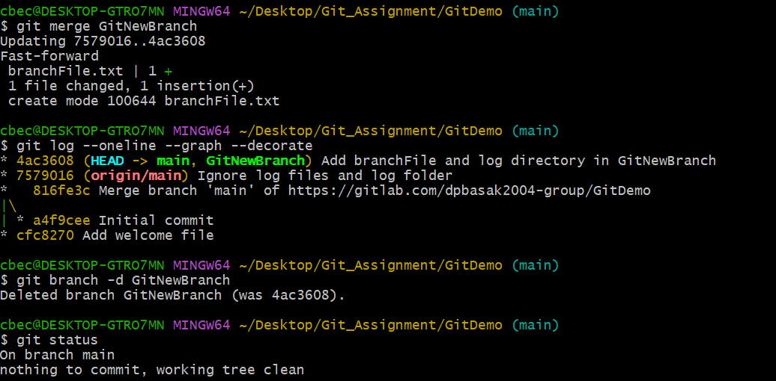

Assignment 4

Created GitWork branch and added hello.xml with the following code:

<?xml version="1.0"encoding="UTF-8"?>

<beans xmlns="http://www.springframework.org/schema/beans"

xmlns:xsi="http://www.w3.org/2001/XMLSchema-instance"

xsi:schemaLocation="

http://www.springframework.org/schema/beans

http://www.springframework.org/schema/beans/spring-beans.xsd">

<bean id="helloBean" class="com.example.HelloWorld">

<property name="message" value="Hello, Spring XML!" />

</bean>

</beans>

In main branch also added hello.xml with following code:  
<?xml version="1.0" encoding="UTF-8"?>

<bookstore>

<book category="programming">

<title lang="en">Learning Java</title>

<author>John Smith</author>

<year>2021</year>

<price>39.95</price>

</book>

<book category="fiction">

<title lang="en">The Time Machine</title>

<author>H.G. Wells</author>

<year>1895</year>

<price>9.99</price>

</book>

</bookstore>

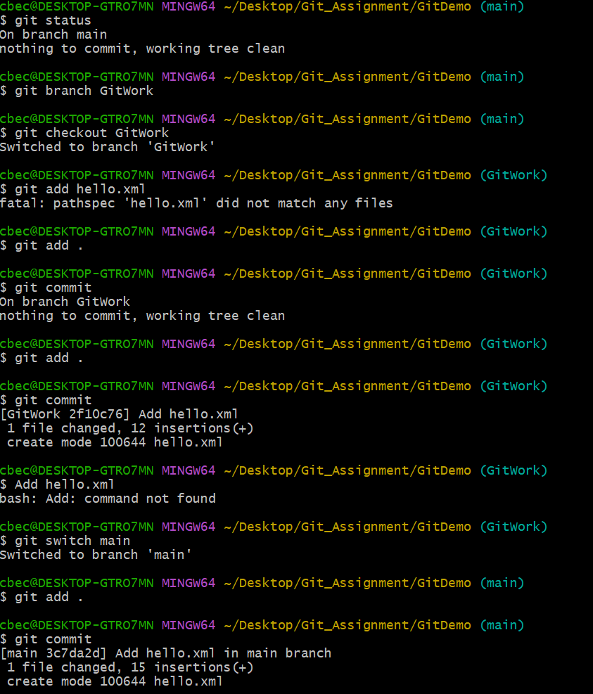Code & Output

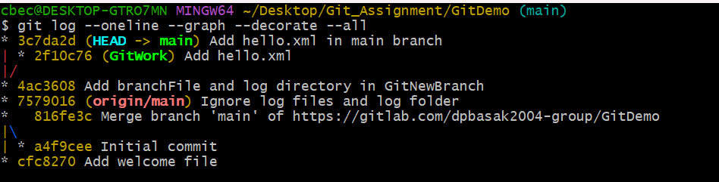

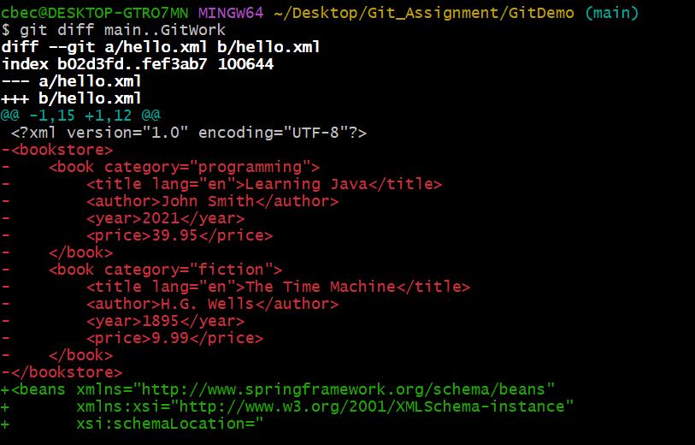

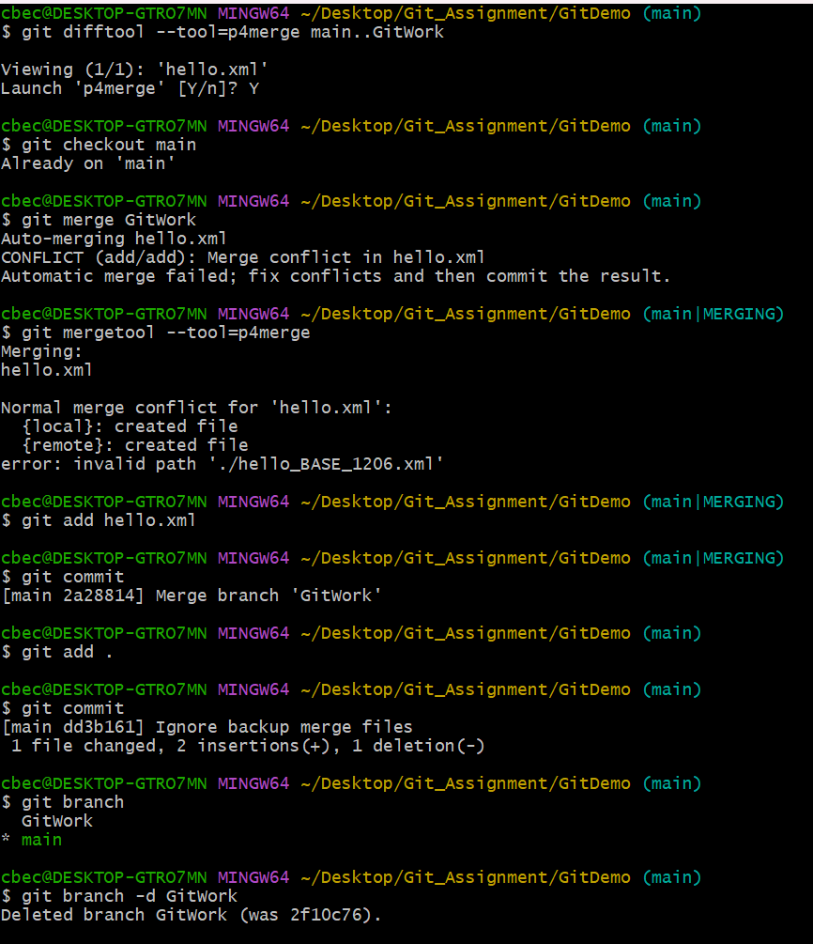

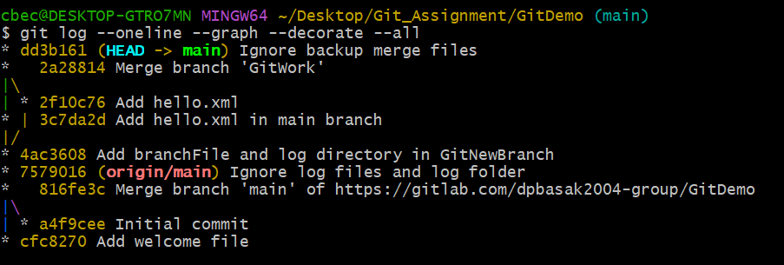

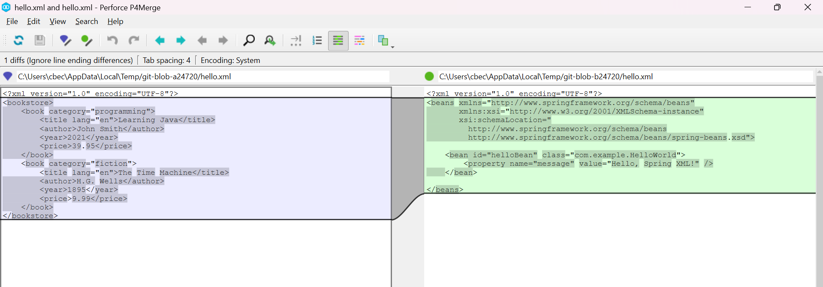

Assignment 5

Pushed the previous changes of the merged branch into GitLab.

