***INPUT:***

<html>

<head>

<title>COSC 31103</title>

</head>

<body>

<!--DGDP Sathsara-->

<!--PS/2021/167-->

<!--COSC 31103-->

<address>

381/1,<br>

Nahalla,<br>

Rideegama.

</address>

<h1>WEB & INTERNET TECHNOLOGY</h1>

<p>Web Design is the process of creating, making, and developing websites. It includes many

different features such as webpage layout, webpage content, and also graphic designs. In

general web design and web development work together, but the term web design is an actual

category of web development.

</p>

<div class="box" align="center">

<p><b>This Text is Bold</b></p>

<p><big>This Text is Big<big></p>

<p><em>This Text is Emphasized</em></p>

<p><i>This Text is Italic</i></p>

<p><small>This Text is Small<small></p>

<p><strong>This Text is Strong</strong></p>

<p><del>This Text is Deleted</del></p>

<p><ins>This Text is Inserted</ins></p>

<p>This is <sub>subscript</sub>and<sup>superscript</sup></p>

</div>

<div align="left">

<p><em>Aquilaria</em> and <em>Gyrinops</em> are genera of tropical trees<br> that produce a valuable resinous wood

called <b>agarwood.</b><br> The aromatic properties of agarwood when burned or distilled are<br>

extraordinary and<br> there is high demand for the resinous wood to make incense,<br> perfume<br> and<br> as

traditional medicine.</p>

</div>

<div>

<p>There are some example of Abbreviations are as follows<br>

<abbr title="Personal Computer"><center>PC</center></abbr><br>

<abbr title="Graphical User interface"><center>GUI</center></abbr><br>

<abbr title="Universal Serial Bus"><center>USB</center></abbr><br>

<abbr title="Visual Graphic Adaptor"><center>VGA</center></abbr><br>

<abbr title="Hard Disk Drive"><center>HDD</center></abbr></p>

</div>

</body>

</html>

***OUTPUT:***

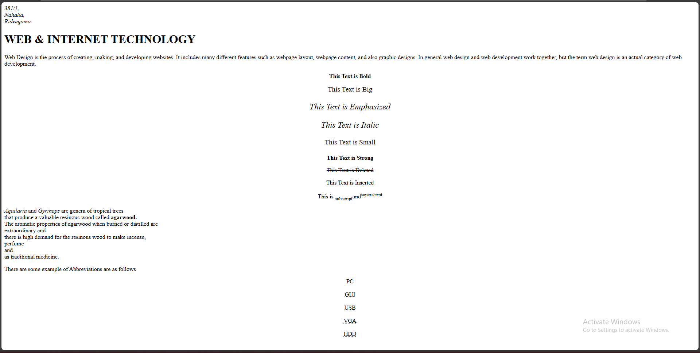

***INPUT:***

<html>

<head><title></title>

</head>

<body>

<div align="left">

<h1><b>Nested Unordered List</b></h1>

<p>GeeksforGeeks courses list:</p>

<ul>

<li>DSA</li>

<ul>

<li>Array</li>

<li>Linked List</li>

<li>Stack</li>

<li>Queue</li>

</ul>

</ul>

<ul>

<li>Web Technologies</li>

<ul>

<li>HTML</li>

<li>CSS</li>

<li>JavaScript</li>

</ul>

<li>Web Aptitude</li>

<li>Gate</li>

<li>Placement</li>

</ul>

</div>

<br>

<br>

<div>

<h1><b>Learning Web Development</b></h1>

<ol type="i">

<li>Introdution to HTML</li>

<ol type="A">

<li>HTML Tags</li>

<ol type="a">

<li>HTML Tag Attributes</li>

</ol>

<li>HTML Elements</li>

</ol>

<li>HTML Text Formatting</li>

<li>HTML Links</li>

<ol type="A">

<li>Create Hyperlinks</li>

<ol type="a">

<li>Use of target attribute</li>

<li>Use of name attribute</li>

</ol>

<li>An image as link</li>

<li>Create a mailto link</li>

</ol>

<li>HTML Tables</li>

<ol type="A">

<li>Table Borders</li>

<li>Table Headings</li>

<ol type="a">

<li>Vertical Headers</li>

<li>Horizontal Headers</li>

</ol>

<li>Table With A Caption</li>

<li>Table Cell Span</li>

<ol type="a">

<li>Use of rowspan attribute</li>

<li>Use of colspan attribute</li>

</ol>

<li>Tags Inside A Table</li>

<ol type="a">

<li>Cellspacing</li>

<li>cellpadding</li>

<li>frame</li>

</ol>

<li>Add Backgrount Image To Table</li>

<li>Align The Content In The Table</li>

</ol>

<li>HTML Lists</li>

<ol type="a">

<li>Ordered List</li>

<li>Unordered List</li>

<li>Definition List</li>

</ol>

<li>HTML Forms</li>

<ol type="a">

<li>Text Fields</li>

</ol>

</ol>

</div>

</body>

</html>

***OUTPUT:***

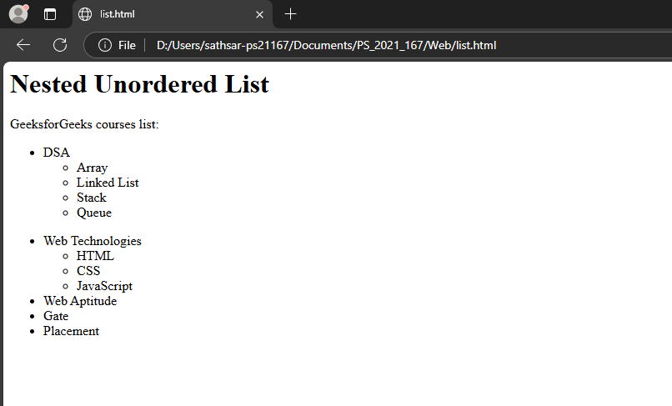

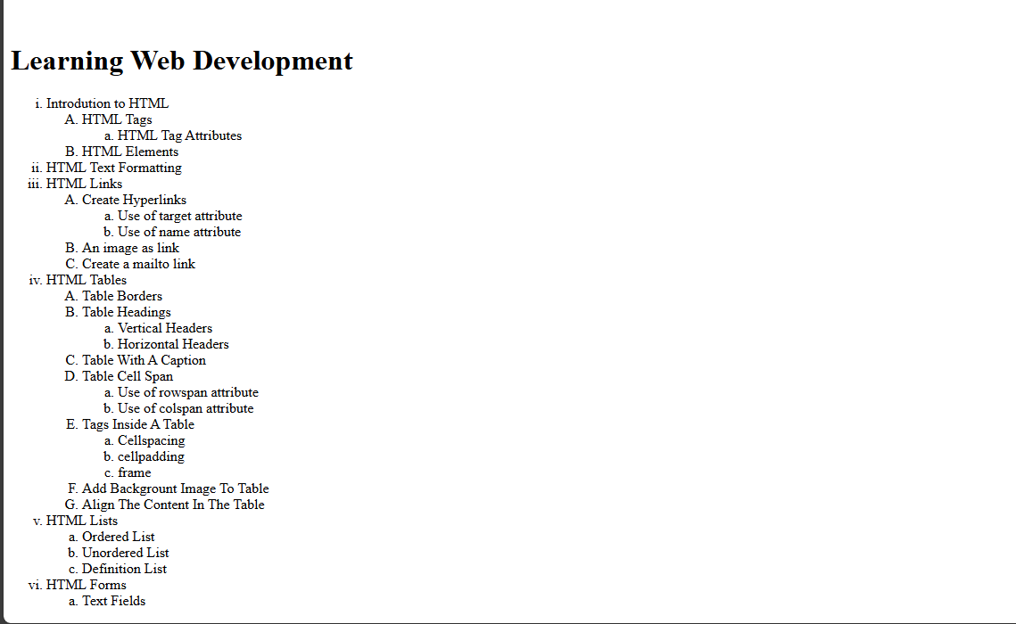

Input:

<html>

    <head>

        <title>Student Registation Form</title>

    </head>

    <body>

        <h2>Student Registation Form</h2>

        <form action="">

            Student ID:<input type="text" name="Student_id"><br><br>

            Name : <input type="text" name="name"><br><br>

            Course (PS/BS/PE/HS):

                    <select name="course">

                        <option value="PS">Physical Science</option>

                        <option value="BS">Biological Science</option>

                        <option value="EC">Electronc & Computer Science</option>

                        <option value="SE">Software Engineering</option>

                    </select><br><br>

            University:<input type="text" name="university"><br><br>

            District:<input type="text" name="district"><br><br>

            Email:<input type="email" name="email"><br><br>

            Any Inquiries:<br>

            <textarea name="Inquiries" rows="4" cols="30"></textarea><br><br>

            <input type="submit" value="Submit">

            <input type="reset" value="Reset">

        </form>

    </body>

</html>

Output:

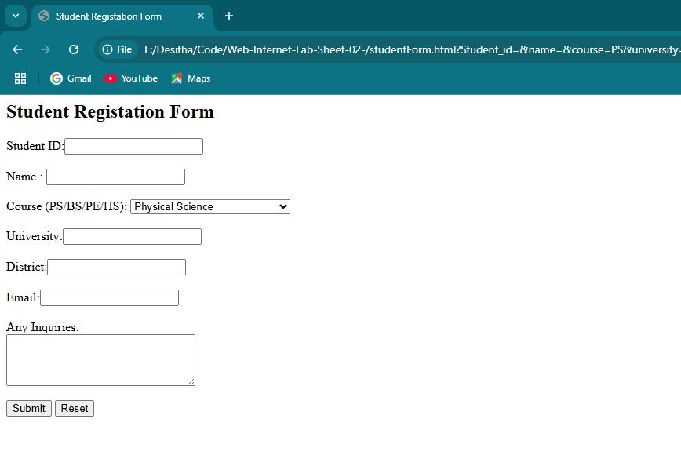

Github Link: <https://github.com/Dp-Sathsara/Web-Internet-Lab-Sheet-02-.git>