**Name: Dhruv Patel**

**Assignment: Bootstrap Basic & Advanced**

1. **What are the advantages of Bootstrap?**

Bootstrap is very easy and quite simple to use for designing and

Development. Bootstrap is a framework which is easily integrated with bulk

Frameworks. Uninterrupted with existing sites or the new one. Bootstrap is an agile framework that is quite faster than other frameworks. It saves time due to its standard ready-made coding blocks, responsiveness, and cross-browser capabilities. Bootstrap supports JavaScript Components so one doesn't require knowledge of scripting.

**2. What is a Bootstrap Container, and how does it work?**

In Bootstrap, container is used to set the content's margins dealing with

The responsive behaviours of your layout. It contains the row elements

And the row elements are the container of columns (known as grid system).

<!DOCTYPE html>

<html lang="en">

<head>

    <meta charset="UTF-8">

    <meta name="viewport" content="width=device-width, initial-scale=1.0">

    <title>Airtel Black Bill Payment </title>

    <link rel="stylesheet" href="https://cdnjs.cloudflare.com/ajax/libs/font-awesome/6.4.0/css/all.min.css">

</head>

<style>

    *{

        margin: 0;

        padding: 0;

        box-sizing: border-box;

    }

    .logo{

        height: 80px;

        width: 200px;

    }

user agent stylesheet

h1 {

    text-align: center;

}

    #root, body, html {

    background-color: #f7f7fa;

}

.wt-row {

    color: #f7f7fa;

    display: flex;

}

#recharge{

    padding-left: 150px;

    padding-top: 50px;

    padding-right: 100px;

    padding-bottom: 300px;

}

#prepaid{

    padding: 100px;

    color: #121312;

}

h2{

    padding-bottom: 50px;

    size: 50px;

}

p{

    padding-bottom: 50px;

    word size: 60px;

}

</style>

<body>

   <div class="container-fluid logo" >

         <div><img src="logo-red (1).svg" alt="">

   </div>

   <div class="container">

   <div class="wt-row">

    <div class="col-md-4 text-center text-white" id="recharge" style="background-color: #121312;">

        <h1>RechargeOnline</h1>

        <p>faster recharges - anywhere,any time</p>

    </div>

    <div class="col-md-6 text-center" id="prepaid">

        <h2>Prepaid mobile recharge</h2>

        <p>Recharge your number for validity,talktime or data </p>

        <p>mobile no</p>

        <img src="page 1 main.png" alt="">

        <button></button>

    </div>

</div>

   </div>

</body>

</html>

**3. What are the default Bootstrap text settings?**

Bootstrap 4 uses a default font-size of 16px, and its line-height is

1.5. The default font-family is "Helvetica Neue", Helvetica, Arial, sans-

Serif. In addition, all <p> elements have margin-top: 0 and margin-

bottom: 1rem (16px by default).

<!DOCTYPE html>

<html lang="en">

<head>

  <title>Bootstrap Example</title>

  <meta charset="utf-8">

  <meta name="viewport" content="width=device-width, initial-scale=1">

  <link rel="stylesheet" href="https://cdn.jsdelivr.net/npm/bootstrap@4.6.2/dist/css/bootstrap.min.css">

  <script src="https://cdn.jsdelivr.net/npm/jquery@3.6.4/dist/jquery.slim.min.js"></script>

  <script src="https://cdn.jsdelivr.net/npm/popper.js@1.16.1/dist/umd/popper.min.js"></script>

  <script src="https://cdn.jsdelivr.net/npm/bootstrap@4.6.2/dist/js/bootstrap.bundle.min.js"></script>

</head>

<body>

<div class="container">

  <h1>h1 Bootstrap heading (2.5rem = 40px)</h1>

  <h2>h2 Bootstrap heading (2rem = 32px)</h2>

  <h3>h3 Bootstrap heading (1.75rem = 28px)</h3>

  <h4>h4 Bootstrap heading (1.5rem = 24px)</h4>

  <h5>h5 Bootstrap heading (1.25rem = 20px)</h5>

  <h6>h6 Bootstrap heading (1rem = 16px)</h6>

</div>

</body>

</html>

**4. What do you know about the Bootstrap Grid System?**

Bootstrap’s grid system uses a series of containers, rows, and columns to

Layout and align content. It’s built with [flex box](https://developer.mozilla.org/en-US/docs/Web/CSS/CSS_Flexible_Box_Layout/Basic_Concepts_of_Flexbox) and is fully responsive.

Below is an example and an in-depth explanation for how the grid system

Comes together.

<div class="container">

  <div class="row">

    <div class="col">

      Column

    </div>

    <div class="col">

      Column

    </div>

    <div class="col">

      Column

    </div>

  </div>

</div>

**5. What is the difference between Bootstrap 4 and Bootstrap 5?**

| **BASIS OF** | **BOOTSTRAP 4** | **BOOTSTRAP 5** |
| --- | --- | --- |
| **Grid System** | It has 5 tier (xs, sm, md, lg, xl). | It has 6 tier (xs, sm, md, lg, xl, xxl). |
| **Color** | It has limited colors. | Extra colors added with the looks, A card improved color palette. There are various shades available to choose. |
| **Jquery** | It has jquery and all related plugins. | Jquery is removed and switched to vanilla JS with some working plugins |
| **Internet Explorer** | Bootstrap 4 supports both IE 10 and 11. | Bootstrap 5 doesn’t support IE 10 and 11. |
| **Form elements** | Radio buttons, checkboxes have different look in different OS and browsers. The form uses whatever default browsers provide. | The look of form elements will not change, on different OS or browser. The forms can be customized and form controls can be added, they would not depend on browser. |
| **Utilities API** | We cannot modify utilities in bootstrap 4 | Bootstrap 5 gave freedom to modify and also create our own utility |
| **Gutter** | We use .glutter with fontsize in px | We use .g* with fontsize in rem |
| **Vertical Classes** | Columns can be positioned relative | Columns cannot be positioned relative |
| **Bootstrap Icons** | Bootstrap 4 doesn’t have its own SVG icons, we have to use font-awesome for icons. | Bootstrap 5 have its own SVG icons |
| **Jumbotron** | It supports. | It doesn’t support jumbotron. |
| **Card deck** | The card deck is used to create a set of cards with equal width and height. | Card deck class in removed in bootstrap |
| **Navbar** | We have inline-block property and we will get white dropdown as default for dropdown-menu-dark class. | Inline-block property is removed and we will get black dropdown as default for dropdown-menu-dark class. |
| **Static Site Generator** | Bootstrap 4 uses Jekyll software. | Bootstrap 5 uses Hugo software as it is fast static site generator. |
| **flexbox grid** | this makes easier to implement vertical designs, and the columns and rows can easily be implemented. the classes justify-center-content can directly be used to align according to the requirement. | advanced grid system is made available , also columns don’t have relative positions. |
| **RTL Support** | It does not enable RTL(Right to Left) switching. | It enables RTL(Right to Left) switching. |
| **Offcanvas Component** | It does not support Offcanvas Component. | It supports Offcanvas Component(that is it is available now). |

**6. What is a Button Group, and what is the class for a basic Button Group?**

A button group is a grouping of buttons whose actions are related

to each other. Use Bootstrap's custom button styles for actions in forms,

dialogs, and more with support for multiple sizes, states, and more.

“Button Groups” in Bootstrap is a class of name “btn-group” which is used to create a series of buttons in groups (without spaces) vertically or horizontally. Syntax: This is the basic syntax of the button group class where each button has its own class of “btn”.

<button type="button" class="btn btn-secondary">Left</button>

<div class="btn-group-vertical">...</div>

**7. How can you use Bootstrap to make thumbnails?**

A lot of sites need a way to lay out images, videos, text, etc., in a grid, and Bootstrap has an easy way to do this with thumbnails. To create thumbnails using Bootstrap −

* Add an <a> tag with the class of **.thumbnail** around an image.
* This adds four pixels of padding and a gray border.
* On hover, an animated glow outlines the image.

<!DOCTYPE html>

<html>

   <head>

      <title>Thumbnail</title>

      <link href="/bootstrap/css/bootstrap.min.css" rel="stylesheet">

      <script src="/bootstrap/scripts/jquery.min.js"></script>

      <script src="/bootstrap/js/bootstrap.min.js"></script>

   </head>

   <body>

      <div class = "row">

         <div class = "col-sm-6 col-md-3">

            <a href = "#" class = "thumbnail">

               <img src = "images/kittens.jpg" alt = "thumbnail">

            </a>

         </div>

         <div class = "col-sm-6 col-md-3">

            <a href = "#" class = "thumbnail">

               <img src = "images/kittens.jpg" alt = "thumbnail">

            </a>

         </div>

         <div class = "col-sm-6 col-md-3">

            <a href = "#" class = "thumbnail">

               <img src = "/images/kittens.jpg" alt = "thumbnail">

            </a>

         </div>

         <div class = "col-sm-6 col-md-3">

            <a href = "#" class = "thumbnail">

               <img src = "/images/kittens.jpg" alt = "thumbnail">

            </a>

         </div>

      </div>

   </body>

</html>

**8. In Bootstrap 4, what is flexbox?**

In Bootstrap 4, flex box is used to control the layout and alignment specification of Bootstrap 4 components. This box makes it easier to design flexible responsive layout structures without using float or positioning attributes.

<div class="d-flex align-items-start">..</div>  
<div class="d-flex align-items-end">..</div>  
<div class="d-flex align-items-center">..</div>  
<div class="d-flex align-items-baseline">..</div>  
<div class="d-flex align-items-stretch">..</div>

<div class="d-flex justify-content-start">...</div>  
<div class="d-flex justify-content-end">...</div>  
<div class="d-flex justify-content-center">...</div>  
<div class="d-flex justify-content-between">...</div>  
<div class="d-flex justify-content-around">...</div>

**9. How can one create an alert in Bootstrap?**

<!DOCTYPE html>

<html lang="en">

<head>

  <title>Bootstrap Example</title>

  <meta charset="utf-8">

  <meta name="viewport" content="width=device-width, initial-scale=1">

  <link rel="stylesheet" href="https://maxcdn.bootstrapcdn.com/bootstrap/3.4.1/css/bootstrap.min.css">

  <script src="https://ajax.googleapis.com/ajax/libs/jquery/3.6.4/jquery.min.js"></script>

  <script src="https://maxcdn.bootstrapcdn.com/bootstrap/3.4.1/js/bootstrap.min.js"></script>

</head>

<body>

<div class="container">

  <h2>Alerts</h2>

  <div class="alert alert-success">

    <strong>Success!</strong> This alert box could indicate a successful or positive action.

  </div>

  <div class="alert alert-info">

    <strong>Info!</strong> This alert box could indicate a neutral informative change or action.

  </div>

  <div class="alert alert-warning">

    <strong>Warning!</strong> This alert box could indicate a warning that might need attention.

  </div>

  <div class="alert alert-danger">

    <strong>Danger!</strong> This alert box could indicate a dangerous or potentially negative action.

  </div>

</div>

</body>

</html>

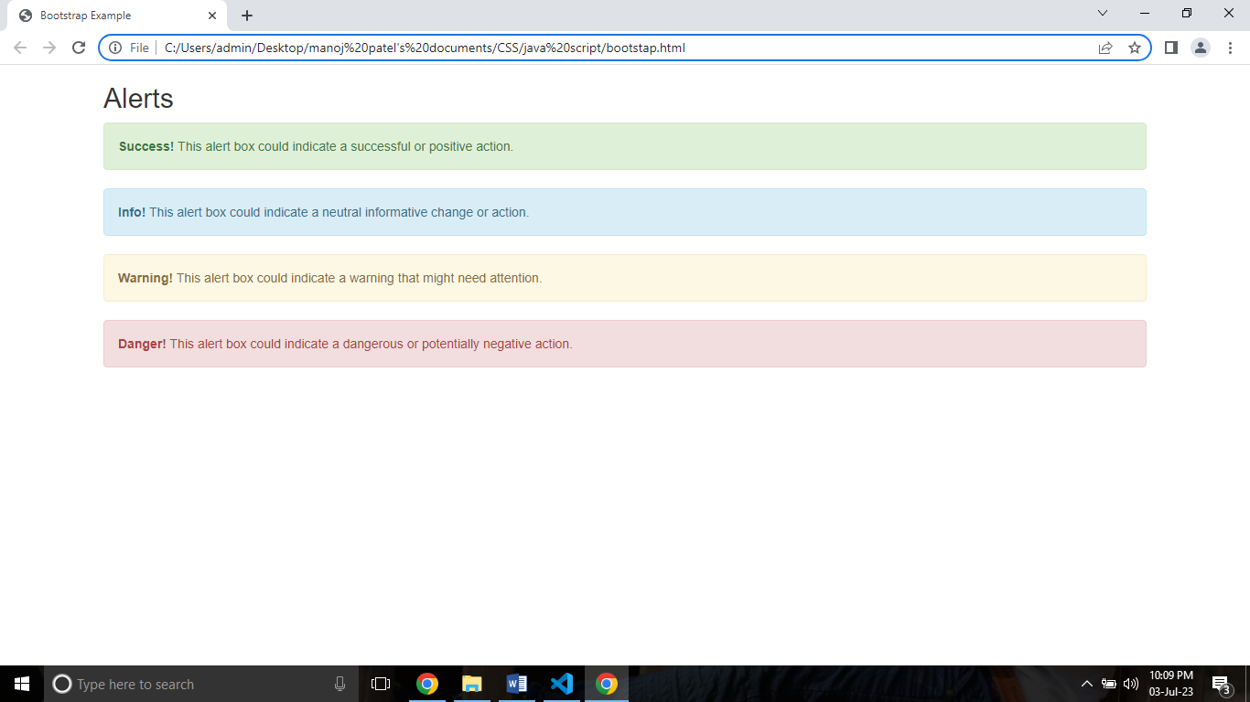

**10. What is a bootstrap card and how would you create one?**

A card is a flexible and extensible content container. It includes options for headers and footers, a wide variety of content, contextual background colors, and powerful display options. If you're familiar with Bootstrap 3, cards replace our old panels, wells, and thumbnails.

<!DOCTYPE html>

<html lang="en">

<head>

  <title>Bootstrap Example</title>

  <meta charset="utf-8">

  <meta name="viewport" content="width=device-width, initial-scale=1">

  <link rel="stylesheet" href="https://cdn.jsdelivr.net/npm/bootstrap@4.6.2/dist/css/bootstrap.min.css">

  <script src="https://cdn.jsdelivr.net/npm/jquery@3.6.4/dist/jquery.slim.min.js"></script>

  <script src="https://cdn.jsdelivr.net/npm/popper.js@1.16.1/dist/umd/popper.min.js"></script>

  <script src="https://cdn.jsdelivr.net/npm/bootstrap@4.6.2/dist/js/bootstrap.bundle.min.js"></script>

</head>

<body>

<div class="container">

  <div class="card" style="width:400px">

    <img class="card-img-top" src="https://t4.ftcdn.net/jpg/05/11/55/91/360_F_511559113_UTxNAE1EP40z1qZ8hIzGNrB0LwqwjruK.jpg" alt="Card image" style="width:100%">

    <div class="card-body">

      <h4 class="card-title">John Doe</h4>

      <p class="card-text">John Doe is an architect and engineer</p>

      <a href="#" class="btn btn-primary">See Profile</a>

    </div>

  </div>

  <br>

</body>

</html>

