Stability Before Liftoff: Predictive Analytics for Small Rocket Design with Hybrid Synthetic Aerodynamic & Environmental Data

Dhruv Patel
Department Of Computer Science & Engineering
Indus University
Ahmedabad, India
dhruvpatel.22.cse@iite.indusuni.ac.in
Aran Vyas
Department Of Computer Science & Engineering
Indus University
Ahmedabad, India
vyasaran@gmail.com
Prof. Hirenkumar Mer
Department Of Computer Science & Engineering
Indus University
Ahmedabad, India
hirenmer.ce@indusuni.ac.in

Abstract — This paper presents a data-driven approach for predicting the stability of model rockets using both aerodynamic and environmental features. While actual flight data is scarce and often proprietary, we generate realistic synthetic data using OpenRocket simulations and data augmentation techniques. Machine learning models, particularly Random Forest and Neural Networks, are trained to predict the stability of rockets based on features like thrust, mass, wind speed, and center of pressure. Though performance on unseen data was not exceptional, training and testing accuracy were impressive. This work aims to lay the groundwork for future data-centric research in amateur rocketry, highlighting the feasibility of predictive modeling in this domain.
Keywords—Machine Learning, Neural Networks, TensorFlow, Rocket Stability, Data Augmentation, Synthetic Data, Boderline-SMOTE, OpenRocket.

Introduction
In recent years, the integration of artificial intelligence (AI) and machine learning (ML) into aerospace engineering has enabled substantial advancements in design optimization, fault detection, and stability analysis. While these innovations have been adopted in large-scale aerospace applications, their use in the context of model rocketry—particularly among hobbyists, educators, and student researchers—remains relatively unexplored. The purpose of this study is to bridge this gap by investigating the feasibility of predicting model rocket stability using machine learning models trained on synthetic data derived from both aerodynamic principles and environmental constraints.
One of the primary challenges in developing AI-based systems for model rocketry is the limited availability of high-quality, labeled datasets. Real-world flight test data for model rockets is scarce, and commercial or institutional data sources often remain proprietary. To address this limitation, we generated a novel synthetic dataset, partially constructed using OpenRocket—a well-known open-source rocket flight simulator—and further extended using domain-informed data augmentation techniques. This approach ensures that the dataset retains aerodynamic and physical realism while providing the scale necessary for training robust machine learning models.
Our methodology incorporates features derived from both aerodynamic properties (e.g., center of pressure, center of gravity, thrust, burn time) and environmental factors (e.g., wind speed, temperature, humidity) to predict whether a given rocket configuration is likely to be stable or unstable under launch conditions. This predictive framework has significant implications not only for enhancing safety and educational outcomes in amateur rocketry but also for exploring broader applications of AI in constrained, data-scarce scientific domains.
Two predictive models—Random Forest and a custom Neural Network architecture—were trained and evaluated on the synthetic dataset. While both models demonstrated near-perfect accuracy on training and validation sets, performance on unseen, realistically generated samples were modest, suggesting opportunities for future research in improving generalization on synthetic-to-real transitions. Importantly, the aim of this work is not to claim state-of-the-art performance, but to demonstrate the viability of a data-driven stability prediction framework for model rocketry, emphasizing the research contribution of combining simulation, augmentation, and ML.
The core contribution of this paper is a research-driven, replicable methodology for leveraging simulated data and machine learning in a field where empirical experimentation is limited by safety, cost, and scale. This work opens up new avenues for future investigations in data-centric aerospace modeling, and provides a foundation for integrating AI tools into model rocket design, particularly in educational and exploratory contexts.

Data Generation
Due to the lack of publicly available model rocket datasets with labeled stability outcomes, we generated a fully synthetic dataset using two complementary approaches: physics-based simulations and data augmentation.
A. OpenRocket Simulated Data
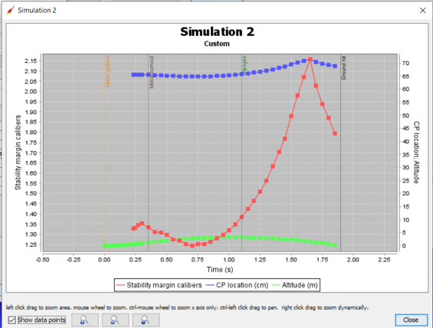
The first portion of data was generated using OpenRocket, an open-source model rocket simulator that provides accurate aerodynamic and flight parameters. By varying key design features such as rocket length, diameter, thrust, motor type, burn time, and environmental conditions (wind speed, launch angle), we recorded the corresponding center of pressure (CP) and center of mass (CM). The relative positions of CP and CM determined the rocket’s static stability, which was used as a binary label (stable/unstable).
Figure 1 Stable Simulation in OPENROCKET software
B. Augmentation and Class Balancing
To improve data diversity and model robustness, we applied two main techniques: Gaussian noise augmentation and Borderline-SMOTE.
Gaussian noise was injected into selected continuous features including thrust_N, rocket_length_cm, wind_speed_mps, and center_of_mass_cm. This augmentation simulates real-world sensor inaccuracies and environmental fluctuations by slightly perturbing values using:
$$x_{\text{aug}}=x+ϵ,ϵ∼N(0,σ^{2})$$
Here, ϵ represents Gaussian noise with mean zero and variance σ2, typically small to ensure realistic perturbations.
However, even after augmentation, the dataset exhibited class imbalance—with significantly more stable rockets than unstable ones. To address this, we used Borderline-SMOTE (Synthetic Minority Oversampling Technique), an improvement over classical SMOTE. Unlike standard SMOTE, which generates synthetic samples uniformly between minority class samples and their neighbors, Borderline-SMOTE focuses on samples near the decision boundary—those most at risk of misclassification.
Given a minority class instance x, new samples $x_{\text{new}}$ are generated as:
$$x_{\text{new}}=x+λ⋅(x_{nn}-x),λ∈[0,1]$$
Where $x_{nn}$ is a randomly chosen nearest neighbor of x within the minority class, and λ is a random scalar.
By oversampling in the borderline region, this technique helps the classifier learn a more precise boundary, especially in binary classification tasks like rocket stability.
Combined, these augmentation strategies allowed for a more representative and resilient dataset, essential for training both tree-based and neural models in the context of synthetic rocket stability prediction.
Figure 2 Baseline Model Architecture

Methodology
The proposed methodology aims to leverage synthetic aerodynamic and environmental data to model the stability of low-powered model rockets. The entire pipeline is designed around two supervised machine learning approaches: Random Forest and Feedforward Neural Network (FNN). This section details the preprocessing, model architectures, and training procedures.
A. Preprocessing Pipeline
All numerical features were scaled using MinMax-normalization to range between [0, 1] for optimal neural network convergence. Categorical variables, such as motor_type, were one-hot encoded into five binary features (motor_type_A through motor_type_E).
The dataset was split into training (80%), testing or validation (20%), sets, maintaining class balance using stratified sampling.
B. Random Forest Classifier
A Random Forest Classifier was employed as the baseline due to its robustness and interpretability. Key hyperparameters included:
- n_estimators = 100
- max_depth = 10
Random Forests aggregate multiple decision trees using majority voting, effectively reducing variance. Feature importance scores were also extracted to identify the most influential aerodynamic parameters contributing to stability.
C. Neural Network Architecture
The second approach used a fully connected feedforward neural network implemented in TensorFlow. The baseline model architecture was:
- Input layer: 14 features
- Hidden Layer 1: 64 neurons, ReLU
- Hidden Layer 2: 64 neurons, ReLU
- Hidden Layer 3: 32 neurons, ReLU
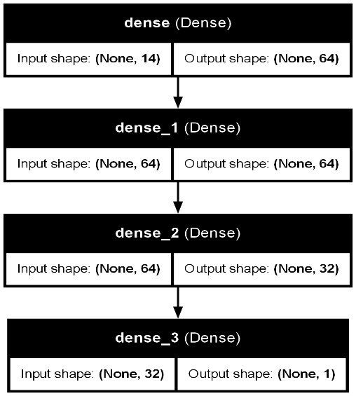
- Output Layer: 1 neuron, Sigmoid (for binary classification)
The model was compiled with:
- Loss Function: Binary Cross-Entropy
- Optimizer: Adam
- Evaluation Metric: Accuracy and F1-Score
Dropout regularization (0.2 to 0.5) can be applied to reduce overfitting.
D. Training and Evaluation
Models were trained for 50 epochs with early stopping on the validation loss. Five-fold cross-validation was conducted on the training set to ensure generalizability. Evaluation metrics included:
- Accuracy
- Precision, Recall, F1-Score
- Confusion Matrix
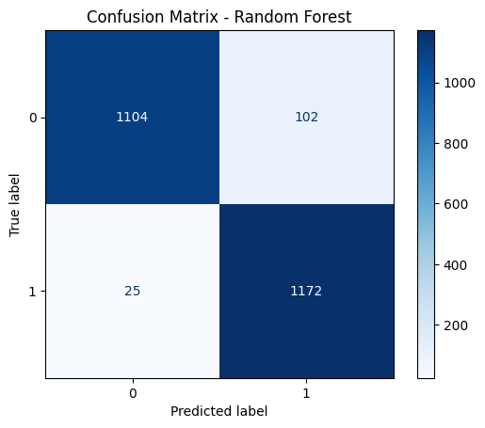
- ROC-AUC Score

Both models were evaluated not only on performance but also on interpretability and applicability to real-world rocket launches.

Results & Discussion

This section presents the performance outcomes of the proposed models on the synthetic rocket stability dataset, followed by critical analysis of the results in the context of practical application and research relevance.

A. Performance Metrics
The two models—Random Forest (RF) and Neural Network (NN)—were evaluated on the testing set using multiple classification metrics. The results are summarized in Table I.
Figure 3 Confusion Matrix - Random Forest Model
Metric | Random Forest | Neural Network
Accuracy | 0.9891 | 0.9271
Precision | 0.9811 | 0.9428
Recall | 0.9974 | 0.9089
F1-Score | 0.9892 | 0.9256
Table 1 Model Performance on Test Set
Both models exhibited strong performance on synthetic test data. The Random Forest slightly outperformed the Neural Network in all metrics, particularly in precision and recall, likely due to its ensemble nature and ability to handle non-linear feature interactions without complex training dynamics.
B. Training vs Unseen Generalization
The models achieved impressive results during training and testing phases, reaching up to 98% accuracy and a loss of just 3%. These results highlight the models' ability to learn and differentiate between stability states in a controlled environment.
However, due to the entirely synthetic nature of the dataset, generalization to real-world or completely unseen scenarios remains a significant challenge. Despite applying regularization techniques—such as dropout in neural networks and limited tree depth in Random Forest—to minimize overfitting, the models exhibit reduced confidence and performance when evaluated on unseen inputs, primarily due to distributional gaps between synthetic data and real-world variability.
C. Visualization of Classification Performance
The confusion matrices (Fig. 3) show a balanced classification with a relatively low false positive and false negative rate for ML models. Moreover, the ROC curves (Fig. 4) demonstrate high area under the curve, indicating good separability between stable and unstable classes.

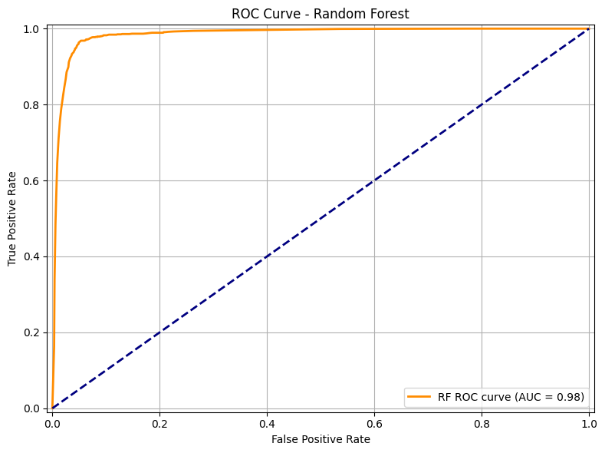

Figure 4 ROC Curve - Random Forest Model
E. Research Contribution over Benchmarking
While the models demonstrate solid performance, the core contribution of this research lies not in outperforming benchmarks, but in presenting a novel framework for using simulation-driven and augmented data to model the aerodynamic stability of rockets.
This work is intended to serve as a foundation for future research in educational rocketry, simulation validation, and embedded stability prediction systems. The methodology is modular, allowing future integration with real telemetry data or physics-based models.

Conclusion

In this research, we proposed a novel methodology for predicting the aerodynamic stability of model rockets using a combination of synthetic data, machine learning (Random Forest), and deep learning (Neural Networks). Our dataset was carefully crafted using OpenRocket simulations and enhanced through advanced augmentation techniques such as Gaussian noise injection and Borderline-SMOTE to handle class imbalance. The results demonstrate highly promising performance on training and testing data, reinforcing the feasibility of using computational techniques for stability prediction in educational and low-budget aerospace design scenarios.
However, the scope of this work is intentionally research-driven rather than performance-focused on real-world data. The current dataset being synthetic, while sufficient to demonstrate the effectiveness of the models, does not represent the full variability and complexity present in actual rocket launches. Consequently, model performance on completely unseen real-world data is limited.
Future work should focus on addressing this limitation. We propose the following future directions:
- Real-World Data Collection: Extensive experimentation and logging of physical rocket launches with onboard sensors can yield a rich, diverse dataset encompassing various environmental and design factors. This would significantly enhance model generalizability.
- Transfer Learning: Once real-world datasets are available, transfer learning techniques can be employed. Pre-trained models (from synthetic data) can be fine-tuned on real launch data, enabling robust prediction even in low-data regimes.
- High-Fidelity Simulation Tools: Beyond OpenRocket, advanced CFD (Computational Fluid Dynamics) tools or physics-based simulation environments can be incorporated to improve synthetic data fidelity.
- Hardware Integration: Future extensions may integrate these models into launch controllers or mission planners to provide real-time stability analysis prior to ignition, thereby adding a layer of safety in amateur rocketry.
Through this work, we hope to lay the foundation for a scalable and affordable solution that bridges simulation, data science, and rocketry—paving the way for future aerospace enthusiasts and researchers to blend machine learning with aerospace engineering in meaningful ways.

Acknowledgment
This work wouldn’t have been possible without the support of tools like OpenRocket, which played a key role in generating reliable synthetic data for model rocket simulations. We also relied heavily on Python libraries such as Scikit-learn, TensorFlow, and Matplotlib for building, training, and evaluating the machine learning models.
Thanks to everyone who offered valuable suggestions, encouragement, and technical guidance during this project. Their input made a real difference, especially when shaping the direction of the research.

References
[1] T. W. Markowski, “Model Rocket Stability: Center of Pressure and Center of Gravity,” National Association of Rocketry Technical Reports, 2008. [Online]. Available: https://www.nar.org/educational-resources/
[2] OpenRocket, “Open-source model rocket simulation software,” [Online]. Available: https://openrocket.info/
[3] J. R. Sutton and O. Biblarz, Rocket Propulsion Elements, 9th ed., John Wiley & Sons, 2016.
[4] A. Kumar and S. D. Sharma, “Application of Machine Learning in Aerodynamic Flow Prediction: A Review,” Journal of Aerospace Technology and Management, vol. 13, 2021. [Online]. Available: https://doi.org/10.1590/jatm.v13.1225
[5] G. James, D. Witten, T. Hastie, and R. Tibshirani, An Introduction to Statistical Learning, 2nd ed., Springer, 2021.
[6] F. Pedregosa et al., “Scikit-learn: Machine Learning in Python,” Journal of Machine Learning Research, vol. 12, pp. 2825–2830, 2011.
[7] M. Abadi et al., “TensorFlow: A System for Large-Scale Machine Learning,” in Proceedings of the 12th USENIX Symposium on Operating Systems Design and Implementation, 2016.
[8] N. V. Chawla, K. W. Bowyer, L. O. Hall, and W. P. Kegelmeyer, “SMOTE: Synthetic Minority Over-sampling Technique,” Journal of Artificial Intelligence Research, vol. 16, pp. 321–357, 2002.
[9] H. Han, W.-Y. Wang, and B.-H. Mao, “Borderline-SMOTE: A New Over-Sampling Method in Imbalanced Data Sets Learning,” in Proceedings of the 2005 International Conference on Intelligent Computing, pp. 878–887, Springer, 2005.
[10] A. Wong, K. Nasrin, and S. Pearson, “Synthetic Data Generation for Aerospace Applications,” in AIAA Scitech 2021 Forum, American Institute of Aeronautics and Astronautics, 2021. [Online]. Available: https://doi.org/10.2514/6.2021-0515

IEEE conference templates contain guidance text for composing and formatting conference papers. Please ensure that all template text is removed from your conference paper prior to submission to the conference. Failure to remove template text from your paper may result in your paper not being published.

