================================================
DataCo Supply Chain — SQL Analysis Notes
================================================
Date: May 2026
Tool: PostgreSQL pgAdmin 4
Database: dataco_db
Rows: 180,519
================================================

QUERY 1: Delivery Status Distribution
------------------------------------------------
Business Question:
Which delivery status appears most?
My Hypothesis Before Running:
I thought late delivery would be highest because
in real life on time delivery count is mostly less

Query:
SELECT
"Delivery Status",
COUNT(*) AS order_count,
ROUND(COUNT(*) * 100.0 / SUM(COUNT(*)) OVER(), 2) AS percentage
FROM supply_chain
GROUP BY "Delivery Status"
ORDER BY order_count DESC;

Output:
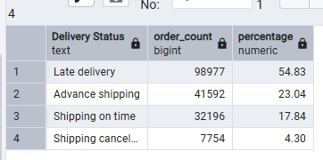
What I Found:
More than half of all orders are late delivered
Late delivery count is highest which i expected
Only 17.8% orders are on time

Did It Surprise Me:
No - it confirmed what i thought
Late delivery being high is common in real life

Business Meaning:
- More than half orders are late so in future
- customers will stop ordering from this company
- Order count will decrease if this continues
- Company needs to fix delivery operations urgently

QUERY 2: Shipping Mode Delay Analysis
------------------------------------------------
Business Question:
Which shipping mode has highest late delivery rate?
My Hypothesis Before Running:
I thought Second Class would be worst because
in Excel it showed ~2 days average delay
First Class showed only 1 day average delay
Standard Class was almost on time in Excel

Query:
SELECT "Shipping Mode",
COUNT(*) AS total_orders,
SUM("Late_delivery_risk"::INT) AS late_orders,
ROUND(SUM("Late_delivery_risk"::INT) * 100.0 / COUNT(*), 2) AS late_percentage
FROM supply_chain
GROUP BY "Shipping Mode"
ORDER BY late_percentage DESC;

Output:
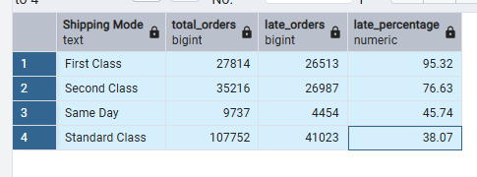
What Surprised Me:
First Class is worst at 95.32% late
I was surprised because First Class is expensive
Expensive shipping should mean faster delivery
But data shows opposite - paying more = worse service
Excel showed Second Class worst by average delay days
SQL showed First Class worst by late percentage
Both measure different things - percentage is more accurate

What I Learned:
Excel average delay days vs SQL late percentage
are two different measurements
Average delay = how many days late on average
Late percentage = how many orders were late out of total
Percentage gives fairer comparison than raw count
Never judge performance by one metric alone

Business Meaning:
Standard Class handles 107,752 orders but only 38% late
First Class handles only 27,814 orders but 95% late
Company manages Standard Class operations better
Customers paying premium price getting worst service
First Class operations need urgent investigation
Pricing vs performance mismatch is a serious problem

================================================
Concepts I Learned Today:
------------------------------------------------
SELECT = choose which columns to show
COUNT(*) = count how many rows in each group
GROUP BY = group same values together like pivot table
ORDER BY DESC = sort from highest to lowest
SUM() = add up numbers in a column
::INT = convert text column to number
ROUND(,2) = show only 2 decimal places
WHERE = filter rows like Excel dropdown filter
* 100.0 = convert decimal to percentage
OVER() = calculate percentage of total

Key Lesson Today:
Percentage is more accurate than raw count
Excel and SQL measure same data differently
Always verify Excel findings with SQL exact numbers
================================================
QUERY 3: Region Profitability Analysis
------------------------------------------------
Business Question:
Which regions have highest late delivery and lowest profit?
My Hypothesis Before Running:
I thought USA or America would have highest profit
because it is a rich and well known country

Query:
SELECT "Order Region",
AVG("Delivery Delay"::INT) AS avg_delay,
SUM("Order Profit Per Order") AS total_profit
FROM supply_chain
WHERE "Delivery Delay"::INT > 0
GROUP BY "Order Region"
ORDER BY total_profit DESC;

Output:
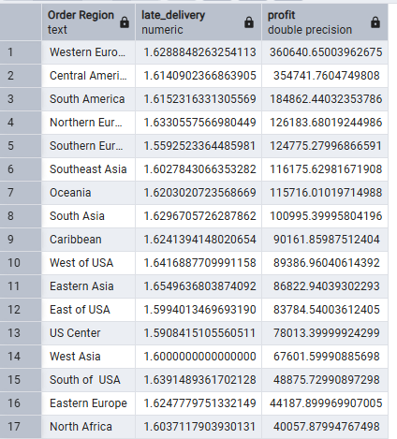
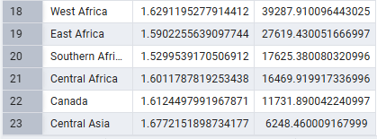
What I Found:
Western Europe has highest profit not USA
which surprised me because USA is rich country
Central Asia has highest delay 1.67 days
AND lowest profit 6,248
All regions have almost same delay around 1.6 days

What Surprised Me:
USA was not highest profit - Western Europe was
My assumption about rich country = high profit was wrong
Data does not always match assumptions

Key Analytical Insight:
All regions have same delay around 1.6 days
So delay is NOT the main reason for profit difference
Main reasons for profit difference are:
- discount strategy per region
- total order count per region
This is my own observation from connecting findings

Business Meaning:
Central Asia has double problem - high delay + low profit
But delay alone does not explain low profit
Company needs to investigate discount strategy
per region not just delivery operations

New Concept Learned:
Always look for multiple reasons not just one
One metric never tells the full story
Connect findings across queries for deeper insight
================================================
QUERY 4: Discount Impact on Profit
------------------------------------------------
Business Question:
Do higher discounts reduce profit?
My Hypothesis Before Running:
High discount reduces profit margin
this is basic understanding of pricing

Query:
SELECT "Discount Bucket",
COUNT(*) AS total_orders,
ROUND(SUM("Order Profit Per Order"::NUMERIC), 2) AS total_profit,
ROUND(AVG("Order Profit Per Order"::FLOAT)::NUMERIC, 2) AS avg_profit_per_order
FROM supply_chain
GROUP BY "Discount Bucket"
ORDER BY avg_profit_per_order DESC;

Output:
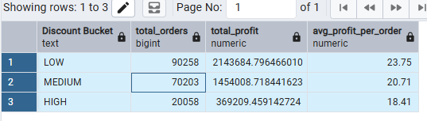
What I Found:
As discount increases profit decreases consistently
LOW to MEDIUM to HIGH = 23.75 to 20.71 to 18.41
Clear pattern confirmed my hypothesis

Did It Surprise Me:
No it confirmed what i thought
High discount always reduces profit margin

Key Analytical Insight:
Medium discount is safer side for company
High discount attracts customers attention
but reduces profit which makes services weak
If profit is less then company cannot maintain
good service quality in long term
This creates a cycle - bad service = less customers

Business Meaning:
Company giving high discount to attract more orders
But high discount = less profit = weaker operations
They should limit high discounts
Focus on low discount strategy for sustainable profit
Medium discount is acceptable but needs monitoring

New Concept Learned:
AVG combines positive and negative values together
So AVG profit can look positive even when some
individual orders have negative profit
Always check both AVG and individual order level
================================================
QUERY 5: Top 10 Loss Making Products
------------------------------------------------
Business Question:
Which 10 products are losing the most money?
My Hypothesis Before Running:
I did not expect fitness equipment to be loss making
because elliptical machines are used most by people
Poor service and less orders may also cause losses

Query:
SELECT "Product Name",
COUNT(*) AS total_orders,
ROUND(SUM("Order Profit Per Order"::NUMERIC), 2) AS total_profit,
ROUND(AVG("Order Profit Per Order"::FLOAT)::NUMERIC, 2) AS avg_profit_per_order
FROM supply_chain
GROUP BY "Product Name"
ORDER BY avg_profit_per_order ASC
LIMIT 10;

Output:
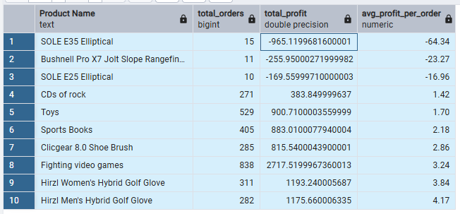
What I Found:
Top 3 products have negative profit per order
SOLE E35 loses 64.34 on every single order
Both SOLE products are elliptical machines
Same brand same category both losing money
Sports Books has 405 orders but only 1.42 avg profit
Not many people buying sports books

What Surprised Me:
Fitness equipment expected to sell well
But both elliptical machines are top loss makers
Poor service and high discount likely causing this
Selling more of these products = losing more money

Key Analytical Insight:
It is not just one bad product
Entire elliptical category is unprofitable
Both SOLE E35 and SOLE E25 from same brand
Company needs to review entire product line
not just individual products

Business Recommendations:
1. Improve service quality for SOLE elliptical products
2. Improve product quality or reduce price
3. Stop creating new versions of loss making products
4. Remove SOLE E25 and E35 from catalog or reprice
5. Review discount strategy on these specific products

New Concept Learned:
LIMIT = show only top N results
ORDER BY ASC = lowest first to find worst performers
Negative AVG profit = company loses money every sale
Always check both total and average for full picture
================================================
QUERY 6: CTE — Double Trouble Regions
------------------------------------------------
Business Question:
Which regions have BOTH high delay AND low profit?

New Concept — CTE:
Normal query = one question one answer
CTE = save first answer then ask second question
on top of that saved answer
Like Excel — make pivot table then filter it further

Why CTE needed here:
WHERE cannot filter on AVG or SUM directly
So we calculate first in CTE
Then filter on calculated values in second SELECT

My Thinking Process:
Step 1 — find regions with avg delay and total profit
Step 2 — filter where delay high AND profit low
Cutoff used: avg_delay > 0.6 AND total_profit < 50,000

Query:
WITH regions AS (
SELECT "Order Region",
AVG("Delivery Delay"::INT) AS avg_delay,
SUM("Order Profit Per Order"::NUMERIC) AS total_profit
FROM supply_chain
GROUP BY "Order Region"
)
SELECT *
FROM regions
WHERE avg_delay > 0.6 AND total_profit < 50000
ORDER BY total_profit ASC;

Output:
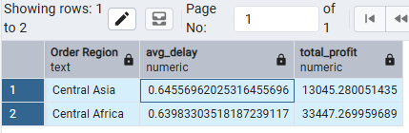
What I Found:
Only 2 regions are double trouble zones
Central Asia = worst performer overall
Both regions are remote locations

Why These Regions Struggle:
Remote location = longer travel distance
Longer distance = higher shipping cost
Higher cost = lower profit margin
More distance = more chances of delay
I connected geography to logistics to profit myself

Business Meaning:
Central Asia needs most urgent attention
Review shipping routes and pricing strategy
Consider if these markets worth serving
at current cost and delay levels

New Concept Learned:
CTE = WITH cte_name AS (first query)
SELECT FROM cte_name WHERE condition
Used when WHERE cannot filter on aggregates
Makes complex two step queries clean and readable
================================================
QUERY 7: Window Function — Shipping Mode Ranking
------------------------------------------------
Business Question:
Rank shipping modes by late delivery percentage

New Concept — Window Function:
GROUP BY = groups rows, individual rows disappear
Window Function = calculates but keeps all rows visible
RANK() OVER(ORDER BY column DESC) = assigns rank number
Rank 1 = worst performer, Rank 4 = best performer

Important Rule Learned:
Cannot use alias name inside OVER()
SQL reads OVER() before creating alias
Must repeat full formula inside OVER()

Excel Equivalent:
Adding RANK column next to data
All rows stay but each gets rank number

Query:
SELECT "Shipping Mode",
COUNT(*) AS total_orders,
SUM("Late_delivery_risk"::INT) AS late_orders,
ROUND(SUM("Late_delivery_risk"::INT) * 100.0 / COUNT(*), 2) AS late_percentage,
RANK() OVER(ORDER BY
ROUND(SUM("Late_delivery_risk"::INT) * 100.0 / COUNT(*), 2)
DESC) AS delay_rank
FROM supply_chain
GROUP BY "Shipping Mode"
ORDER BY delay_rank;

Output:
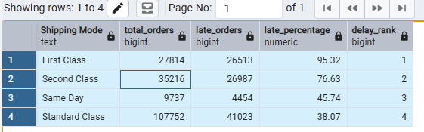
My Hypothesis Before Running:
I did not expect First Class to be Rank 1 worst
They charge more so should deliver better service

What Surprised Me:
Standard Class has most orders but still best rank
Same Day also performed decently at Rank 3
First Class charging premium but worst performer

Business Recommendations:
1. Fix First Class urgently or reduce premium pricing
2. Invest more in Standard Class operations
3. Standard Class improvement = biggest impact
because it handles most order volume

New Concept Learned:
Window Function = RANK() OVER(ORDER BY)
Keeps all rows visible unlike GROUP BY
Cannot use alias inside OVER()
Must repeat full formula inside OVER()

