**Dimitrije Prosevski Lab 7 03/31/2019**

1. The data set is about mushrooms with 926136 (8124x114) entries in the item matrix with density of 0.193. Data set has the description of samples corresponding to 23 gilled mushrooms. The data contains 23 features and a class that specifies if its edible or poisonous. 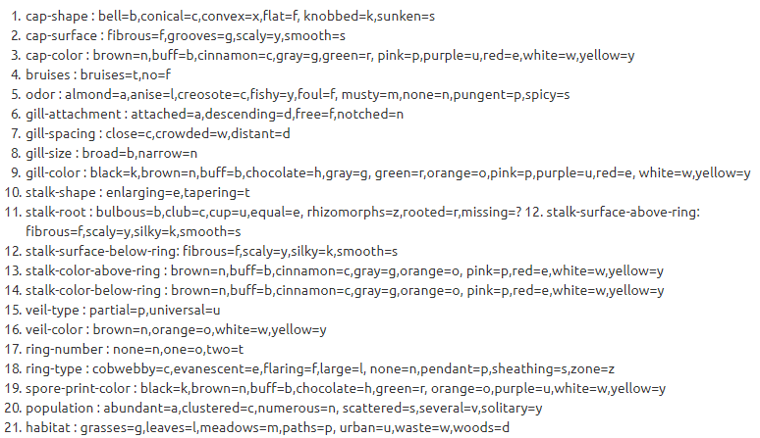

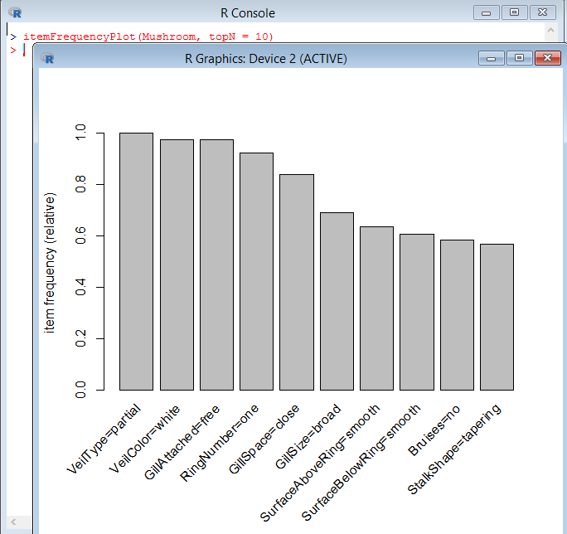The top 10 items/features occurring were:

1. The purpose of this associative rule analysis is to analyze the physical metrics obtained and predict the classification whether the mushroom is poisonous or edible.

inspect(Mushroom[1:1])

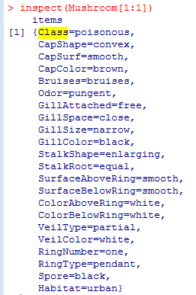

install.packages("arules")

require(arules)

installing the package

data(Mushroom)

summary(Mushroom)

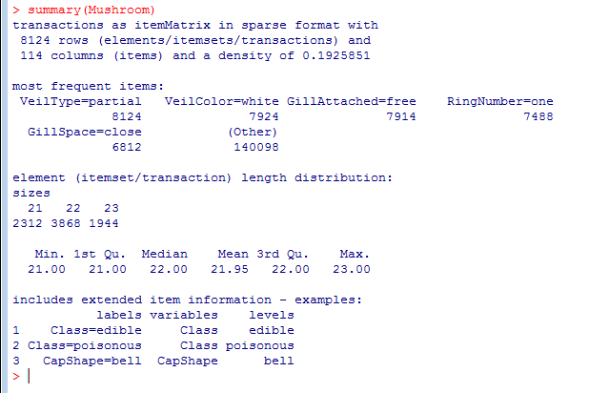

choosing Mushroom as dataset and prompt the summary information

mod1 = apriori(Mushroom, parameter=list(support=0.40, confidence=0.60, minlen=2))

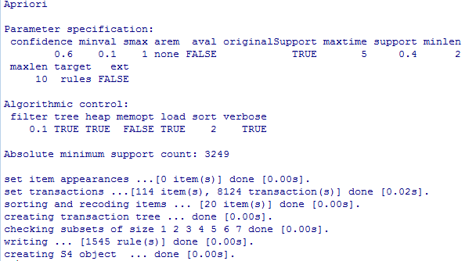

Using apriori method to set the rules for frequent entries and predict the results

inspect(sort(mod1, by="lift")[1:10])

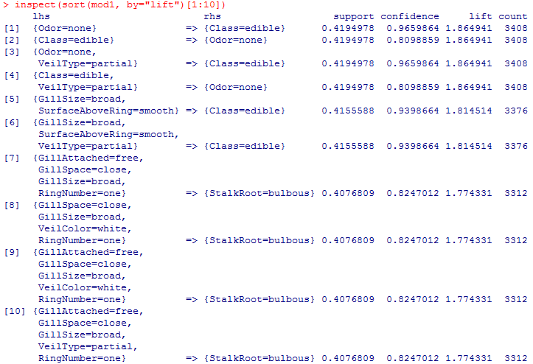

Inspecting the ten entries sorted by lift we can conclude that edible mushroom would be the one that have no odor, since lift is the highest of 1.865.

(Odor=none) -> Class=edible

4.

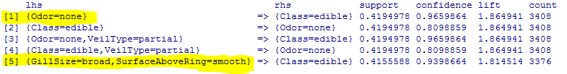

I found number one and five the most interesting since I never knew that odor or smooth surface could mean poisonous.