**Newton’s method Dimitrije Prosevski MATH 414**

**Source Code:**

clear

clc

syms x;

eps = 0.000001; % for error less 10^-6

inputFunction = input('Input your function of "x"');

f=inline(inputFunction);

f1=inline(diff(f(x)));

x = input('Your initial guess:');

% prints

fprintf('\n\nn\t xn\t\t\t\t\t f(xn)');

fprintf('\n%d\t %1.16f\t %e\n', i, x, f(x));

% Newton's method

for i=0:5000

xn = x;

x = xn - (f(x)/f1(x));

if(abs(x - xn) < eps)

fprintf('Converge\n\n');

break;

elseif(i == 5000)

fprintf('Diverge\n\n');

break;

end

fprintf('\n%d\t %1.16f\t %e\n', i+1, x, f(x));

end

**Problem 10:**

**A)**

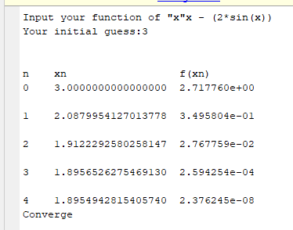

**B)**

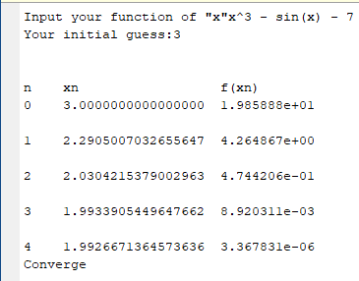

**C)**

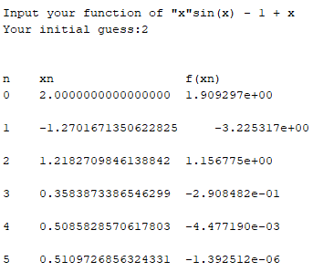

**D)**

