Environmental Forest Management (EFM)

Dimitrije Prosevski

NN: 25

CSCI-44300 Database Systems

11/22/2019

**Executive Summary**

As newly selected Design Team Leader for EFM project I designed the database that is 5NF (no redundancy) and the security provided by normal integrity constrains which are automatically enforced by the DBMS based upon the information provided in all four memos. Database contains 9 entities and 20 attributes. Program used to create Logical and Physical Data Models and generate database was “ERwin”. Further data insertion and manipulation was done in SSMS (Microsoft SQL Server Management Studio 18).

**Memorandum**

**To:** Dr. John Gersting

**From:** Dimitrije Prosevski

**Date:** 11/22/2019

**Subject:** Delivery of EFM database

**Introduction**

To get the better idea I will begin with Memos (1-4).

**Memo 0, 1, 2:**

Introductory information provided by the Memo 0, Memo 1. Memo 2

**Requested functional dependency:**

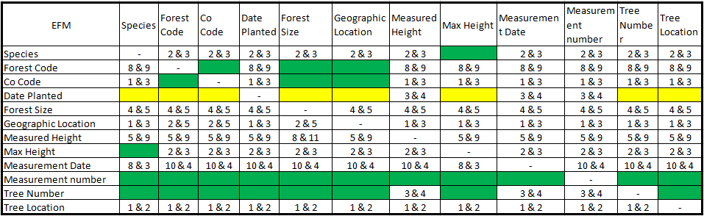

**Logical Data Model (LDM):**

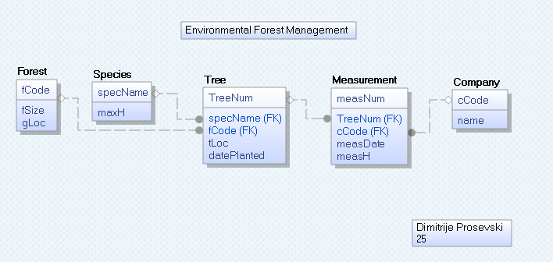

**Memo 3:**

After adding additional, data database had to be modified with new entities and relationships.

**LDM:**

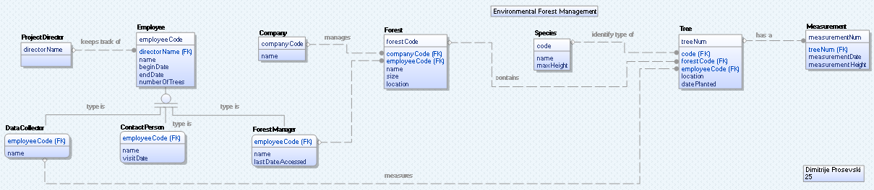

**PDM:**

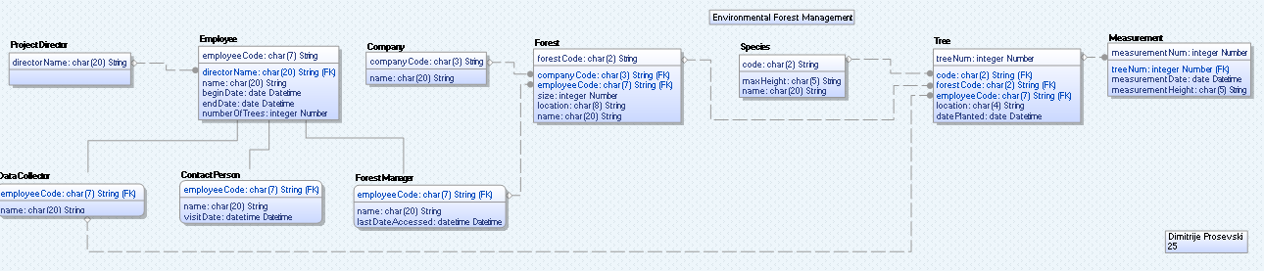

**Memo 4:**

After consultation with Dr. John Gersting, Memo 4 got analyzed and with several correction final LDM and PDM are:

**LDM:**

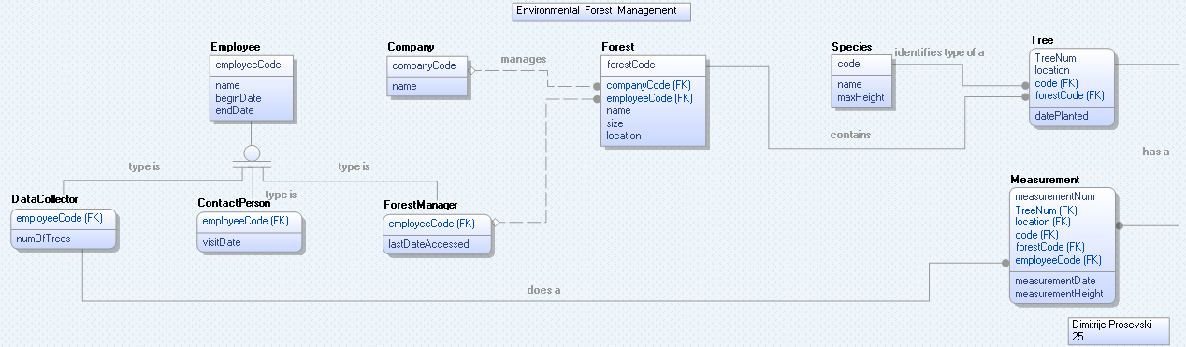

**PDM:**

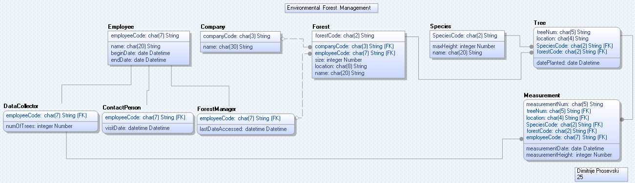

**Database generation:**

**Settings from Erwin:**

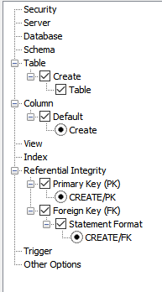

**Generated code:**

CREATE TABLE Company

(

companyCode char(3) NOT NULL ,

name char(30) NULL ,

PRIMARY KEY CLUSTERED (companyCode ASC)

)

Execution Successful

CREATE TABLE Employee

(

employeeCode char(7) NOT NULL ,

name char(20) NULL ,

beginDate date NULL ,

endDate date NULL ,

PRIMARY KEY CLUSTERED (employeeCode ASC)

)

Execution Successful

CREATE TABLE ForestManager

(

employeeCode char(7) NOT NULL ,

lastDateAccessed datetime NULL ,

PRIMARY KEY CLUSTERED (employeeCode ASC),

FOREIGN KEY (employeeCode) REFERENCES Employee(employeeCode)

)

Execution Successful

CREATE TABLE Forest

(

forestCode char(2) NOT NULL ,

companyCode char(3) NULL ,

employeeCode char(7) NULL ,

size integer NULL ,

location char(8) NULL ,

name char(20) NULL ,

PRIMARY KEY CLUSTERED (forestCode ASC),

FOREIGN KEY (companyCode) REFERENCES Company(companyCode),

FOREIGN KEY (employeeCode) REFERENCES ForestManager(employeeCode)

)

Execution Successful

CREATE TABLE Species

(

SpeciesCode char(2) NOT NULL ,

maxHeight integer NULL ,

name char(20) NULL ,

PRIMARY KEY CLUSTERED (SpeciesCode ASC)

)

Execution Successful

CREATE TABLE Tree

(

treeNum char(5) NOT NULL ,

location char(4) NOT NULL ,

SpeciesCode char(2) NOT NULL ,

forestCode char(2) NOT NULL ,

datePlanted date NULL ,

PRIMARY KEY CLUSTERED (treeNum ASC,location ASC,SpeciesCode ASC,forestCode ASC),

FOREIGN KEY (forestCode) REFERENCES Forest(forestCode),

FOREIGN KEY (SpeciesCode) REFERENCES Species(SpeciesCode)

)

Execution Successful

CREATE TABLE DataCollector

(

employeeCode char(7) NOT NULL ,

numOfTrees integer NULL ,

PRIMARY KEY CLUSTERED (employeeCode ASC),

FOREIGN KEY (employeeCode) REFERENCES Employee(employeeCode)

)

Execution Successful

CREATE TABLE Measurement

(

measurementNum char(5) NOT NULL ,

treeNum char(5) NOT NULL ,

location char(4) NOT NULL ,

SpeciesCode char(2) NOT NULL ,

forestCode char(2) NOT NULL ,

employeeCode char(7) NOT NULL ,

measurementDate date NULL ,

measurementHeight integer NULL ,

PRIMARY KEY CLUSTERED (measurementNum ASC,treeNum ASC,location ASC,SpeciesCode ASC,forestCode ASC,employeeCode ASC),

FOREIGN KEY (treeNum,location,SpeciesCode,forestCode) REFERENCES Tree(treeNum,location,SpeciesCode,forestCode),

FOREIGN KEY (employeeCode) REFERENCES DataCollector(employeeCode)

)

Execution Successful

CREATE TABLE ContactPerson

(

employeeCode char(7) NOT NULL ,

visitDate datetime NULL ,

PRIMARY KEY CLUSTERED (employeeCode ASC),

FOREIGN KEY (employeeCode) REFERENCES Employee(employeeCode)

)

Execution Successful

Schema Generation Complete

9 query succeeded.

**DB STATS:**

DB name: EFM25

Number of entities: 9

Number of sub-types: 3

Number of attributes: 20

**Entities:** (Gray fill for independent entities)

|  |  |  |  |  |  |  |  |  |
| --- | --- | --- | --- | --- | --- | --- | --- | --- |
| Measurement | Tree | Species | Forest | Employee | ContactPerson | DataCollector | ForestManager | Company |

**Attributes:** (Gray fill for Primary Keys)

|  |  |  |  |  |  |  |
| --- | --- | --- | --- | --- | --- | --- |
| Species Code | Species Name | Forest Code | Forest Name | Company Code | Company Name | Date Planted |

|  |  |  |  |  |  |
| --- | --- | --- | --- | --- | --- |
| Forest Size | Geographic Location | Measured Height | Max Height | Measurement Date | Measurement Number |

|  |  |  |  |  |  |  |
| --- | --- | --- | --- | --- | --- | --- |
| Tree Number | Tree Location | Employee Code | Employee Name | Begin Date | End Date | Number of Trees |

**Comments:**

In order to do the DB efficiently and avoid NULL values for Primary Keys (PKS)

I used “NA” word that stands for “Not Available”, in other words, “NA” replaces all the missing values in the PK fields. Blank spaces for the other attributes, that are not PKS, are inserted as “NULL” values.

**Relationships in “English”:**

**Employee**s hired for the project are under **Employee** entity. There are three types of employees: **Data Collector**, **Forest Manager** and **Contact Person**. **Data Collector** does the **Measurement**s on **Tree**s that are identified by **Species**. Different trees are inside different **Forest**s, and each **Forest** has a **Company** and is managed by a **Forest Manager**.

**Inserting data into the DB:**

--Edit order of insert statements:

--Species

--Company

--Employee

--Forest manager

--Contact person

--Data collector

--Forest

--Tree

--Measurement

--Before starting, type:

use EFM25;

--Species

INSERT INTO Species VALUES

('OK', 50, 'Oak'),

('MP', 45, 'Maple'),

('PN', 50, 'Pine'),

('NA', NULL, NULL);

--Company

INSERT INTO Company VALUES

('INF', 'Indiana Forest Company'),

('SSF', 'South State Forest Company'),

('NSF', 'North State Forest Company'),

('NA', NULL);

--Employee

INSERT INTO Employee VALUES

('EMP0000', 'Bob Bureaucrat', NULL, NULL),

('EMP0101', 'Sam Supervisor', NULL, NULL),

('EMP0102', 'Mary Manager', NULL, NULL),

('EMP0103', 'Fred Foreman', NULL, NULL),

('EMP1010', 'Bill', '2011/02/12', NULL),

('EMP1011', 'Joe', '2011/02/12', NULL),

('EMP1012', 'Vern', '2011/04/12', '2011/12/31'),

('EMP1013', 'Ann', '2011/04/12', '2011/12/31'),

('EMP1014', 'Mike', '2013/01/01', NULL),

('EMP1015', 'Kelly', '2013/03/12', NULL),

('EMP2025', 'Dimitrije', '2001/01/12', NULL),

('NA', NULL, NULL, NULL);

--ForestManager

INSERT INTO ForestManager VALUES

('EMP0101', NULL),

('EMP0102', NULL),

('EMP0103', NULL),

('NA', NULL);

--ContactPerson

INSERT INTO ContactPerson VALUES

('EMP0000', NULL),

('EMP0101', NULL),

('NA', NULL);

--DataCollector

INSERT INTO DataCollector VALUES

('EMP1010', 3),

('EMP1011', 1),

('EMP1012', 5),

('EMP1013', NULL),

('EMP1014', 3),

('EMP1015', 2),

('EMP2025', 3),

('NA', NULL);

--FOREST

INSERT INTO Forest VALUES

('IF', 'INF', 'EMP0101', 50, 'Area-311', 'Indiana Forest'),

('SS', 'SSF', 'EMP0102', 75, 'Area-933', 'South State Forest'),

('NS', 'NSF', 'EMP0103', 50, 'Area-933', 'North State Forest'),

('NA', 'NA', 'NA', NULL, NULL, NULL);

--TREE

INSERT INTO Tree VALUES

('728', '5W7S', 'OK', 'IF', '1996/11/01'),

('191', '5W7S', 'MP', 'SS', '1995/01/01'),

('391', '5W7S', 'MP', 'SS', '1996/01/01'),

('836', '3E5N', 'MP', 'IF', '1995/12/01'),

('836', '2W5N', 'PN', 'NS', '1996/01/01'),

('837', '2W5N', 'MP', 'NS', '1996/01/01'),

('850', '4W6N', 'PN', 'NS', '1996/02/01'),

('859', '2W5N', 'MP', 'IF', '1996/01/01'),

('859', '4W6N', 'PN', 'NS', '1996/02/01'),

('859', '4W6N', 'MP', 'SS', '1996/02/01'),

('836', '3E5N', 'PN', 'NS', '1995/01/01'),

('NA', 'NA', 'NA', 'NA', NULL);

--MEASUREMENT

INSERT INTO Measurement VALUES

('77', '728', '5W7S', 'OK', 'IF', 'EMP1014', '2017/03/01', 40),

('20', '391', '5W7S', 'MP', 'SS', 'NA', '2015/02/01', 31),

('21', '836', '3E5N', 'MP', 'IF', 'NA', '2015/03/01', 33),

('33', '836', '3E5N', 'MP', 'IF', 'NA', '2016/02/01', 38),

('57', '859', '4W6N', 'PN', 'NS', 'EMP1015', '2017/04/01', 42),

('54', '836', '3E5N', 'MP', 'IF', 'NA', '2017/03/01', 40),

('98', '391', '5W7S', 'MP', 'SS', 'EMP1010', '2018/02/01', 39),

('30', '728', '5W7S', 'OK', 'IF', 'NA', '2015/03/01', 35),

('80', '836', '3E5N', 'MP', 'IF', 'EMP1014', '2018/02/01', 42),

('44', '391', '5W7S', 'MP', 'SS', 'NA', '2016/02/01', 29),

('45', '191', '5W7S', 'MP', 'SS', 'EMP1010', '2016/02/01', 35),

('43', '859', '4W6N', 'MP', 'SS', 'EMP1010', '2018/03/01', 51),

('20', '850', '4W6N', 'PN', 'NS', 'EMP1014', '2017/03/01', 46),

('22', '837', '2W5N', 'MP', 'NS', 'NA', '2014/03/01', 31),

('42', '837', '2W5N', 'MP', 'NS', 'NA', '2016/02/01', 33),

('46', '837', '2W5N', 'MP', 'NS', 'NA', '2018/02/01', 46),

('80', '728', '5W7S', 'OK', 'IF', 'EMP1015', '2017/03/01', 40),

('54', '836', '2W5N', 'PN', 'NS', 'EMP1011', '2017/03/01', 36),

('44', '859', '2W5N', 'MP', 'IF', 'EMP1011', NULL, NULL),

('NA', 'NA', 'NA', 'NA', 'NA', 'EMP1012', NULL, NULL),

('NA', 'NA', 'NA', 'NA', 'NA', 'EMP1013', NULL, NULL),

('54', '836', '3E5N', 'PN', 'NS', 'EMP2025', '2017/03/01', 36);

**Insert statements results:**

(4 rows affected)

(4 rows affected)

(12 rows affected)

(4 rows affected)

(3 rows affected)

(8 rows affected)

(4 rows affected)

(12 rows affected)

(22 rows affected)

**Selecting data:**

SELECT * FROM Measurement;

measurementNum treeNum location SpeciesCode forestCode employeeCode measurementDate measurementHeight

-------------- ------- -------- ----------- ---------- ------------ --------------- -----------------

20 391 5W7S MP SS NA 2015-02-01 31

20 850 4W6N PN NS EMP1014 2017-03-01 46

21 836 3E5N MP IF NA 2015-03-01 33

22 837 2W5N MP NS NA 2014-03-01 31

30 728 5W7S OK IF NA 2015-03-01 35

33 836 3E5N MP IF NA 2016-02-01 38

42 837 2W5N MP NS NA 2016-02-01 33

43 859 4W6N MP SS EMP1010 2018-03-01 51

44 391 5W7S MP SS NA 2016-02-01 29

44 859 2W5N MP IF EMP1011 NULL NULL

45 191 5W7S MP SS EMP1010 2016-02-01 35

46 837 2W5N MP NS NA 2018-02-01 46

54 836 2W5N PN NS EMP1011 2017-03-01 36

54 836 3E5N MP IF NA 2017-03-01 40

54 836 3E5N PN NS EMP2025 2017-03-01 36

57 859 4W6N PN NS EMP1015 2017-04-01 42

77 728 5W7S OK IF EMP1014 2017-03-01 40

80 728 5W7S OK IF EMP1015 2017-03-01 40

80 836 3E5N MP IF EMP1014 2018-02-01 42

98 391 5W7S MP SS EMP1010 2018-02-01 39

NA NA NA NA NA EMP1012 NULL NULL

NA NA NA NA NA EMP1013 NULL NULL

(22 rows affected)

SELECT * FROM Tree;

treeNum location SpeciesCode forestCode datePlanted

------- -------- ----------- ---------- -----------

191 5W7S MP SS 1995-01-01

391 5W7S MP SS 1996-01-01

728 5W7S OK IF 1996-11-01

836 2W5N PN NS 1996-01-01

836 3E5N MP IF 1995-12-01

836 3E5N PN NS 1995-01-01

837 2W5N MP NS 1996-01-01

850 4W6N PN NS 1996-02-01

859 2W5N MP IF 1996-01-01

859 4W6N MP SS 1996-02-01

859 4W6N PN NS 1996-02-01

NA NA NA NA NULL

(12 rows affected)

SELECT * FROM Species;

SpeciesCode maxHeight name

----------- ----------- --------------------

MP 45 Maple

NA NULL NULL

OK 50 Oak

PN 50 Pine

(4 rows affected)

SELECT * FROM Forest;

forestCode companyCode employeeCode size location name

---------- ----------- ------------ ----------- -------- --------------------

IF INF EMP0101 50 Area-311 Indiana Forest

NA NA NA NULL NULL NULL

NS NSF EMP0103 50 Area-933 North State Forest

SS SSF EMP0102 75 Area-933 South State Forest

(4 rows affected)

SELECT * FROM Company;

companyCode name

----------- ------------------------------

INF Indiana Forest Company

NA NULL

NSF North State Forest Company

SSF South State Forest Company

(4 rows affected)

SELECT * FROM Employee;

employeeCode name beginDate endDate

------------ -------------------- ---------- ----------

EMP0000 Bob Bureaucrat NULL NULL

EMP0101 Sam Supervisor NULL NULL

EMP0102 Mary Manager NULL NULL

EMP0103 Fred Foreman NULL NULL

EMP1010 Bill 2011-02-12 NULL

EMP1011 Joe 2011-02-12 NULL

EMP1012 Vern 2011-04-12 2011-12-31

EMP1013 Ann 2011-04-12 2011-12-31

EMP1014 Mike 2013-01-01 NULL

EMP1015 Kelly 2013-03-12 NULL

EMP2025 Dimitrije 2001-01-12 NULL

NA NULL NULL NULL

(12 rows affected)

SELECT * FROM DataCollector;

employeeCode numOfTrees

------------ -----------

EMP1010 3

EMP1011 1

EMP1012 5

EMP1013 NULL

EMP1014 3

EMP1015 2

EMP2025 3

NA NULL

(8 rows affected)

SELECT * FROM ContactPerson;

employeeCode visitDate

------------ -----------------------

EMP0000 NULL

EMP0101 NULL

NA NULL

(3 rows affected)

SELECT * FROM ForestManager;

employeeCode lastDateAccessed

------------ -----------------------

EMP0101 NULL

EMP0102 NULL

EMP0103 NULL

NA NULL

(4 rows affected)

**Useful queries:**

--1) What is the largest height observed for Maple?

SELECT MAX(measurementHeight) as 'Maple Max Height'

FROM Measurement

WHERE SpeciesCode = 'MP';

Maple Max Height

----------------

51

Warning: Null value is eliminated by an aggregate or other SET operation.

(1 row affected)

--2) For each tree, list all of its measured heights (along with its tree number) in chronological (date) order.

SELECT DISTINCT Measurement.measurementDate, Tree.treeNum, Measurement.measurementHeight

FROM Measurement, Tree

WHERE Tree.treeNum = Measurement.treeNum;

measurementDate treeNum measurementHeight

--------------- ------- -----------------

NULL 859 NULL

NULL NA NULL

2014-03-01 837 31

2015-02-01 391 31

2015-03-01 728 35

2015-03-01 836 33

2016-02-01 191 35

2016-02-01 391 29

2016-02-01 836 38

2016-02-01 837 33

2017-03-01 728 40

2017-03-01 836 36

2017-03-01 836 40

2017-03-01 850 46

2017-04-01 859 42

2018-02-01 391 39

2018-02-01 836 42

2018-02-01 837 46

2018-03-01 859 51

(19 rows affected)

--3) What forest does NSF company manage?

SELECT Company.companyCode, Forest.forestCode, Forest.name

FROM Company, Forest

WHERE Company.companyCode = Forest.companyCode

and Company.companyCode = 'NSF';

companyCode forestCode name

----------- ---------- --------------------

NSF NS North State Forest

(1 row affected)

--4) List the trees that are within 5 feet of their maximum height.

SELECT DISTINCT Tree.treeNum, Measurement.measurementHeight, Species.maxHeight

FROM Measurement, Tree, Species

WHERE Tree.treeNum = Measurement.treeNum

and Species.SpeciesCode = Tree.SpeciesCode

and Species.SpeciesCode = Measurement.SpeciesCode

and measurementHeight >= maxHeight - 5;

treeNum measurementHeight maxHeight

------- ----------------- -----------

836 40 45

836 42 45

837 46 45

850 46 50

859 51 45

(5 rows affected)

--5) List the measurements in the Indiana forest made in 2015 and 2018

SELECT measurementNum, measurementHeight, measurementDate, Forest.name as 'Forest Name'

FROM Measurement, Forest

WHERE Measurement.forestCode = Forest.forestCode

and Forest.name = 'Indiana Forest'

and (YEAR(Measurement.measurementDate) = '2015' or YEAR(Measurement.measurementDate) = '2018')

measurementNum measurementHeight measurementDate Forest Name

-------------- ----------------- --------------- --------------------

21 33 2015-03-01 Indiana Forest

30 35 2015-03-01 Indiana Forest

80 42 2018-02-01 Indiana Forest

(3 rows affected)

--6) What companies planted Maples in 1996?

SELECT Forest.companyCode, Species.name, Tree.datePlanted

FROM Tree, Forest, Species

WHERE Forest.forestCode = Tree.forestCode

and Species.SpeciesCode = Tree.SpeciesCode

and (YEAR(Tree.datePlanted) = '1996' and MONTH(Tree.datePlanted) = '01')

and Tree.SpeciesCode = 'MP';

companyCode name datePlanted

----------- -------------------- -----------

SSF Maple 1996-01-01

NSF Maple 1996-01-01

INF Maple 1996-01-01

(3 rows affected)

--7) Where is the Indiana Forest located and how big is it?

SELECT forestCode, name, location, size

FROM Forest

WHERE name = 'Indiana forest';

forestCode name location size

---------- -------------------- -------- -----------

IF Indiana Forest Area-311 50

(1 row affected)

--8) Who (Name and EMP code) manages South State Forest?

SELECT Employee.name as 'Employee name', ForestManager.employeeCode as 'Employee code', Forest.name as 'Forest name'

FROM Forest, ForestManager, Employee

WHERE Forest.employeeCode = ForestManager.employeeCode

and Employee.employeeCode = ForestManager.employeeCode

and Forest.name = 'South State Forest';

Employee name Employee code Forest name

-------------------- ------------- --------------------

Mary Manager EMP0102 South State Forest

(1 row affected)

--9) Who (Name and EMP code) has access to data about Indiana Forest?

SELECT Employee.name as 'Employee name', Employee.employeeCode as 'Employee code', Forest.name as 'Forest name'

FROM Forest, Employee

WHERE Forest.employeeCode = Employee.employeeCode

and Forest.name = 'Indiana Forest';

Employee name Employee code Forest name

-------------------- ------------- --------------------

Sam Supervisor EMP0101 Indiana Forest

(1 row affected)

--10) How many trees are assigned to each data collector (Name and EMP code)?

SELECT Employee.name as 'Employee name', Employee.employeeCode as 'Employee code', DataCollector.numOfTrees as 'Trees assigned'

FROM Employee, DataCollector

WHERE Employee.employeeCode = DataCollector.employeeCode;

Employee name Employee code Trees assigned

-------------------- ------------- --------------

Bill EMP1010 3

Joe EMP1011 1

Vern EMP1012 5

Ann EMP1013 NULL

Mike EMP1014 3

Kelly EMP1015 2

Dimitrije EMP2025 3

NULL NA NULL

(8 rows affected)

--11) List the measurements made by EMP1015.

SELECT Employee.name as 'Employee name', Employee.employeeCode as 'Employee code', measurementNum, measurementHeight, measurementDate

FROM Employee, DataCollector, Measurement

WHERE Employee.employeeCode = DataCollector.employeeCode

and Employee.employeeCode = Measurement.employeeCode

and Employee.employeeCode = 'EMP1015';

Employee name Employee code measurementNum measurementHeight measurementDate

-------------------- ------------- -------------- ----------------- ---------------

Kelly EMP1015 57 42 2017-04-01

Kelly EMP1015 80 40 2017-03-01

(2 rows affected)

**Universal set:**

**Query:**

SELECT DISTINCT Species.SpeciesCode, Species.name, Forest.forestCode, Forest.name, Company.companyCode,

Company.name, Tree.datePlanted, Forest.size, Forest.location, Measurement.measurementHeight, Species.maxHeight,

Measurement.measurementDate, Measurement.measurementNum, Tree.treeNum, Tree.location,

Employee.employeeCode, Employee.name, Employee.beginDate, Employee.endDate, DataCollector.numOfTrees

FROM Measurement, Tree, Forest, Species, Company, Employee, DataCollector, ContactPerson, ForestManager

WHERE

Species.SpeciesCode = Tree.SpeciesCode

and Forest.forestCode = Tree.forestCode

and Tree.treeNum = Measurement.treeNum

and Tree.location = Measurement.location

and Tree.SpeciesCode = Measurement.SpeciesCode

and Tree.forestCode = Measurement.forestCode

and Company.companyCode = Forest.companyCode

and Measurement.employeeCode = DataCollector.employeeCode

and DataCollector.employeeCode = Employee.employeeCode

and ForestManager.employeeCode = Forest.employeeCode;

**Comment:** Output was too large to be copied; screenshots are inserted on the next page.

Rows affected 22; 21 rows from the original data + added DB designer as data collector.

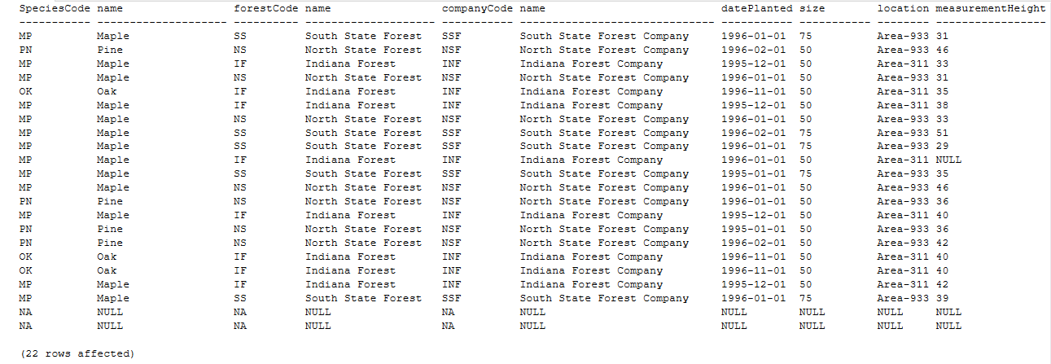

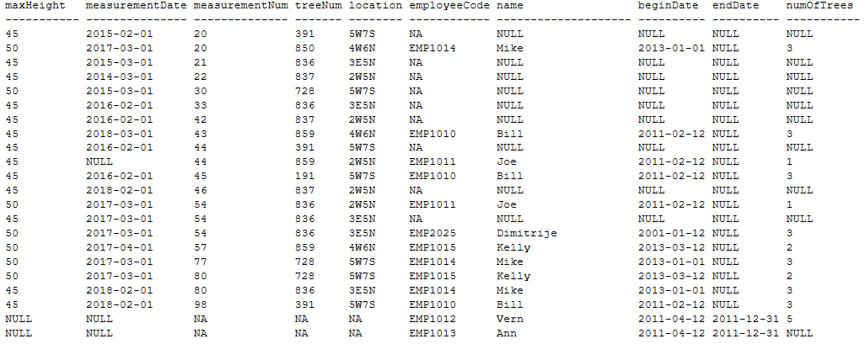

**Conclusion:**

Benefits of the database and potential future use:

* No redundancy - Redundancy reduced with 5NF to improve efficiency of inputting and outputting data.
* Useful queries - Queries to generate wanted views that make data easier to visualize.
* Possibility of transactions - Transactions can be implemented to add functionality.
* Constrains and Triggers - Database can decline and alarm the user about bad data input.
* Data types and Domains - DB makes sure that the user inputs are valid data type and format.

The idea of expanding the project is assumed and the database is designed in that way that will welcome any new data as long as the data attributes are in the right format.

*“We are always 5NF!”*