

**DGT212: Digital Humanities**

**Concept Note – Data Essay**

**~ Submitted to Prof. Pritha Roy**

|  |  |  |
| --- | --- | --- |
| **Details** | | |
| **Enrolment No.** | **Name** | **Programme** |
| AU2140089 | Shaili Gandhi | B.Tech (Mech) |
| AU2140058 | Prashansa Shah | B.Tech (CSE) |
| AU2140081 | Divya Patel | B.Tech (CSE) |
| AU2140082 | Hrishikesh Rana | B.Tech (CSE) |
| AU2140099 | Aditya Chaudhari | B.Tech (CSE) |
| AU2120125 | Tulsi Joshi | BA(Hons.) |

February 25, 2024

**“Enhancing Online Accessibility Of UNESCO World Heritage Sites In India”**

* **Context:**

Despite the increasing interest in UNESCO World Heritage sites, online availability of adequate information remains a wide gap. Regarding cultural heritage and global consciousness, it has been extensively documented that digital platforms are essential. However, research needs to pay more attention to the challenges these sites face regarding their presence on the internet.

* **Research Questions / Problems**:
* What are the problems associated with online access to UNESCO World Heritage sites in India?
* How do these obstacles affect distance education, virtual tourism, and global awareness?
* What can be done to make these sites more accessible online?
* **Aims**:

This investigation is directed at bridging the gaps concerning inadequate online accessibility of UNESCO World Heritage Sites in India. In particular, it tries:

* To find out what hinders people from accessing them through the internet.
* To investigate how poor internet connectivity prevents educationists from reaching students far away and reduces knowledge about India's culture.
* To suggest ways that can help promote their presence online as well as access to UNESCO World Heritage Sites located in India.
* **Objectives**:
* To comprehensively survey the literature on preserving digital heritage and enabling online access.
* To identify specific challenges faced by UNESCO World Heritage Sites in India regarding their online platforms.
* To check out how poor access to an online environment can affect educational outreach, tourism, and cultural awareness.
* Strategy development is focused on improving these sites' online accessibility through website redesigns and multimedia generation.
* This includes research publications, internet-based resources, and recommendations for conservationists and tourism stakeholders in this area.
* **Methodology**:

Mixed research methods, such as literature review, case study, interviews with stakeholders, etc., will be used in the study for data collection. The data collection methods include website analysis, user surveys, expert interviews, and interviewing residents with knowledge about heritage sites in India. The ethical standards are observed during the process, which will take twelve months before completion.

* **Significance**:

This study will help fill a void in the existing body of knowledge concerning online access to UNESCO World Heritage Sites in India by examining issues related to those platforms and suggesting ways forward for them. It will be helpful for professionals involved in heritage preservation or policy-making along with communities that care for heritage conservation or tourism if they know what problems they face today and how they can solve them. The discoveries will also aid in designing interventions to increase these sites' cyber landscape to promote cultural awareness and sustainable tourism.



**DGT212: Digital Humanities**

**Concept Note – Multimodal Writing**

**~ Submitted to Prof. Pritha Roy**

|  |  |  |
| --- | --- | --- |
| **Details** | | |
| **Enrolment No.** | **Name** | **Programme** |
| AU2140089 | Shaili Gandhi | B.Tech (Mech) |
| AU2140058 | Prashansa Shah | B.Tech (CSE) |
| AU2140081 | Divya Patel | B.Tech (CSE) |
| AU2140082 | Hrishikesh Rana | B.Tech (CSE) |
| AU2140099 | Aditya Chaudhari | B.Tech (CSE) |
| AU2120125 | Tulsi Joshi | BA(Hons.) |

February 25, 2024

**“Enhancing Online Accessibility Of UNESCO World Heritage Sites In India”**

* **Context:**

Despite the increasing interest in UNESCO World Heritage sites, online availability of adequate information remains a wide gap. Regarding cultural heritage and global consciousness, it has been extensively documented that digital platforms are essential. However, research needs to pay more attention to the challenges these sites face regarding their presence on the internet.

* **Research Questions / Problems**:
* What are the problems associated with online access to UNESCO World Heritage sites in India?
* How do these obstacles affect distance education, virtual tourism, and global awareness?
* What can be done to make these sites more accessible online?
* **Aims**:

This investigation is directed at bridging the gaps concerning inadequate online accessibility of UNESCO World Heritage Sites in India. In particular, it tries:

* To find out what hinders people from accessing them through the internet.
* To investigate how poor internet connectivity prevents educationists from reaching students far away and reduces knowledge about India's culture.
* To suggest ways that can help promote their presence online as well as access to UNESCO World Heritage Sites located in India.
* **Objectives**:
* To comprehensively survey the literature on preserving digital heritage and enabling online access.
* To identify specific challenges faced by UNESCO World Heritage Sites in India regarding their online platforms.
* To check out how poor access to an online environment can affect educational outreach, tourism, and cultural awareness.
* Strategy development is focused on improving these sites' online accessibility through website redesigns and multimedia generation.
* This includes research publications, internet-based resources, and recommendations for conservationists and tourism stakeholders in this area.
* **Methodology**:

Mixed research methods, such as literature review, case study, interviews with stakeholders, etc., will be used in the study for data collection. The data collection methods include website analysis, user surveys, expert interviews, and interviewing residents with knowledge about heritage sites in India. The ethical standards are observed during the process, which will take twelve months before completion.

* **Significance**:

This study will help fill a void in the existing body of knowledge concerning online access to UNESCO World Heritage Sites in India by examining issues related to those platforms and suggesting ways forward for them. It will be helpful for professionals involved in heritage preservation or policy-making along with communities that care for heritage conservation or tourism if they know what problems they face today and how they can solve them. The discoveries will also aid in designing interventions to increase these sites' cyber landscape to promote cultural awareness and sustainable tourism.



**DGT212: Digital Humanities**

**Distant Reading**

**“Enhancing Online Accessibility of UNESCO World Heritage Sites In India”**

**~ Submitted to Prof. Pritha Roy**

|  |  |  |
| --- | --- | --- |
| **Group - 13** | | |
| **Enrolment No.** | **Name** | **Programme** |
| AU2140089 | Shaili Gandhi | B.Tech (Mech) |
| AU2140058 | Prashansa Shah | B.Tech (CSE) |
| AU2140081 | Divya Patel | B.Tech (CSE) |
| AU2140082 | Hrishikesh Rana | B.Tech (CSE) |
| AU2140099 | Aditya Chaudhari | B.Tech (CSE) |
| AU2120125 | Tulsi Joshi | BA(Hons.) |

February 25, 2024

**Citations (APA format)**

Gupta, S., Meena, K., & Jingar, P. (2022). Digital Development of Tourism Events in India. In Technology Application in Tourism Fairs, Festivals and Events in Asia (pp. 221-231). Singapore: Springer Singapore.

Maitra, R. (2021). ADOPTION AND IMPLEMENTATION OF DIGITAL TRANSFORMATION FOR THE SUSTAINABILITY OF TOURISM AND HOSPITALITY BUSINESS IN INDIA. *Journal of Services Research*, *21*(1).

Chalana, M., & Krishna, A. (Eds.). (2020). Heritage Conservation in Postcolonial India: Approaches and Challenges.

Munjal, P. G. (2021). Charting the role of digital platforms for cultural heritage tourism in India. *Worldwide Hospitality and Tourism Themes*, *13*(2), 186-198.

Comes, R., Neamțu, C., Buna, Z. L., Bodi, Ș., Popescu, D., Tompa, V., ... & Mateescu-Suciu, L. (2020). Enhancing accessibility to cultural heritage through digital content and virtual reality: A case study of the Sarmizegetusa Regia UNESCO site. *Journal of Ancient History And Archaeology*, *7*(3).

Hausmann, A., & Schuhbauer, S. (2021). The role of information and communication technologies in cultural tourists’ journeys: the case of a World Heritage Site. Journal of Heritage Tourism, 16(6), 669-683.

Ray, H. P. (2019). Decolonising Heritage in South Asia The Global, the National and the Transnational Introduction. *Decolonising Heritage in South Asia: the Global, the National and the Transnational*, 1-29.

De Jong, M. D., & Wu, Y. (2018). Functional complexity and web site design: Evaluating the online presence of UNESCO world heritage sites. Journal of business and technical communication, 32(3), 347-372.

Hausmann, A., Weuster, L., & Nouri-Fritsche, N. (2015). Making heritage accessible: Usage and benefits of web-based applications in cultural tourism. *International Journal of Cultural and Digital Tourism*, *2*(1), 19-30.

Meskell, L. (2021). A tale of two cities: The fate of Delhi as UNESCO World Heritage. *International Journal of Cultural Property*, *28*(1), 27-42.

Chakraborty, S., Ramakrishnan, K. R., & Chatterjee, P. (2021). A PROMETHEE-GAIA Method-based Appraisal of UNESCO World Heritage Sites in India. *International Journal of Hospitality & Tourism Systems*, *14*(1).

Bobbio, T. (2019). National revisionism and commodification in the production of India’s heritage. Ahmedabad as UNESCO World Heritage site. *Quaderni storici*, *54*(2), 417-442.

Permatasari, P. A., Rech, M., Adukaite, A., & Cantoni, L. (2016). The online presence of the UNESCO World Heritage Sites in East, South, and South East Asia.

Bearman, D., & Geber, K. (2008). Transforming cultural heritage institutions through new media. *Museum Management and Curatorship*, *23*(4), 385-399.

**Voyant Tools Output**

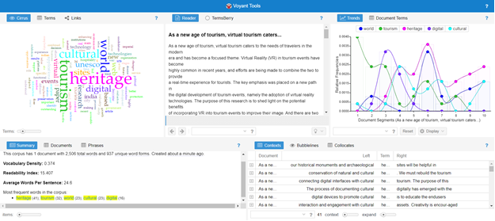

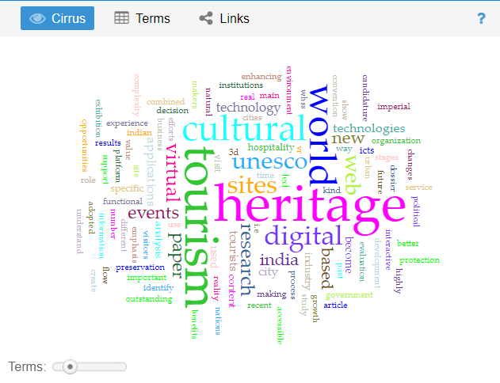

**Word Cloud Result**

The words 'Heritage' and 'Tourism' are the most prominently appearing words, highlighting the text's central theme of heritage tourism. The words 'World', 'Cultural' and 'UNESCO' suggest focus on globally recognized cultural heritage sites. The presence of 'UNESCO' and 'India' precisely points towards World Heritage Sites in India, as India is a signatory to the UNESCO World Heritage Convention. Words like 'Digital' and 'Virtual' indicate the possible exploration of the use of digital technologies in heritage tourism, including virtual tours, online resources or technology for preservation and promotion. Overall, the word cloud suggests exploring the potential of digital tools and approaches to enhance and promote heritage tourism and awareness, particularly related to UNESCO World Heritage Sites in India.

The importance of online presence and digital availability of information for heritage sites, especially UNESCO World Heritage Sites, cannot be overstated in today's digital age. These sites hold immense cultural, historical and societal significance and must be preserved and promoted. Leveraging digital platforms and online resources can significantly enhance visibility, accessibility and conservation efforts.

One of the primary reasons for the significance of online presence is the unlimited potential to reach a global audience. UNESCO World Heritage Sites are located in different parts of the world and only some people can visit them physically. By establishing a solid online presence, these sites can transcend geographical boundaries and be accessible to people from all corners of the globe. This exposure increases awareness about the sites and fosters a sense of cultural appreciation and understanding among diverse audiences.

Moreover, the digital availability of information allows for preserving and documenting heritage sites in a virtual format. Visitors can explore these sites in detail through interactive websites, virtual tours and multimodal content, even if they cannot visit them in person. This enhances the visitor experience and is a valuable resource for research, education and conservation efforts.

Also, online platforms provide opportunities for storytelling and interpretation, allowing heritage sites to share their rich history, significance and cultural context with the world. Engaging narratives, multimedia content and user-generated contributions can create immersive experiences that captivate and educate audiences, fostering a deeper appreciation for these sites and their importance in our collective heritage.

Moreover, an online presence facilitates the effective management and promotion of heritage sites. Websites and social media channels can be used to disseminate information about upcoming events, preservation initiatives and visitor guidelines. They also serve as platforms for collaboration and networking among stakeholders, including government agencies, conservation organizations, researchers and local communities.

Overall, the digital availability of information plays a crucial role in preserving, promoting and sustainably managing UNESCO World Heritage Sites. By harnessing the power of digital technologies, these sites can ensure their continued relevance and accessibility for generations to come.