**Project 2: UAV’s Ground Sample Distance (GSD) calculation using AU drone dataset.**

Mehul Raval, Hrishikesh Rana, Divya Patel, Prashansa Shah, Aditya Chaudhari,

Ahmedabad University

**Abstract**

*This project focuses on deriving the Ground Sample Distance (GSD) using linear regression analysis and its relationship with object size in aerial imagery, explicitly utilising the AU drone dataset for UAVs (Unmanned Aerial Vehicles). The GSD is a critical parameter for accurately determining objects' actual size and orientation in images captured by UAVs. This study establishes a method to calculate GSD based on object size by employing linear regression techniques on real-time data. Understanding GSD is essential for various applications, including object detection, size estimation, and orientation assessment in aerial imagery.*

1. **Keywords**Ground Sampling Distance, Object detection, PCA (principal component analysis), Annotation, Feature extraction, Model creation, Linear Regression, bounding box, Root Mean Square Error.
2. **Introduction**

The primary aim of this project is to develop a robust methodology for calculating Ground Sample Distance (GSD) using an AU (Autonomous Unmanned) drone dataset. GSD is a critical parameter in aerial imagery, providing a relationship between pixel dimensions in images and actual distances on the ground. The project will employ linear regression on real-time data to establish this relationship, enabling accurate object size and orientation determination in Machine learning and computer vision applications.

1. **Methodology**
   1. **Data Collection**

The data collection process involved using a nearly two-minute video as the dataset, from which frames were extracted at 30 frames per second (fps). These frames were then subjected to Gaussian blur to enhance image quality. Subsequently, the filtered images were saved for further processing.

* 1. **Object Detection**

While performing object detection on frames extracted from a 2-minute video consisting of 30 frames per second (fps), a challenge arose in obtaining more precise colour values and coordinates. The objective was to create accurate bounding boxes around a bike at each image's dead centre. Due to the need for more specific information, identifying and delineating the bike's boundaries within the frames took a lot of work.

Object detection algorithms typically rely on distinguishing features such as colour, shape, and spatial coordinates to define bounding boxes around objects of interest. In this case, without predefined colour thresholds or exact coordinates for the bike's location, the object detection algorithm had to rely on more generalised criteria.

* 1. **Feature Extraction**

The details of each object, such as height, width, x and y coordinates, and the angle from the centre, were extracted and compiled into a CSV file.

To extract features from the drone dataset, we utilise a comprehensive annotation tool, CVAT.ai, to annotate objects of interest within the aerial imagery. Annotation involves marking bounding boxes around each object and labelling them appropriately.

The annotated dataset so produced is saved in the PASCAL VOC 1.1 format, consisting of an XML file for each video frame. Each XML file contains detailed information about the annotated objects within the frame, including their labels, bounding box X and Y coordinates, and additional attributes such as truncation, occlusion, and difficulty.

We extract relevant features from the annotated bounding boxes in the XML files, including minimum and maximum X and Y coordinates of the objects, height and width of the objects, area, angle from the centre of the frame, Euclidian distance and Manhattan distance.

Then, we compile the extracted features of all the objects in each frame into a structured dataset by organising the data into a CSV file for easy analysis and processing.

* 1. **Model Creation for GSD**

The methodology includes loading the dataset using pandas, dropping redundant features, scaling the features with StandardScaler, performing Principal Component Analysis of the variation caused by each feature and selecting the first eight. This process helps reduce dimensionality and understand the data's variance in a compact representation. This extracted data is the input for calculating the Ground Sample Distance (GSD) using linear regression analysis and object size relationship.

1. **Result:**

We fit a linear regression model on the data collected to find the exact dimensions of the object.

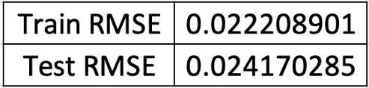

We fit a linear regression model on the data collected to obtain the relationship between the GSD values predicted from the extracted data and the observed GSD. A linear relationship is established between the features and the target variables. The root mean squared error (RMSE) is used to evaluate the model’s performance on both the training and testing sets. The test RMSE is slightly higher than the training RMSE, suggesting that the model may be overfitting the training data.

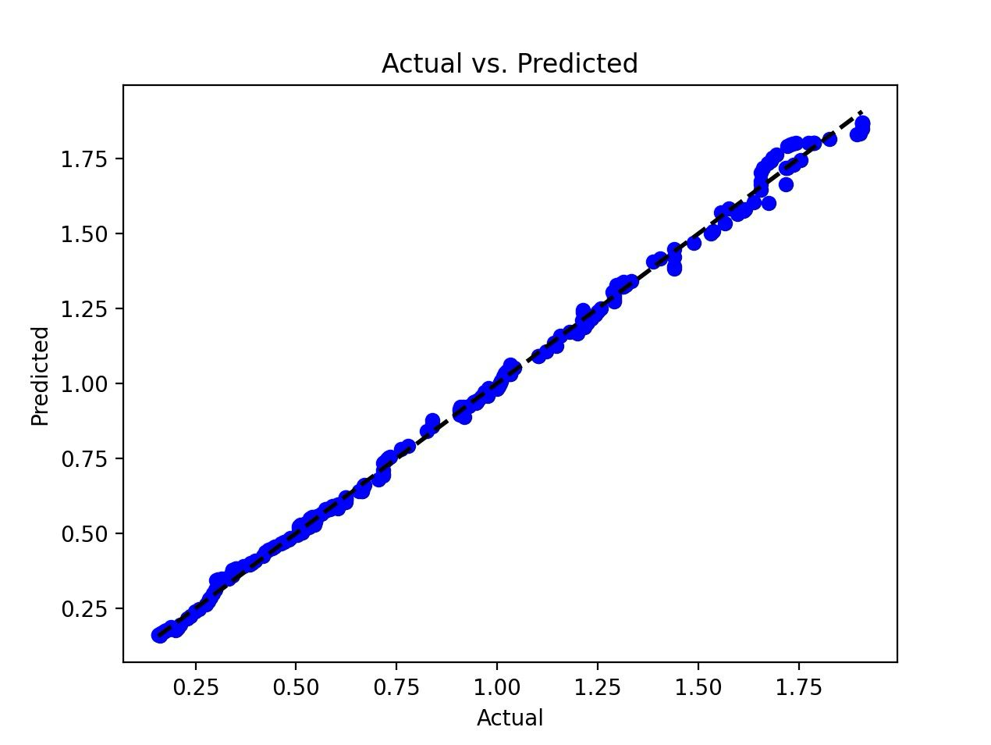

The model is far from precisely accurate predictions due to the diversity in the data. It considers multiple objects of varying sizes and orientations, shot from varying altitudes. These variations give rise to a nearly realistic model with non-zero errors, unlike the earlier calibration performed on data consisting of a single object captured from a fixed altitude.

1. **Discussion:**

This finding is crucial for various applications, such as urban planning, environmental monitoring, and infrastructure development, where accurate object size determination from aerial imagery is paramount.

Our project underscores the critical role of data preprocessing and curation in machine learning model development. By meticulously refining the dataset to address redundancy and incomplete data, we created a robust training dataset, leading to a highly accurate model with minimal errors. This meticulous data preparation process significantly contributed to the model's performance during testing, maintaining a high accuracy level of around 89%.

Furthermore, our methodology for feature extraction, encompassing height, width, coordinates, and angle from the centre, effectively captured essential information for Ground Sample Distance (GSD) calculation. Leveraging PCA (Principal Component Analysis) to reduce dimensionality and comprehend data variance provided valuable insights into the data's underlying patterns, enhancing the model's overall accuracy. Despite challenges in obtaining precise colour values and coordinates, the successful implementation of object detection algorithms highlights our approach's adaptability and robustness, laying a solid foundation for future research in aerial imagery analysis and object size estimation.

1. **Conclusion:**

In conclusion, our paper presents a comprehensive approach to analysing drone-captured aerial data, emphasising the determination of Ground Sample Distance (GSD) through linear regression algorithms. The presence of a stationary bike in the centre of the frame served as a reference point, enabling accurate measurements of objects at various distances from the drone.

Our investigation clarifies the process of calculating GSD and emphasises its significance in aerial photography orientation evaluation and object recognition. Our method underscores the necessity of precise GSD estimates to enhance the accuracy and reliability of drone-based imaging technologies, with potential applications in transportation, urban planning, and remote sensing domains.

1. **Reference:**

* “The Risks of Steroid Use - OrthoInfo - AAOS,” *The Risks of Steroid Use - OrthoInfo - AAOS*, May 01, 2019. <https://orthoinfo.aaos.org/en/staying-healthy/the-risks-of-using-performance-enhancing-drugs-in-sports/>
* Propelleradmin, “What is Ground Sample Distance and How Does it Affect Your Drone Data?,” *Propeller*, Mar. 07, 2023. <https://www.propelleraero.com/ground-sample-distance-gsd-calculate-drone-data/>
* Y. M. Bhavsar, M. Zaveri, M. S. Raval, and S. B. Zaveri, “Vision-based Investigation of Road Traffic and Violations at Urban Roundabout in India using UAV Video: A Case Study,” *Transportation Engineering*, Dec. 01, 2023. <https://www.sciencedirect.com/science/article/pii/S2666691X23000477?fr=RR-2&ref=pdf_download&rr=86540e0c4be86ec8>
* “CVAT.” <https://www.cvat.ai/>