**LEARNING ACTIVITY SHEET**

**SPECIAL PROGRAM IN ICT 9**

**BASIC PROGRAMMING 9**

*Fourth Quarter, Week 1*

Name of Learner: Date:

Grade Level /Section:

**DEFINING STRING**

**Background Information for Learners**

In Java, string is basically an object that represents sequence of char values. An array of characters works same as Java string. For example:

char[] ch={'j','a','v','a','_','p','o','i','n','t'};

String s=new String(ch);

is same as:

String s="java_point";

Java String class provides a lot of methods to perform operations on strings such as compare(), concat(), equals(), split(), length(), replace(), compareTo(), intern(), substring() etc.

**What is String in Java?**

Generally, String is a sequence of characters. But in Java, string is an object that represents a sequence of characters. The java.lang.String class is used to create a string object.

There are two ways to create String object:

1. By string literal - Java String literal is created by using double quotes. For Example:

String s="welcome";

1. By new keyword

String s=new String("Welcome");//creates two objects and one reference variable

Example 1:

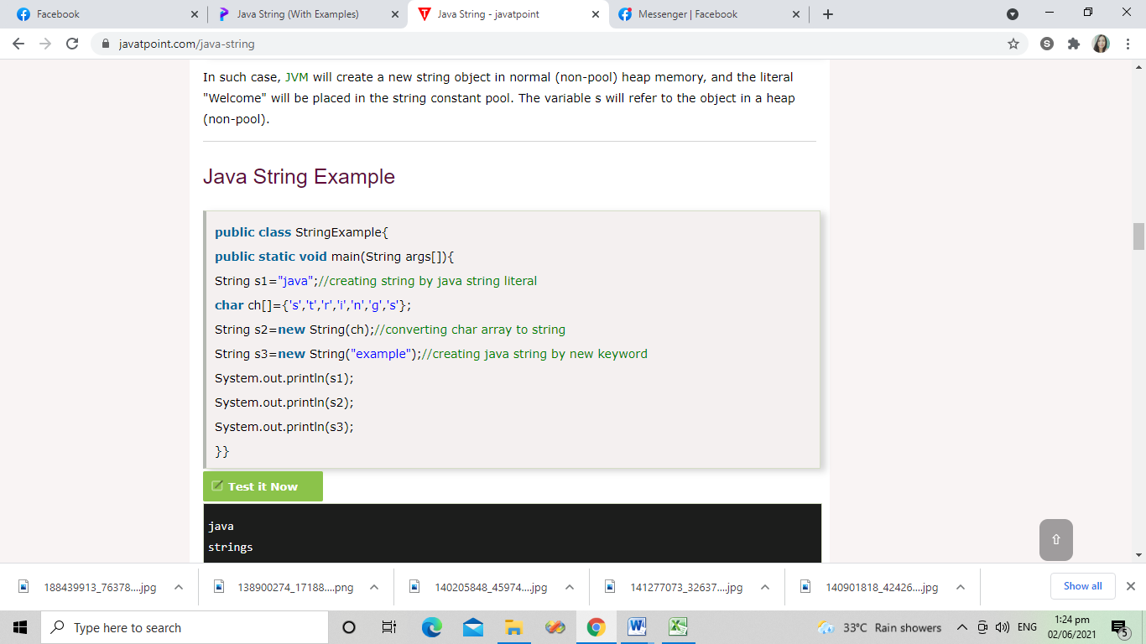

Output:

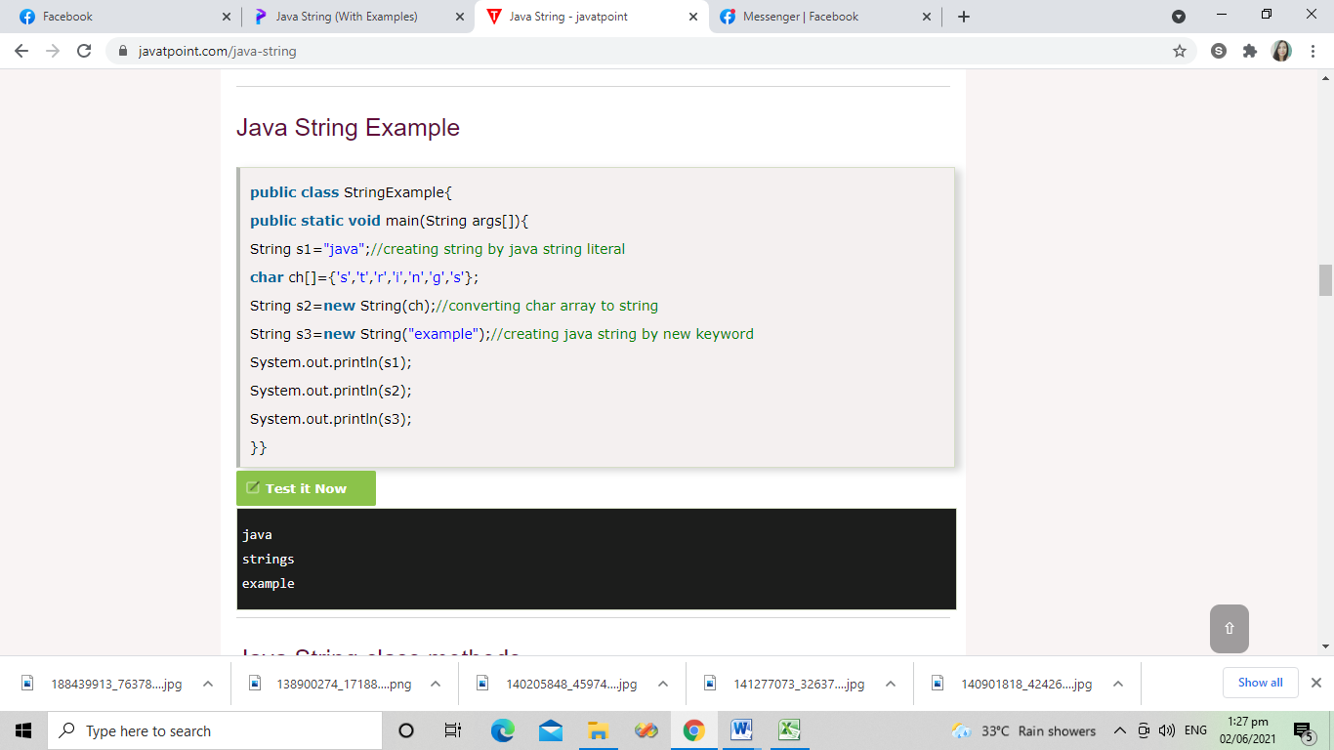

Example 2:

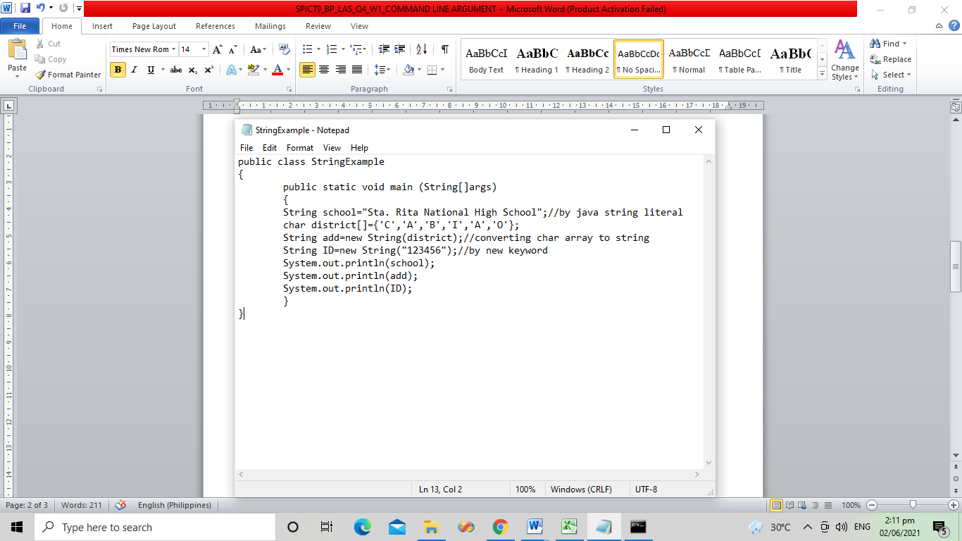

Output:

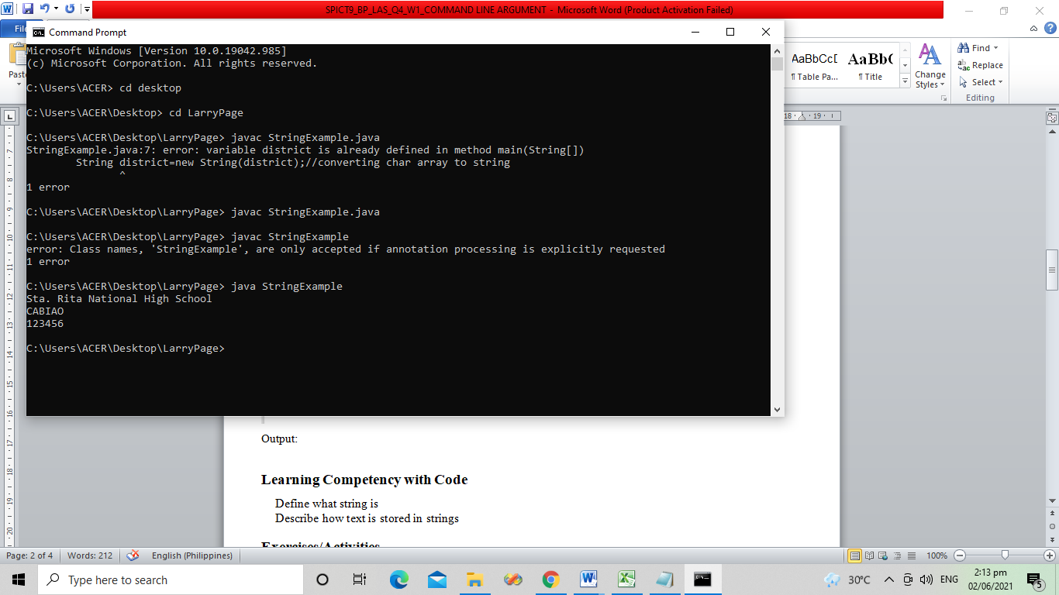

**Learning Competency with Code**

Define what string is

Describe how text is stored in strings

**Exercises/Activities**

**Activity 1**

Direction: Create a source code that will print the following:

* Full name (java string literal)
* Section(char array to string) and
* School name(by new keyword)

Sample Output:

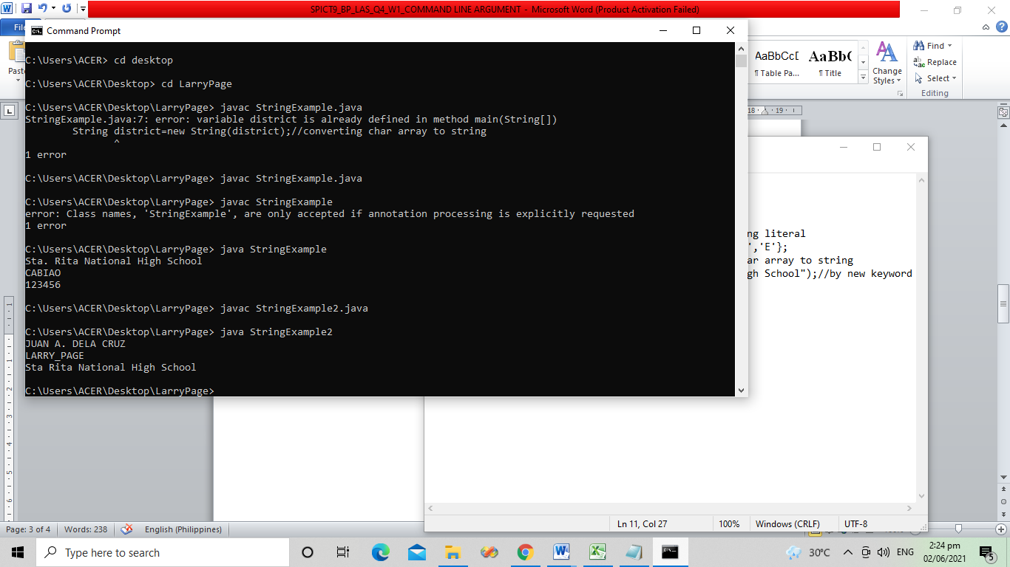

Write your code inside the box

**Reflection**

What is the difference between string and char?

**______________________________________________________________________________________________**

**______________________________________________________________________________________________**

**______________________________________________________________________________________________**

**______________________________________________________________________________________________**

**References for Learners**

<https://www.javatpoint.com/java-string>

Prepared by: **NOEMI F. MAGNO**

Name of Writer

Noted by: **LABERNE A. LADIGNON, JR**

Division ICT Coordinator/ OIC EPS