This is Juan’s Website

About Me
- I am 16 years old
- I like food
- I like the gym

Family Life
- I have 2 older brother
- I have a lot of cousins
- I live with my mom & dad

Cool Pictures
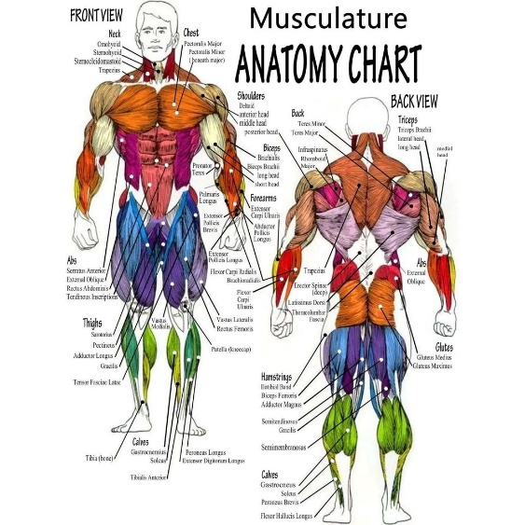
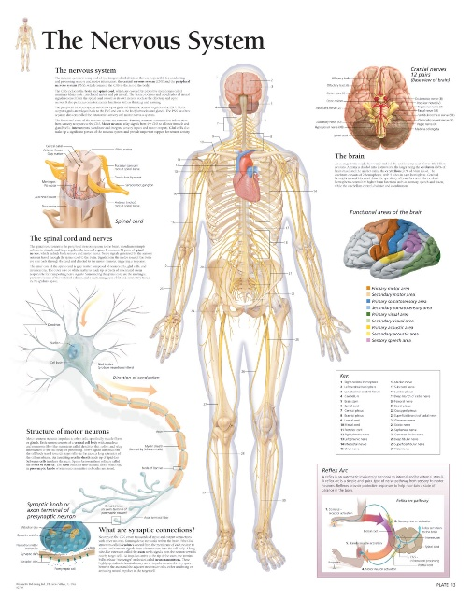


Sources
https://www.almanac.com/sites/default/files/image_nodes/american-flag-1.jpg
https://www.scientificpublishing.com/wp-content/uploads/2017/05/nervous-system-anatomical-wall-chart.jpg
https://static.wixstatic.com/media/71a0ba_4320c0abda3d4c95a63d97897c84496b~mv2.jpg/v1/fill/w_597,h_720,al_c,q_85,enc_auto/musculature%20anatomy%20chart.jpg

