Healthcare Data Pipeline & Dashboard Report

Executive Summary
This project demonstrates an end-to-end healthcare data pipeline built using Azure Blob Storage and Databricks. Raw clinical data is ingested, transformed through Bronze, Silver, and Gold layers, and stored in Unity Catalog. A dynamic dashboard provides insights into hospital utilization, ICU pressure, and patient risk.

Business Insights
• Emergency admissions dominate hospital intake.
• ICU stays are higher for emergency patients.
• Mortality risk increases with ICU duration.
• Top diagnoses highlight critical health trends.
• Insurance impacts admission patterns.

Azure Storage Account
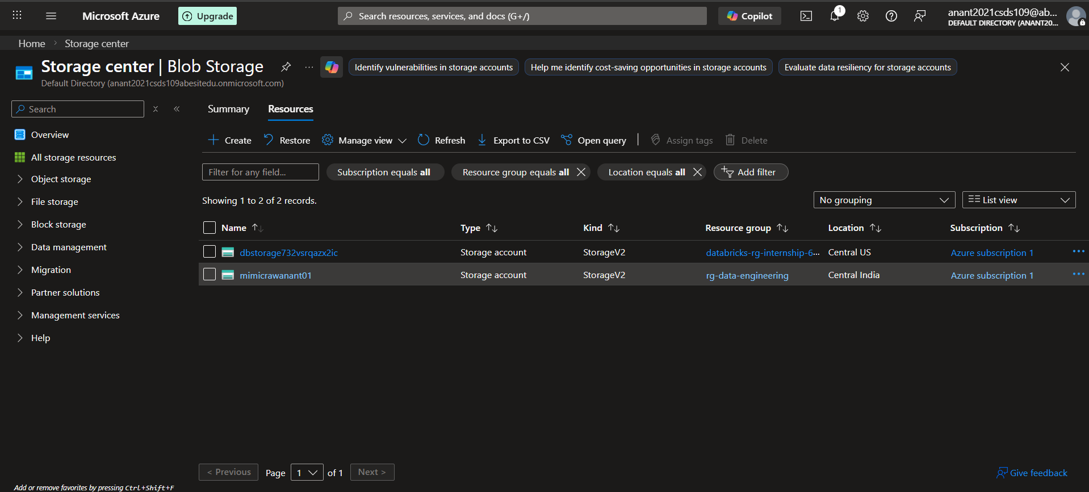

Azure Upload Script
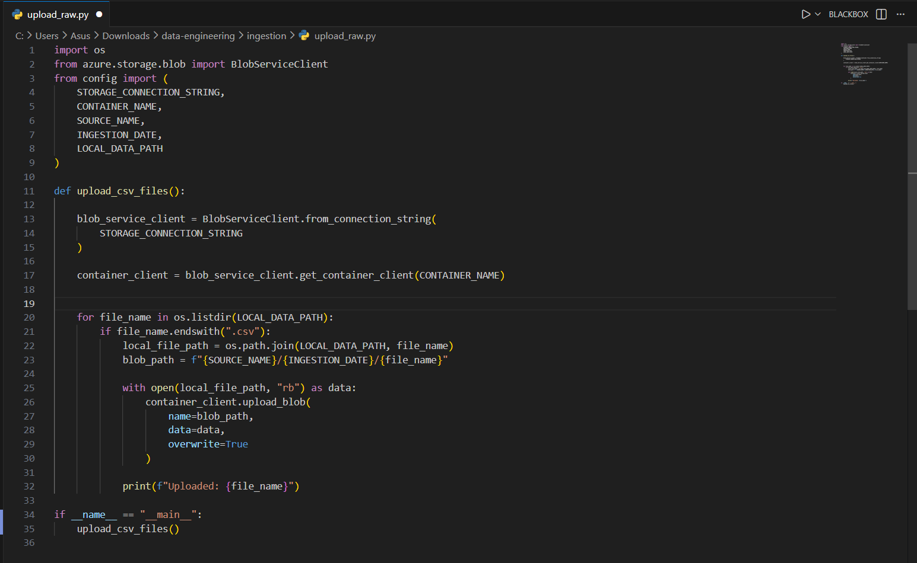

Databricks Workspace
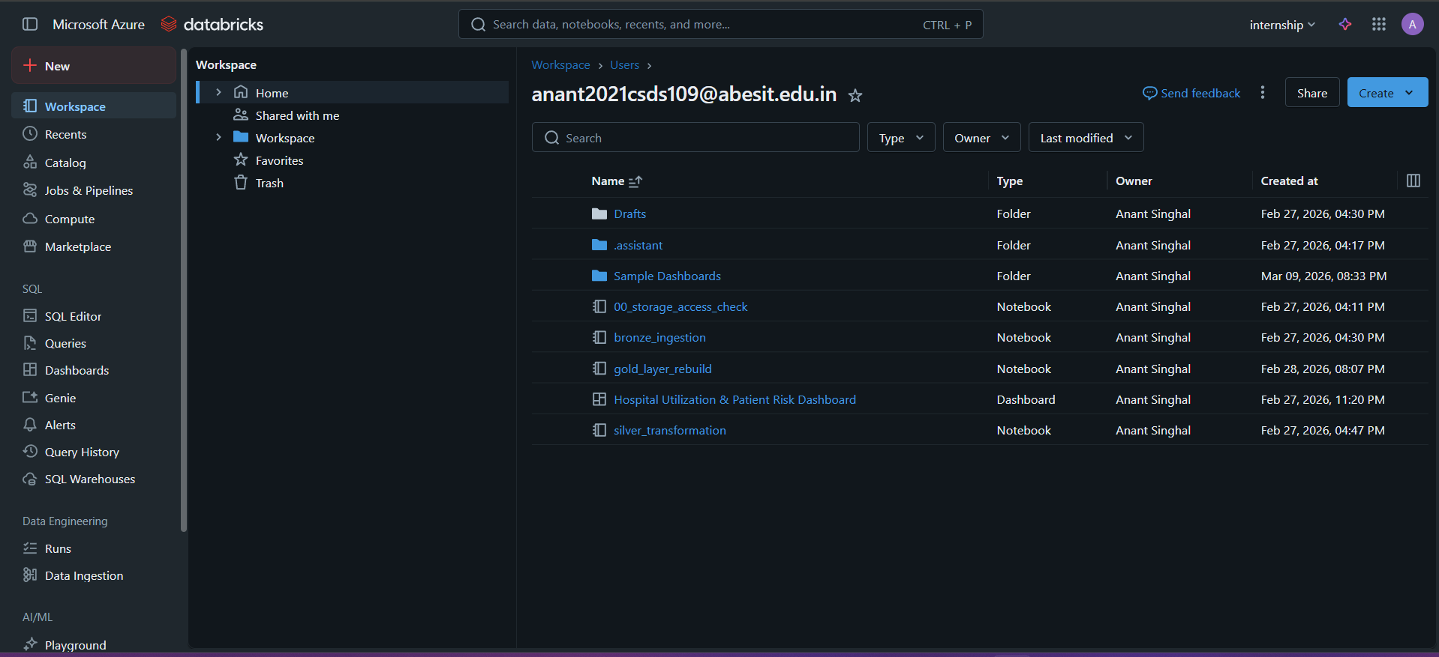

Bronze Ingestion
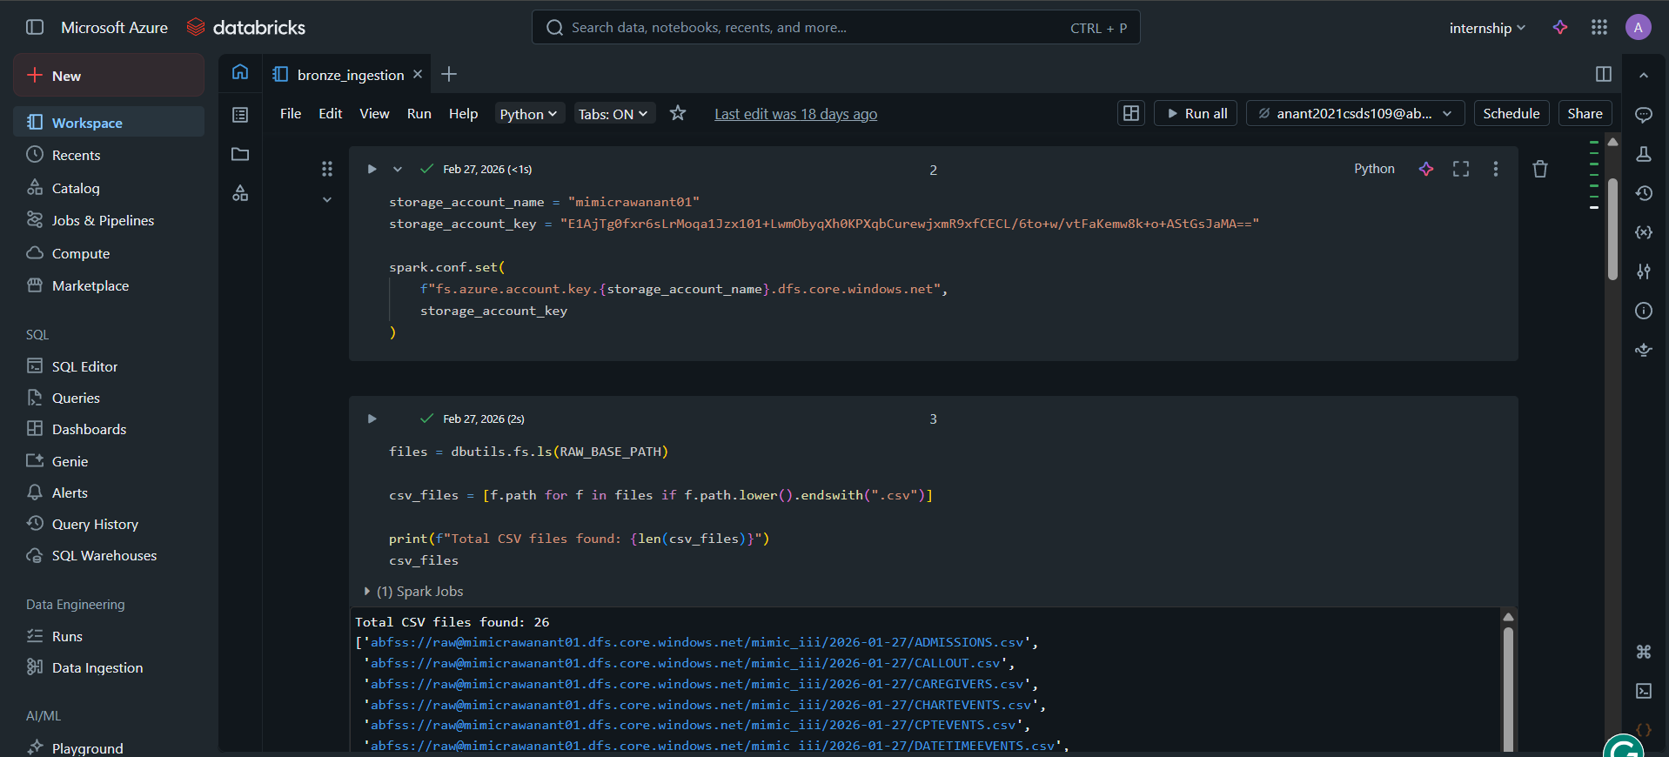

Bronze Output
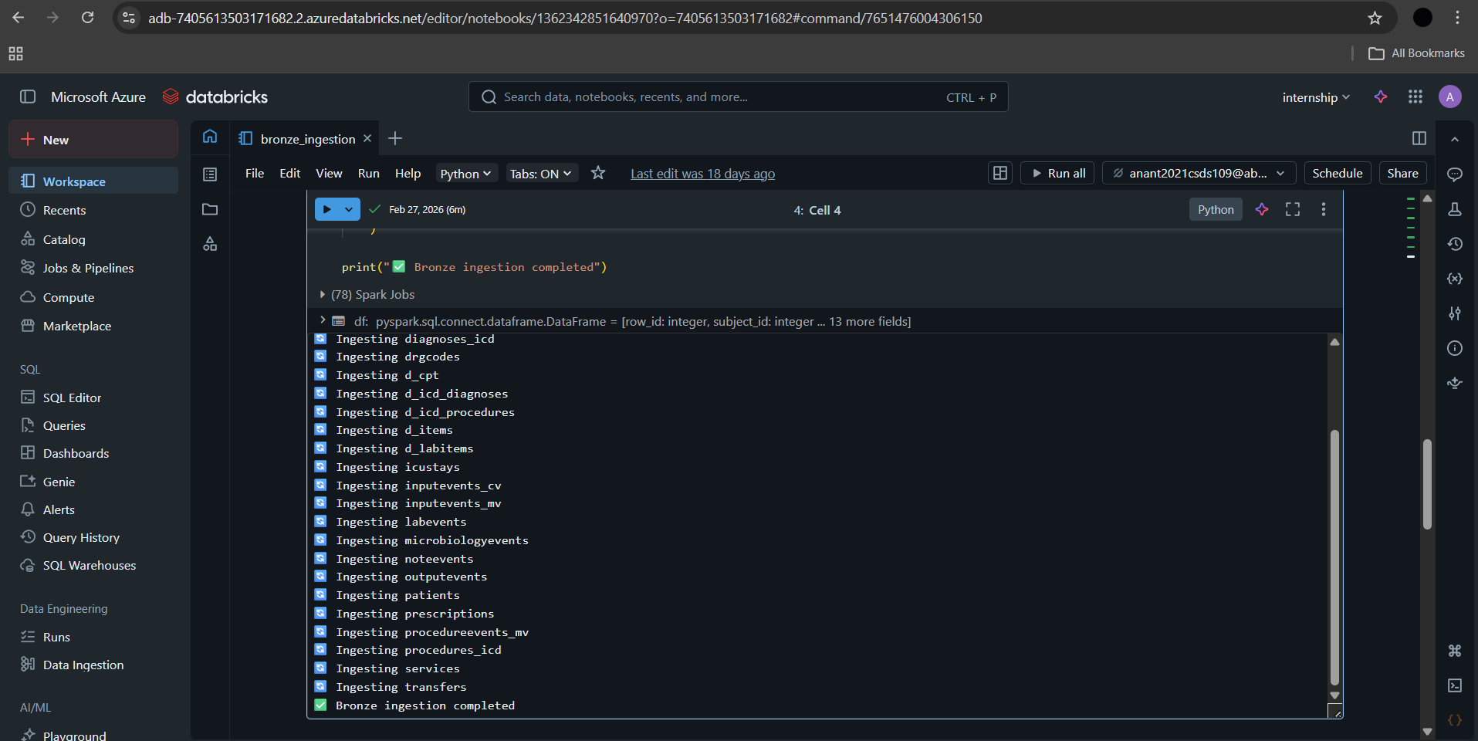

Gold Join Logic
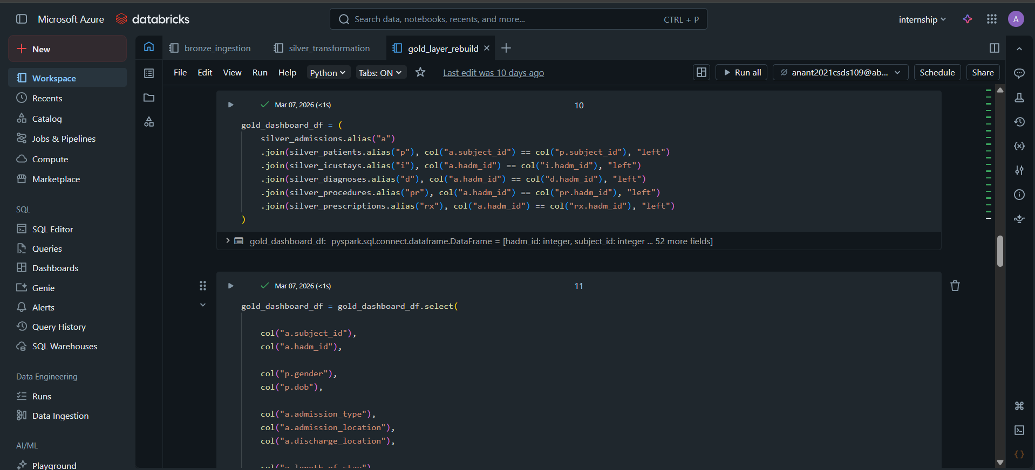

Unity Catalog
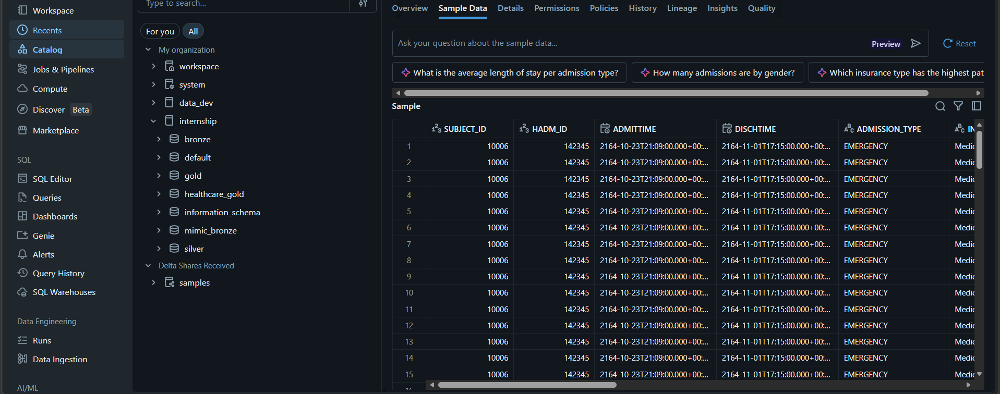

Dashboard Overview
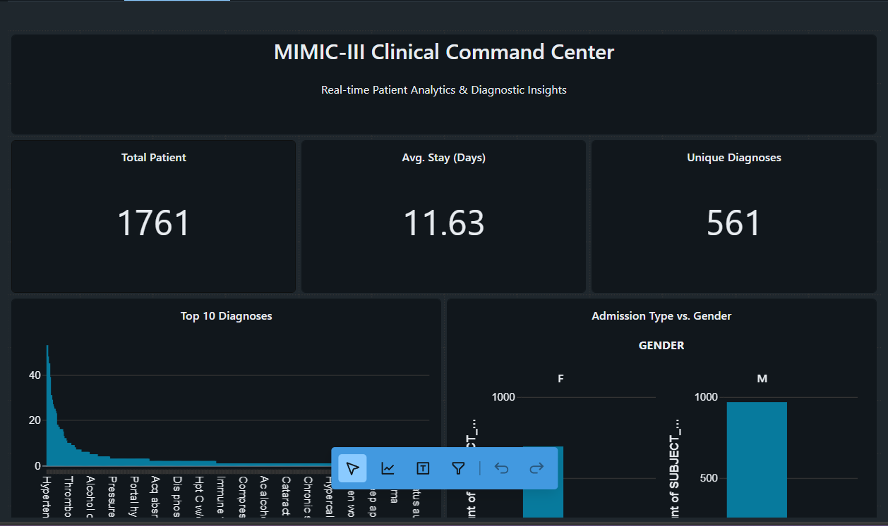

Top Diagnoses
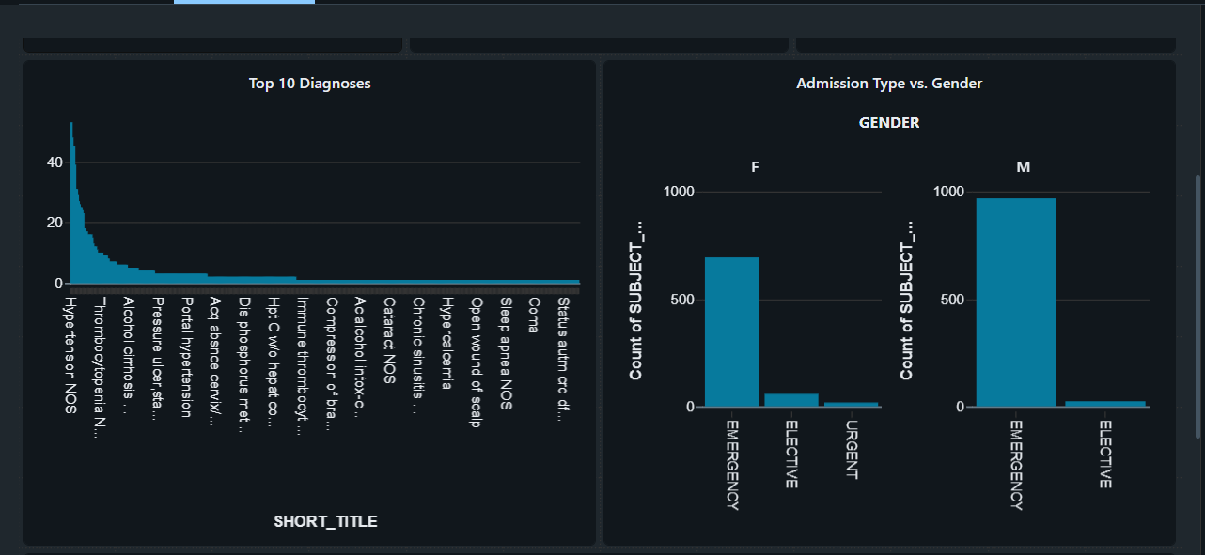

Admission vs Gender


Insurance Heatmap
