## Operative System

The following instructions will work for sure under Ubuntu 16.04.3 LTS

## Installing cURL

Open a terminal window: CTRL+ALT+T.

Type the following command and enter your password:

**$ sudo apt install curl**

To check, run the following command in your terminal/command line:

**$ curl -V**

Note: The "V" is capitalized.

## Installing Docker

https://docs.docker.com/engine/installation/linux/docker-ce/ubuntu/

To create the docker group and add your user:

1. 1. Create the docker group:

**$ sudo groupadd docker**

1. 2. Add your user to the docker group:

**$ sudo usermod -aG docker $USER**

1. 3. Log out and log back in, so that your group membership is re-evaluated.
2. 4. Since we are on a virtual machine, it may be necessary to restart the virtual machine for changes to take effect.
3. 5. Verify that you can run Docker commands without sudo:

**$ docker run hello-world**

1. 6. This command downloads a test image and runs it in a container. When the container runs, it prints an informational message and exits.

## Docker Compose

To install Docker Compose, run the following commands in your terminal/command line:

**$ sudo apt update**

**$ sudo apt install docker-compose**

Check to make sure that you have **Docker version 17.03.1-ce or greater**, and **Docker Compose version 1.8.0 or greater:**

**$ docker --version && docker-compose –version**

## Installing Node.js and npm

To install Node.js and npm, run the following commands in your terminal/command line:

**$ sudo bash -c "cat >/etc/apt/sources.list.d/nodesource.list" <<EOL deb https://deb.nodesource.com/node_6.x xenial main deb-src https://deb.nodesource.com/node_6.x xenial main EOL**

**$ curl -s https://deb.nodesource.com/gpgkey/nodesource.gpg.key | sudo apt-key add -**

**$ sudo apt update**

**$ sudo apt install nodejs**

**$ sudo apt install npm**

Verify the installation, as well as the versions of both Node.js and npm, and make sure the **Node.js version you are installing is greater than v6.9 (do not use v7)**, and the **npm version is greater than 3.x:**

**$ node --version && npm –version**

## Installing Go Language

Visit **https://golang.org/dl/** and make note of the latest stable release (**v1.8 or later**).

To install Go language, run the following commands in your terminal/command line:

**$ sudo apt update**

**$ sudo curl -O https://storage.googleapis.com/golang/go1.9.2.linux-amd64.tar.gz**

Note: Switch out the black portion of the URL with the correct filename.

**$ sudo tar -xvf go1.9.2.linux-amd64.tar.gz**

**$ sudo mv go /usr/local**

**$ echo 'export PATH=$PATH:/usr/local/go/bin' >> ~/.profile**

**$ source ~/.profile**

Check that the Go version is v1.8 or later:

**$ go version**

## Installing Hyperledger Fabric Docker Images and Binaries

Check [https://hyperledger-fabric.readthedocs.io/en/latest/samples.html#binaries](https://hyperledger-fabric.readthedocs.io/en/latest/samples.html" \l "binaries)

and then, for example:

**$ curl -sSL https://goo.gl/Q3YRTi | bash**

This command downloads binaries for cryptogen, configtxgen, configxlator, peer AND downloads the Hyperledger Fabric Docker images. These assets are placed in a bin subdirectory of the current working directory.

To confirm and see the list of Docker images you’ve just downloaded, run:

**$ docker images**

The expected response is:

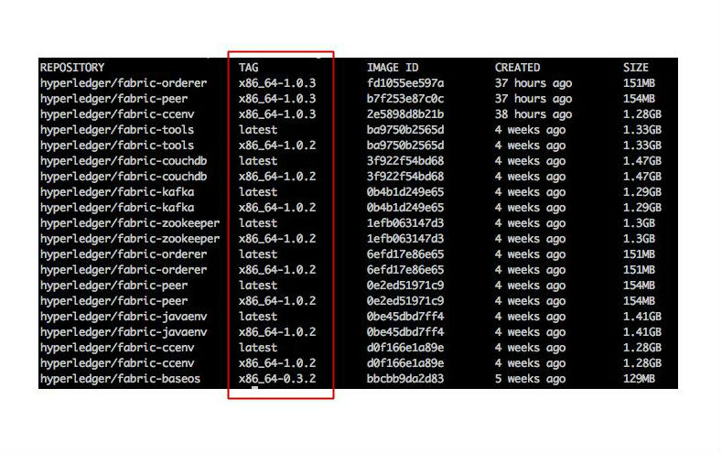Note the tags for each of the repositories above boxed in red. If the Docker images are not already tagged with the latest tag, perform the following command for each of the Docker images:

$ docker tag hyperledger/fabric-tools:x86_64-1.0.2 hyperledger/fabric-tools:latest

Swap out the blue portion with the tags you see in your list of repositories. Also, swap out the red portion with the name of the Docker image you are switching the tag for (e.g.: fabric-tools, fabric-ccenv, fabric-orderer, etc.). Repeat this step for all Docker images you see in the list.

In the screenshot above, the Docker images are already tagged. If this is the case for you, you do not need to do this extra step.

## Running Hyperledger Fabric

**$ git clone https://Diego882@bitbucket.org/iDavide/bct4mas.git**

Go in “bc-mas-app” folder and execute **./startFabric.sh**

Wait until the load is completed.

**NOTE**: this will not run CouchDB buf LevelDB because we need to wait for a fix of the following bug <https://jira.hyperledger.org/browse/FAB-6938>

**NOTE2:** if you want to perform rich queries, you will need CouchDB.

## Importing the application

Now, from Eclipse:

1. import→ existing maven project→ bct4mas folder downloaded with git clone
2. right click on the generated project → properties → java build path
3. add external jars → and the jars inside the lib folder → apply and close
4. run configuration
5. right click on Java Application → new
6. on main page:
   1. Project: bc4mas
   2. Main class: jade.Boot
7. check the “Include system libraries when searching for a main class”
8. on Arguments page:
   1. -gui -port 12324 main:agents.CAagent;a1:agents.Agent1;a2:agents.Agent2;a3:agents.Agent3;sniffer:jade.tools.sniffer.Sniffer;
   2. (be sure that the port is free, otherwise select another port)
9. Before running the code, check the config.xml
10. Run the code.