Schizophrenia project: analyses for overall efficacy and association with the placebo response

Prepared by Georgia on 18 February 2019

# Description of the network

Below is a description for the network formed my studies examining the primary outcome, overall efficacy. Open studies and studies with missing outcome or standard deviations have been excluded from the analysis.

Below are the total number of participants in each of the included drug

## Amisulpride Aripiprazole Asenapine Brexpiprazole   
## 705 1926 1027 1180   
## Cariprazine Chlorpromazine Clopenthixol Clozapine   
## 999 741 60 270   
## Flupentixol Fluphenazine Haloperidol Iloperidone   
## 88 53 4400 2157   
## Levomepromazin Loxapine Lurasidone Molindone   
## 21 289 1363 67   
## Olanzapine Paliperidone Penfluridol Perazine   
## 5602 1584 14 51   
## Perphenazine Pimozide Placebo Quetiapine   
## 378 44 8067 3002   
## Risperidone Sertindole Sulpiride Thioridazine   
## 3827 868 66 121   
## Thiothixene Trifluoperazine Ziprasidone Zotepine   
## 71 123 1228 245   
## Zuclopenthixol   
## 178

Number of drugs:

## [1] 33

Number of studies:

## [1] 218

The total available sample size is:

## [1] 40815

# Frequentist network meta-analysis

Below are the relative treatment effects from the NMA model.

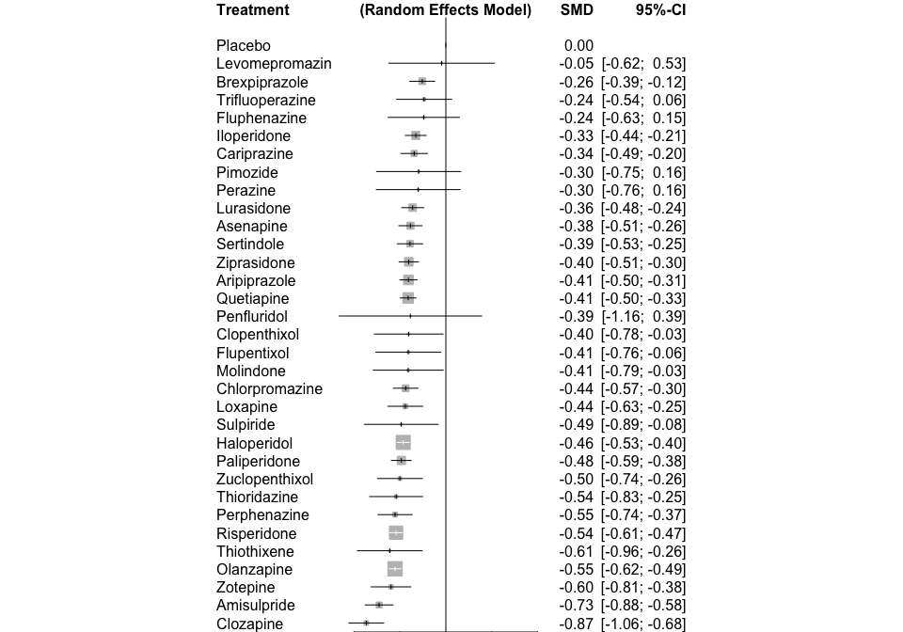

The P-scores (equivalent to the SUCRAs) are shown below

## P-score  
## Clozapine 0.9835  
## Amisulpride 0.9314  
## Zotepine 0.7999  
## Olanzapine 0.7787  
## Thiothixene 0.7698  
## Risperidone 0.7579  
## Perphenazine 0.7454  
## Thioridazine 0.6945  
## Zuclopenthixol 0.6386  
## Paliperidone 0.6356  
## Haloperidol 0.5985  
## Sulpiride 0.5901  
## Loxapine 0.5331  
## Chlorpromazine 0.5252  
## Molindone 0.4789  
## Flupentixol 0.4748  
## Clopenthixol 0.4695  
## Penfluridol 0.4671  
## Quetiapine 0.4602  
## Aripiprazole 0.4537  
## Ziprasidone 0.4450  
## Sertindole 0.4182  
## Asenapine 0.4044  
## Lurasidone 0.3509  
## Perazine 0.3382  
## Pimozide 0.3343  
## Cariprazine 0.3242  
## Iloperidone 0.2809  
## Fluphenazine 0.2485  
## Trifluoperazine 0.2120  
## Brexpiprazole 0.1856  
## Levomepromazin 0.1395  
## Placebo 0.0322

The heterogeneity standard deviation is estimated at

## [1] "tau= 0.118"

and I-square (total) is

## [1] "I2= 0 %"

There is little to no evidence of inconsistency in the data. There are in total

## 105

comparisons in the network, and there is inconsistency (according to SIDE p-value<0.10) in

## 11

loops which gives a % of inconsistent loops equal to

## [1] "10.5 %"

The p-value from the design-by-treatment test is

## [1] 0.25

# Bayesian network meta-analysis in JAGS

The SMDs against placebo from the Bayesian model are pretty much in line with those obtained in R. Warning: The 95% CrI presented below might be a bit different from those in the league tables. The reason is that in order to plot them in R I used the CrI normally approximated using the standard deviation of the posterior distribution, while in the league table displays the posterior CrI directly. Do not worry, I only note this just in case you notice the small numerical differences.

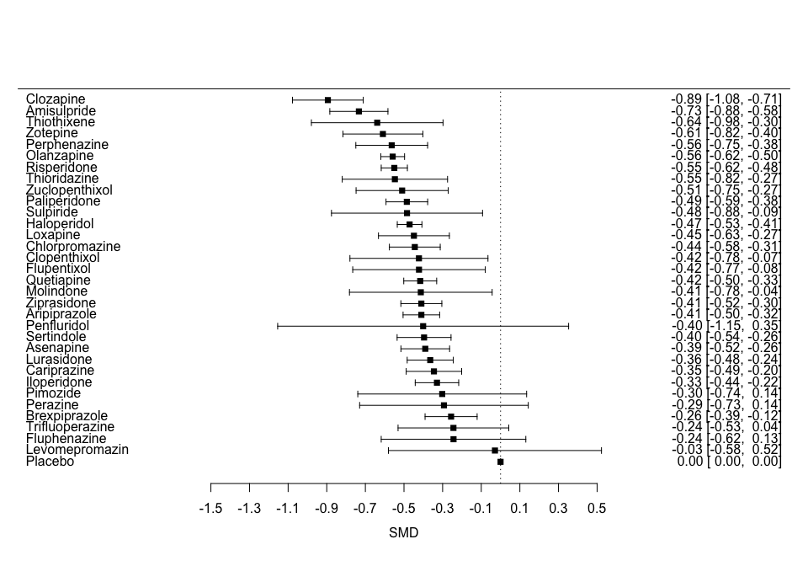

and similarily the SUCRAs are very very close. The heterogeneity standard deviation was estimated

## tau= 0.118

The League table is presented in a separate league table

# Association between SMD and year

Some drugs are studied primarily in old studies while some others are newer. The table below shows the mean year of randomisation in study arms:

## Amisulpride Aripiprazole Asenapine Brexpiprazole   
## 1995 2008 2011 2016   
## Cariprazine Chlorpromazine Clopenthixol Clozapine   
## 2013 1982 1970 1989   
## Flupentixol Fluphenazine Haloperidol Iloperidone   
## 1993 1970 1995 2008   
## Levomepromazin Loxapine Lurasidone Molindone   
## 1996 1976 2011 1976   
## Olanzapine Paliperidone Penfluridol Perazine   
## 2007 2008 1976 1990   
## Perphenazine Pimozide Placebo Quetiapine   
## 1986 1978 2001 2004   
## Risperidone Sertindole Sulpiride Thioridazine   
## 2003 2001 1979 1983   
## Thiothixene Trifluoperazine Ziprasidone Zotepine   
## 1977 1973 2005 1994   
## Zuclopenthixol   
## 1991

and the study publication year ranges between

## 1967 2018

# Meta-regression on the change in PANSS score for the participants randomised to placebo.

## Meta-regression for placebo response using comparison-specific consistent coefficients

As we have seen before the response to placebo (measured as change in PANSS in the placebo arm) increases over time. Because of poor convergence, we exlcuded drugs with less than 100 people randomised

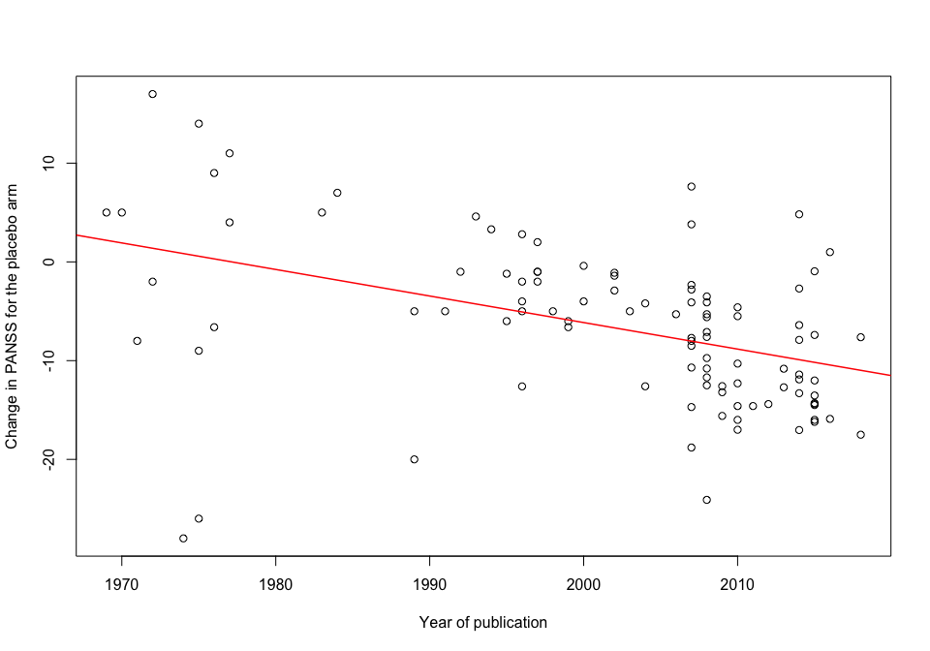 Below is a description of the change in PANSS in the placebo arm in our data

## [1] -6.612121

## Min. 1st Qu. Median Mean 3rd Qu. Max. NA's   
## -28.000 -12.600 -6.400 -6.612 -2.000 17.000 321

We fit therefore a network meta-regression where the SMD is a function of the change in PANSS for the placebo arm. For the head-to-head studies where no response to placebo is observed, we fit a hierarchical model where a response to placebo value is stochastically imputed as a prediction from the year of the study publication. The SMDs presented below are the intercepts from the meta-regression model and they represent the SMDs for an imaginary situation where patients in placebo change their PANSS score from baseline by -6 units.

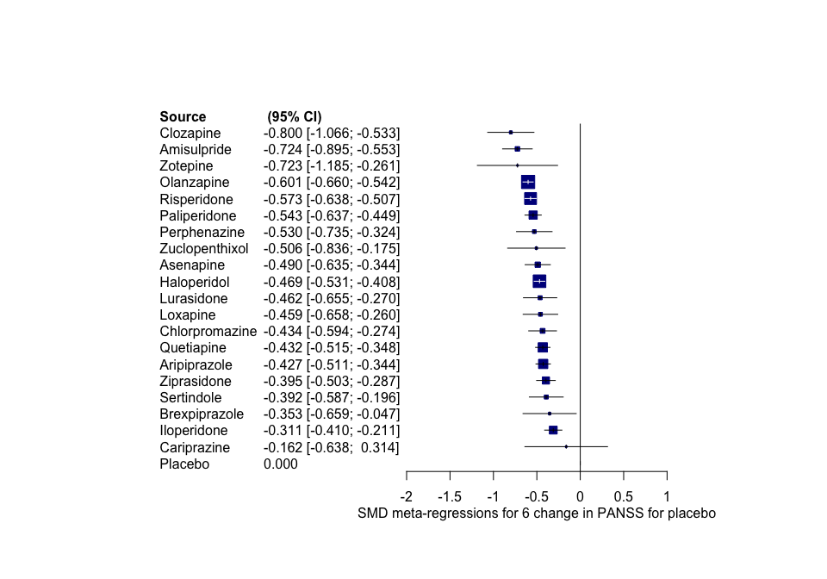

The SUCRA values are presented below - they also refer to the situation where PANSS score of -6 for patients randomised to placebo.

## DRUGS sucra  
## 1 Clozapine 94  
## 2 Amisulpride 92  
## 3 Zotepine 84  
## 4 Olanzapine 81  
## 5 Risperidone 75  
## 6 Paliperidone 68  
## 7 Perphenazine 63  
## 8 Zuclopenthixol 56  
## 9 Asenapine 54  
## 10 Haloperidol 50  
## 11 Lurasidone 48  
## 12 Loxapine 47  
## 13 Chlorpromazine 41  
## 14 Quetiapine 39  
## 15 Aripiprazole 38  
## 16 Sertindole 32  
## 17 Ziprasidone 30  
## 18 Brexpiprazole 30  
## 19 Iloperidone 15  
## 20 Cariprazine 14  
## 21 Placebo 1

The league table is in a separate Excel file. In the excell we also include the SMDs for zero change in the PANSS score.

The coefficients of the regression between SMD and PANSS in placebo are alltogehter significant as shown below

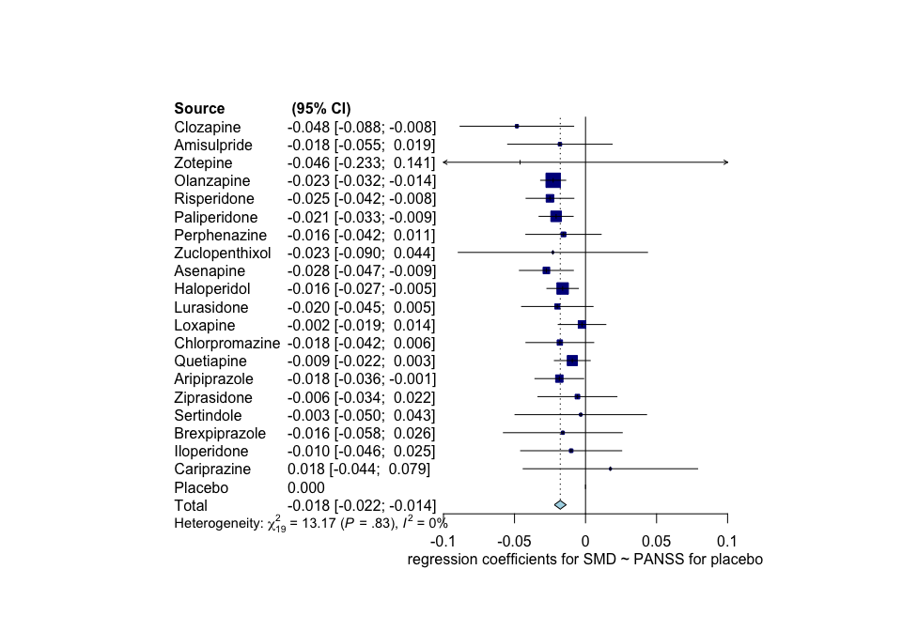

Interestingly, the association is very close to what we found in AJP; we had -0.15 (-0.21,-0.09). for a 10-units increase in PANSS - that is -0.18 [-0.222; -0.138] for 10 units increase also (see below).

## Number of studies combined: k = 20  
##   
## 95%-CI z p-value  
## Random effects model -0.0178 [-0.0220; -0.0136] -8.34 < 0.0001  
##   
## Quantifying heterogeneity:  
## tau^2 = 0; H = 1.00 [1.00; 1.15]; I^2 = 0.0% [0.0%; 24.9%]  
##   
## Test of heterogeneity:  
## Q d.f. p-value  
## 13.17 19 0.8296  
##   
## Details on meta-analytical method:  
## - Inverse variance method  
## - DerSimonian-Laird estimator for tau^2

The heterogeneity drops a little bit…

## tau= 0.072

Also, the regression between PANSS change in placebo and year of publication, gave the following results:

Intercept (95% CI):

## mean 2.5% 97.5%   
## -10.296 -12.350 -8.232

Slope (95% CI):

## mean 2.5% 97.5%   
## 0.254 0.149 0.361

Note that, we we previously found the slope is significant and close to what we published in AJP (we had 0.274 (0.16 to 0.388)).

## Meta-regression for placebo response using a common coefficient B

This is a more restricted model where we assume that all coefficients are drown from the same distribution with mean B.

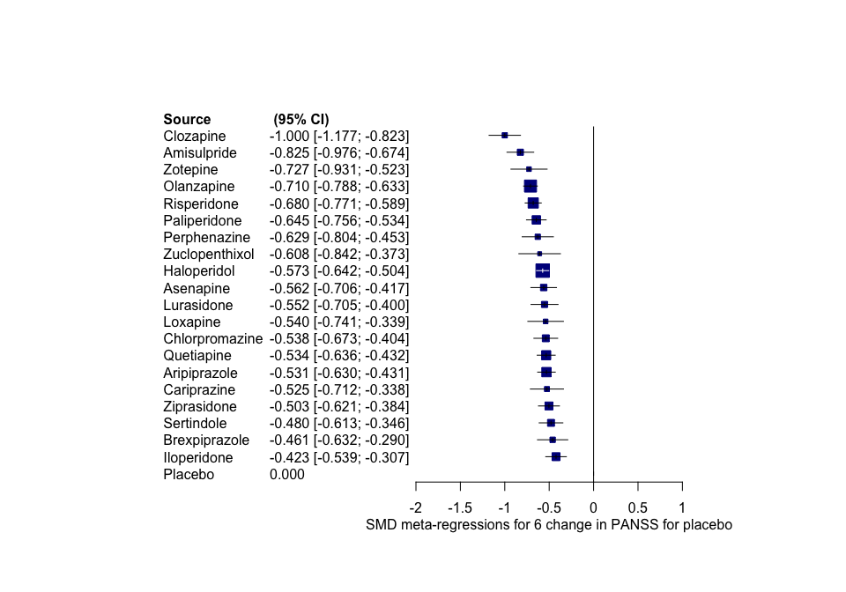

The common coefficent B with 95% CrI is estimated as below

## mean 2.5% 97.5%   
## -0.01727285 -0.02299226 -0.01145191

and the heterogeneity is pretty much the same as in the more flexible model

## tau= 0.075