Schizophrenia project: meta-regressions and sensitivity analyses overall efficacy

Prepared by Georgia on 18 February 2019

2019-02-19

# Description of the network

Below is a description for the network formed by studies examining the primary outcome, overall efficacy and also excluding the drugs that have been examined in less than 100 participants.

Below are the total number of participants in each of the included drug

## Amisulpride Aripiprazole Asenapine Brexpiprazole Cariprazine   
## 627 1926 1027 1180 999   
## Chlorpromazine Clozapine Haloperidol Iloperidone Loxapine   
## 636 270 4337 2157 233   
## Lurasidone Olanzapine Paliperidone Perphenazine Placebo   
## 1363 5589 1584 353 8019   
## Quetiapine Risperidone Sertindole Ziprasidone Zotepine   
## 3002 3827 868 1228 209   
## Zuclopenthixol   
## 178

Number of drugs:

## 21

Number of studies:

## 190

The total available sample size is:

## 39612

For comparions we present below the unadjusfed results. The league table is presented in the excel file.

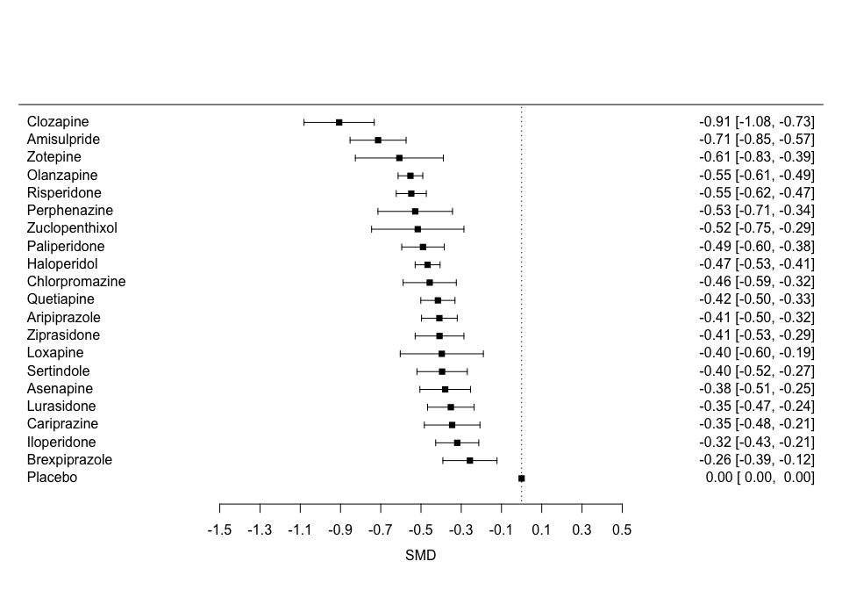

The heterogeneity standard deviation was estimated

## tau= 0.112

# Meta-regression on year

This is the mean year by drug:

## Amisulpride Aripiprazole Asenapine Brexpiprazole Cariprazine   
## 1996 2008 2011 2016 2013   
## Chlorpromazine Clozapine Haloperidol Iloperidone Loxapine   
## 1983 1989 1996 2008 1976   
## Lurasidone Olanzapine Paliperidone Perphenazine Placebo   
## 2011 2007 2008 1990 2002   
## Quetiapine Risperidone Sertindole Ziprasidone Zotepine   
## 2004 2003 2001 2005 1996   
## Zuclopenthixol   
## 1991

The overal mean and range are

## Min. 1st Qu. Median Mean 3rd Qu. Max.   
## 1969 1994 2003 2000 2009 2018

The SMDs adjusted for year 2016 and the regression coefficients are shown below 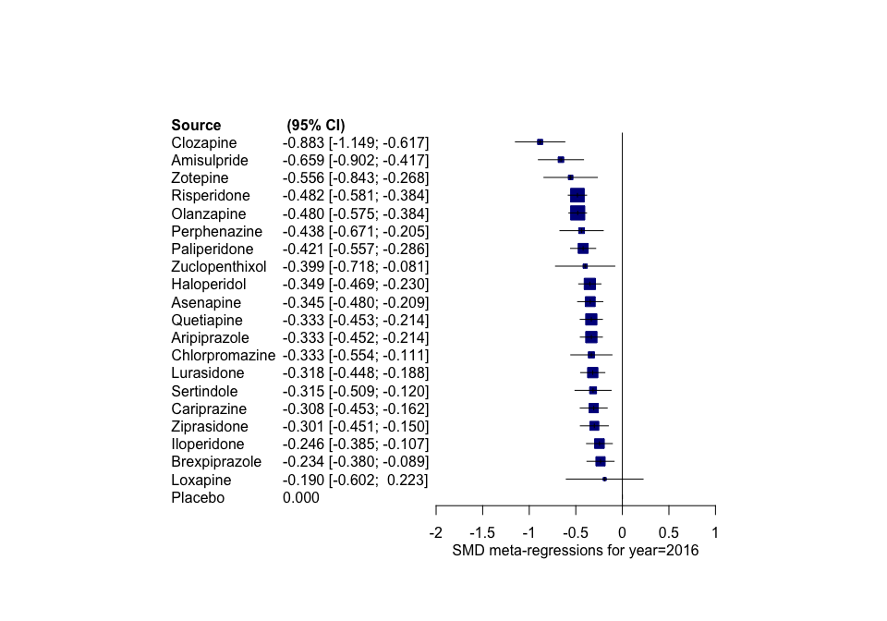

The common regression coefficient and the 95% Ci are

The league table is in a separate Excel file.

## 2.5% 50% 97.5%   
## -0.013 -0.007 -0.001

The heterogeneity standard deviation is

## tau= 0.111

# Meta-regression on age

This is the mean age by drug:

## Amisulpride Aripiprazole Asenapine Brexpiprazole Cariprazine   
## 37 38 40 40 38   
## Chlorpromazine Clozapine Haloperidol Iloperidone Loxapine   
## 36 36 38 38 34   
## Lurasidone Olanzapine Paliperidone Perphenazine Placebo   
## 40 39 38 40 38   
## Quetiapine Risperidone Sertindole Ziprasidone Zotepine   
## 38 38 36 37 36   
## Zuclopenthixol   
## 37

The overal mean and range are

## Min. 1st Qu. Median Mean 3rd Qu. Max.   
## 23.10 35.50 38.00 37.92 40.10 59.90

The SMDs adjusted for age 40 and the regression coefficients are shown below 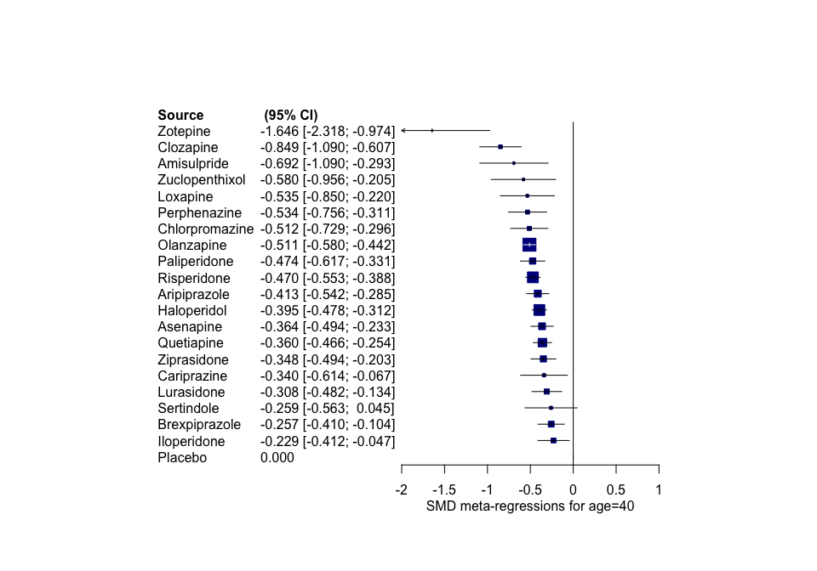

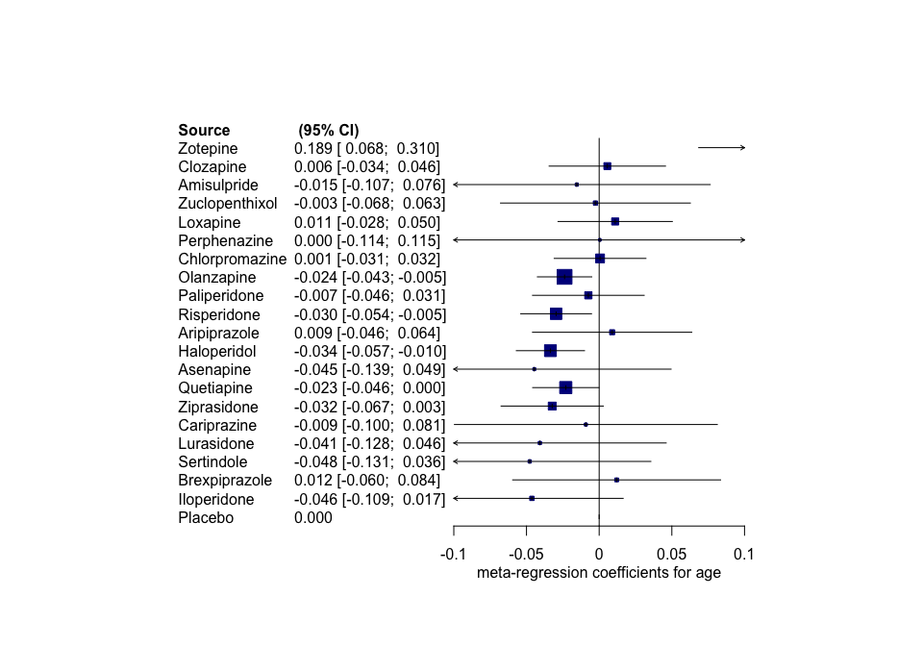

The league table is in a separate Excel file.

The heterogeneity standard deviation is

## tau= 0.111

# Meta-regression on baseline severity

This is the mean baseline severity by drug:

## Amisulpride Aripiprazole Asenapine Brexpiprazole Cariprazine   
## 103 94 92 96 96   
## Chlorpromazine Clozapine Haloperidol Iloperidone Loxapine   
## 101 103 94 92 101   
## Lurasidone Olanzapine Paliperidone Perphenazine Placebo   
## 95 92 92 86 95   
## Quetiapine Risperidone Sertindole Ziprasidone Zotepine   
## 94 92 89 87 105   
## Zuclopenthixol   
## 94

The overal mean and range are

## Min. 1st Qu. Median Mean 3rd Qu. Max.   
## 59.00 90.35 94.50 94.57 98.44 126.00

The SMDs adjusted for baseline severity 94 and the regression coefficients are shown below 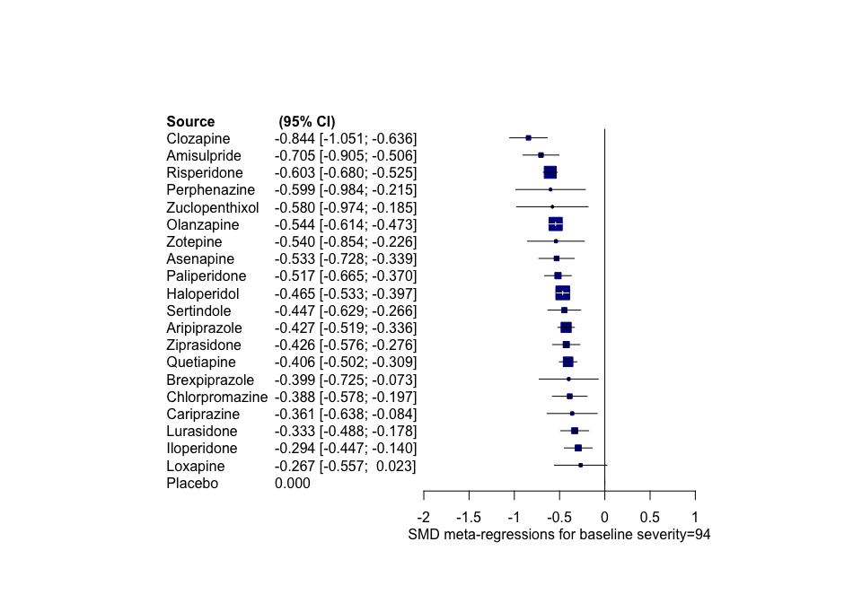

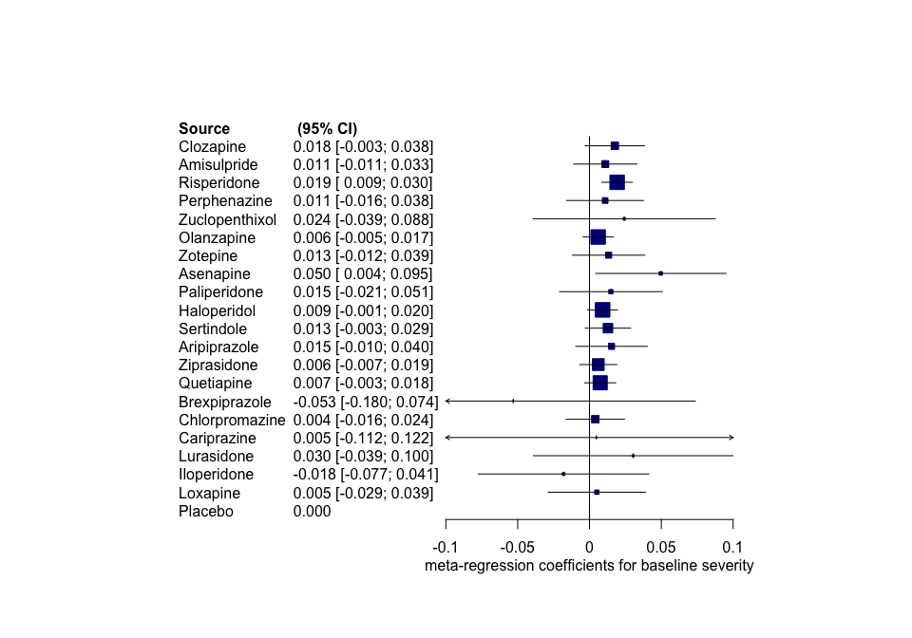

The league table is in a separate Excel file.

The heterogeneity standard deviation is

## tau= 0.121

# Meta-regression of percentage of male participants

This is the mean % male by drug:

## Amisulpride Aripiprazole Asenapine Brexpiprazole Cariprazine   
## 0.574 0.702 0.660 0.597 0.733   
## Chlorpromazine Clozapine Haloperidol Iloperidone Loxapine   
## 0.500 0.579 0.692 0.720 0.595   
## Lurasidone Olanzapine Paliperidone Perphenazine Placebo   
## 0.708 0.646 0.607 0.591 0.677   
## Quetiapine Risperidone Sertindole Ziprasidone Zotepine   
## 0.656 0.692 0.695 0.733 0.589   
## Zuclopenthixol   
## 0.561

The overal mean and range are

## Min. 1st Qu. Median Mean 3rd Qu. Max.   
## 0.0000 0.5630 0.6717 0.6589 0.7650 1.0000

The SMDs adjusted for 50% of male participants and the regression coefficients are shown below 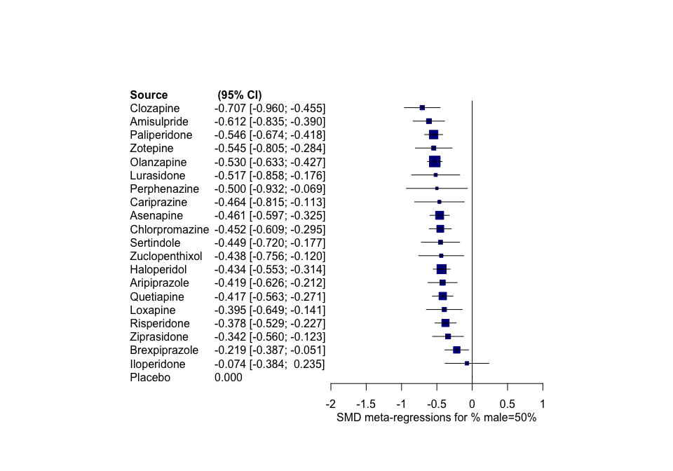

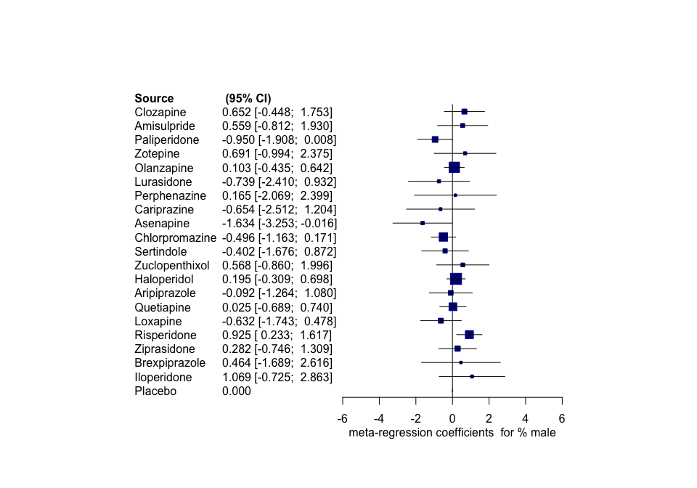

The league table is in a separate Excel file. Unfortunately, as you see above, some of the coefficients have no information (the 95% CrI just reflect the vague prior). This is the case for those drugs with few studies that cover a small range of %male values; for instance Brixiprazole has 4 studies all with precentage males that vary very little

## [1] 0.635 0.613 0.667 0.560 0.509

The heterogeneity standard deviation is

## tau= 0.112

# Meta-regression on study variance

The SMDs adjusted for a study with infinitely large sample size (or, more correly, zero variance) and the regression coefficients are shown below 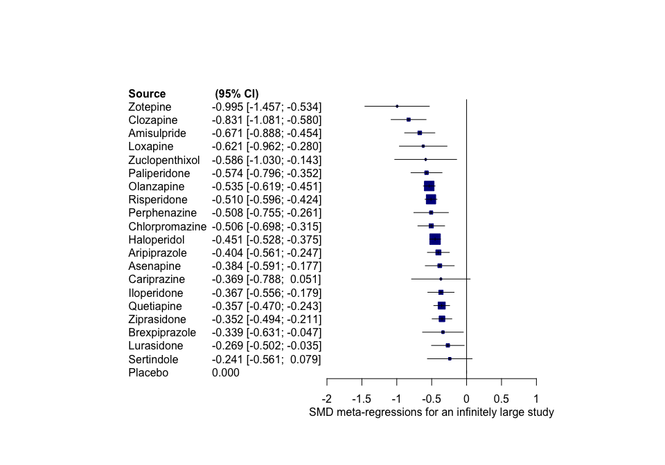

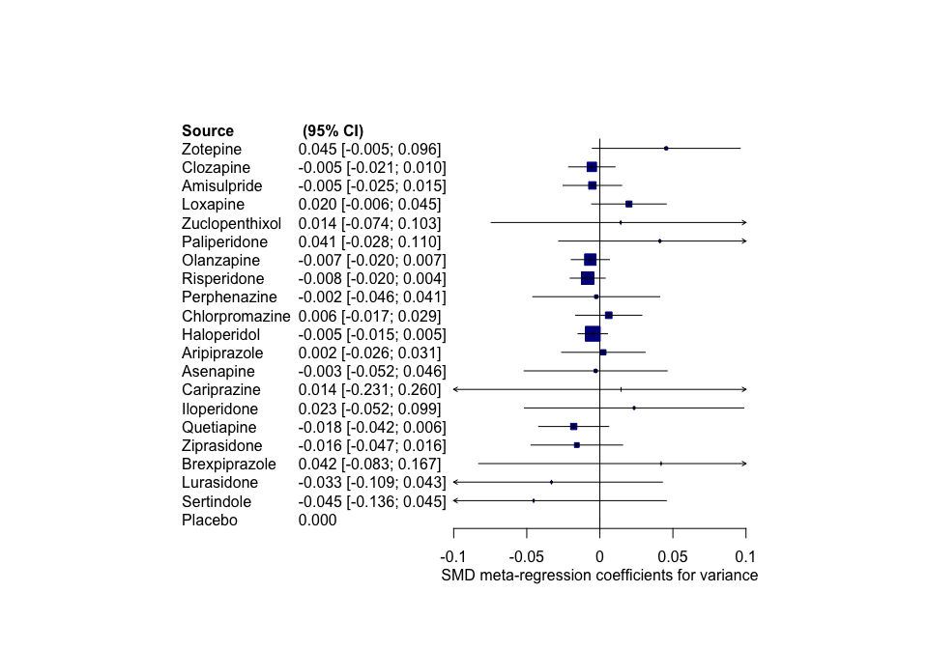

The league table is in a separate Excel file.

The heterogeneity standard deviation is

## tau= 0.123

# Meta-regression for sponsoring

A small number of studies did not provide information on sponsoring, in at least one of the arms. These where the following studies:

## [1] "Abdolahian 2008" "Charalampous 1974, 00559"  
## [3] "Singer 1974" "Klein 1985"   
## [5] "Mori 2004" "Allan 1998"   
## [7] "Borison 1989" "Ceskova 1993"   
## [9] "Delcker 1990" "Klieser 1991"   
## [11] "Murasaki 1993" "Remvig 1987"   
## [13] "Balasubramanian 1991" "Dube 1976"   
## [15] "Moore 1975" "Svestka 1990"   
## [17] "Heikkila 1981"

The table below shows how frequenly (in percentage %) a drug was the sponsored drug out of the total times it has been tested in a trial

## Amisulpride Aripiprazole Asenapine Brexpiprazole Cariprazine   
## 87.5 73.3 100.0 100.0 100.0   
## Chlorpromazine Clozapine Haloperidol Iloperidone Loxapine   
## 0.0 33.3 1.7 100.0 100.0   
## Lurasidone Olanzapine Paliperidone Perphenazine Placebo   
## 100.0 31.1 100.0 0.0 0.0   
## Quetiapine Risperidone Sertindole Ziprasidone Zotepine   
## 66.7 35.9 100.0 69.2 100.0   
## Zuclopenthixol   
## 33.3

The SMDs below are adjusted for the situation where all drugs in a trial are sponsored or not sponsored - so that the sponsoring interests do not bias the result towards any of the arms.

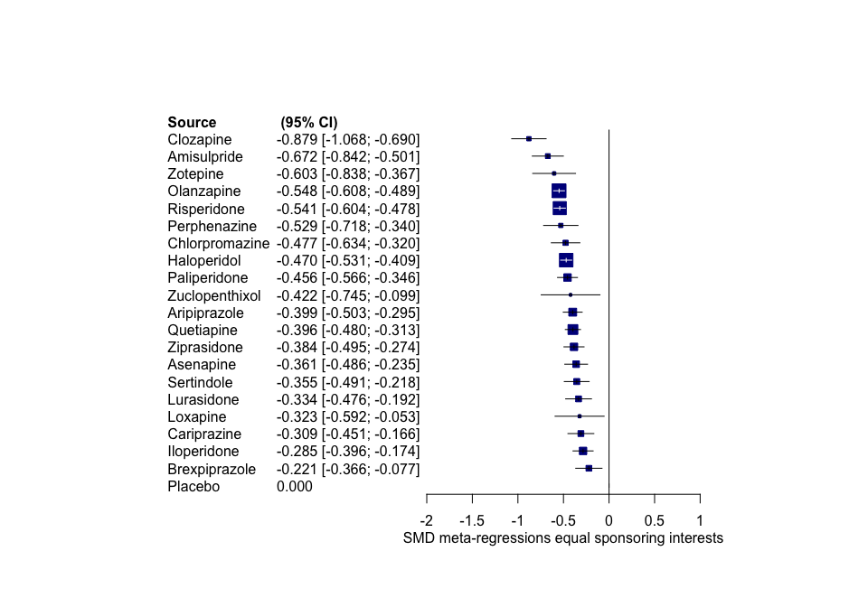

Not important differences are observed- this is not surprising as the (common) regression coefficient Beta is close to zero:

## mean 2.5% 97.5%   
## 0.02980390 -0.02715087 0.06209653

The heterogeneity standard deviation is

## tau= 0.107

# Subgroup for trial Duration

The mean trial duration and the distribution of duration in weeks are shown below.

##   
## 3 4 5 5.7 6 8 9 10 12   
## 8 84 2 8 205 71 2 2 40

## mean duration in weeks= 6.47

After exluding studies with duration less than 4 or more than 8 weeks,the mean duration of trial by drug is

## Amisulpride Aripiprazole Asenapine Brexpiprazole Cariprazine   
## 6.00 5.20 6.00 6.00 6.00   
## Chlorpromazine Clozapine Haloperidol Iloperidone Loxapine   
## 5.64 5.59 6.10 5.71 5.00   
## Lurasidone Olanzapine Paliperidone Perphenazine Placebo   
## 6.00 6.13 6.00 8.00 5.61   
## Quetiapine Risperidone Sertindole Ziprasidone Zotepine   
## 6.35 6.28 7.42 5.50 6.33   
## Zuclopenthixol   
## 6.00

And SMD against placebo is shown below

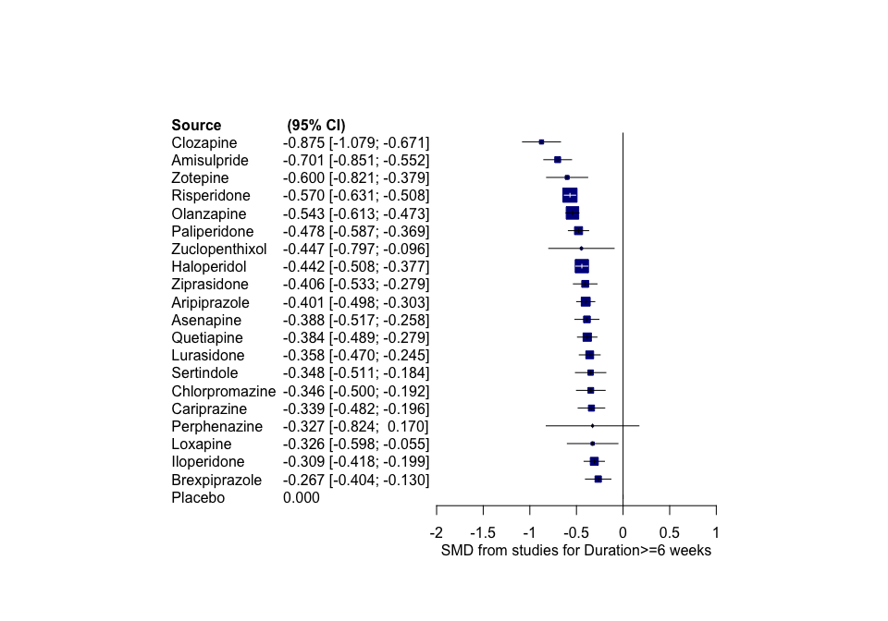

The heterogeneity standard deviation is

## tau= 0.115

# Subgroup analysis for RoB

Only a few studies have been judged to pertain to high Risk of Bias; namely

## 17

studies. When excluded them from the dataset, no notable changes are observed in the SMDs:

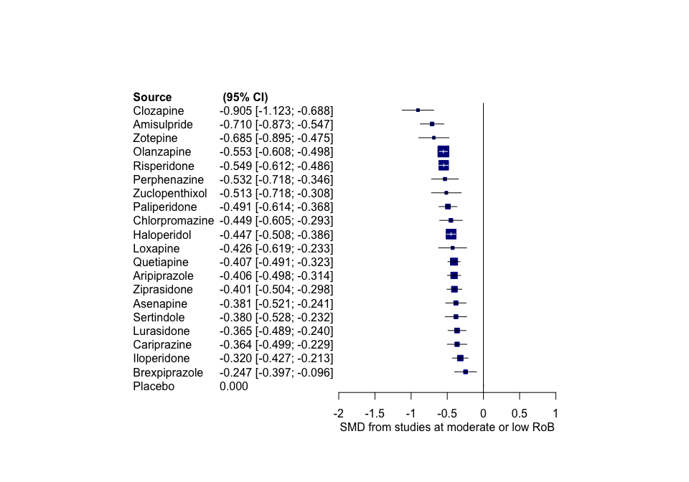

The league table is in a separate Excel file. The heterogeneity standard deviation is

## tau= 0.11

# Subgroup analysis for imputed standard deviations

Only a few studies had the SDs imputed; after exlcuding them we have

## 158

studies. When excluded efrom the dataset, no notable changes are observed in the SMDs:

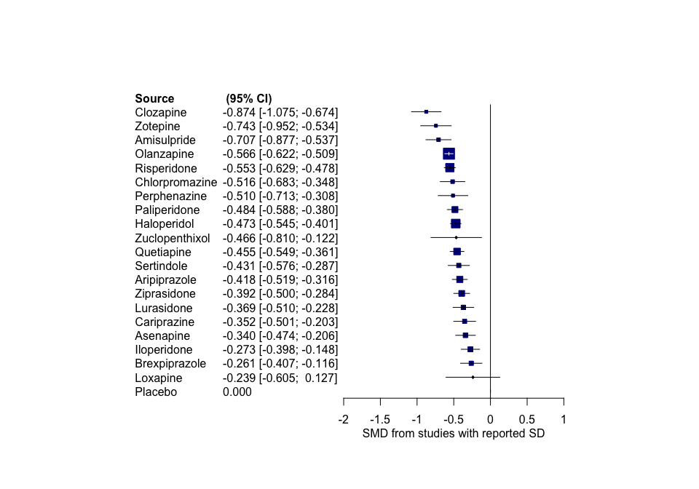

The league table is in a separate Excel file. The heterogeneity standard deviation is

## tau= 0.112

# Subgroup analysis of head to head studies only

We excluded placebo-controlled trials from the data set. Studies with placebo arm were excluded even if they had two or more active arms. The number if head-to-head studies per drug is shown below

##   
## Amisulpride Aripiprazole Chlorpromazine Clozapine Haloperidol   
## 10 6 9 12 47   
## Iloperidone Loxapine Olanzapine Paliperidone Perphenazine   
## 3 4 27 2 3   
## Quetiapine Risperidone Sertindole Ziprasidone Zotepine   
## 10 27 3 9 5   
## Zuclopenthixol   
## 6

In total we included

## 89

stydies and

## 16

drugs. The SMDs against Haloperidol are shown below:

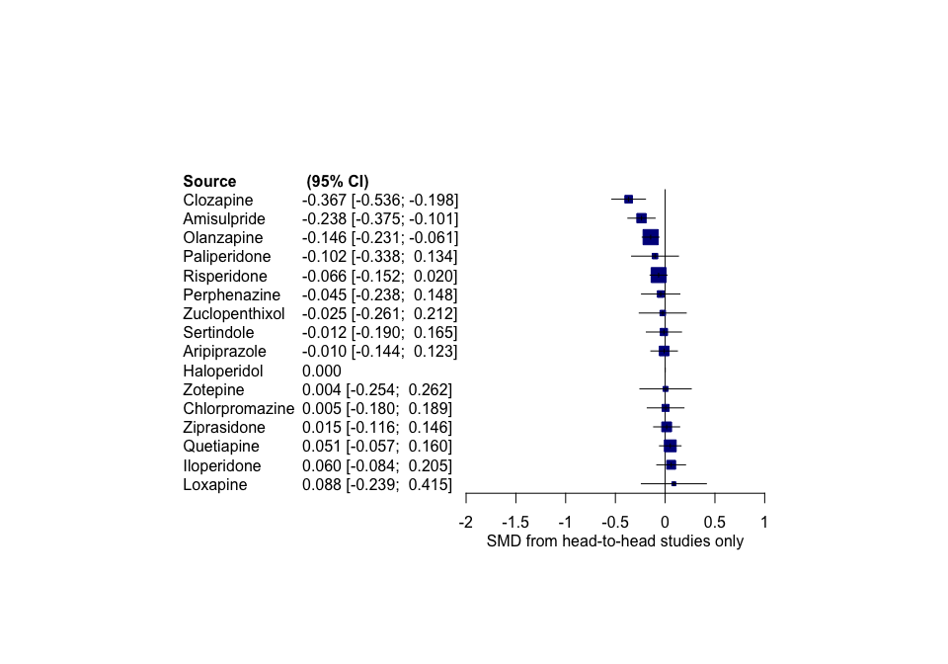

The league table is in a separate Excel file. The heterogeneity standard deviation is smaller than in the total network

## tau= 0.08

# Subgroup analysis excluding placebo arms

Now we exclude only the placebo arms but we keep the active arms in the data set (of course 2-arm placebo controlled studies are excluded).

We ended up with

## 126

studies.

The SMDs against Haloperidol are shown below:

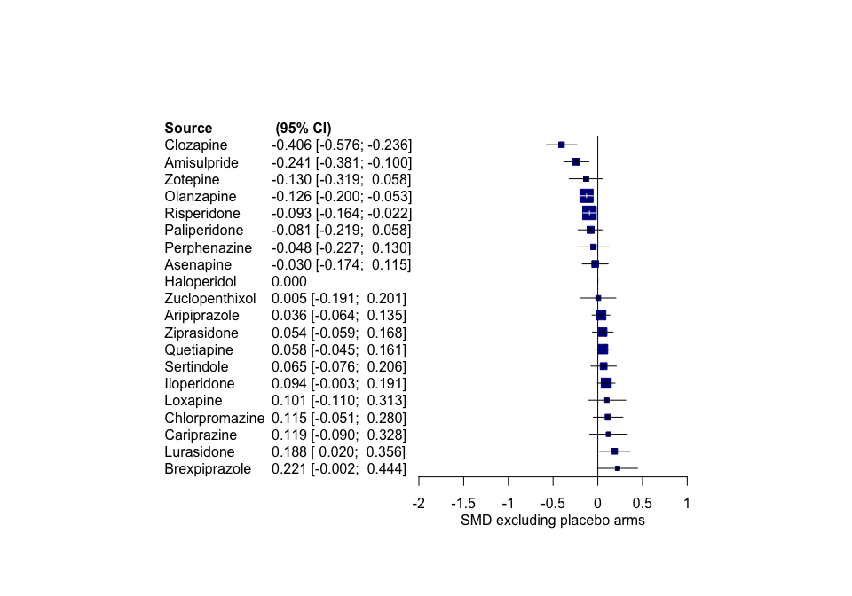

The league table is in a separate Excel file. The heterogeneity standard deviation is smaller than in the total network

## tau= 0.082

# Subgroup analysis for studies reported as ITT

We excluded studies that did not seem to have reported ITT analyses (although what ITT meant, is very variable accross studies). The data set includes

## 147

studies. The SMDs below are estimated

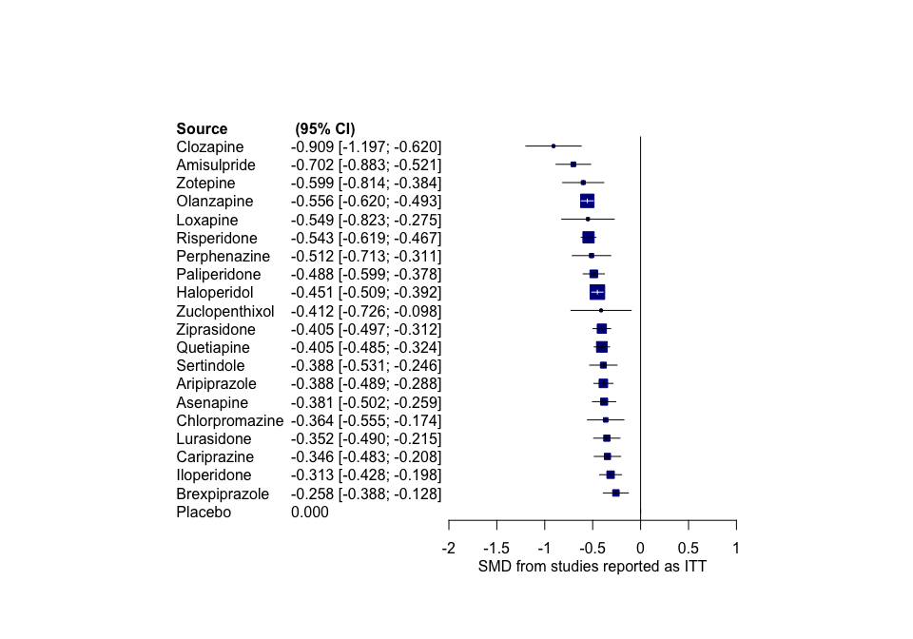

The heterogeneity standard deviation is

## tau= 0.113

# Subgroup analysis for studies that compare drugs at doses that do not differ a lot

From each study we calculated the difference between the active doses, as calculated in Olanzapine-equivalent doses.

The active arms from several studies included arms in which the lowest dose was less than 50% of the largest dose. After exluding those studies we ended up with

## 108

studies.

The SMDs below are estimated

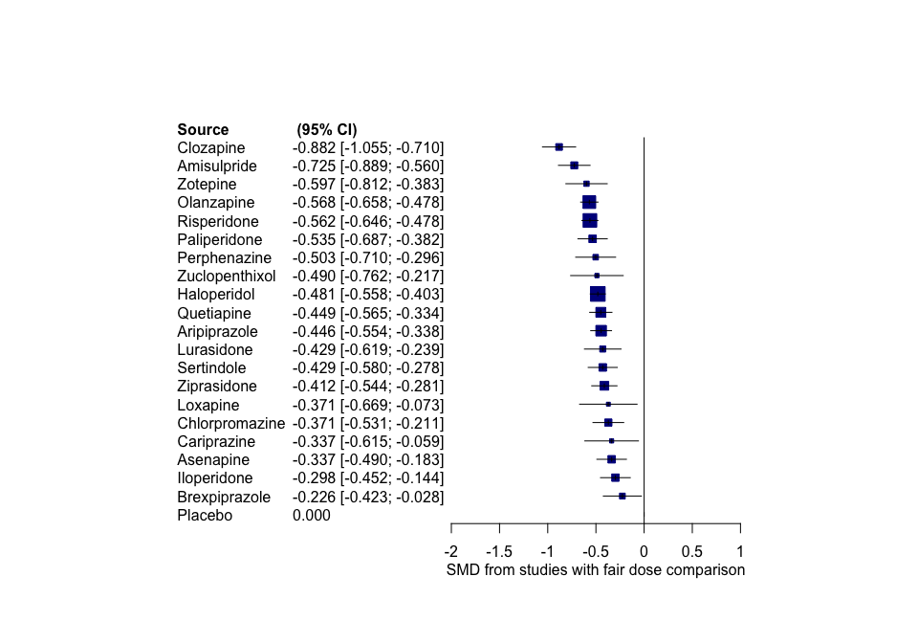

The heterogeneity standard deviation is

## tau= 0.121

# Subgroup analysis for studies published in 1990 or later

We excluded studies publisehd before 1990

After exluding those studies we ended up with

## 157

studies.

The SMDs below are estimated

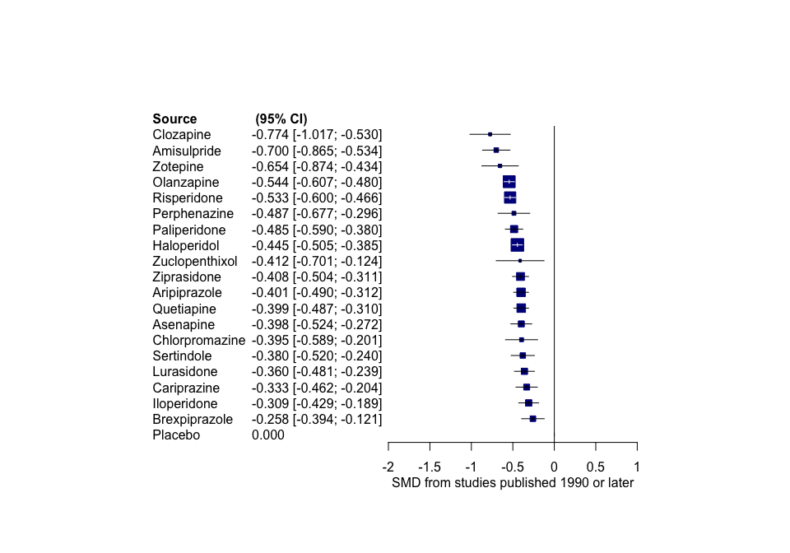

The heterogeneity standard deviation is

## tau= 0.109

# Subgroup analysis for non-failed studies

We excluded stuies characterised as ‘failed’

After exluding those studies we ended up with

## 178

studies.

The SMDs below are estimated

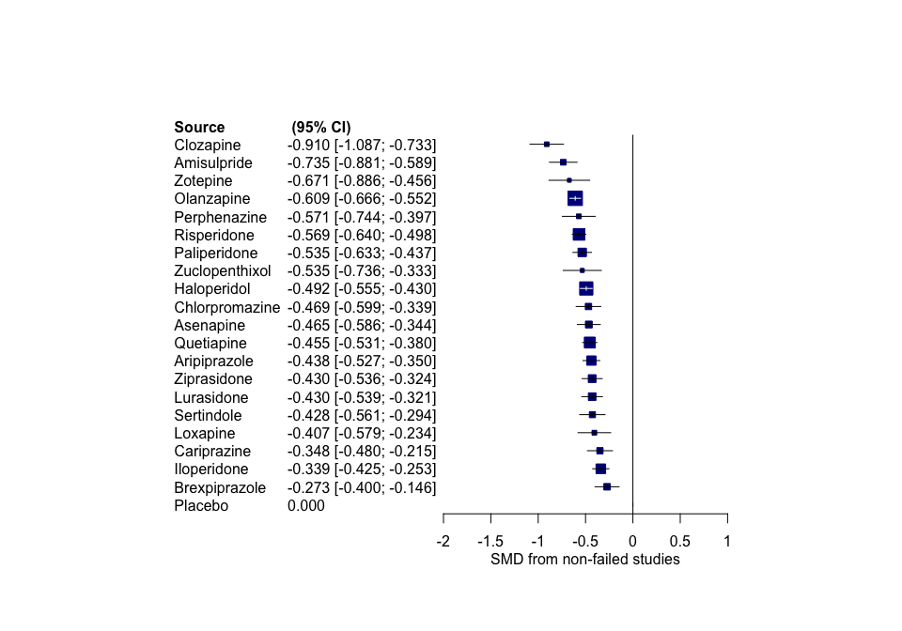

The heterogeneity standard deviation is

## tau= 0.084