Drosophila yakuba – Tsc1

Bailey Lose1Ω, Abigail Myers1Ω, Ian Alberts2, Savanah Fondse3, Joyce Stamm2, James Youngblom3, Chinmay P. Rele1Ω

1. The University of Alabama, Tuscaloosa, AL 35487
2. University of Evansville, Evansville, IN 47722
3. California State University Stanislaus, Turlock, CA 95382

Ω  To whom correspondence should be addressed

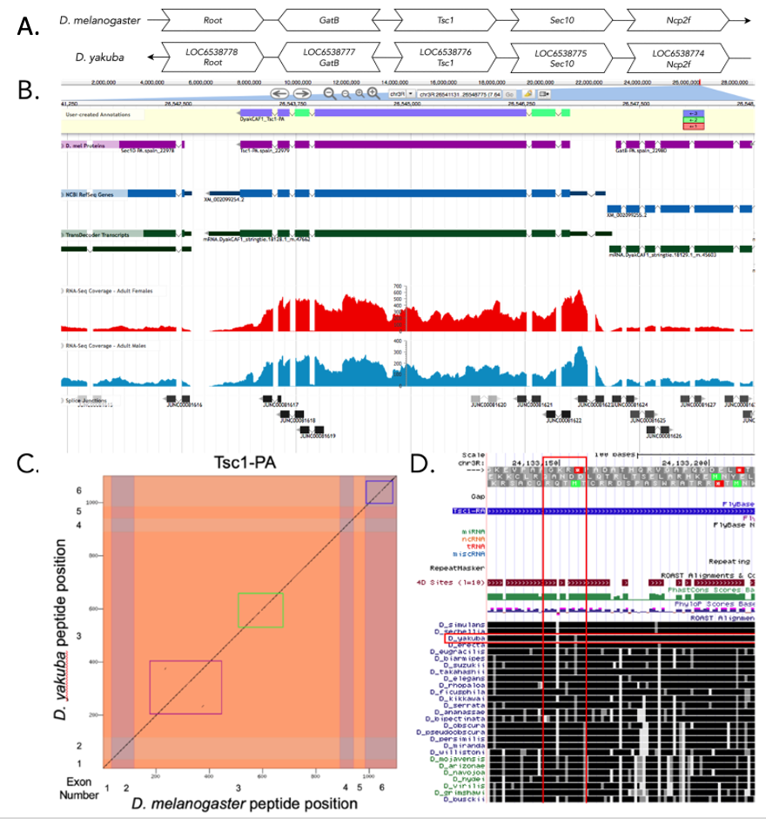

**Figure 1:** (A) Synteny of genomic neighborhood of *Tsc1* in both D. melanogaster as well as D. yakuba.(B) Gene Model in Apollo: A screenshot of the Apollo instance housing the gene model, containing student annotations, D. mel Proteins, NCBI RefSeq Genes, TransDecoder Transcripts, RNA-Seq tracks and splice junctions; (C) Dot Plot of gene in D. melanogaster (x-axis) vs. the gene in *D. yakuba* (y-axis); (D) *Drosophila* conservation across 28 species shows that the region, shown in the vertical red box, for exon 3 in *D. melanogaster* contains a lower level of sequence similarity in comparison to the majority of the other species, including *D. yakuba* (highlighted by the horizontal red box).

## Introduction

Tsc1 in D. yakuba is an ortholog to the Tsc1 gene (LOC6538776) in D. melanogaster. Mutations in either the Tsc1 or Tsc2 gene can cause the hamartoma syndrome tuberous sclerosis complex (TSC). (Dabora et. al, 2008) These two genes operate together in the insulin signaling pathway as tumor suppressors because of their ability to control cell growth. (Gao, 1970) A mutation in the Tsc1 gene can also cause benign tumors to form in multiple organs. (Potter, Huang, Xu, 2001) The Gnomon predicted model in D. yakuba, with a RefSeq accession number of XM_0020099254.2, has the same number of exons as the Tsc1 gene (LOC6538776) in D. melanogaster indicating they have an orthologous relationship.

## Synteny

The Tsc1 gene, located on chromosome 3R in D. melanogaster, is neighboring the genes Root, GatB, Sec10, and Ncp2f. The best candidate for the Tsc1 ortholog gene in D. yakuba based on the tblastn search is found on chromosome 3R. The candidate is also surrounded by the genes LOC6538778, LOC6538777, LOC6538775, and LOC6538774 (which are likely orthologous to Root, GatB, Sec10, and Ncp2f in D. melanogaster respectively, Figure 1A). We performed a blastp search of protein sequence XP_002099290.1 in D. yakuba against the protein sequences found in the refseq_protein database for D. melanogaster and it showed a high percent identity to Tsc1 in comparison to the second-best hit. After confirming that the genes surrounding Tsc1 are orthologous between the two species and the blastp results indicate a high percent identity for the Tsc1 gene between the two species, we determined that this region does contain the ortholog for Tsc1 in D. yakuba.

## Gene Model

Tsc1 has one isoform in D. yakuba, Tsc1-PA, with 6 exons. There are also 6 exons in the Tsc1 gene located in D. melanogaster. A blastp search of the protein sequence of Tsc1 in D. yakuba against D. melanogaster yields a 97.00% identity with only 33 amino acids differing out of 770. There were small misalignments between the protein sequences of the two species in coding exon 3 and 6 as is displayed by the green, blue, and pink boxes in the dot plot. (Figure 1C) The large misalignment in exon 3, shown by the green box, can also be seen in the conservation tracks of 28 different Drosophila species in the UCSC Genome Browser and especially in D. yakuba. (Figure 1D) These misalignments, however, are probably not large enough to cause any significant change in the function of the gene in either species.

# References

Dabora, S.L., Jozwiak, S., Franz, D.N., Roberts, P.S., Nieto, A., Chung, J., Choy, Y.-S., Reeve, M.P., Thiele, E., Egelhoff, J.C., Kasprzyk-Obara, J., Domanska-Pakiela, D., Kwiatkowski, D.J., 2008. Mutational Analysis in a Cohort of 224 Tuberous Sclerosis Patients Indicates Increased Severity of TSC2, Compared with TSC1, Disease in Multiple Organs [WWW Document]. The American Journal of Human Genetics. URL <https://www.sciencedirect.com/science/article/pii/S0002929707624720> (accessed 6.4.20).

Gao, X., Pan, D., 1970. TSC1 and TSC2 tumor suppressors antagonize insulin signaling in cell growth [WWW Document]. Genes & Development. URL <http://genesdev.cshlp.org/content/15/11/1383.short> (accessed 6.4.20).

Potter, C.J., Huang, H., Xu, T., 2001. Drosophila Tsc1 Functions with Tsc2 to Antagonize Insulin Signaling in Regulating Cell Growth, Cell Proliferation, and Organ Size [WWW Document]. Cell. URL <https://www.sciencedirect.com/science/article/pii/S0092867401003336> (accessed 6.4.20).

**Funding:** This material is based upon work supported by the National Science Foundation under Grant No. IUSE-1915544 to LKR and the National Institute of General Medical Sciences of the National Institute of Health Award R25GM130517 to LKR. The Genomics Education Partnership is fully financed by Federal moneys. The content is solely the responsibility of the authors and does not necessarily represent the official views of the National Institutes of Health.

## Acknowledgements: Laura K. Reed, Wilson Leung, and Chinmay P. Rele, who created and maintains the GEP technological infrastructure.

**Author Contributions:**

Bailey Lose and Abigail Myers and Chinmay P. Rele

* Formal analysis
* Writing – original draft
* Writing – review & editing

University of Evansville, California State University

* Formal analysis
* Writing – original draft

Joyce Stamm, James Youngblom

* Writing – review & editing
* Supervision

Please select a tag below that best describes your submission

|  |  |  |
| --- | --- | --- |
| New findings | Replication – successful | Negative results |
| Methods & reagents | Replication – unsuccessful |  |

**You declare the following by submitting your article to microPublication Biology: “**I/we declare to the best of my/our knowledge that the experiment is reproducible; that the submission has been approved by all authors; that the submission has been approved by the laboratory's Principal Investigator, and that the results have not been published elsewhere. The author(s) declare no conflict of interest.”

Ignore the grayed out text below

**Reviewed by :**

**Received** yyyy/mm/dd, **Accepted** yyyy/mm/dd. **Published Online** yyyy/mm/dd.

**Copyright** © 2020 by the authors. This is an open-access article distributed under the terms of the Creative Commons Attribution 4.0 International (CC BY 4.0) License, which permits unrestricted use, distribution, and reproduction in any medium, provided the original author and source are credited.

**Citation**: