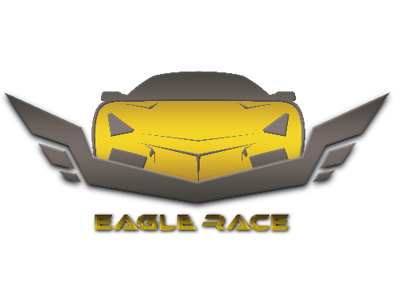

Scott Lester is a driver, one of the best. He was called " the eagle ".

Day after day, Scott’s name began to hit due to his driving skills that what made a Russian mob decides to benefit from his talent. So, they kidnapped his daughter in order to threaten him.

Meanwhile, Scott was going crazy and he was going to call the police until he received a text message:

"Want to save your daughter!! Do what we ask you to do, we'll send you missions' details.

REMEMBER SHE'S IN OUR HANDS AND NO COPS "

STAGE 1:

/\*helping the player to explore the game\*/

Two days later, Scott received his first mission details, he was asked to drop off a bombed car.

STAGE 2:

/\*time out without obstacles\*/

After winning the mob's trust, Scott was asked to drop off some of the mob's members in time in order to rub a bank.

During that Scott heard one of the mob's members talking to the boss.

STAGE 3:

/\*time out with obstacles\*/

After finishing the second mission, Scott remembered the voices he heard from the call, he heard a train coming and waves drifting that what helped him to identify the mob's place so he decided to take a chance and save his daughter in the right time.

STAGE 4:

/\*Race\*/

The boss knew about Scott’s coming so he escaped with the girl.

When Scott made it to the place, he didn't find anyone but he heard cars' engines so he ran back to his car and got into a race with the mob's members in order to turn his daughter back.

STAGE 5:

/\*Race\*/

Scott reached the mob's members but the boss was way too far so he continued driving after him.

After a long race, the boss crashed into a van crossing his way so Scott stopped and ran to see his daughter who was in the back seat.

Putting an end to this nightmare, Scott took his daughter back home safe and sound.