Diamondsizes
2016-08-25
We have data about 53940 diamonds. Only 126 are larger than 2.5 carats. The distribution of the remainder is shown below: 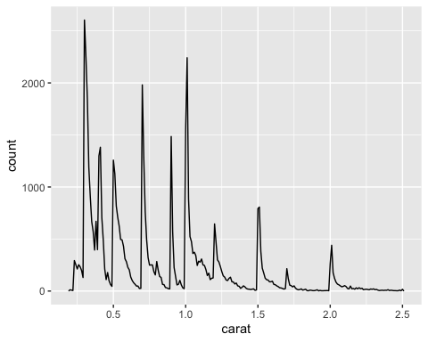 Mit cmd + shift + K -> kriegt man nur den plot ausgespuckt
27.3 Text formatting with R Markdown

italic or italic bold or bold code superscript² and superscript₂

Headings
#1st Level Header #2nd Level Header #3th Level Header

Lists
- Bulleted list item
- Item 2
  - Item 2a
  - Item 2 b
- Numbered list item
- Item 2. The numbers are incremented automatically in the output

Links and images
http://example.com linked phrase optional caption text

Tables
First Header | Second Header
Content Cell | Content Cell
Content Cell | Content Cell

