Community Participation & Innovative approaches in Maternal Health Programme at Birganj Upazila Health Complex, Dinajpur.
Dr. Md. Zahangir Kabir
Ex-UHFPO, Birganj, Dinajpur.

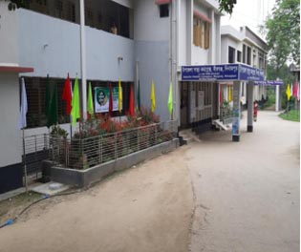
Since July 2017 Birganj Upazila Health Complex, Dinajpur launched an innovative approach “ We need to go to health Centre for safe delivery” ( wbivc` cÖmi PvB, m¦v¯’¨ †K‡›`ª Pj hvB )

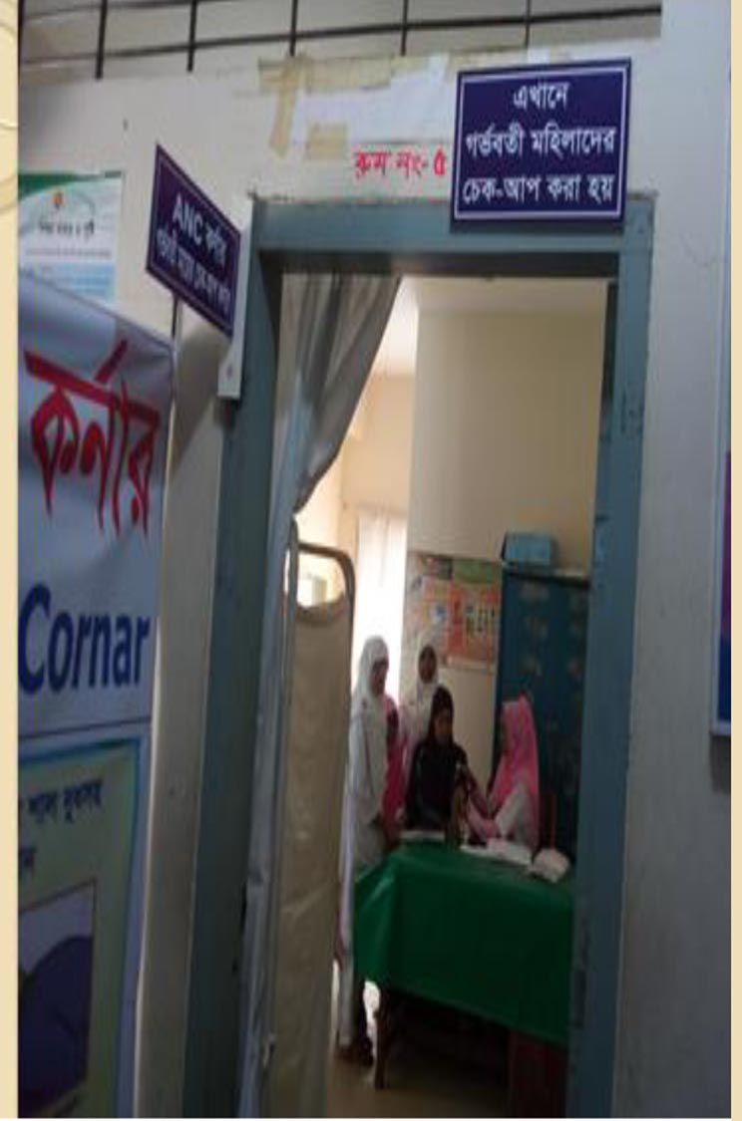
The Upazila Health Complex takes some initiatives for maternal care with dignity with its four doctors and five midwives through team work by involving previously unengaged non-governmental organization (NGO’S) and other civil society organization, this includes wide spectrum of local government Community leaders, School & College teachers, Journalist, Community based organizations working in primary health Care.

In the outpatient department of the Upazila Health Complex a Corner has been established, to render antenatal Care (ANC) post natal care (PNC). Female doctors and midwives provide quality maternal health care there from.

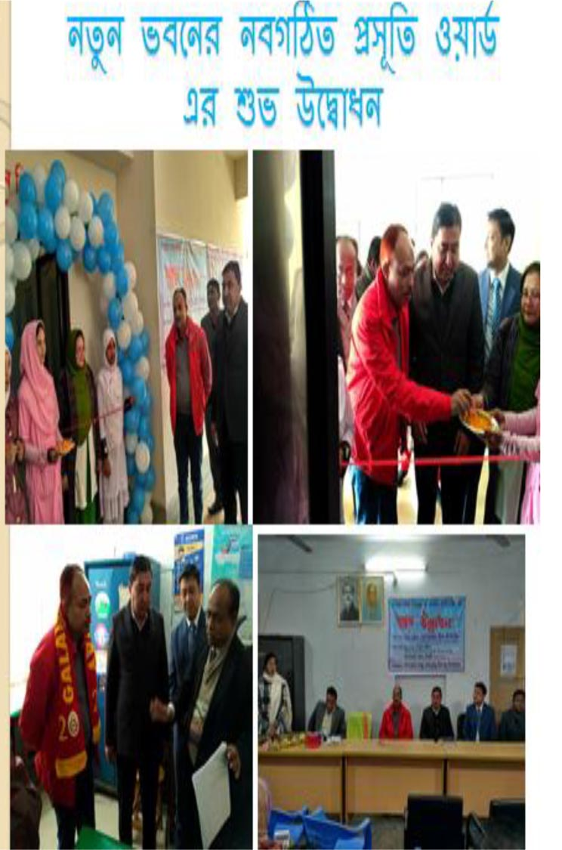

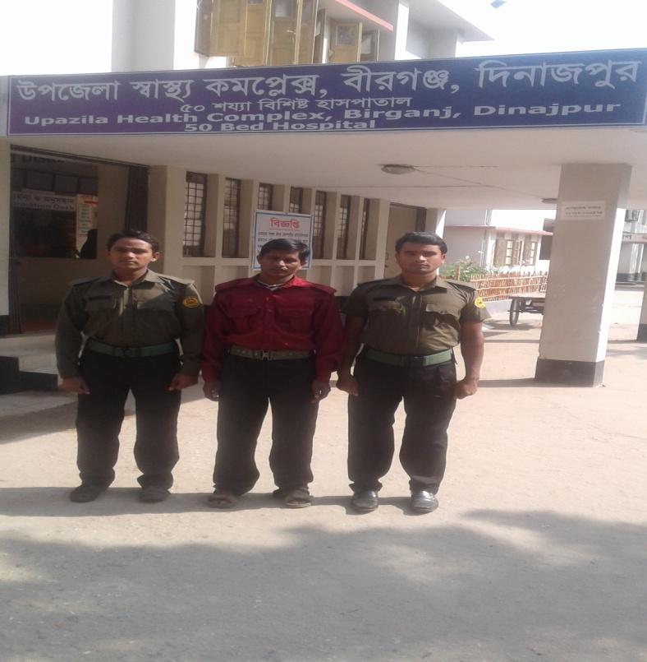
In the new building of the upgraded Upazila Health Complex (upgraded to 50 beds from 30 beds). A maternal department equipped with all modern and improved facilities has been established. Local elected representatives and sensible community expressed their solidarity with this generous initiatives.

Five cleaners and three security persons are engaged in this program with their financial support.

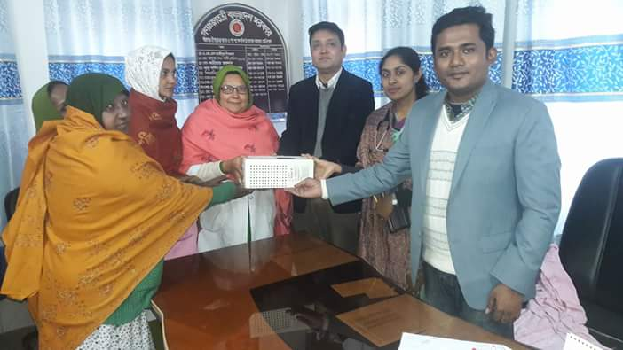
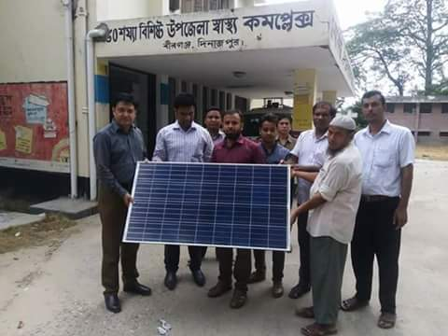

Local community has donated 3 IPS for maternal department and Upazila parishad has provided CCTV & Solar system.
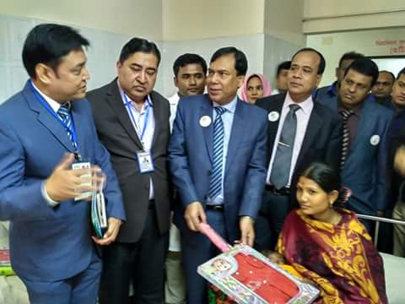
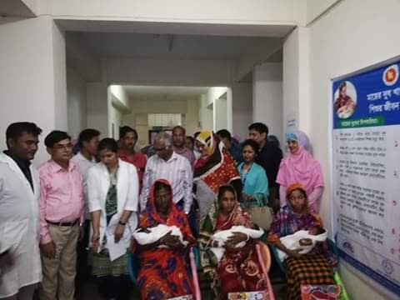
With the support of local community patient welfare fund has been developed to provide medicine free of cost for the pregnant mother if not available at Upazila Health Complex.

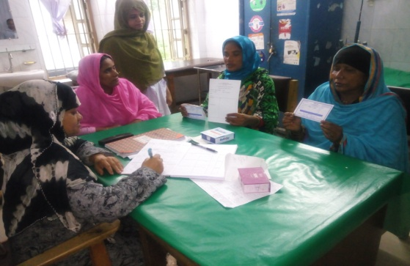
With the support of Upazila parishad & social welfare department each new born is welcomed with a health protective gift hamper consisting of two sets of cotton kids dress, a baby soap & a baby mosquito net.

With the locally designed maternal health card the field workers of health & family planning department, elected representatives, teachers, media representatives, local elites, refer pregnant mother to the health complex. As the maternal card contains the mobile no. of the referee, when the pregnant mother attends health complex, then instantaneously thanks giving
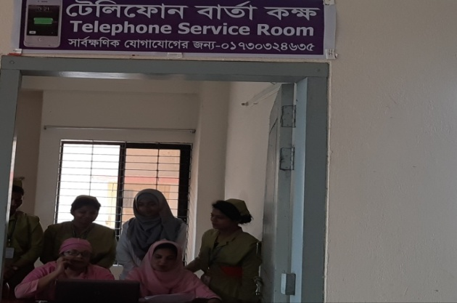

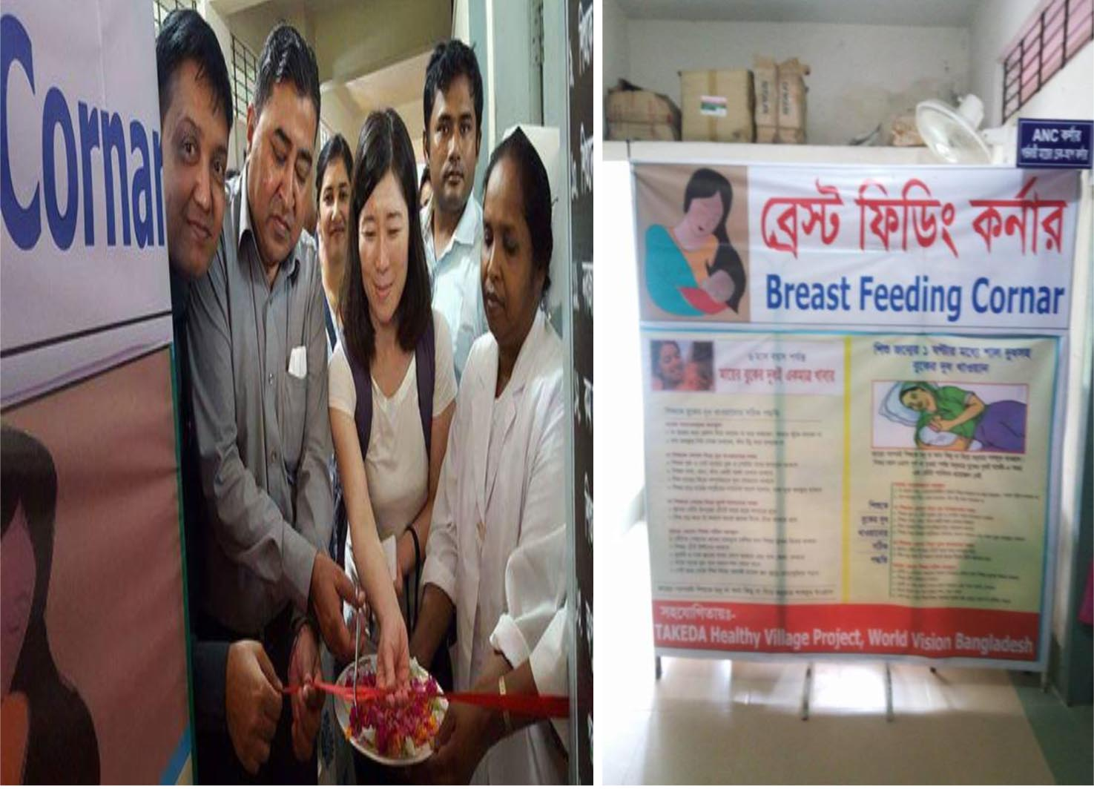
message is sent to the referee. Even after delivery she/he is informed about the status of mother and the new born. For this local people become happy, honoured and think of their participation.

With the support of NGO partner a modern breast feeding corner has been established in the health complex.

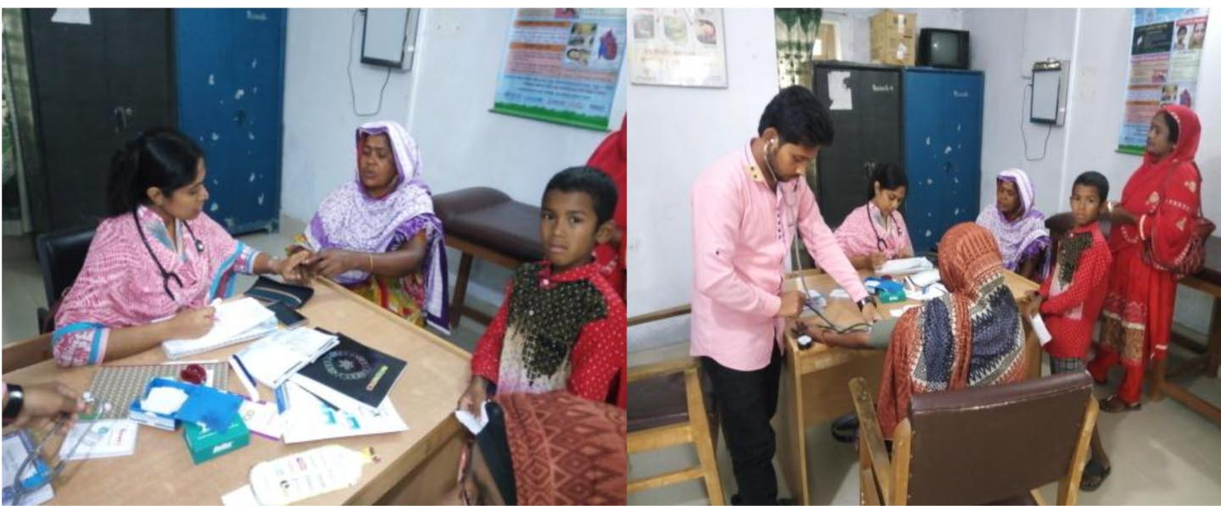
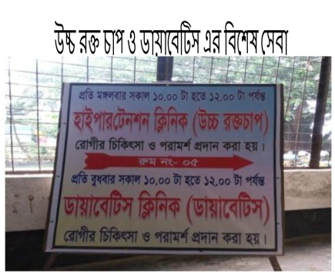

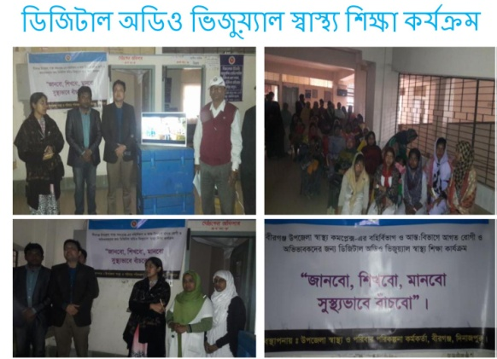
Hypertension & Diabetic centre Besides this, a clinic has been established to adress hypertension and diabetes that operates on every tuesday & wednesday. From here an advising card is provided to any diagnosed as hypertensive or diabetes patients under management so that they can be followed up in Community Clinic, Particularly who lived in far away from health complex including patients of remote areas. At Community clinic, the service provider follow the cases and may seek any advice from health complex if needed. It minimize the Cost, time & sufferings of journey.

Recently digital audio, video health education program titled “ We will know, learn, practice, and lead healthy lives” has been introduced in OPD & IPD for patients and visitors.

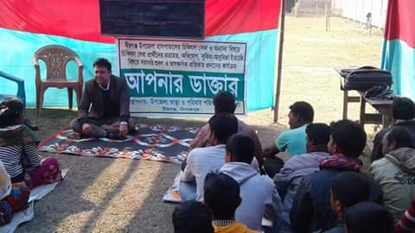

Pic: Your doctor program.
Through another innovation “ Your doctor” UH&FPO Birganj personally listen to the observation and comments from the service seekers on the opportunities, problems, suggestion of solution and take necessary measures instantaneously. It is scheduled on every saturday at Upazila Health Complex and once in a month in one Union.
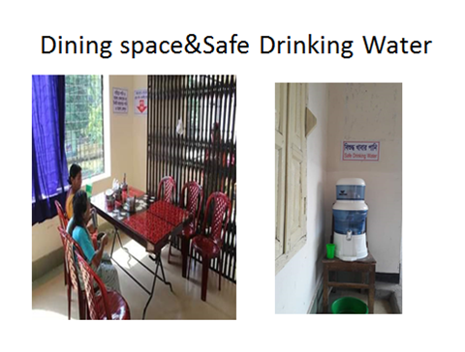
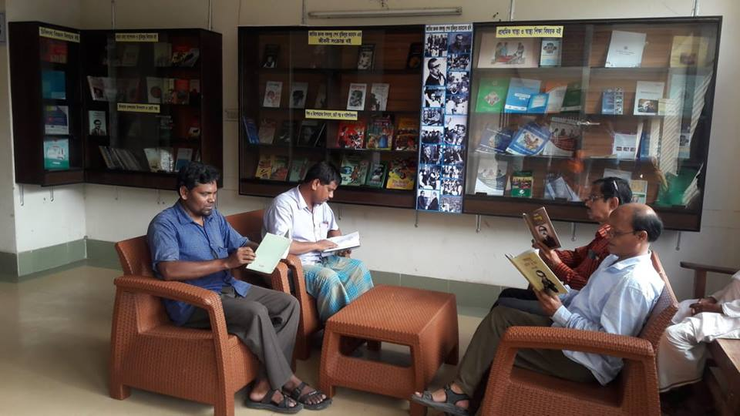
In addition to the routine activities the notable steps taken by Birganj UHC are as following------------

Establishment of a library in front of maternity Unit having an ample collection of books on liberation war, Biography of father of nation, novels of renowned writers, Short stories, books on Children & mother’s health and nutrition. The attendants of the maternal patient and others, even patients can read books as per their choice, Sitting on the comfortable chairs on the library. As a result of patients and their attendants need not to roam around different sections of the UHC, Unnecessary rather they can pass their leisure time in the library. It helps in learning on different issues, in maintenance of healthy environment and at the same time they feel honoured as well.

For the patients, their guardians and relatives a separate well furnished dining hall with dining tables and Chairs has been established having provision for safe drinking water. They can take their meal there with due dignity. They are happy with the arrangement and as outcome all the words remain neat and Clean instead of previous unhealthy environment. Besides the health service with dignity some innovative activities have made Birganj Upazila health complex different from others. The major ones among those are as follows:
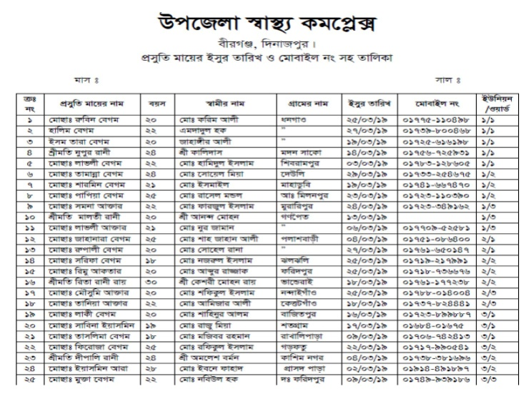

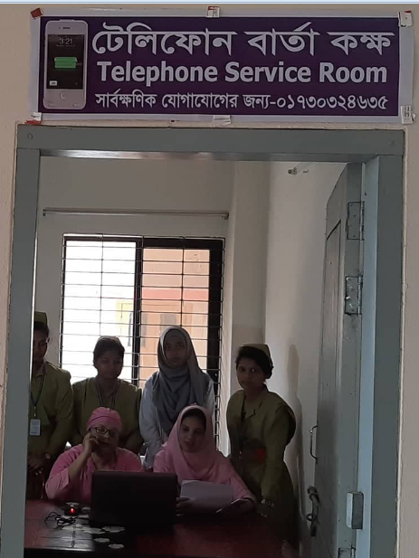
- Database of all pregnant mother of the Upazila.

- Monitor and track the pregnant mother from the telephone message Unit

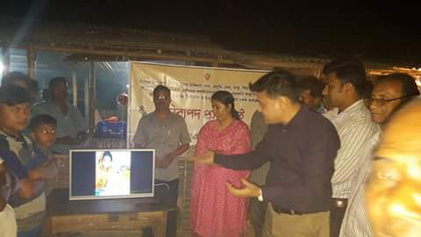
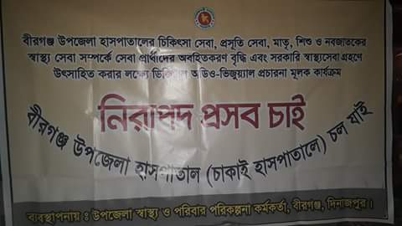

- Inspire the mother and guardians for hospital delivery.
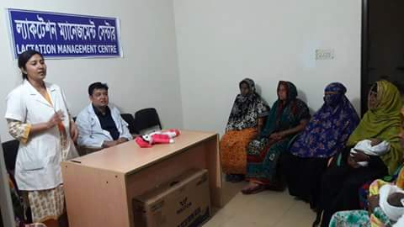

- Through the established lactation Corner at UHC Each mother is counselled on child health, breast feeding& nutrition.
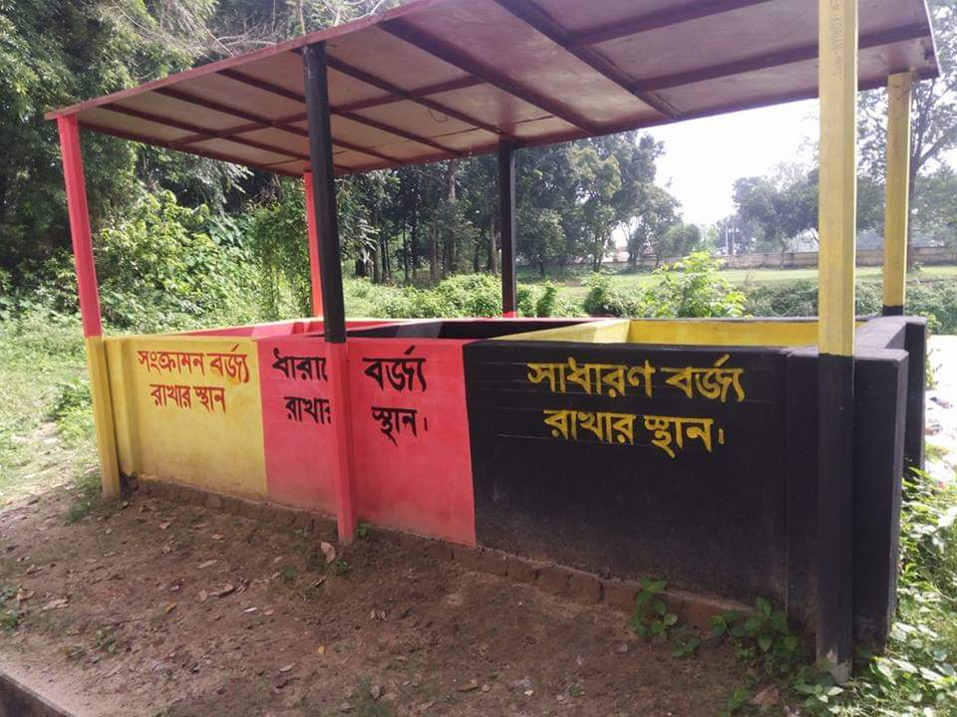
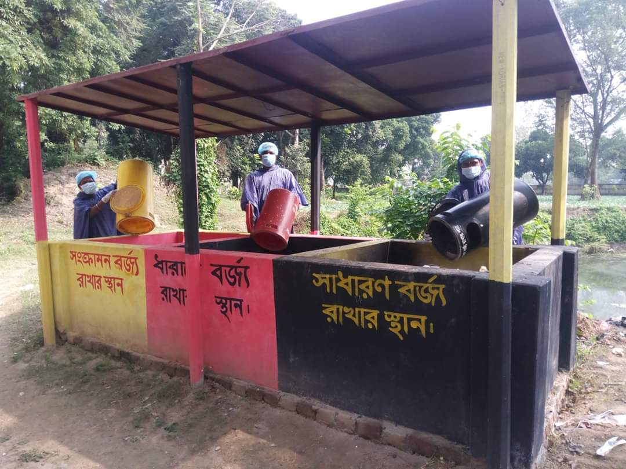

- Medical Waste Disposal is an environmental concern. So to make the hospital environment friendly, a modern waste disposal pit has been established with support of upazila parishad.

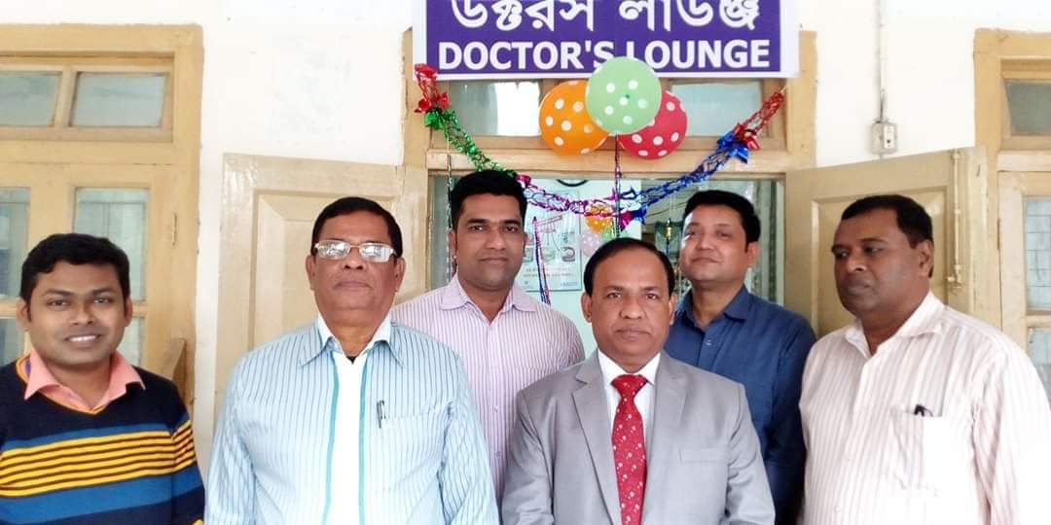
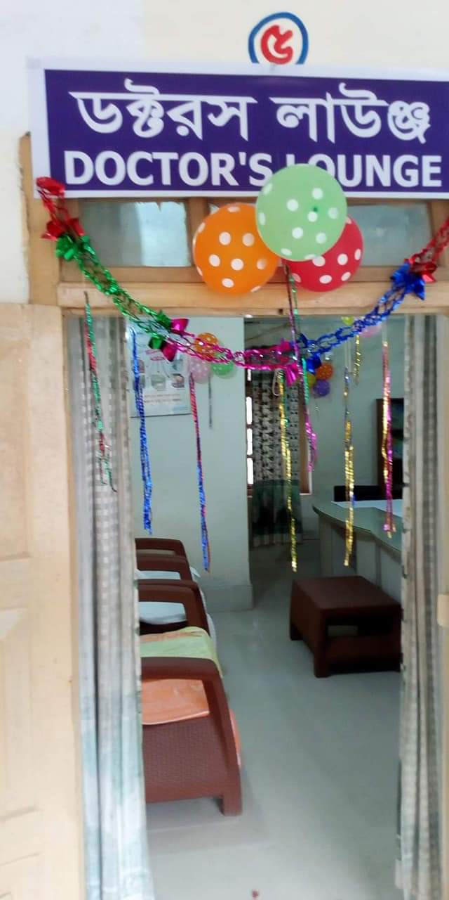
- To make the hospital Doctors friendly, Doctors` Lounge has been established where all the Doctors of this hospital can pass their leisure time in this Lounge, Lounge is well furnished and decorated with Sofa set, modern Chairs and tables.
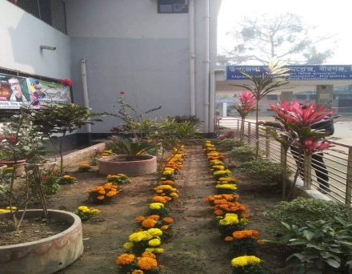
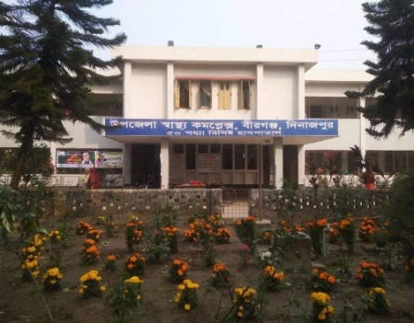
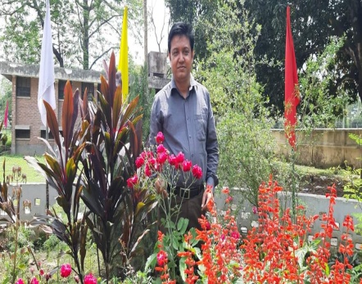


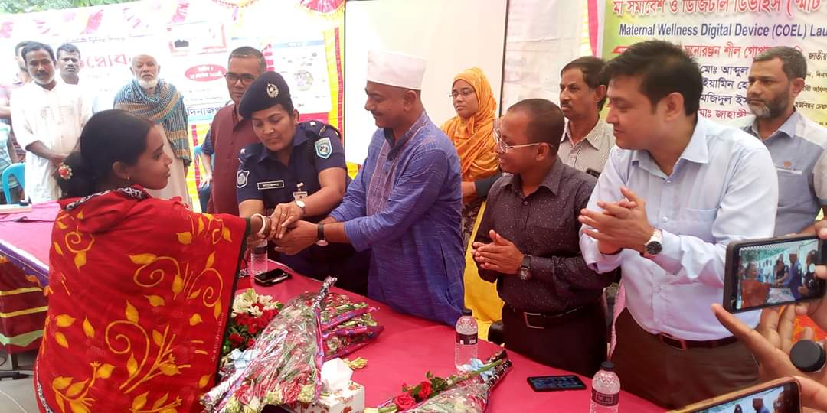
- To enrich and improve the lives of patients during hospital stay, five flower gardens have been established at hospital surroundings with the support of Local elected representatives, and union parishad.

- Maternal wellness Digital Device (COEL) for pregnant mother has been launched in Birganj Upazila with the support of Takeda Healthy Project Japan and World Vision Bangladesh.
As a result of these measure number of normal delivery of hospital is increasing successively.
Year | No. of ANC | No. of NVD | No. of PNC
2016 | 961 | 140 | 140
2017 | 1773 | 298 | 298
2018 | 3084 | 772 | 772
2019 | 6034 | 802 | 802
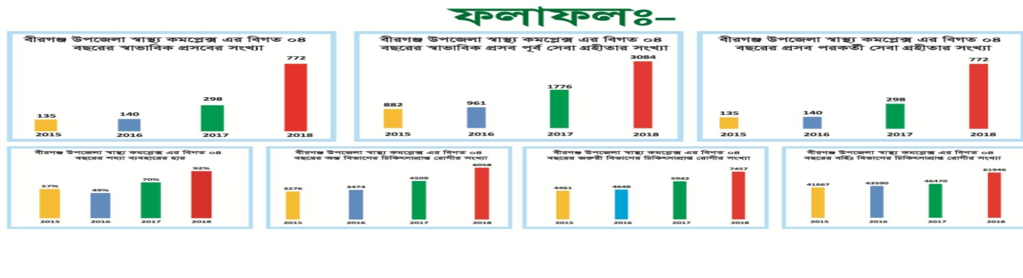

Due to the Creation of as instance on health services by Birganj Upazilla Health Complex,
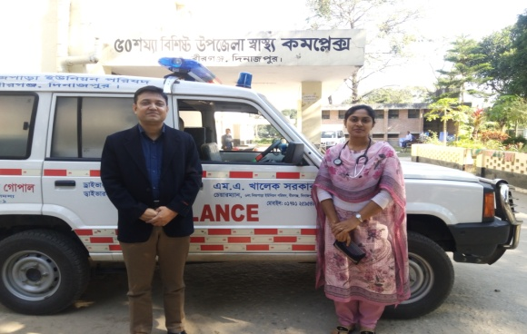
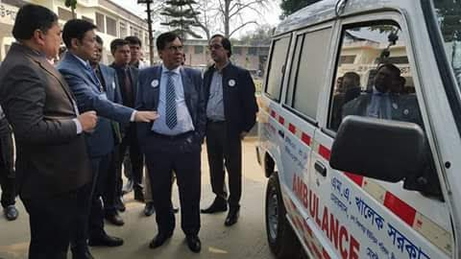

Honourable MP Mr. Manoranjan shill Gopal & Mr. Abdul Khaleque Up Chairman of 6 no. Up extended their support in the procurement of ambulance. Union parishad is bearing the whole expenditure for the transportation of pregnant mother free of cost.

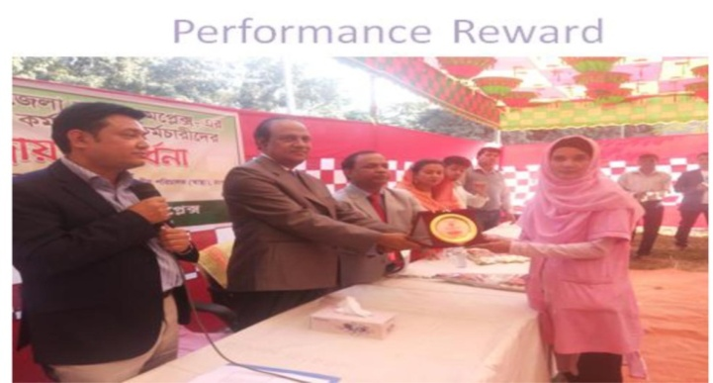

To inspire the health workers, the good performers are being awarded quaterly and annualy.
With these locally taken and implemented initiatives, local government representatives, journalists, teacher of school & College and local elites are keenly involved with Birganj Upazila health complex. They have extended their supports for its successful implementation. Service quality and facility delivery in a few public health facilities of Bangladesh have been improved substantially due to these sorts of innovative steps. this trait is ongoing.
We always talk about quality health but only quality is not enough to make the service seekers or their attendants or community happy. In addition to quality, service with dignity is very important too. It is also needed for the service providers who have been tierdlessly working for the ameliorations of the people’s sufferings. So Birganj Upazila health complex has taken a few initiatives to make health services dignified along with service quality, that can be followed by other health facilities.

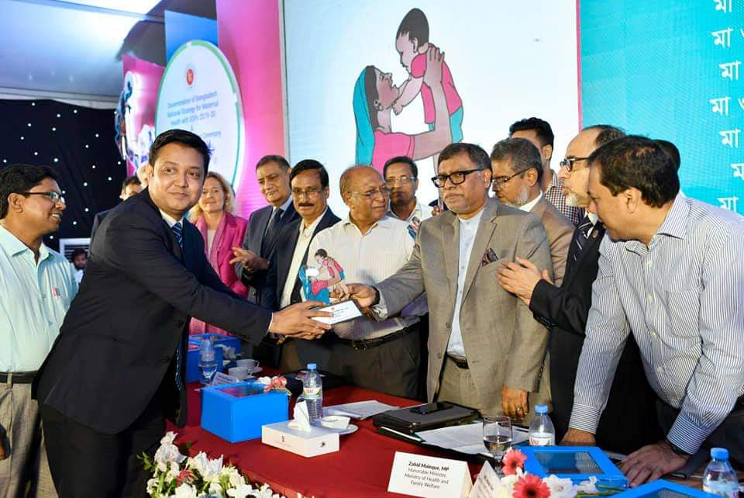
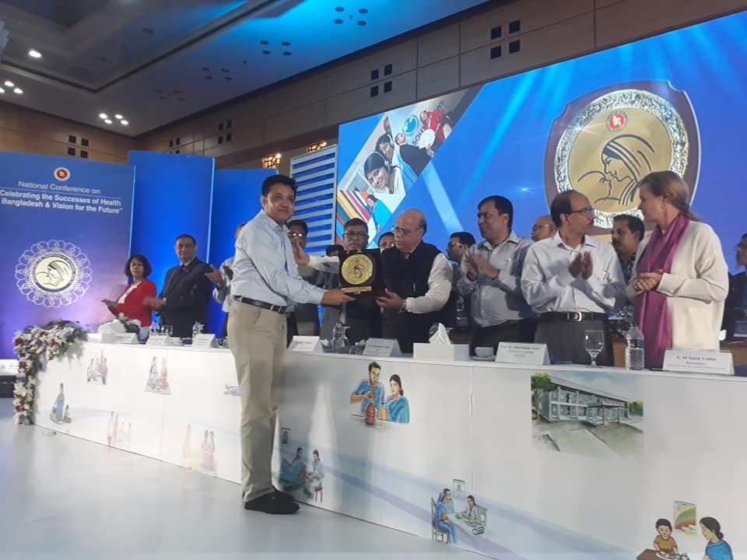

2018 2019
For these innovative activities and remarkable contribution in maternal health services, including emergency obstetrical care ( EOC ) service.
Birganj Upazila Health Complex has been awarded by Ministry of health & Family welfare with special reward in 2018 & 2019 Consecutively . Above all the assistance of government local administration, Upazila and participation of local Community, Birganj Upazila Health complex Dinajpur has created an extraordinary example in health service delivery, Birganj upazila health complex may be a model for others to follow. On behalf of Birganj Upazila Health complex. I am expressing my sincere gratitude and thanks to Honourable minister, ministry of health and Family welfare, MR. Zahid Maleque, MP Honourable Secretary health service Division, Md. Asadul Haque, prof. Dr. Abul Kalam Azad Honourable Director General of Health Service, my team members and all other stakeholders for their supports and Co-operation resulting improvement of health status of peoples of Birganj with request Continue the support.

