Guessing π with Random Darts
Work through this on your own. You will find the value of π using nothing but random numbers and Python. About 45 minutes.
Name: ______________________________ Class: ____________
You need: Spyder (or any Python editor). Type your code into a new file and press Run. You only need import random. Work through the Parts in order and tick them off at the end.

Part 1 The question

Q1 How could you find out the value of π without already knowing it? Write down one idea.

Today you will do it with a dartboard, random numbers and Python. π ≈ 3.14159… and its digits never end, so any method only gives an estimate.
Part 2 What is π? The maths first

π is in every circle's area: area = π × r². Here is a circle with radius 1 inside a square that is 2 wide and 2 tall.
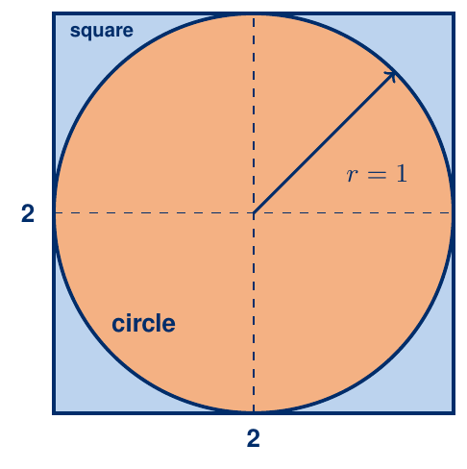
Q2 Area of the circle (r = 1): π × 1² = ______ Area of the square: 2 × 2 = ______
Q3 Imagine throwing darts at random so they land evenly over the square. The fraction that land inside the circle is circle area ÷ square area = ____ ÷ ____
Q4 If π ÷ 4 ≈ 0.785, about how many out of 1000 darts land inside the circle? _______
The four quarters of the picture are identical, so we only need one. Our dartboard is the top-right quarter: a square 1 wide and 1 tall, with a quarter circle of radius 1 whose centre is the bottom-left corner.
Q5 Area of the 1 by 1 square: ____ Area of the quarter circle: ¼ × π × 1² = ______. So the fraction inside is still π ÷ 4.
Part 3 Random numbers in Python

Type these two lines into the console (bottom right in Spyder), one at a time:
import random
random.random()

Q6 Run random.random() three times. Write the numbers you get: _______ _______ _______
Q7 Every number you got is between ____ and ____.
random.random() is uniform: every value from 0 to 1 is equally likely. So if we use one random number for x and another for y, the dart lands evenly anywhere in the square.
Q8 Why would our π come out wrong if the darts bunched up in one corner? Write one sentence.

Part 4 Throw one dart

Type this into a new file and run it:
import random

x = random.random() # how far across
y = random.random() # how far up

print(x, y)

Q9 Run it three times. Write each x and y in the table, then mark each dart with a cross on the dartboard.
Dart | x | y
1
2
3

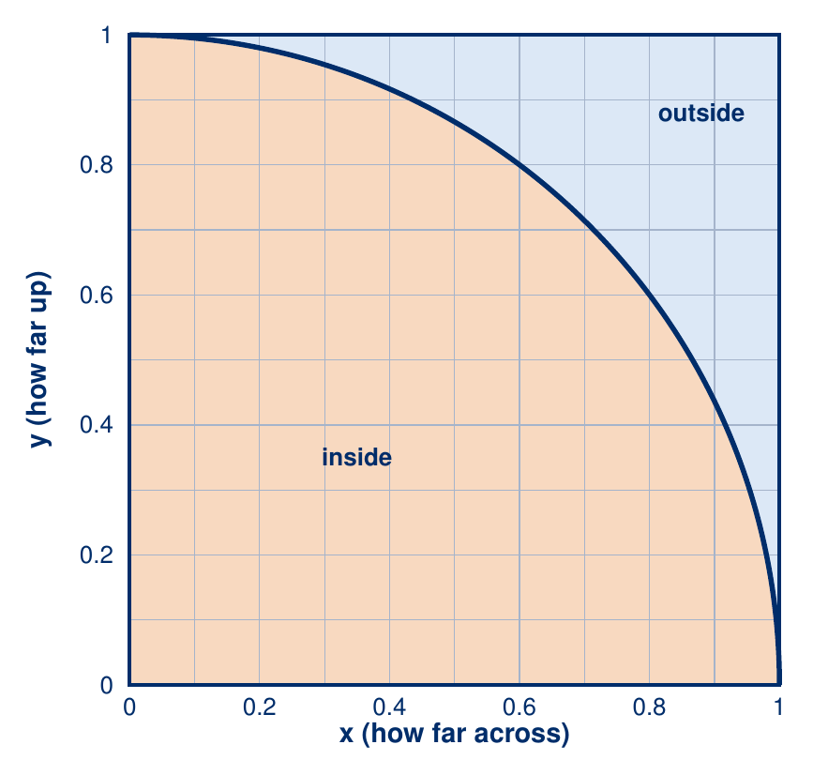

Part 5 Is the dart inside?

A dart is inside if its distance from the bottom-left corner is at most r = 1. By Pythagoras, the distance is √(x²+y²). Fill in the steps:
Step | Maths
inside means | distance ≤ r
square both sides | x² + y² ≤ ____
r = 1, and 1² = ___ | x² + y² ≤ ____
in Python | x*x + y*y <= ____

In Python, x^2 does not square x. Write x*x (or x**2).

Q10 Work out each dart by hand. Dart 1 is done for you. Use the rule: inside if x*x + y*y is 1 or less.
Dart | x | y | x*x + y*y | Inside or outside?
1 | 0.6 | 0.5 | 0.61 | inside
2 | 0.9 | 0.8
3 | 0.3 | 0.7
4 | 0.2 | 0.95
5 | 0.95 | 0.4

Part 6 Your turn: inside or outside in code

Fill in the two blanks, then type it in and run it five times.
import random

x = random.random()
y = random.random()

if _______________:
print("inside!")
else:
print("_______")

Q11 Out of your 5 runs, how many said inside? _____ About how many would you expect? _____
Hints (try it without them first). Stretch: use a for loop to throw 10 darts. Hint 1: the first line is for i in range(10):. Hint 2: everything you want repeated is indented underneath it.

Part 7 Count 10,000 darts

Now throw lots of darts and count the ones that land inside. inside = inside + 1 adds one to the count. Fill in the three blanks and run it three times.
import random

total = ______
inside = ___

for i in range(____):
x = random.random()
y = random.random()
if x*x + y*y <= 1:
inside = ________

print(inside)

Q12 Write the three numbers it printed: ________ ________ ________
Q13 Divide your first number by 10,000: _______. Now use a calculator for π ÷ 4 (use 3.14159): _______. Are they close?
Part 8 The trick

We know that inside ÷ total ≈ π ÷ 4. Multiply both sides by 4:
Q14 π ≈ ______________
Add these two lines at the end of your program (not indented):
pi_guess = 4 * inside / total
print(pi_guess)

Q15 Run it three times and fill in the table. For the last column, work out how far each guess is from 3.14159.
Run | My guess for π | How far from 3.14159?
1
2
3

Part 9 More darts, better guess

Q16 Change only the number in total = ... and fill in the table. One million darts takes a few seconds.
total | Guess 1 | Guess 2 | Guess 3
100
10,000
1,000,000

Q17 What do you notice as the number of darts gets bigger? Write one or two sentences.

Q18 Why can this method never give π exactly?

Part 10 This has a name

A Monte Carlo method uses lots of random tries to answer a question. It is named after a famous casino in Monaco. People use it for weather forecasts, video game AI and physics simulations.

Q19 Think of something else that is too hard to work out exactly, but that you could estimate by trying it thousands of times at random. Write it down.

Hints (try it without them first). Stretch: print the guess every 1,000 darts so you can watch it settle. Hint 1: do this inside the loop. Hint 2: i % 1000 == 0 is true on every 1,000th dart. Hint 3: if i % 1000 == 0: then, indented, print(4 * inside / (i + 1)).

Finished What I can do now

☐ I know random.random() is uniform, so darts land evenly
☐ I know the distance from the corner is √(x²+y²)
☐ I know inside means x*x + y*y <= 1
☐ I know the quarter circle is π ÷ 4 of the square
☐ I know π ≈ 4 × inside ÷ total

