____/____/26 - Y12 Networks L3: Build the network: hardware, client-server and peer-to-peer
Today's Topic(s) & Link(s):  - To describe the purpose of common network hardware and compare client-server with peer-to-peer networks  - PMT 1.3.3 Networks notes (PDF)  - Filius network simulator (free)  - Cisco Packet Tracer (free NetAcad account needed)  - Filius introduction (official English PDF) | Keywords:  - modem  - router  - switch  - hub  - WAP  - NIC  - MAC address  - twisted pair  - coaxial  - fibre optic  - client  - server  - peer-to-peer  - single point of failure | Homework:  - See your teacher
Important Points:
★
★
★
Lesson Notes:
Include your own notes here

Lesson Tasks
Starter: complete your SmartRevise 5-A-DAY. Work in OneNote: type your answers in the boxes.
Task 1: Retrieval (5 min)
1. Name the three problems a protocol solves in the throwing demo.
Your answer
1. ...
2. ...
3. ...

2. What is the difference between a de facto standard and a formal standard?
Your answer
A de facto standard ... A formal standard ...

3. What does HTTPS add to HTTP?
Your answer
HTTPS adds ...

Task 2: Identify the hardware (10 min)
Identify each piece of network hardware and explain what it is and what it does.
Photo | What is it? | What does it do?
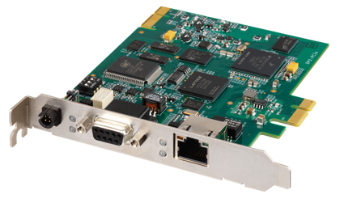 | It is a ... | It ...
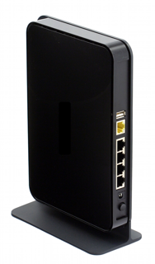
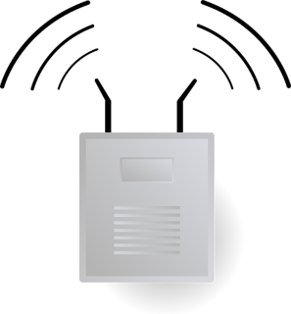
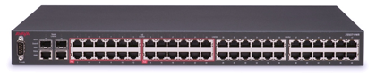
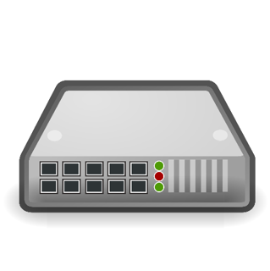
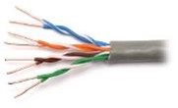

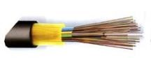

The hotel's network uses multiple switches.
Explain the purpose of a network switch. [3]
Real OCR question. Source: OCR H446/01 Nov 2020, Q1 (PMT Set B Q6(b))
Your answer
A switch ...

a) Discuss: which cable would you choose for a long distance link between two buildings, and why?
Your answer
I would choose ... because ...

Task 3: Build a LAN (25 min)
Open Filius. Work in pairs. Filius has a Design mode (hammer icon, build the network) and a Simulation mode (green arrow, run it). Paste screenshots into your OneNote page.
Part A: peer-to-peer
- In Design mode, drag four Notebook computers and one Switch from the left bar. Choose Connection (the cable icon), then click a computer and then the switch to cable each one.
- Double-click each computer. Untick Use DHCP, then set the IP Address to 192.168.0.1, 192.168.0.2, 192.168.0.3 and 192.168.0.4, and the Netmask to 255.255.255.0.
- Click the green arrow (Simulation mode). Double-click computer 1, choose Software Installation, and install Command Line, File explorer and Gnutella. Do the same on computer 2.
- On computer 1 open Command Line and type ping 192.168.0.2. Record the result.
- On computer 1 use File explorer to copy a file into the folder called peer2peer. On computer 2 open Gnutella, type computer 1's IP address as the Member IP address, click Enter network, search for the file name and download it.
Part B: client-server
- Click the hammer to go back to Design mode. Add a Computer (not a Notebook) as the server, cable it to the switch and give it the IP Address 192.168.0.10 and the same Netmask.
- In Simulation mode install Webserver and File explorer on the server. Use File explorer to put the file in the webserver folder, then click Start in Webserver.
- On a client install Webbrowser and visit http://192.168.0.10 to reach the file through the server.
- Click Stop in Webserver. Try the client again. What happens?
Question | Peer-to-peer | Client-server
Where is the shared file stored? | The file is stored on ... | The file is stored on ...
What happens if one computer is off?
What happens if the server is stopped?
Who manages security and backups?

Screenshots (paste here) and what changed
Screenshot 1: peer-to-peer
Screenshot 2: client-server
What changed: ...

Task 4: Design and justify (15 min)
Zac has an accountancy business. He is moving into an office that has enough space for up to five members of staff. Zac would like to install a Local Area Network (LAN) to allow his staff to work together.
Zac has hired a company that will advise him on what type of LAN he should set up.

Discuss how Zac could set up a peer-to-peer network and a client-server network.

You should refer to the following in your answer:
- how the computers in each type are connected
- the benefits of each type
- the drawbacks of each type
- the suitability of each type. [9]
Real OCR question. Source: OCR H046/01 June 2023 (PMT Set B Q3(b))
Your answer
Zac's office has five staff. A peer-to-peer network is ... The computers are connected ...
A client-server network is ...
I recommend ... because ...

Give two advantages of client-server compared to peer-to-peer. [2]
Real OCR question. Source: OCR H446/01 Nov 2020, Q1 (PMT Set B Q6(a)(ii))
Your answer
1. ...
2. ...

Discuss (from Craig and Dave): a new games developer is considering the best netcode strategy to use for a new multiplayer game currently in development. The company needs to keep production costs down in the early years before it becomes established. Should the company use dedicated servers in a client-server model or peer-to-peer networking? Is there a third option?
Your view
Dedicated servers would ... Peer-to-peer would ... A third option is ...

Task 5: Draw the network (5 min)
Use OneNote's drawing tools (Insert, then Shapes, or the Draw tab) to draw the network you built in Filius. Show every device, the cables, the IP addresses and where the server sits. Label what each device does.
Summary
After the lesson, use this space to summarise the main points of this lesson topic.
Three sentences: the difference between a hub and a switch, and between client-server and peer-to-peer.

