____/____/26 - Y12 Networks L5: DNS, routing, packet switching and circuit switching
Today's Topic(s) & Link(s):  - To explain how DNS finds an IP address and compare packet switching with circuit switching  - TXToolbox Web Terminal (dns command)  - traceroute-online.com  - PMT 1.3.3 Networks notes (PDF)  - Cloudflare Learning: What is DNS? | Keywords:  - DNS  - domain name  - TLD  - DNS resolver  - root server  - router  - hop  - TTL  - routing table  - packet switching  - circuit switching  - bandwidth | Homework:  - See your teacher
Important Points:
★
★
★
Lesson Notes:
Include your own notes here

Lesson Tasks
Starter: complete your SmartRevise 5-A-DAY. Work in OneNote: type your answers in the boxes.
Task 1: Retrieval (5 min)
1. Name the four layers of the TCP/IP stack in order.
Your answer
1. ... 2. ... 3. ... 4. ...

2. Which layer adds IP addresses, and which device uses them?
Your answer
The ... layer adds IP addresses. The ... uses them.

3. Which layer adds MAC addresses?
Your answer
The ... layer

Task 1b: Define and test the commands (10 min)
Term | What it is and what it does, in your own words
DNS (Domain Name System)
ping
traceroute (tracert on Windows)

Now test each command. For each one go to the link, run the command, then fill in the table. Take a screenshot (Windows key + Shift + S), paste it in, and annotate it with the Draw tab: circle the numbers that matter and label what they mean.
dns
Where to go: txtoolbox.com web terminal Click Decline on the cookie box, click in the black box and type:
dns bbc.co.uk
What I did | I typed ...
My screenshot (paste here, then annotate it)
What my screenshot shows | The addresses I got were ... which means ...

ping
Where to go: the same web terminal Type:
ping bbc.co.uk
What I did | I typed ...
My screenshot (paste here, then annotate it)
What my screenshot shows | The round trip times were ... The first reply was ...

traceroute
Where to go: traceroute-online.com Choose Traceroute, type bbc.co.uk and start it. It can take up to a minute.
What I did | I typed ...
My screenshot (paste here, then annotate it)
What my screenshot shows | There were ... hops. The first hop was ... The last was ...

Task 2: DNS role play (15 min)
Your class acts out how a browser finds the IP address of www.example.co.uk. Record each step as it happens.
Step | Who asks | Who answers | What is the answer?
1 | Browser
2
3
4
5

Now open https://www.txtoolbox.com/tool/web-terminal, click in the black box and type dns followed by a domain of your choice, for example dns bbc.co.uk. Compare the result with the role play.
DNS lookup result and what I notice
I looked up ... and got ... This matches the role play because ...

a) Discuss: domain names are stored in a tree (a hierarchy) rather than one big list. Give two reasons.
Your answer
1. ...
2. ...

Elegant Bags is a company that makes designer handbags. It has decided it wants to sell its products online.
Elegant Bags puts its website on its servers which are given a public IP address. It also purchases the domain name elegantbagsonline.co.uk.
Explain the automated process that takes place that allows customers to access the site when they enter the domain name into their browser. [3]
Real OCR question. Source: OCR H046/01 June 2016, Q2(a)
Your answer
The domain name is sent to ...

In order to view a website, a user enters a website address into their web browser such as http:/www.ocr.org.uk. The website will then be displayed onto the user's screen.
Explain how the Domain Name System (DNS) plays a role in websites being loaded. [4]
Real OCR question. Source: OCR H046/01 Nov 2020, Q4(b) (PMT Set B Q7)
Your answer
The Domain Name System is used to ...

Task 3: Traceroute on a map (20 min)
Use https://traceroute-online.com to trace bbc.co.uk and a site hosted on another continent. Screenshot each result (Windows key + Shift + S) and paste it into OneNote. Record the hops in the table, then find a blank world map picture online, insert it in OneNote and use the Draw tab to number each hop on the map. Annotate your screenshots to show where the time jumps.
Hop | IP address or name | Roughly where? | Time (ms)
1
2
3
4
5
6

a) Which hop had the biggest jump in time? What does that suggest?
Your answer
The biggest jump was between hop ... and hop ... This suggests ...

b) What does the time to live (TTL) field do, and how does traceroute make use of it?
Your answer
TTL is ... Traceroute uses it by ...

Task 4: A 30 byte email crosses the internet (15 min)
An email message is 30 bytes. Imagine that with the TCP protocol, this is divided into three 10-byte packets. Using the illustration below, show how this message travels from sender to receiver. One packet should be received incorrectly at one hop between two routers. Copy the picture into OneNote and use the Draw tab, or write the stages in the table.
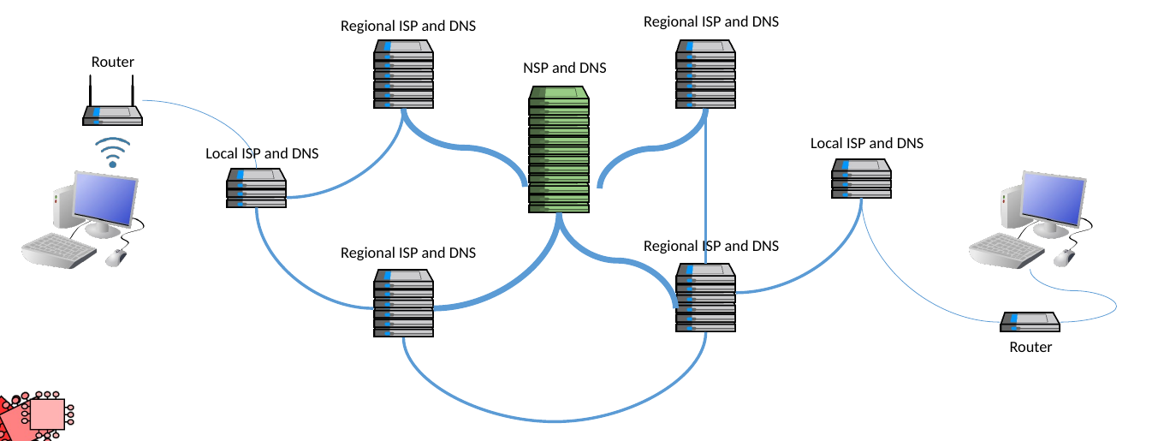
From Craig'n'Dave 03 Activity 1.
Stage | What happens | Layer or protocol
1 | The email application hands the message to ...
2 | The message is split into ...
3
4
5 | One packet arrives incorrectly ...
6
7 | At the destination, ...

Describe how packet switching is used to transmit data from one computer to another computer on a network. [5]
Real OCR question. Source: OCR AS H046 1.3.2 (2019), PMT booklet, Q2(a)
Your answer
Data is split into ...

Task 5: Packet or circuit? (10 min)
 | Packet switching | Circuit switching
Path | Packets ... | A ...
Bandwidth reserved?
Store and forward?
Order of arrival
If a link fails
Best used for

Zac has an accountancy business. He is moving into an office that has enough space for up to five members of staff. Zac would like to install a Local Area Network (LAN) to allow his staff to work together.
A LAN uses packet switching.

Describe one difference between packet switching and circuit switching. [2]
Real OCR question. Source: OCR H046/01 June 2023 (PMT Set B Q3(a)(i))
Your answer
In circuit switching ... In packet switching ...

Explain why packet switching is more suitable for a computer network than circuit switching. [2]
Real OCR question. Source: OCR H046/01 June 2023 (PMT Set B Q3(a)(ii))
Your answer
Packet switching is more suitable because ...

Summary
After the lesson, use this space to summarise the main points of this lesson topic.
Explain in four steps how a browser finds a server. Give one advantage of packet switching and one of circuit switching.

