____/____/26 - Y12 Networks L6: Consolidate and assess the foundations
Today's Topic(s) & Link(s):  - To recall and apply L1 to L5 under exam conditions and set a target for improvement  - OCR H446 specification page  - PMT 1.3.3 Networks questions, 2020 to 2024 (PDF)  - PMT 1.3.3 Networks mark scheme, 2020 to 2024 (PDF) | Keywords:  - all keywords from L1 to L5  - describe  - explain  - state | Homework:  - See your teacher
Important Points:
★
★
★
Lesson Notes:
Include your own notes here

Lesson Tasks
Starter: complete your SmartRevise 5-A-DAY. Work in OneNote: type your answers in the boxes.
Task 1: Compare with your first lesson (5 min)
Open your first page and find your table of the five areas of 1.3.3. Which parts can you now explain properly? Fix anything you got wrong, in a different colour.
Task 2: Draw the whole journey (10 min)
Draw the whole journey of a web request, from your keyboard to the server and back. Use Insert, then Shapes, or the Draw tab. Include DNS, the four layers, packets, routers and the server.
Your journey diagram
Start with the browser ...

Task 3: School email on the school network (10 min)
In the school network, all incoming and outgoing mail is stored on the mail server in the server room. All devices in the school are running SMTP and POP3.
Explain how a student using their phone in the library (172.16.5.17) can retrieve their school emails. Furthermore, suggest why the administrators are considering moving to IMAP.
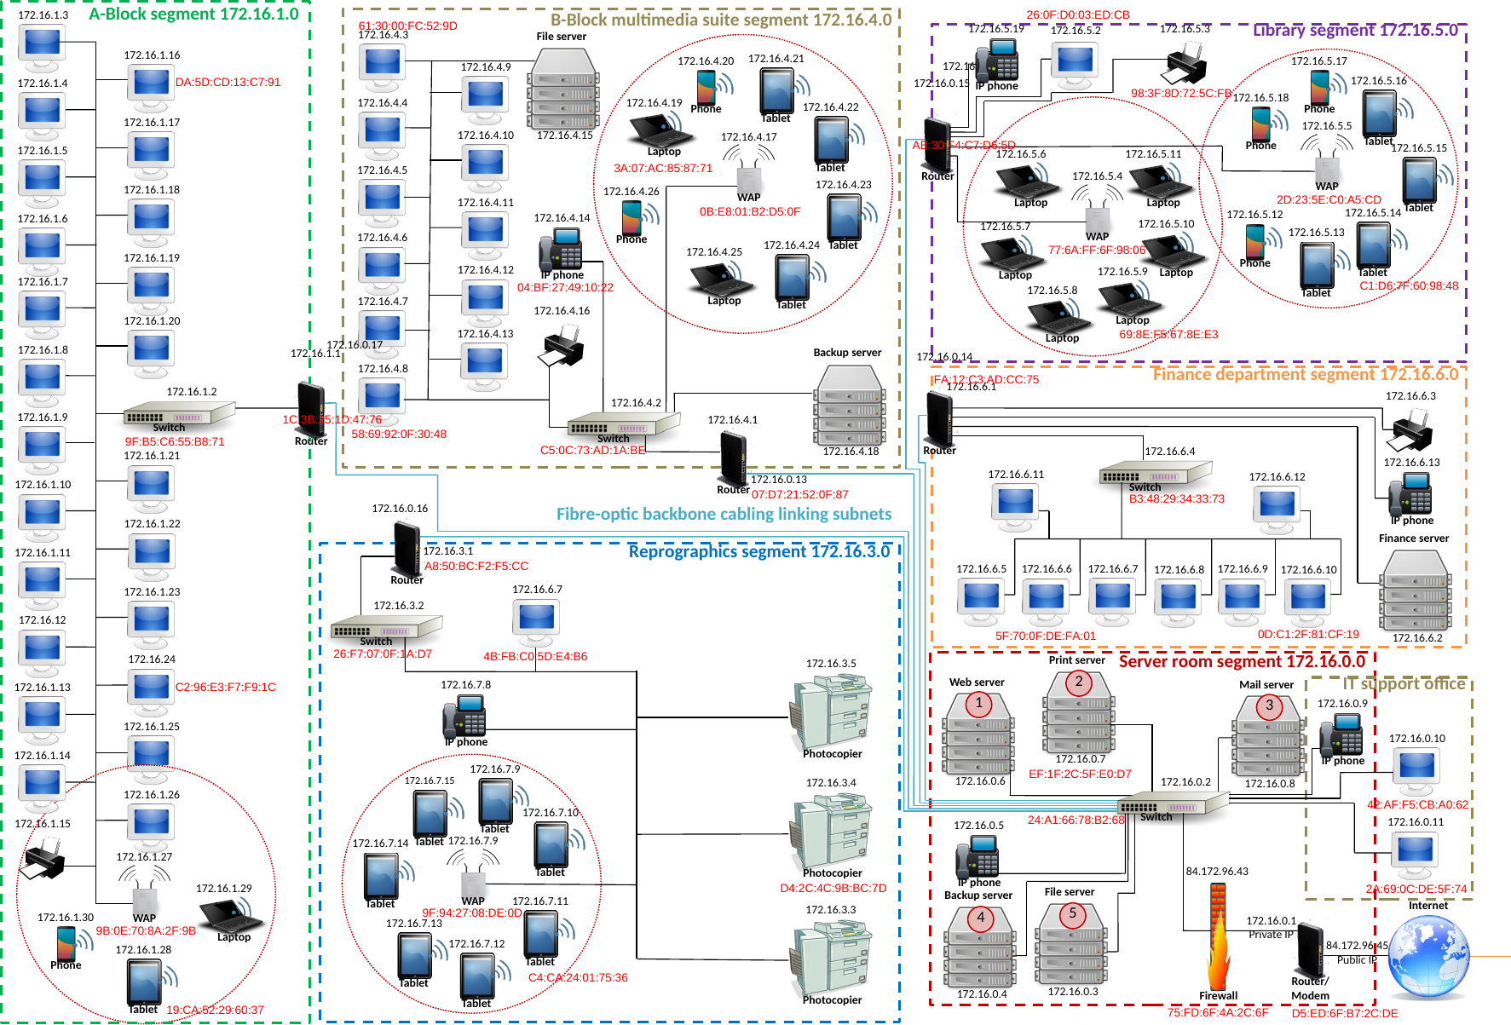
The school network
Your explanation (use the school diagram)
The phone sends a POP3 request ... It reaches ... then ...

Task 4: Assessment (25 min)
A coffee company has coffee shops located across the country. Each shop has its own Local Area Network (LAN). The company wants to connect the shops in a Wide Area Network (WAN).
(i) Describe two characteristics of a LAN. [2]
(ii) Describe two characteristics of a WAN. [2] [4]
Real OCR question. Source: OCR AS H046 1.3.2 (2019), PMT booklet, Q6(a)
Your answer
(i) 1. ...
2. ...
(ii) 1. ...
2. ...

Describe three different pieces of networking hardware in a client-server network apart from the clients and servers themselves. [6]
Real OCR question. Source: OCR H446/01 June 2024, Q6(d) (PMT Set B Q1(b))
Your answer
1. ...
2. ...
3. ...

Describe one piece of hardware that each shop will need to connect their LAN to the company's WAN. [2]
Real OCR question. Source: OCR AS H046 1.3.2 (2019), PMT booklet, Q6(b)
Your answer
...

A hotel uses a computer system to keep track of room bookings. The hotel staff are able to query a database to discover which rooms are booked or which rooms are free.
The hotel's computer network uses a client-server model.
Describe what is meant by the term 'client-server' in this context. [3]
Real OCR question. Source: OCR H446/01 Nov 2020, Q1 (PMT Set B Q6(a)(i))
Your answer
A client-server network is ...

The internet uses a set of protocols referred to as the TCP/IP stack. The TCP/IP stack consists of four different layers, each with its own set of protocols.
State the name of the four layers of the TCP/IP stack. [4]
Real OCR question. Source: OCR H446/01 June 2018, Q4(b)(ii) (PMT AS booklet Q8(b)(ii))
Your answer
1. ...
2. ...
3. ...
4. ...

TCP/IP uses packet switching.
Explain what is meant by packet switching. [4]
Real OCR question. Source: OCR AS H046 1.3.2 (2019), PMT booklet, Q4(b)
Your answer
Packet switching is ...

Explain two advantages of using packet switching instead of circuit switching to send a message between two computer on a network. [4]
Real OCR question. Source: OCR AS H046 1.3.2 (2019), PMT booklet, Q2(b)
Your answer
1. ...
2. ...

Task 5: Self mark and target (5 min)
Area | Red, amber or green
(a) Protocols and standards
(b) TCP/IP and layers
(b) DNS, routing and switching
(d) Hardware
(e) Client-server and P2P

My target
Before the first security lesson I will ...

Summary
After the lesson, use this space to summarise the main points of this lesson topic.
Rate each of the five areas red, amber or green. Choose one target to fix before the first security lesson.

