Y10 Computer Science
Inside the Computer
Systems Architecture: an introduction
Name: ______________________________________
Class: ______________________________________
Date: ______________________________________

Write your name on the front of your workbook.
Keep a pen in a different colour for the end of the lesson.
Part A: What do I already know?
Rate each part of a computer. Use pencil or your first pen colour now. Do the AFTER column at the end of the lesson in a different colour.
1 = I have never heard of it 2 = I have heard of it 3 = I can explain what it does

Part | BEFORE (1, 2 or 3) | AFTER (1, 2 or 3)
CPU (processor)
RAM (memory)
Motherboard
Storage (hard drive or SSD)
Power supply
Heat sink and fan
Graphics card

Write one thing you already know about what is inside a computer.

Part B: Label the motherboard
This is the main circuit board that everything plugs into. Write the name of each numbered part.
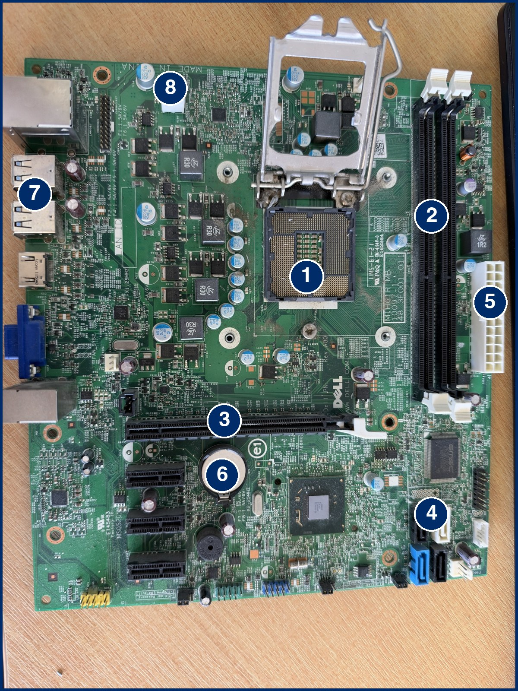
  Word bank
  CPU socket RAM slots graphics card slot SATA ports (storage) main power connector CMOS battery back panel ports CPU power connector
  1 | ________________________
  2 | ________________________
  3 | ________________________
  4 | ________________________
  5 | ________________________
  6 | ________________________
  7 | ________________________
  8 | ________________________

Stretch: the CPU is missing from this board. Which number shows where it goes? ________
Part C: Match up
Match each part to its job, then answer the questions.
1. Match each part to its job. Write the letter in the box.
  CPU
  RAM
  Storage (HDD or SSD)
  Motherboard
  Power supply
  Heat sink and fan
  A | Keeps files and programs when the power is off
  B | Keeps the CPU from overheating
  C | Carries out instructions, like the brain
  D | The main circuit board that everything plugs into
  E | Holds the programs and data in use right now
  F | Changes mains electricity into power the parts can use

2. Pick up one part. Write its name and two things you notice (size, weight, metal, plastic, pins, moving parts).

3. Which part gets hot when the computer is on? How is it kept cool?

4. If you pull out the plug, one of these loses everything inside it. Which one: RAM or storage? Why do you think that is?
Part D: Bringing it together
Fill this in as we talk.
1. The CPU repeats three steps, billions of times a second.
Word bank: RAM instruction carries out

1 | FETCH: the CPU gets the next ____________ from ____________.
2 | DECODE: the CPU works out what the ____________ means.
3 | EXECUTE: the CPU ____________ the instruction.

New word: the CPU has a control unit. It organises these steps, like the conductor of an orchestra. We will look inside the CPU in the next lesson.

2. How do the parts work together? Complete the sentence.
When I open a game, it is copied from ____________ into ____________, so that the ____________ can run it.

3. Example: saving a document. You press Save. Fill in the gaps.
1 | FETCH: the CPU gets the save instruction from ____________.
2 | DECODE: the CPU works out that the document must be ________________.
3 | EXECUTE: the document is copied from RAM to ____________ so it is kept.

4. Why does the CPU need to repeat the cycle?

Part E: Compare two laptops
These are real laptops from a shop website. Use the table to answer the questions.
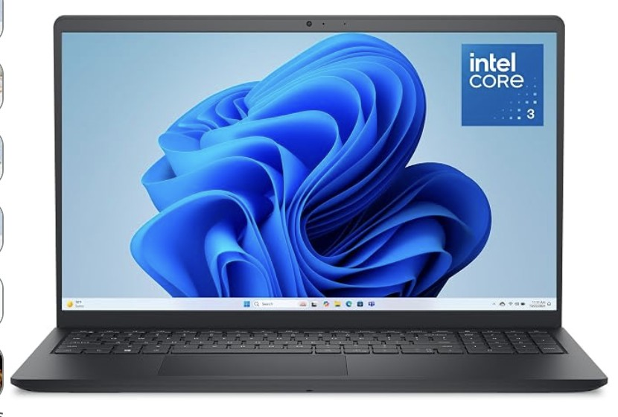 | 
Laptop A: Dell 15 | Laptop B: Dell 14 Plus

Spec | Laptop A | Laptop B
Processor | Intel Core 3 (100U) | Intel Core Ultra 7 (258V)
Processor speed | 1.2 GHz | 2.2 GHz
Number of cores | 6 | 8
Cache (assume MB) | 10 | 12
RAM | 8 GB | 32 GB
RAM speed | 4400 MHz | 8533 MHz
Storage (SSD) | 512 GB | 1 TB
Price | £484 | £1,320

1. Which laptop has more RAM, and how many GB more? ____________________
2. A Blu-ray movie is 50 GB. How many could each laptop store? (Use 1 TB = 1000 GB.)
Laptop A: ____________ Laptop B: ____________
3. Assume an average app uses 500 MB of RAM. How many could each laptop have open at once? (1 GB = 1000 MB.)
Laptop A: ____________ Laptop B: ____________
4. Is GHz a million or a billion cycles per second? ____________
How many fetch-decode-execute cycles per second can Laptop A do? ____________________
Part E: Extension
Keep using the table on the previous page.
5. The RAM speed of Laptop A is 4400 MHz. Write this in GHz. ____________________
6. Laptop B has more cores than Laptop A. How many more? Does that always mean it is that much faster? Explain.

7. Real laptops are never able to use all of their RAM for apps. Give one reason why your answer to question 3 would be lower in real life.

8. A pupil only writes essays and browses the web. Which laptop would you recommend and why? Use at least two numbers from the table.

9. A video editor needs to open big files and run many apps at once. Which laptop would you recommend and why?

Part F: Looking back
What did you learn today?
1 | Go back to Part A and fill in the AFTER column in your second colour.

3 things I learned:

2 parts and how they connect:

1 question I still have:

