CUT OUT: vault 1, the red cards
Two cards, numbered 0 and 1. Cut along the dashed lines and keep each pile together. The Fetcher gets the pile and must pick the card whose number is the Program Counter.
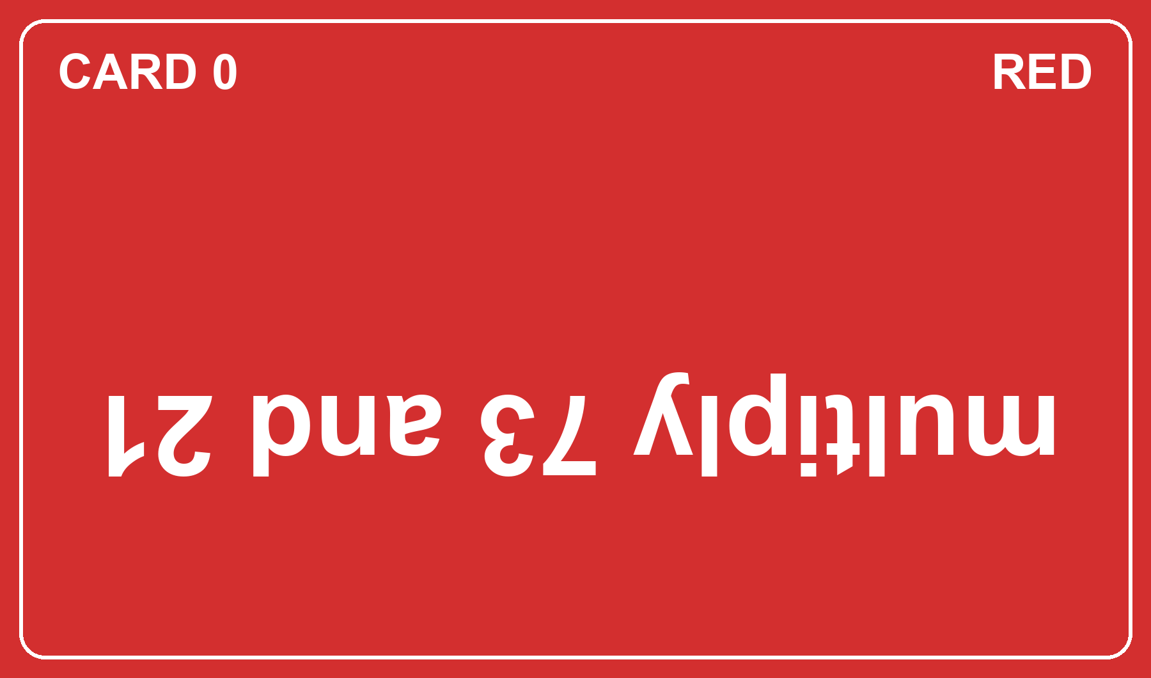
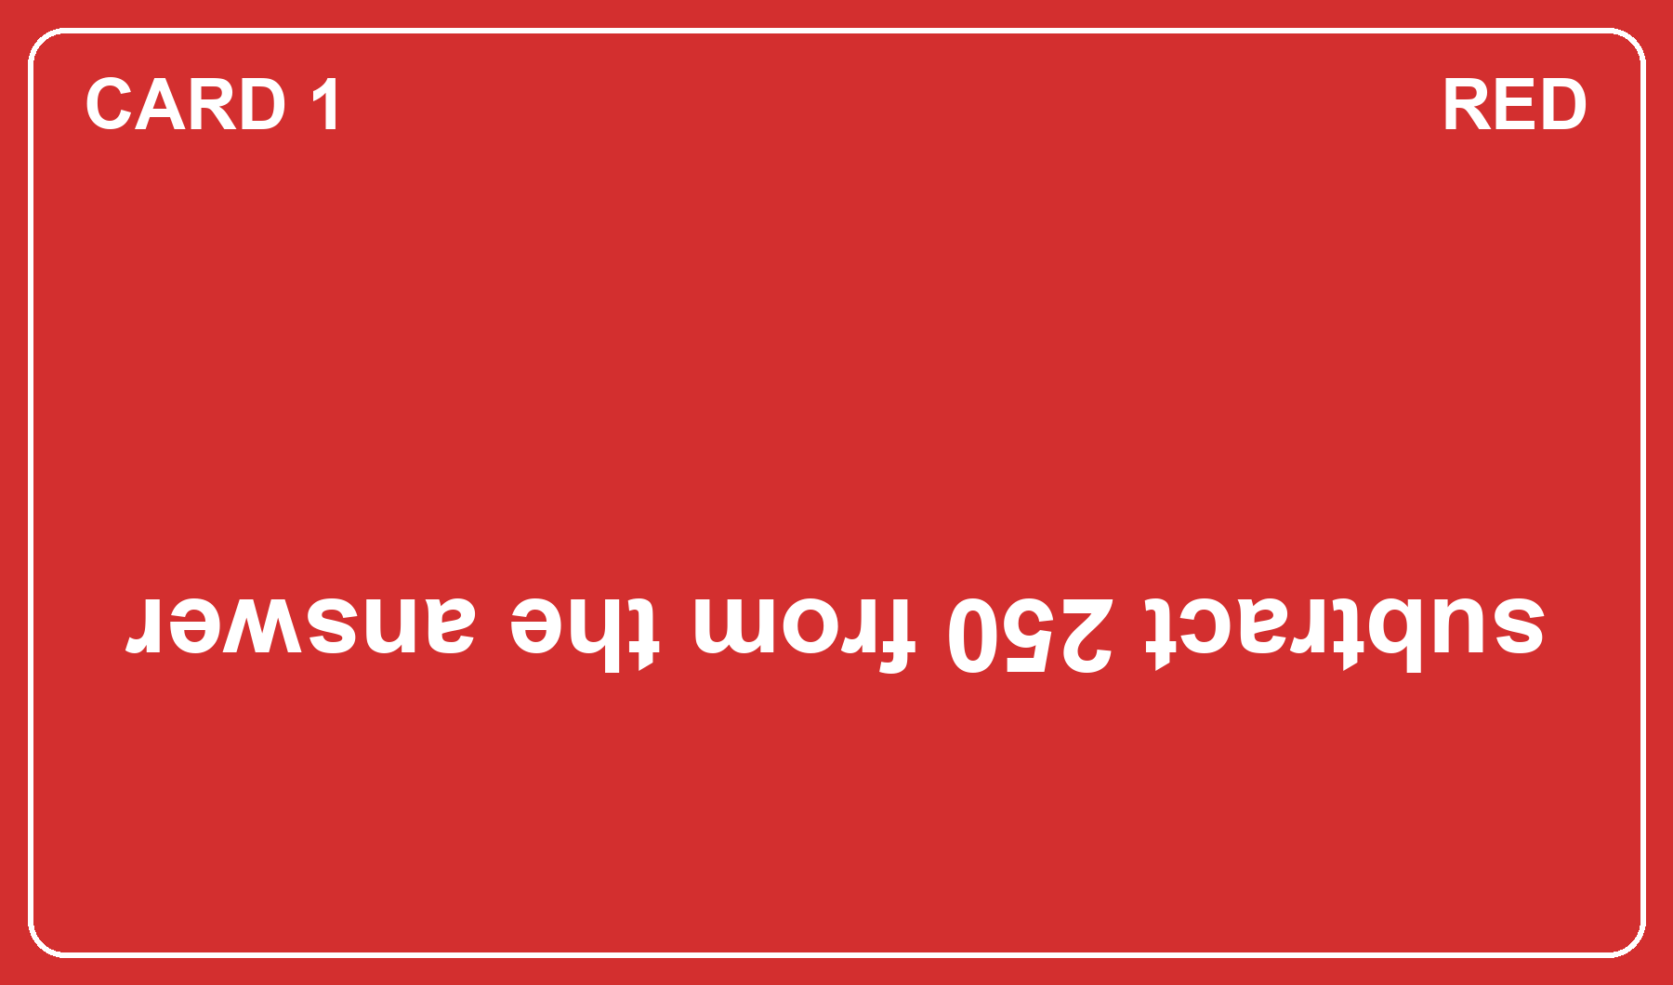

CUT OUT: vault 2, the blue cards
Two cards, numbered 0 and 1. Cut along the dashed lines and keep each pile together. The Fetcher gets the pile and must pick the card whose number is the Program Counter.


