# (Phase Two: Forecast Scenario Analysis, 2023–2025)

## Forecasted Pollution Patterns Across the UAE

In this phase, forecasted mobility data and pollution rasters were integrated to assess air quality trends through 2025. As shown in Figure 1, areas such as Dubai, Abu Dhabi, and Sharjah are expected to remain pollution hotspots under current trajectories.

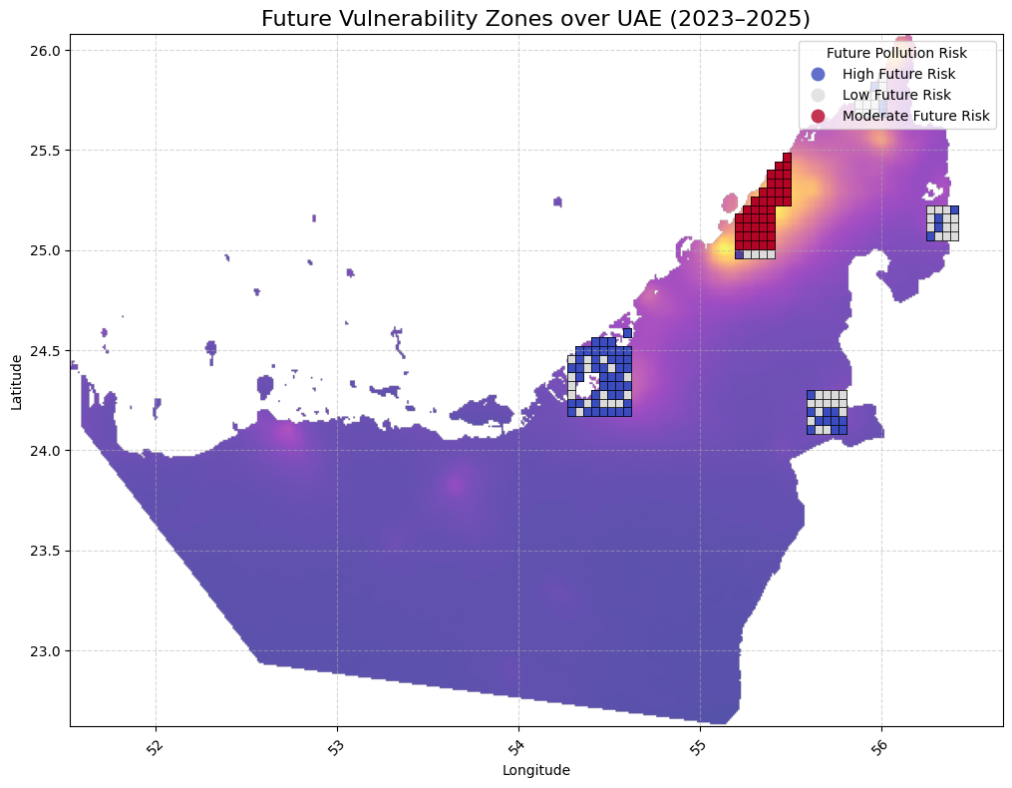

Figure 1: Future Vulnerability Zones over UAE (2023–2025), highlighting areas of high projected pollution risk.

Table 1: Datasets Used for Phase Two (Forecast Scenario Analysis, 2023–2025)

|  |  |
| --- | --- |
| Dataset | Features / Variables |
| Ericsson Mobility Forecast | Forecasted GB/user/month data for the Middle East and Africa, including UAE |
| Sentinel-5P Pollution Raster | Predicted NO₂ Vertical Column Density, SO₂ Density, Aerosol Index (2023–2025) |

## Prediction Model Accuracy and Residual Behavior

We applied a Gradient Boosting Regressor to predict future NO₂ levels using forecasted mobility and population data. The model produced strong predictive performance (Test R² = 0.959), with very low error margins. Table 2 summarizes key evaluation metrics.

Table 2: Prediction Error Summary (Phase Two Model)

|  |  |
| --- | --- |
| Metric | Value |
| Test R² | 0.959 |
| Cross-Validation R² | 0.966 |
| Mean Absolute Error (MAE) | 1.0 × 10⁻⁵ |
| Root Mean Squared Error (RMSE) | 1.4 × 10⁻⁵ |
| Pixels with Detectable Change | 80,422 |

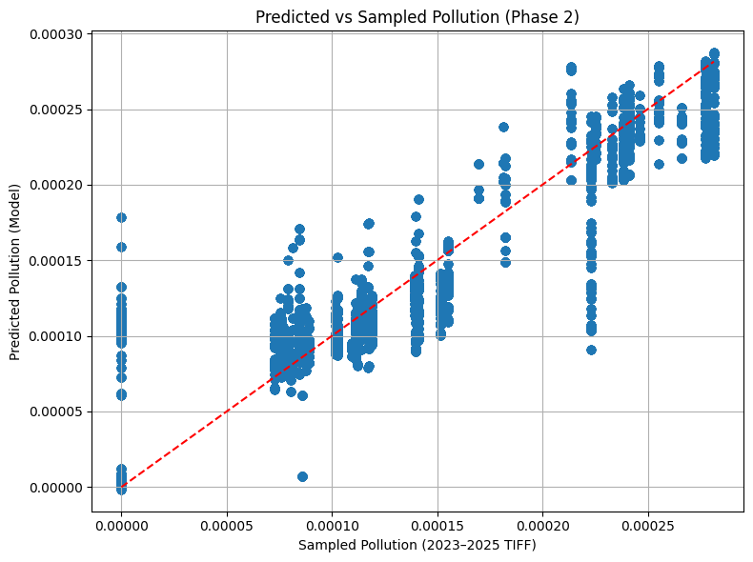

Figure 2: Predicted vs. Sampled Pollution (Phase 2).

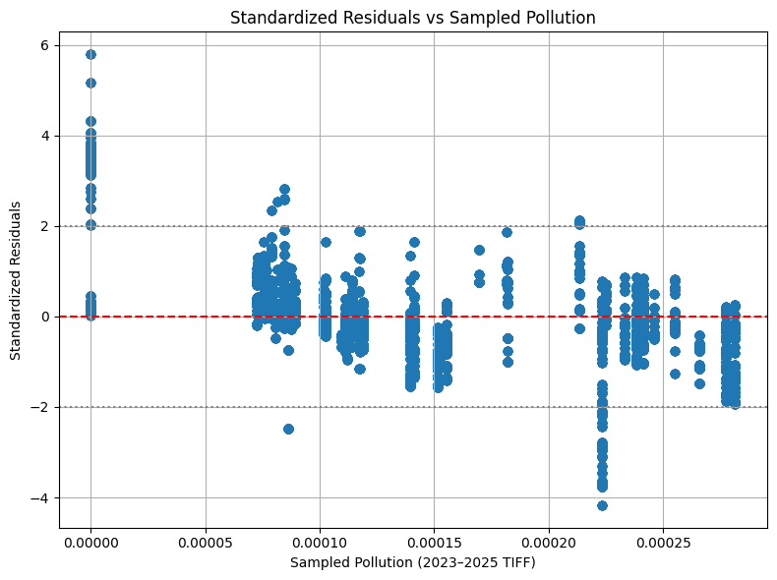

Figure 3: Standardized Residuals vs. Sampled Pollution.

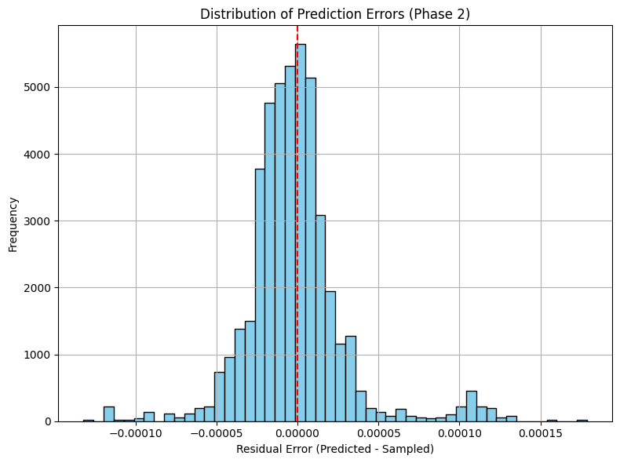

Figure 4: Distribution of Prediction Errors (Phase 2).

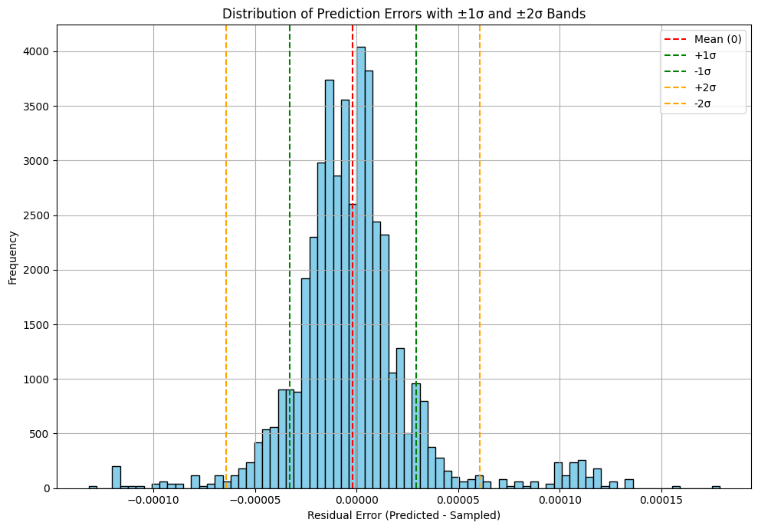

Figure 5: Distribution of Prediction Errors with ±1σ and ±2σ Bands.

## Zones of Concern and Policy Implications

A few geohash zones are expected to breach the WHO NO₂ limit of 40 µg/m³. These critical zones are listed in Table 3.

Table 3: Urban Zones Exceeding WHO NO₂ Limit (40 µg/m³)

|  |  |  |
| --- | --- | --- |
| Geohash | NO₂ (µg/m³) | Mobility Score (%) |
| thqem | 40.40 | -18.93 |
| thqf4 | 76.80 | +12.10 |
| thqf8 | 45.15 | -27.53 |