**RESUME**

Dr. R.KALAIMAGAL

|  |  |
| --- | --- |
| **Address for communication**:  10/47 F3, First floor,  MAHENDRA HOMES,  DHANAPAL STREET,  WEST MAMBALAM,  CHENNAI-33 **Office Address:** Dr.R.Kalai Magal,  Assistant professor,  Department of Computer Science,  Government Arts college(Men),  Nandanam,Chennai-35 | **Associate**  professor, Department of Computer Science,  Government Arts college(Men),Autonomous,  Nandanam,Chennai-35 Email: kalai_magal@rediffmail.com  **Contact. No. :**8754535679  **Educational Qualification**  M.C.A, M.Phil , PhD  **Teaching Experience**  (i) Lecturer-Dept of CSE, Avinashilingam Deemed University,Coimbatore  (**From June- 1998 – Dec 1998)**  (ii) Lecturer - Dept of MCA, Coimbatore Institute of Technology, Coimbatore  **(From Jan 1999-Dec 2006)**  (iii)Assistant professor –Dept of Comp.Sci, Govt Arts College, Chidambaram  **(From Dec-2006 to Jul 2010)**  (iv) Assistant professor –Dept of Comp.Sci, Govt Arts College(M) Autonomous Nandanam,Chennai-35 **.**  **( From Jul 2010 to 2017 Sep)**  **(v) Associate Professor (From sep-2019 to till date)**    **Total Teaching Experience**: **23 yrs and 3**  **months**  **Industrial Experience**  Worked as a Instructress in Proline Institute for computer Studies, Tirunelveli from June 1996 to Dec 1997 |
| **Involved Academic Activities in the following Universities**   1. **Anna University-Chennai** 2. **AVC college of Engineering** 3. **St.Joseph College (Trichy & Cuddalore)**   **Subjects taught in UG & PG:**  *1*.Data and Communication  Networking  2.Mobile Computing  3.WebTechnolgy  4 .Advanced Java Programming.  5. RDBMS  6. VisualProgramming  7. Operation Systems  8. Inter process Communication using Linux  9. Object Oriented Analysis and Design  10. Data Structures  11. Design and Analysis of Algorithms  **GuideShip Approvel :**  1. Manonmaniam Sundaranar University Tirunelveli  2. Sri Chandrasekarendra Saraswathi Viswa Mahavidhyalaya, Kanchipuram.  3.Bharathiar University, Coimbatore. | **Publications & Conferences**  **From 2004 till Date**  Published a paper in Various Inter-National and National Levels.  International Journal 45 (Scopus&Index)  IEEE , IGCST, IJNS , Internet Computing and  I-Manager( 2 times), IJST(2013), KJST(2013-March),Manager(2014), Manager(2015)  **Conferences: [from 2003 –till date**  **International Conferences: 23**  **Research Topic:**  ***Analysis, Design and Implementation of New Multicast Routing algorithm for Heterogeneous Environment.***  **Guide- Ship Given:**  MCA - 60 students (from Jan 2009)  M.Sc (CT) - 35 students (from Jan 2009)  **Guidance for Research Work**  1. MPhil - 25 Candidates  2. PhD - 10 Candidates awarded  3.PhD-(Guiding 4 Research scholars under  University of Madras.)  **Doctoral Committee Member for the Following Universities.**   1. University of Madras 2. Bharathiar University 3. SCSVM University Kanchipuram. 4. SRM University , Chennai   **Government Project Financial Assistant Received for the Year**  2018-2019 Student Mini Project from TANSCHE (Rs 30000)  2021-2022 Financial Assistant Received for International Conference  conducted from TANSCHE and TNSCST(Rs. 40000)  2022-2023 Major Research Project (Rs 1 Lakhs) from TANSCHE  **Academic Audit:**  Subject Expert in Academic Audit panel at Ethiraj College for women at July 2017.  **University Duties:[2012 – 2017]**  1.Assigned as Inspection Committee member for UG Renewal Mar Gregories College,Mogappair( August 8th 2017)  2.Assigned as Inspection Committee member for PG Renewal Christ Arts and Science College, Kelampakkam, Nov-9-2017  3.Academic audit –coordinator for computer  science, Ethiraj College  **Speech Given:**  **Special keynote address given at Sri Krishna college of Arts and Science , Kanchipuram**  ***TCS ion College SPOC form 2021 to Till date under Naan Muthalvan Scheme*** |

|  |  |  |  |  |  |  |  |  |  |
| --- | --- | --- | --- | --- | --- | --- | --- | --- | --- |
| 3 | **Educational Qualification** | | | | | | | | |
| **Degree** | **Subject** | | **Area of Specialization** | | **Year of passing** | | **Name of College/**  **University** | **Class with percentage** |
| X Std. | Maths, Science | | Mathematics&Science | | 1988 | | SGAGHSS,Palayamkottai,Trunelveli | I, 84% |
| XII Std. | Maths&Biology | | Mathematics & Biology | | 1990 | | I, 87.3% |
| B.Sc | Computer Science | | Computer Science | | 1995 | | Sarada College for women,Trunelveli.  Manonmaniam Sundaranar University.TVL | I, 73% |
| M.C.A | Computer Application | | Computer Applications | | 1998 | | MSU-Tvl | I , 70% |
| M.Phil. | Computer Networks | | Multicast Routing | | May 2002 | | Manonmaniam sundaranar University | I |
|  | Ph.D | Computer Science | | Multicast Routing in Mobile Adhoc-Heterogeneous Networks | | Feb 2008 | | MTWU-Kodaikanal | Highly Recommended |
|  | **Publications** | | | | **Published 45 papers in reputed International Journals and 10 papers presented in an International conferences** | | | | |
|  | Name of Two Rreferences | | **Dr.R.M.Suresh** Principal,  Jerusalam College of Engineering,  Chennai. | | | | Dr.B.Arunkumar,  Professor,Department of MCA,  Coimbatore Institute of Technology  Coimbatore. | | |
|  | Membership in Professional Societies | | **(i)ICGST** **Academic Community Member from 2006 to till date**  **(ii)Technical committee members for IICET-2015 and I’manager**  **publication on Wireless Sensor Netwroks from Jan 2014 to till date.**  **(iii) Reviewer for IJWSN**  **(iv) Web Master for Govt Arts College for Men(Autonomous) Nandanam** | | | | | | |
|  | Participation in Workshop/STTP/  Refresher Course  Webminor/FDP/Short term Course/ | | 1. University of Madras: Nov 2013 2. University of Madras Nov 2011   Attached annexure I | | | | | | |

I Dr.R.Kalai Magal, declare that said above information are true.

Thanking you,

**( Dr.R.Kalai Magal)**

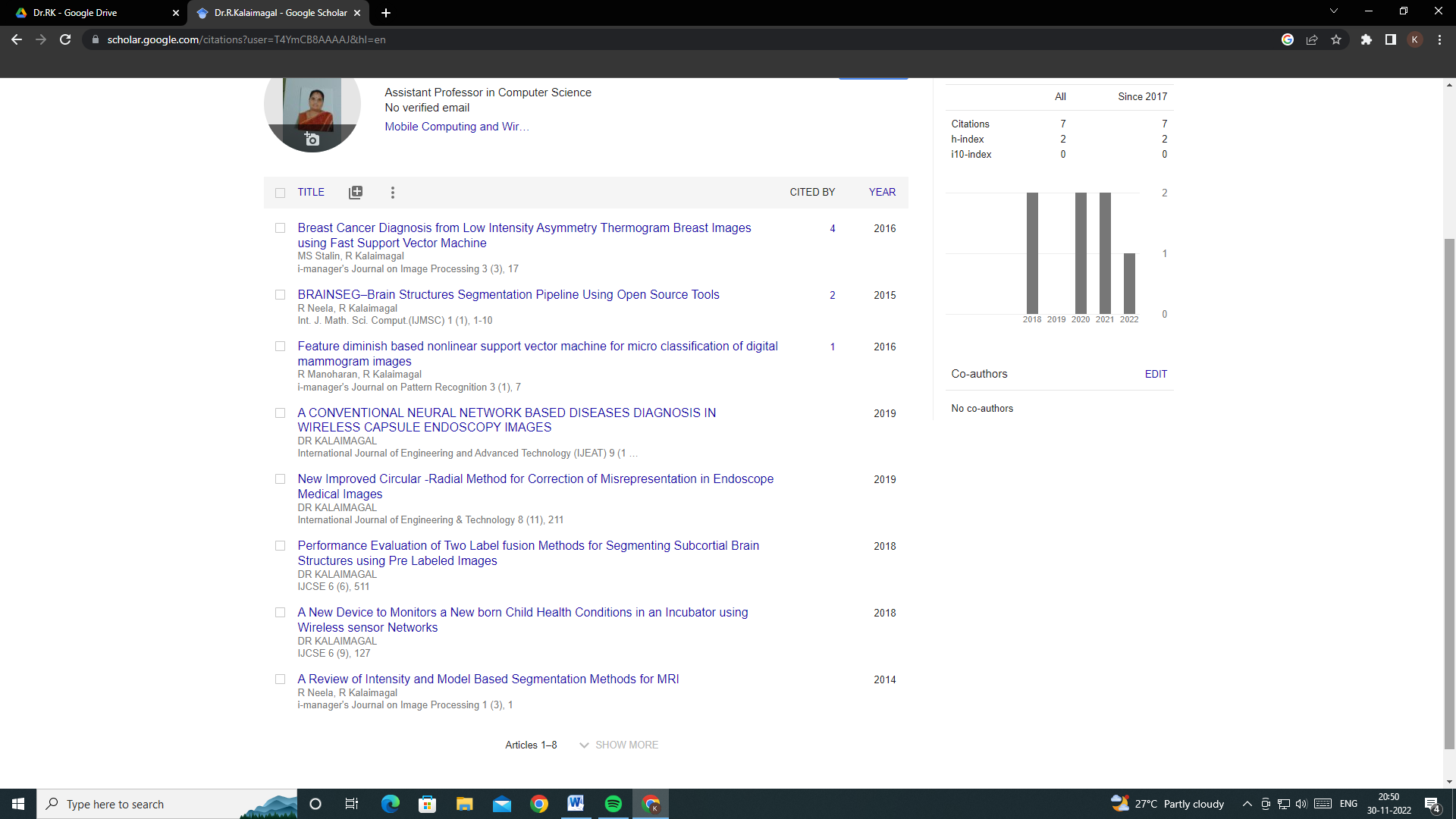

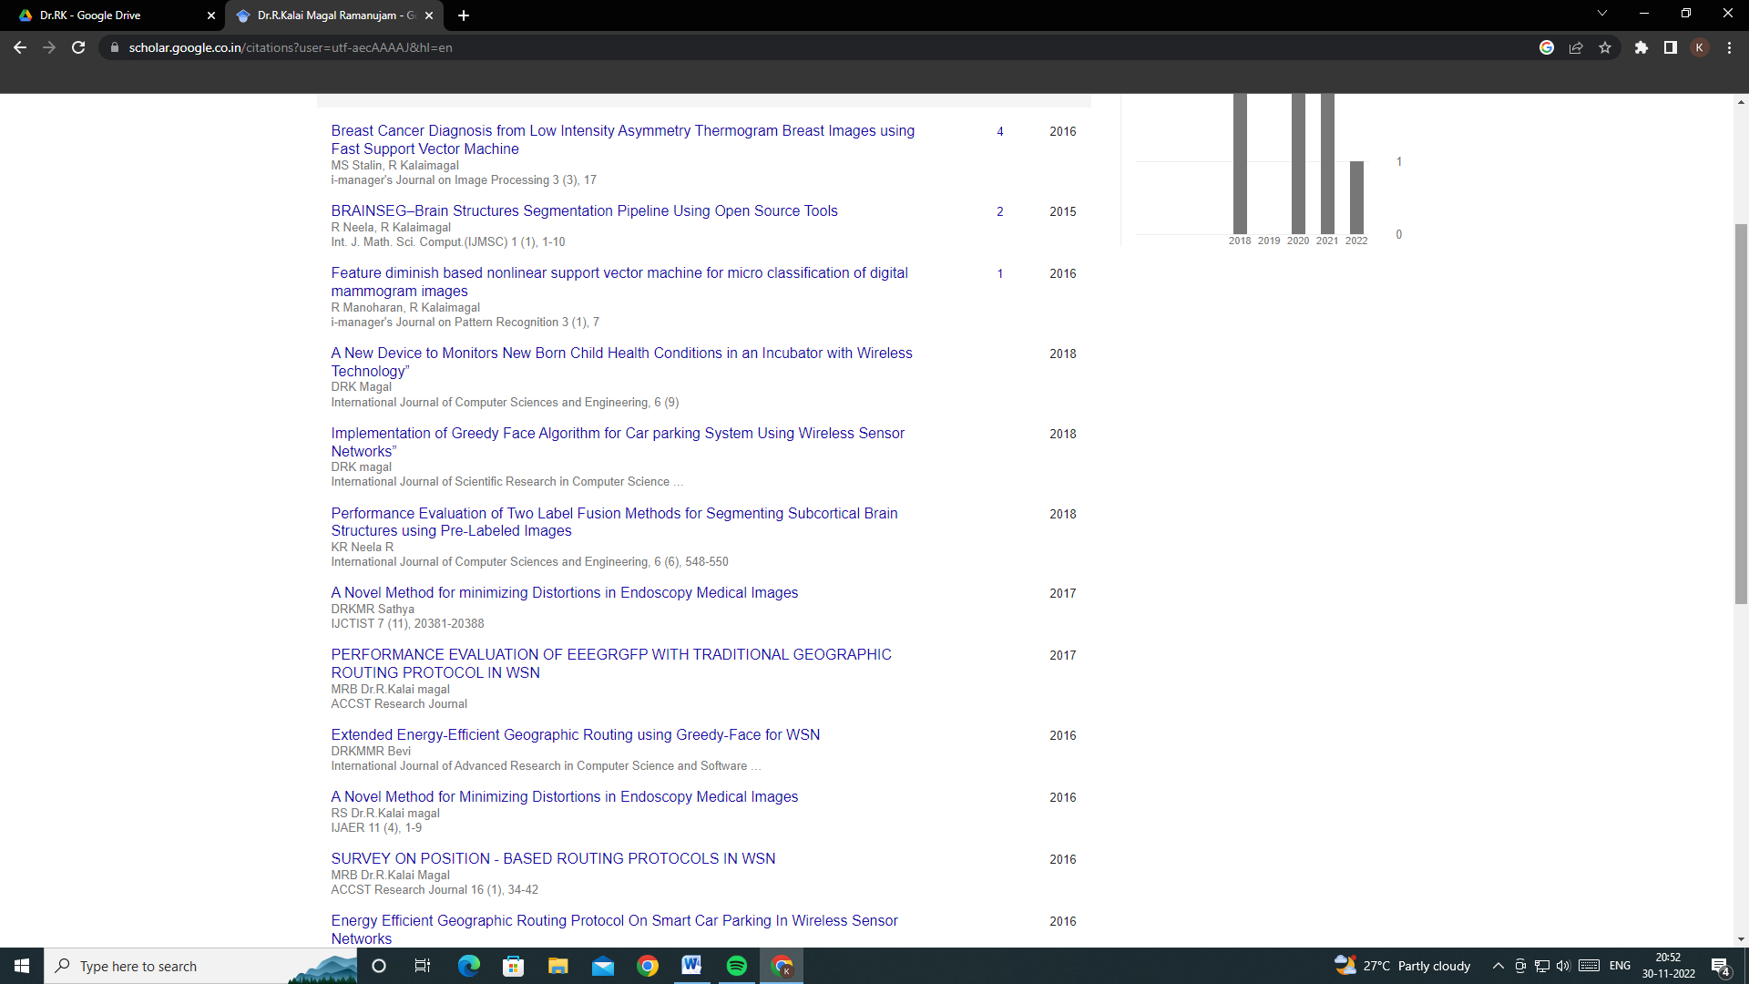

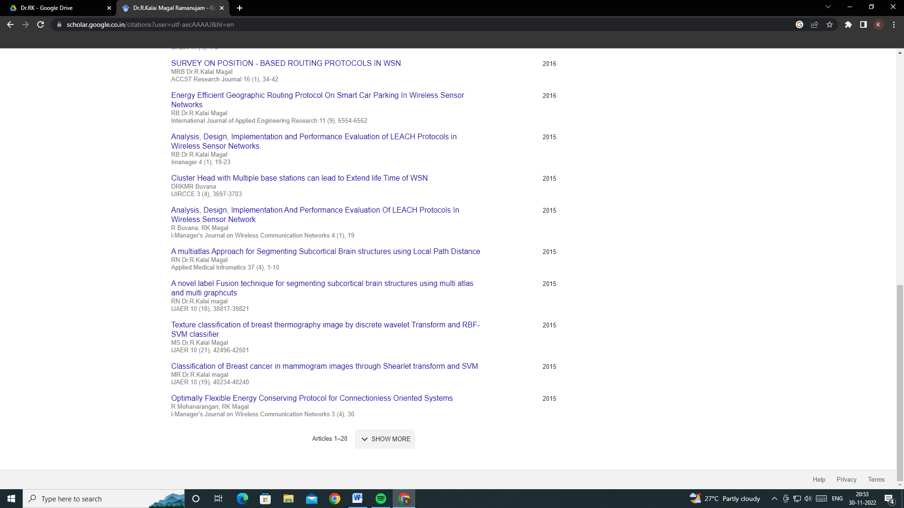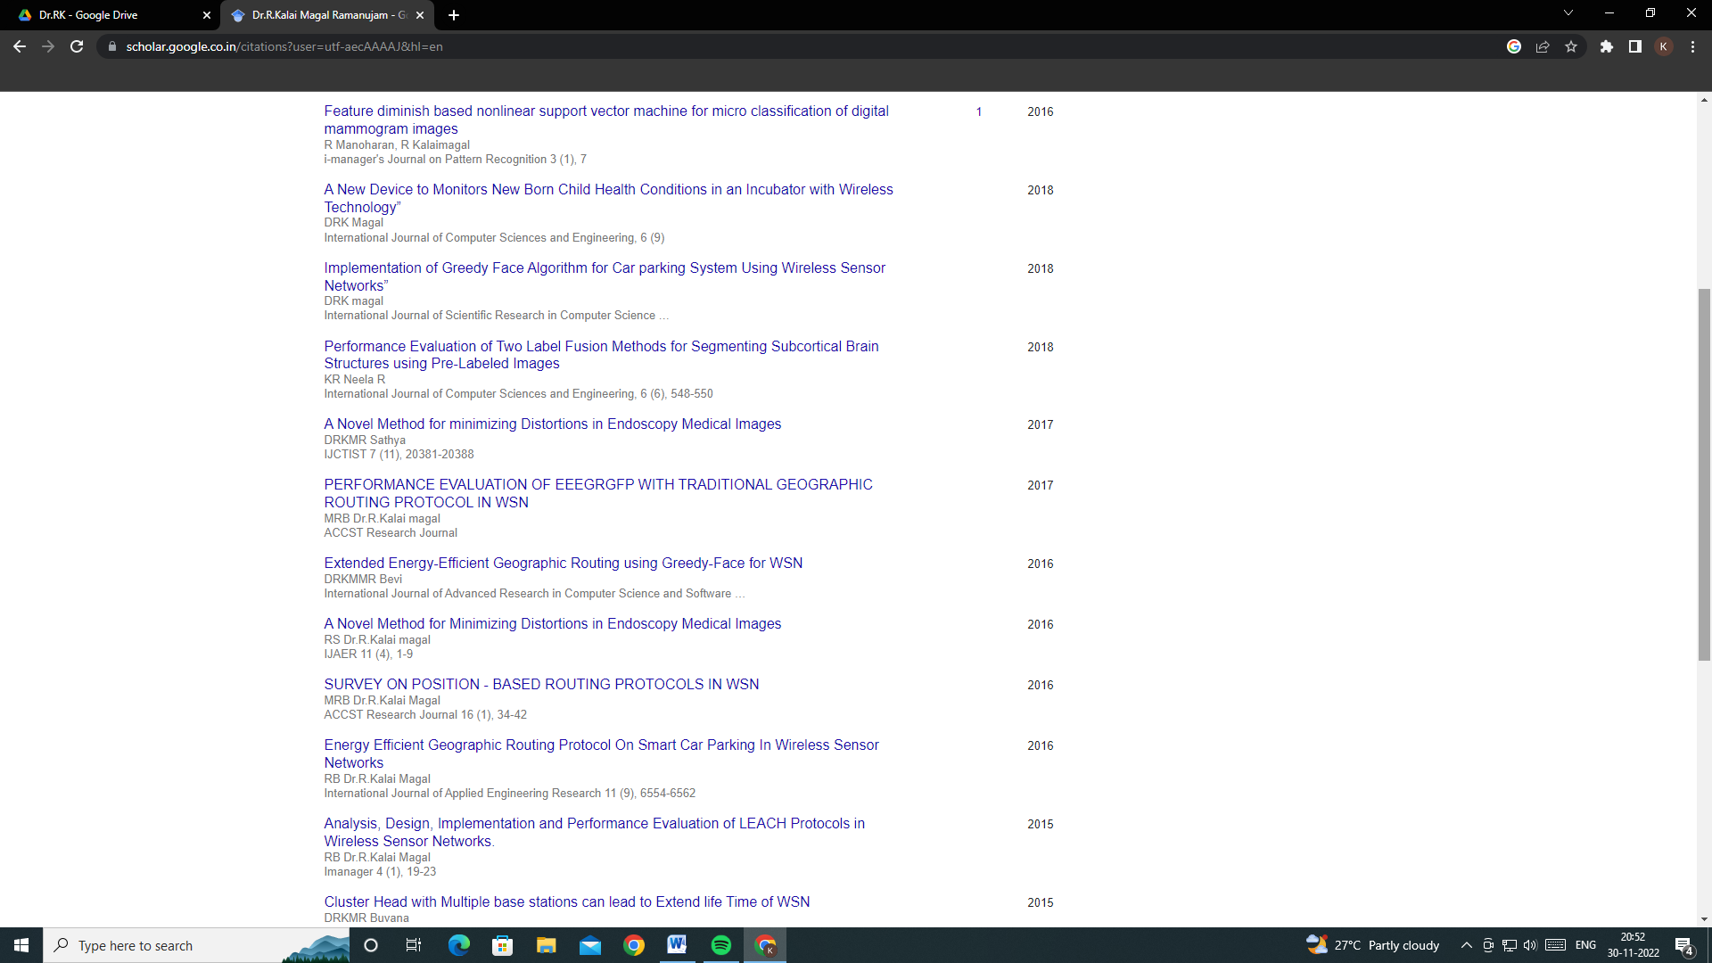

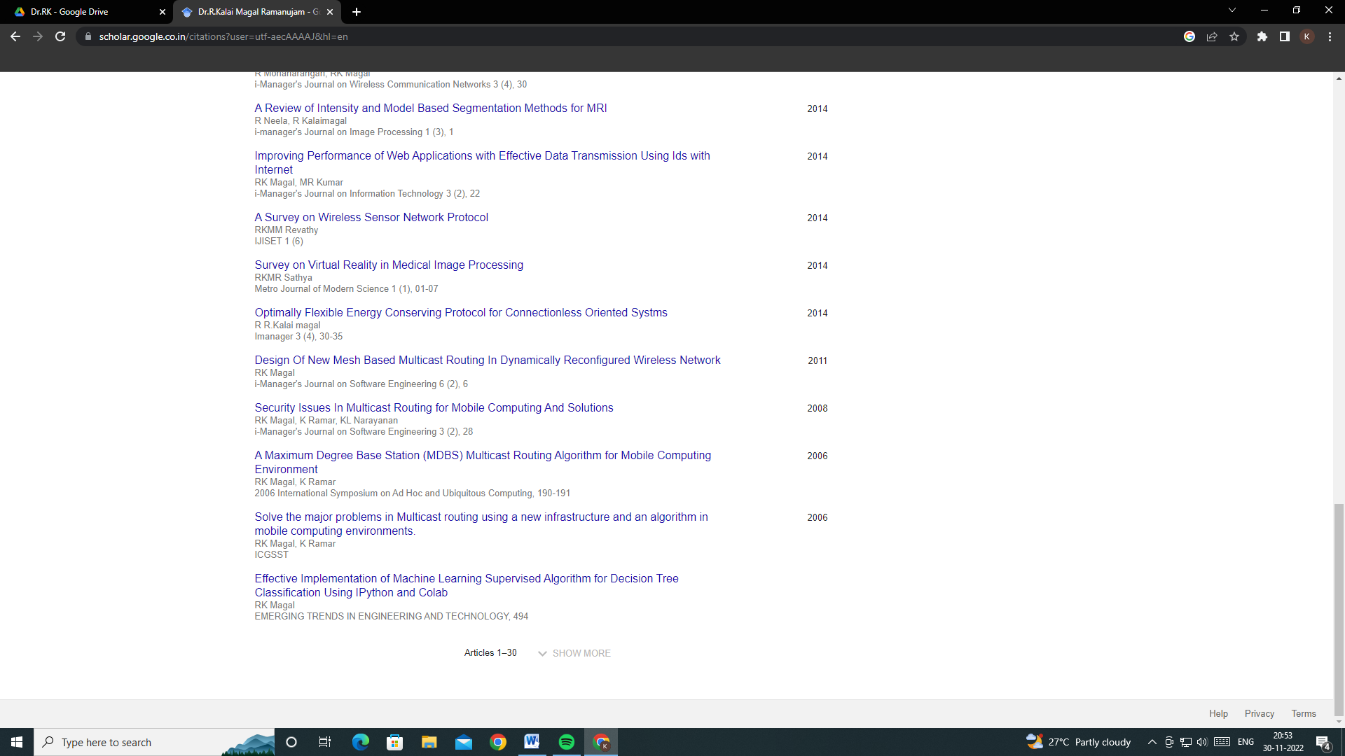

|  |  |  |  |  |
| --- | --- | --- | --- | --- |
| **S.No** | **Name of  the Organizer** | **Date** | **Number of days** | **Tile of  the web minor** |
| **1** | **St.Xavier’s College -Palayamkottai** | **24th July  2020** | **1** | **Optical Nano Biosensors and Microfluidics in X ray Spectroscopy** |
| **2** | **RUSA- Muthurangam Government Arts College.Vellore (National Level Weniar)** | **25th July 2020** | **1** | **N-LIST Resources for Research** |
| **3** | **T.K Govt Arts College-Viruthachalam**  **E-Quiz** | **03th July   202** | **1** | **e-Wuiz on RECENT TRENDS IN DATA MINING** |
| **4** | **IQAC-Presidency College** | **4th August 2020** | **1** | **Effective online Teaching** |
| **5** | **RISE Krishna Sai Gandhi group of Institutions. E-Quiz** | **27-7-2020** | **1** | **Compiler Design** |
| **6** | **SSN college of Engineering** | **July 1st and 2 -2020** | **2** | Advanced Materials and Modern Applications |
| **7** | **VIGAN institute of Technology and Science** | **July 26th 2020** | **1** | **Plastics Challenges-Processing and Recycling.** |
|  |  |  |  |  |
| **8** | **Codegnan IT Solutions OPCpvt Ltd**  **Hydrabed** | **9th May 2020** | **1** | **Building  Decision Tree from Scratch using Python** |
| **9** | **Geethanjali  Institute of Science and Technology - Nellore** | **14th  may  2020** | **1** | **e-vehicles for  sustanible transportation** |
| **10** | **Erode Sengunthar  Engineering College** | **15th May 2020** | **1** | **How to write a Research Paper ?** |
| **11** | **G.T.N Arts College- Dindigul** | **21st May 2020** | **1** | **Quality Analysis of Differential Equations and its Application.** |
| **12** | **SCSVM  University-Kanchipuram** | **29th May 2020**  **(7 pm to  8 pm)** | **1** | **Online Learning Tools POST COVID-19** |
| **13** | **JAIN University Bangalore** | **May 28th 2020** | **1** | **Solar Energy Opportunities and Management.** |
| **14** | **RAI University** | **JUNE 4th 2020** | **1** | **How to Publish Research Articles in SCI journals using INFO-Graphical tools.** |
| **15** | **Sree DATTHA institute of Engineering and Technology** | **June 5th 2020** | **1** | **Hands on Experience on Iot with Cisco Packet Tracer** |
| **16** | **Geethanjali  Institute of Science and Technology - Nellore** | **June 6th 2020** | **1** | **Preparing ourselves to POST Covid Academic Challenges** |
| **17** | **USHARAMA College of Engineering and Technology (Autonomous)** | **June 7th 2020** | **1** | **Tools for Making Your Thesis Complete** |
| **18** | **Meenakshi  College of Engineering** | **June 9th 2020** | **1** | **Evolution  of  Sensor Networks and Internet of Things** |
| **19** | **Voorhees College ,Vellore** | **13th June-2020** | **1** | **Basics of  Latex** |
| **20** | **Loyola College , Chennai** | **15th June to 17th June** | **3** | **Exploring Advances in Graph Theory** |
| **21** | **Online Quiz.** | **27-6-2020** | **1** | **General Mathematics.** |