2027 ASEE MODEL DESIGN COMPETITION
Toronto Food Run
ASEE Two-Year College Division (TYCD)
Toronto, Ontario, Canada
Monday, June 21, 2027
Dear Colleague,
On behalf of the American Society for Engineering Education (ASEE) Two-Year College Division, we invite your institution to participate in the 2027 ASEE Model Design Competition. This event will be held with the ASEE Annual Conference in Toronto, Ontario.
In Toronto Food Run, student teams design and build an autonomous robot system that delivers four Toronto food items to assigned customer addresses and delivers poutine ingredients to the CN Tower Bowl. Each team receives four official trials, each with a maximum duration of 120 seconds. An Engineering Exhibition precedes the robot trials.
The purpose of this competition is to give students a complete engineering design experience: conceiving, building, programming, testing, improving, and communicating an autonomous system. We hope to see your students' ideas on the field in Toronto.
Results from the 2026 ASEE Model Design Competition
Charlotte, North Carolina — June 22, 2026
The 2026 competition challenged teams to collect, sort, and deliver randomly positioned colored foam golf balls.

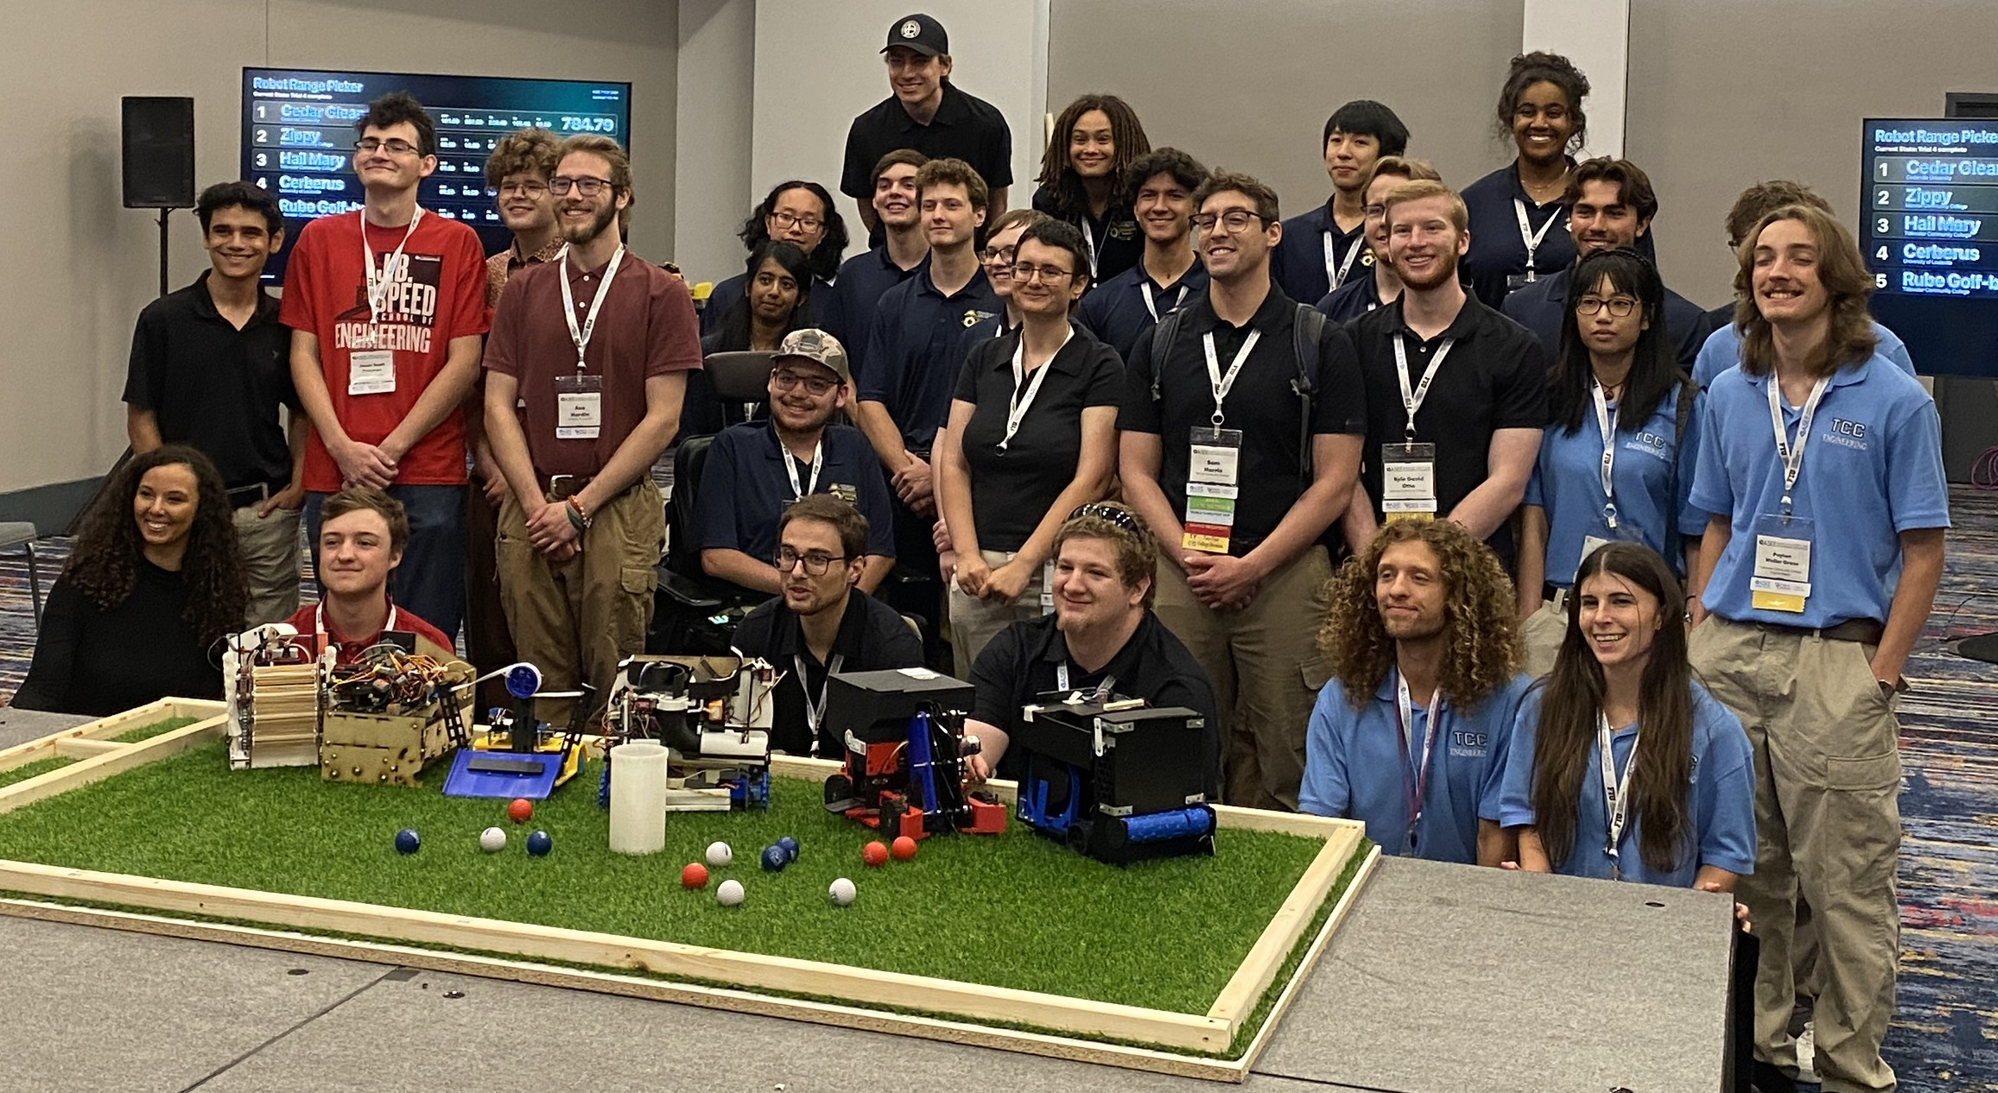
2026 ASEE Model Design Competition teams.

2027 ASEE TYCD MODEL DESIGN COMPETITION RULES
Toronto Food Run
Toronto, Ontario, Canada — June 21, 2027
Event Name:
Toronto Food Run
Objective:
Design and build an autonomous Robot System that delivers four Toronto Food Items to customer Food Cups at randomly assigned addresses and delivers Fries, Cheese Curds, and Gravy to the CN Tower Bowl. The Robot System has 120 seconds in each of four official trials. It must begin within an 8 in × 12 in × 10 in size limit, but may expand or separate after the start. An Engineering Exhibition is included as part of the competition.
Track Specifications:
The Playing Field is a 48 in × 96 in Toronto street map on a 4’ x 8’ plywood sheet. It includes 25 Food Cups, four corner Markets, an integrated CN Tower Bowl, road markings, and a starting area at the bottom center of Lakeshore Boulevard.
The Delivery Address is the Food Cup immediately northwest of the selected street/avenue intersection when the field is viewed with north at the top.
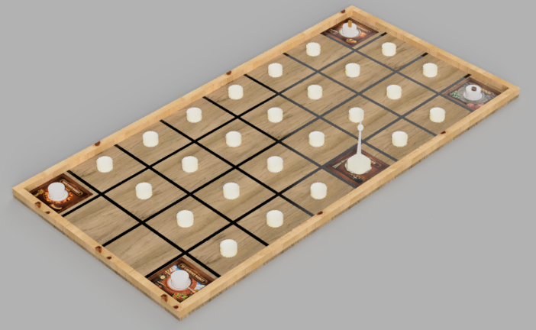
Figure 1: Overall Playing Field.
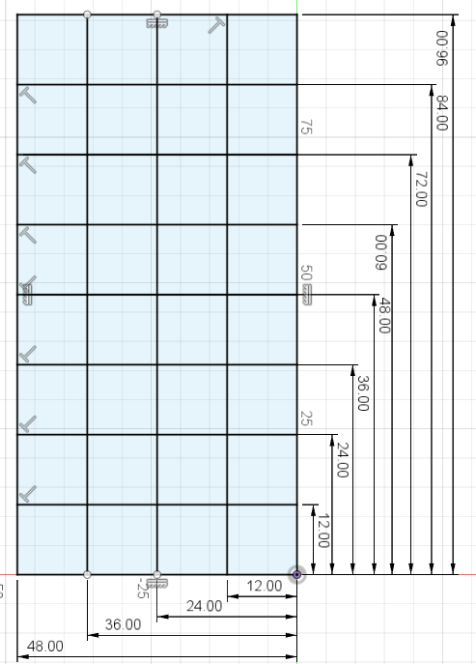
Figure 2: Playing Field dimensions These dimensions are to the center of each line.
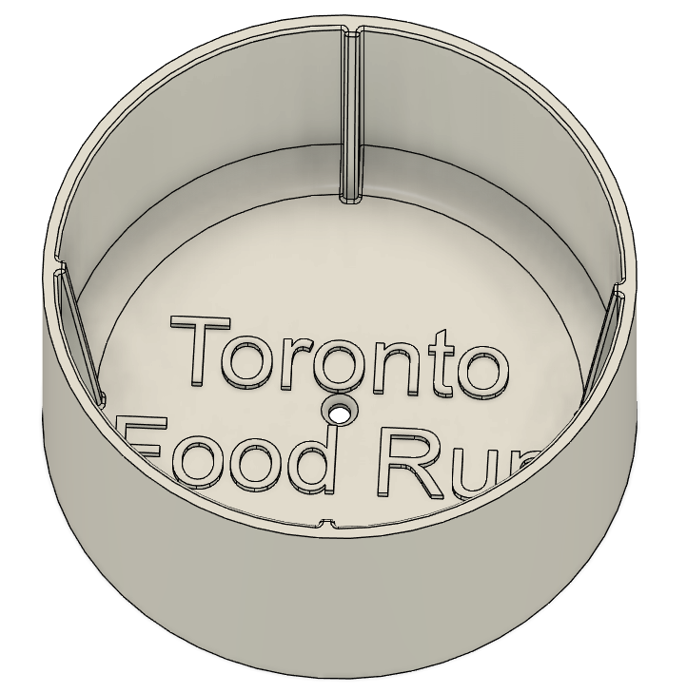 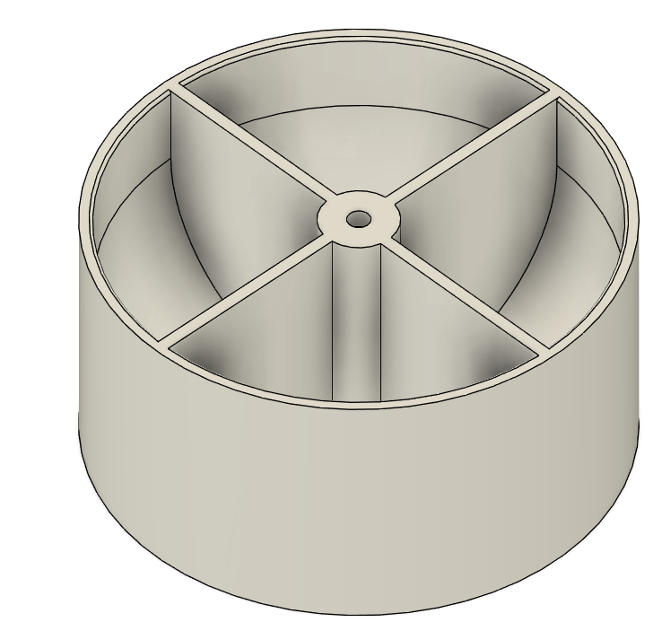 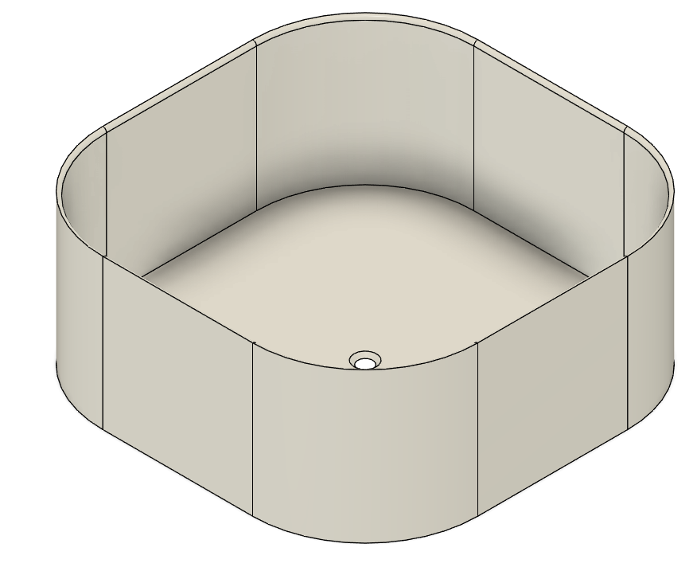 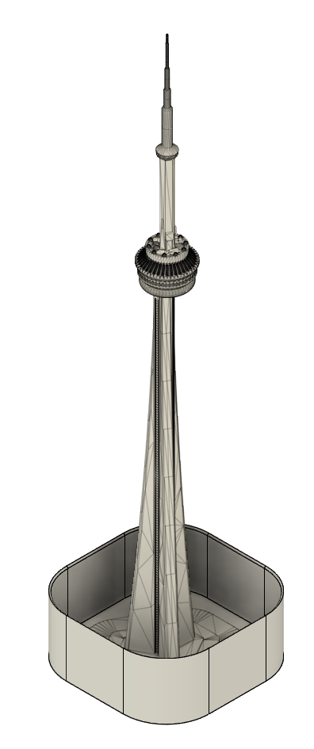
Figure 3: Food Cup, Poutine Cup, CN Tower Base , CN Tower in Base
(These should be printed in white PLA)
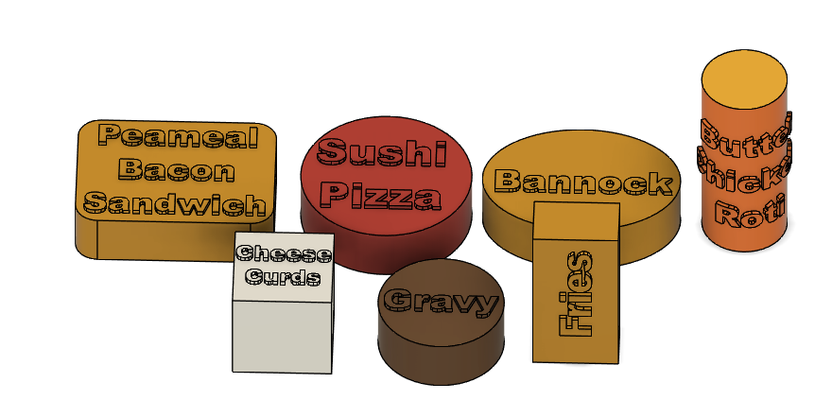
Figure 4:Game Food Elements
(Cheese Curds, Gravy and Fries will be printed in White PLA, other food items are carried on board and color should not matter)
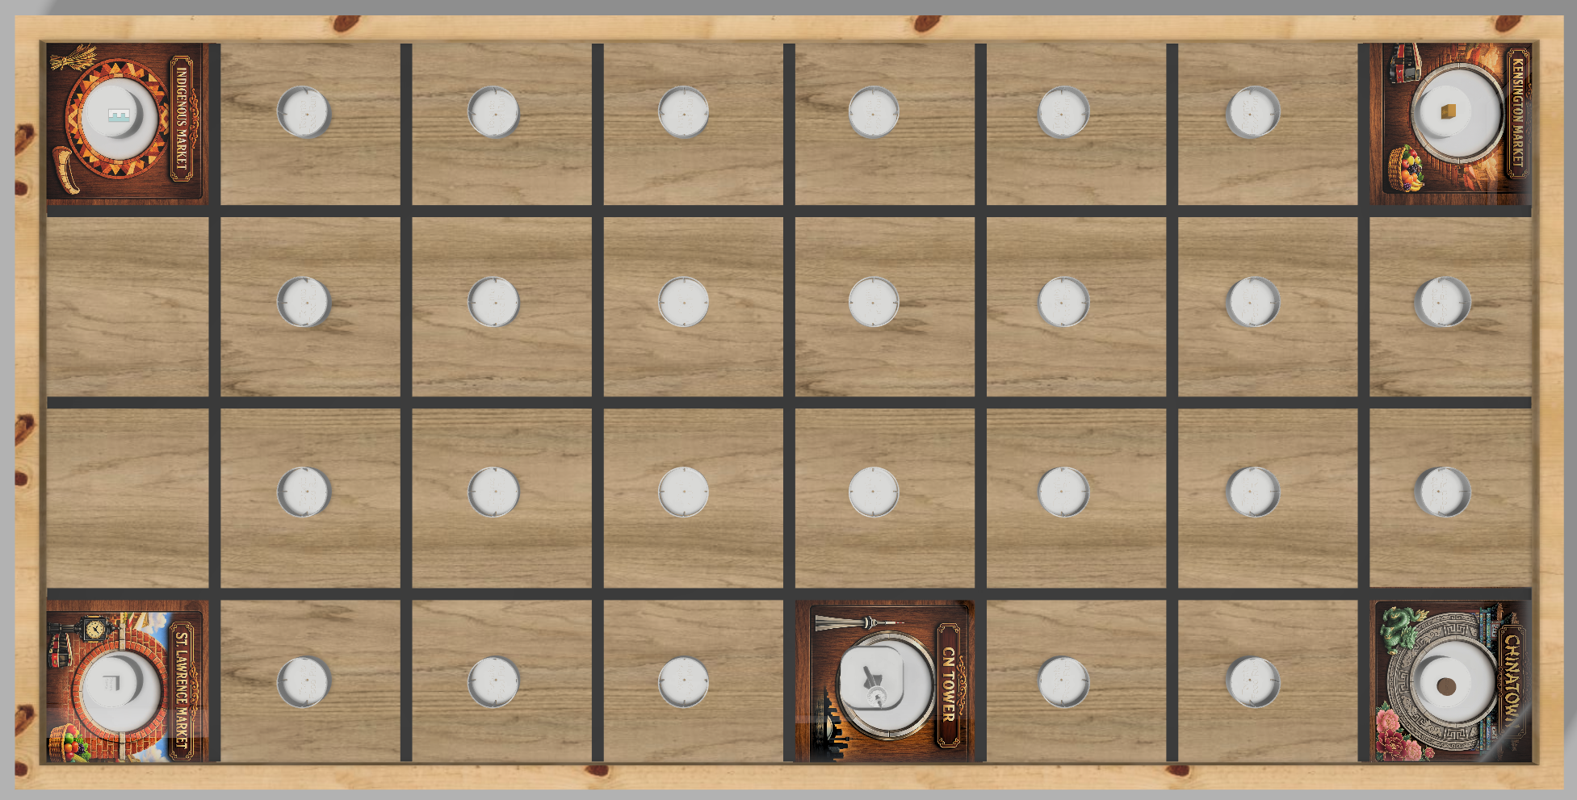
Figure 5: Field with all elements placed
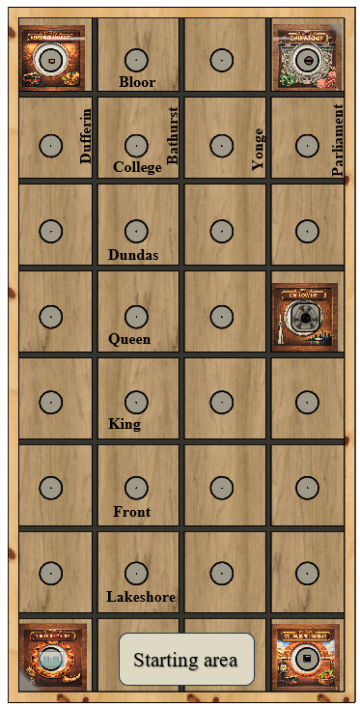

Figure 6: Labels on Streets – These labels are not shown on the field but needed to understand locations
Required Materials:
Quantity | Description
1 | 48 in × 96 in × nominal 3/4 Blonde Wood (High quality- Light colored) Plywood sheet.  See example below
7 | Nominal 2 × 4 × 96 in framing lumber
3 | Nominal 2 × 2 × 96 in perimeter-rail lumber
1 roll | 3/4 in black vinyl electrical tape
As needed | Wood screws and finishing nails or screws
25 | Food Cups
4 | Pickup Cups, installed inverted at the Markets
1 each | Sushi Pizza, Butter Chicken Roti, Peameal Bacon Sandwich, Bannock
1 each | Fries, Cheese Curds, Gravy
1 | CN Tower Base placed in special larger CN Tower Bowl

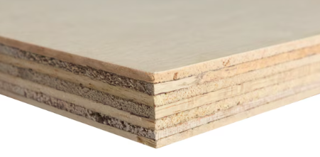
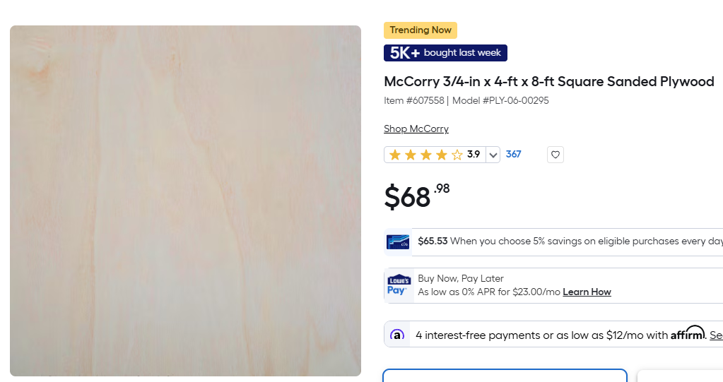
Example plywood available at Lowes.

Use the supplied STL/CAD files for the Food Cups, Pickup Cups, CN Tower Base, Bowl, and game pieces. Decorative Market artwork is encouraged but does not affect scoring. Card Deck file for random drawing.
Field Construction Procedures:
1. First mark all centerlines lightly in pencil according to the dimensions given above. Find and mark the center of each square where a bowl will later be screwed.
2. Cut a clear plastic ruler on a table saw ¾” wide with a curf cut shallowly in the exact center. This can be laid on top of a center line to then mark the two outside edges in a few places to make sure you run the roads as straight as possible. Otherwise you cannot see the center line once the tape is on top of it. Apply the 3/4 in black vinyl road tape according to the drawings. You must stretch the tape first; let it relax and press it in place. The shorter streets should be run first with the longer avenues on top of the streets in the intersections.
3. Install 1.5”× 1.5” perimeter rails as shown on the official field drawing.
4. Predrill the center holes so that it is easy to secure all 25 Food Cups with a single center screw. Next place each of the decorative corner art pages in the four corners and, under the CN Tower. Attach the inverted Bases to the four Market decorations. Finally attach the CN Tower base and place the CN Tower in it.
Market and Poutine Ingredient Locations:
Field corner | Market | Starting contents
Upper left | Kensington Market | Fries
Upper right | Chinatown | Gravy
Lower left | Indigenous Market | Empty
Lower right | St. Lawrence Market | Cheese Curds

Robot Specifications
Allowable Energy Sources:
Any energy source may be used if it is completely contained within the Robot System, creates no gaseous, liquid, or solid emissions, and presents no safety hazard to participants or spectators.

Prohibition Against Flying Robots:
Flying robots, including quadcopters, are prohibited because the competition is held in a crowded exhibition area.
Maximum Robot Size:
Immediately before each trial, the complete Robot System and all four Food Items carried at the start must fit inside an 8 in × 12 in × 10 in rectangular envelope and be completely within the Starting Area. The Robot System may expand, separate, cooperate, reconnect, and exchange game pieces autonomously after the start.
Autonomous Operation:
After one team member performs one start action on the judge's command, no person may touch, control, communicate with, or otherwise assist the Robot System, field, or game pieces during the trial.
Components, Fabrication, and Cost:
Student team members must perform the primary design, fabrication, integration, and programming. Commercial components and subsystems are permitted, but a complete commercially available robot without substantial student-designed integration and modification is not permitted. The reasonable current value of the Robot System must be less than $600. Donated, borrowed, reused, and institution-owned components count at a reasonable current market or replacement value.
Safety and Field Protection:
The Robot System must not intentionally damage the field, game pieces, scoring containers, or other competition equipment. Officials may inspect a Robot System and may prohibit unsafe operation until the team corrects the condition.
Robot Time Trial Rules
Each team receives four official trials, one in each of four rounds. Each trial has a maximum duration of 120 seconds. All teams run the same mission in a given round.
Before Each Trial:
1. The Robot System must satisfy the starting-size requirement and be stationary in the Starting Area.
2. All four Food Items must be carried by or contained within the Robot System.
3. No Poutine Ingredient may be carried by the Robot System. Fries, Gravy, and Cheese Curds begin on their assigned inverted Pickup Cups.
4. All Food Cups and the CN Tower Bowl begin empty.
Timing begins when the judge gives the official start command. A trial ends when the complete mission is scored, the Robot System is disabled, the team asks to end the trial, the judge stops it for safety, or 120 seconds elapse. Teams may repair, recharge, reprogram, and modify their Robot Systems between trials.
Robot Time Trial Scoring
At trial end, a game piece is scored in a container when it is inside, at rest, and touches the container bottom, a side wall, or another scored game piece that forms a continuous contact chain to the bottom or side wall.
Action | Points | Maximum
Food Item in any Food Cup | 10 each | 40
Food Item in its assigned Delivery Address | Additional 15 each | 60
Poutine Ingredient removed from its assigned Pickup Cup | 5 each | 15
Poutine Ingredient in the CN Tower Bowl | 15 each | 45
All three Poutine Ingredients in the CN Tower Bowl | 30 bonus | 30
Complete-mission time bonus | 120 − official time | 120
Maximum Official Trial Score |  | 310

A Food Item in the wrong Food Cup earns the 10 points for being in a Food Cup but not the 15 correct-address points. A Poutine ingredient is considered removed from its assigned pickup cup when it is no longer supported by the cup. Knocking it off the cup will earn 5 points for each poutine ingredient even if the robot never collects it. The time bonus is earned only if all four Food Items are in their assigned Food Cups and all three Poutine Ingredients are in the CN Tower Bowl. The order in which the tasks are completed is not specified and any order is allowed.
Overall Score = Exhibition Score + Trial 1 + Trial 2 + Trial 3 + Trial 4.
Random Mission Procedure
Official Trial 1 uses the published mission below. The remaining three missions are generated at the competition. Every team receives the complete set of four missions at least 30 minutes before robot trials begin.
Official Trial 1 Mission:
Food Item | Delivery intersection
Sushi Pizza | Yonge Street and Queen Street
Peameal Bacon Sandwich | Bathurst Street and Front Street
Butter Chicken Roti | Dufferin Street and College Street
Bannock | Parliament and Lakeshore Boulevard

For each random mission, officials use three card decks: Food Cards (the four Food Items), Street Cards (Bloor, College, Dundas, Queen, King, Front, Lakeshore), and Avenue Cards (Dufferin, Bathurst, Yonge, and Parliament).
1. Shuffle all three decks. Draw one Food Card, one Avenue Card, and one Street Card.
2. If the street and avenue combination is not legal (Bloor and Dufferin, Bloor and Parliament, Queen and Parliament) then a new street card is drawn until a legal combination is found. Food and Avenue cards are always kept, only Street cards are ever not used if drawn. Illegal street cards are simply not used (they are not put back and reshuffled in the drawing.) Once a legal combination is drawn the assignment is made for that Food Item to the Food Cup immediately northwest of the selected street/avenue intersection.
3. Repeat until four unique orders are recorded. Use all four Food Items and all four Avenue cards.
The Poutine Ingredient locations are fixed for every round: Fries at Kensington Market, Gravy at Chinatown, Cheese Curds at St. Lawrence Market, and no ingredient at Indigenous Market.
Delivery Address Likelihoods:
This table gives the chance that a legal location appears in one four-order mission under the card procedure above. Because one card is drawn from each Avenue, every mission uses one Dufferin, one Bathurst, one Yonge, and one Parliament location. The legal Street Cards for that Avenue are equally likely. The three prohibited locations are never drawn.
Street | Dufferin | Bathurst | Yonge | Parliament
Bloor | Illegal | 14.29% | 14.29% | Illegal
College | 16.67% | 14.29% | 14.29% | 20.00%
Dundas | 16.67% | 14.29% | 14.29% | 20.00%
Queen | 16.67% | 14.29% | 14.29% | Illegal
King | 16.67% | 14.29% | 14.29% | 20.00%
Front | 16.67% | 14.29% | 14.29% | 20.00%
Lakeshore | 16.67% | 14.29% | 14.29% | 20.00%

Engineering Exhibition
Before robot trials, every team participates in the Engineering Exhibition. Teams should display their Robot System and supporting material such as drawings, CAD models, electrical schematics, software architecture, design notebooks, test data, photographs, and videos.
Category | Maximum points
Design Development | 20
Robot Operation | 20
Fabrication Methods | 20
Design Analysis | 20
Exhibit Quality | 20
Maximum Exhibition Score | 100

Each official judge scores each team. One captain from every team also scores every other team; a captain may not score their own team. The captain average is treated as one additional judge score. The Exhibition Score is the average of the official judges' totals and the captain average.
Schedule of Events on the Competition Day
The exact schedule is subject to the ASEE conference schedule and will be announced by the competition committee. A typical sequence is:
1. Team check-in, field access, and draw for exhibition/trial order.
2. Engineering Exhibition and judging. Robot testing is not permitted during the Exhibition.
3. Release of all four missions; at least 30 minutes of preparation time.
4. Four Robot Time Trial rounds.
5. Awards and team photos after trials conclude.
Rule Interpretation, Registration, Practice, and Awards
Rule Interpretation:
Before the competition, submit questions through the competition committee's official communication channel. During the competition, the Head Judge interprets the intent of the rules and resolves score questions. A team should raise a question promptly and before its next trial begins. The Head Judge's decision is final except for correction of an arithmetic or transcription error.
Registration and Team Limits:
The competition is open to teams from accredited two-year and four-year colleges and universities. Each team must have at least two or more student members and at least one faculty advisor. Multiple entries from one institution are permitted when each represents a unique engineering solution. Registration details and conference-access instructions will be issued by the competition committee.
Please contact William A. Simmons email: wsimmons@tcc.edu

