CSE 4308: Database Management Systems Lab

Lab-03

Group-B

Mohammod Mahbub Ur Rahman

220042148

BSc.in Software Engineering

**Tasks**

**1.**

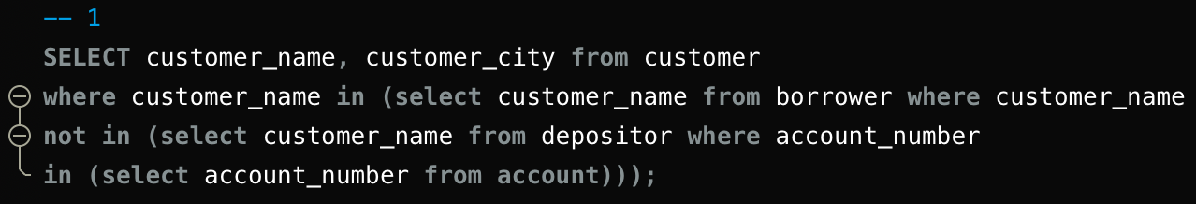

Here I am selecting customer name from borrower whose name is not in the account table

Output:

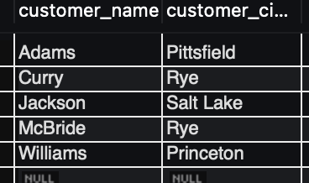

2.

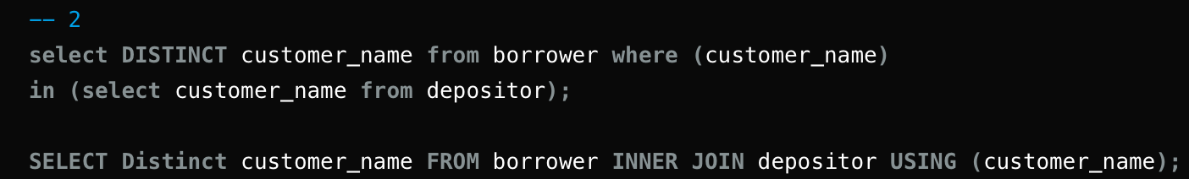

Selecting distinct customer name from borrower table where the customer’s name is also in depositor table

Using set: by inner joining I am selecting the common entry from both table who have the same name.

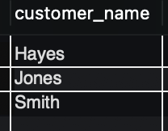

3.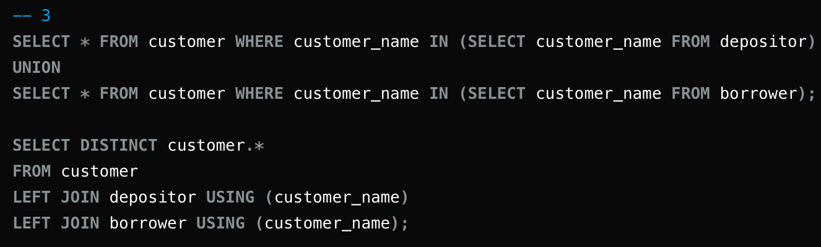

I am doing union operation in both table depositor and borrower. Where they have the name in customer table.

Left join: it joins the common entry (here customer name) from the depositor and borrower and adds it in the customer table.

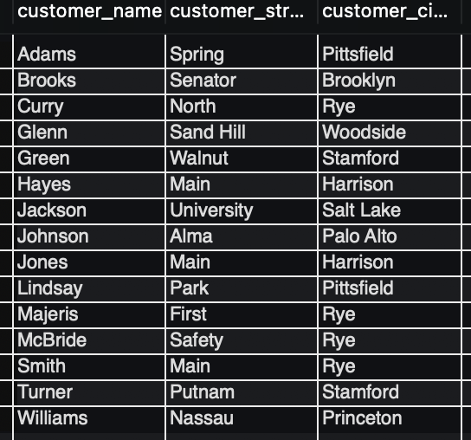

4.



It sums the assets of all branches.

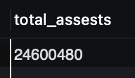

5.

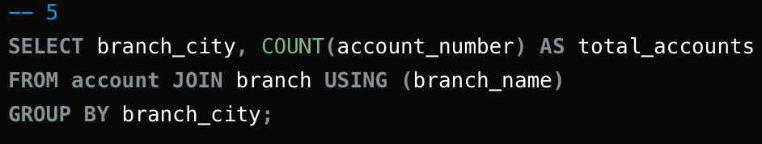

Here I joined account table with branch table using branch name and then counted the account numbers

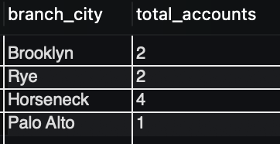

6.

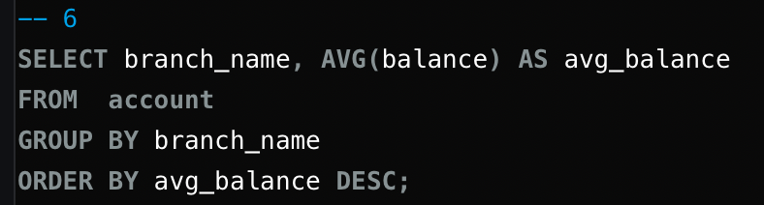

Here I calculated average balance from account and grouped by branch name and ordered by avg_balance in descending order.

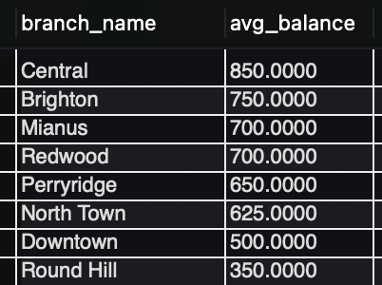

7.

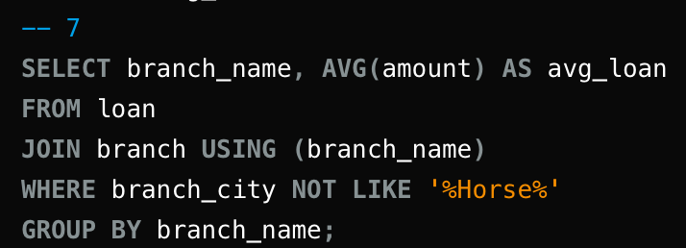

Here I am taking branch name and average amount of loan in each branch. I am joining branch with loan using branch name and checking if the city name has horse in it. if not then display it

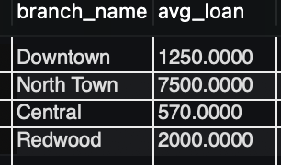

8.

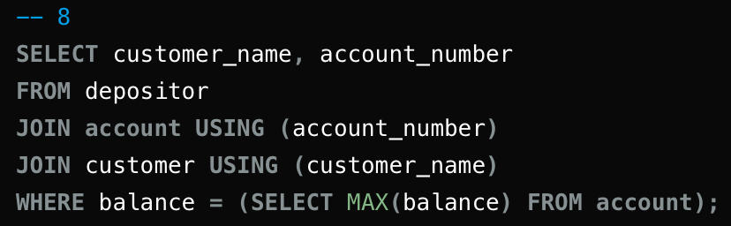

Here I am joining the table account and customer and checking whose balance is max in the account table and returning it.



9.

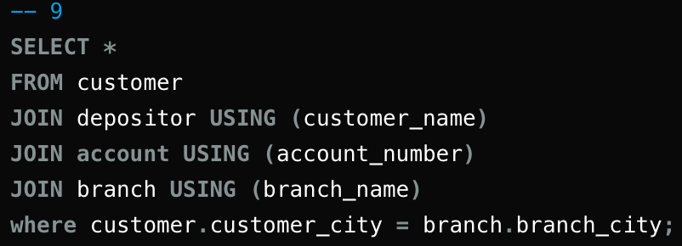

Here I am joining depositor, account, branch with customer and taking the entry where customer city is equal to the branch city



10.

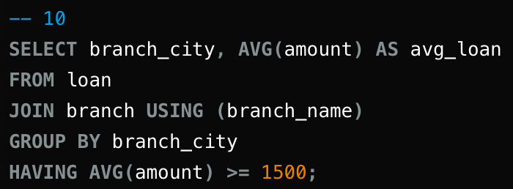

I am joining branch with loan and displaying the branch city having average loan greater than 1500.

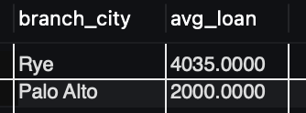

11.

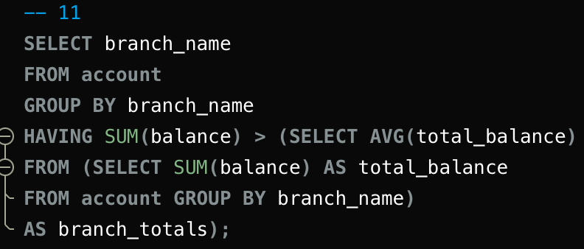

I am selecting branch name whose sum of balance of all account is greater than the average of other branches.

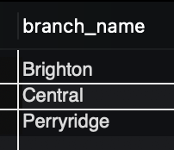

12.

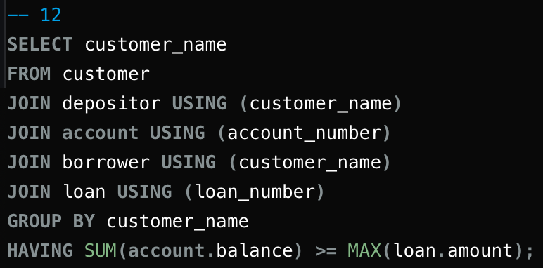

I am joining depositor, account, borrower, loan with customer and displaying the name who has balance greater than or equal of his loan amount.



13.

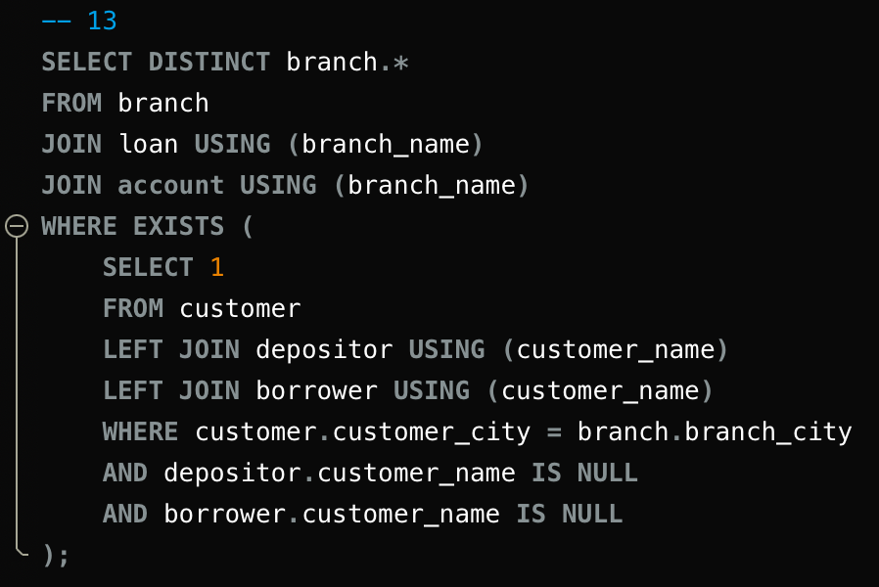

I am finding the person who doesnot have any loan or bank account. For this I have joined loan, account with branch and checking that if there is a customer in the customer table left joined by depositor and borrower who’s city and branch city is same but his name in depositor and borrower table is null. Simply he has no entry in those table.

